EXPERIMENT-7

CREATE TABLE bank_63_ (bankcode VARCHAR(3) PRIMARY KEY ,bankname VARCHAR(50) NOT NULL,headoffice VARCHAR(50),branch INT NOT NULL CHECK (branch > 0));
INSERT INTO bank_63_ VALUES ('SBT', 'SBI Bank', 'Delhi', 30);
INSERT INTO bank_63_ VALUES ('CNB', 'Canara Bank', 'Ernakulam', 20);
INSERT INTO bank_63_ VALUES ('SIB','South Indian Bank','Madras',30);
INSERT INTO bank_63_ VALUES ('AXB','Axis Bank','Kottayam',15);
INSERT INTO bank_63_ VALUES('FDB','Federal Bank','Ernakulam',25);
COMMIT;
select * from bank_63_;
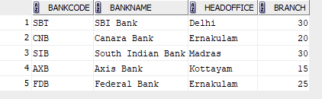
INSERT INTO bank_63_ VALUES('ICL','ICL Fincorp','Ernakulam',5);
SAVEPOINT A;

select * from bank_63_;
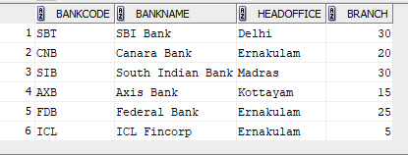
INSERT INTO bank_63_ VALUES('GMB','Grameen Bank','Pune',15);
SAVEPOINT B;

select * from bank_63_;
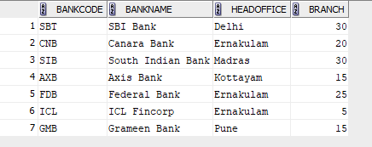
ROLLBACK TO B;
select * from bank_63_;
