**Tagging**

This code launches label candidates files and Renom Tag which we use for Labelling using Bounding Boxes. We set 8081 as port for Renom Tag

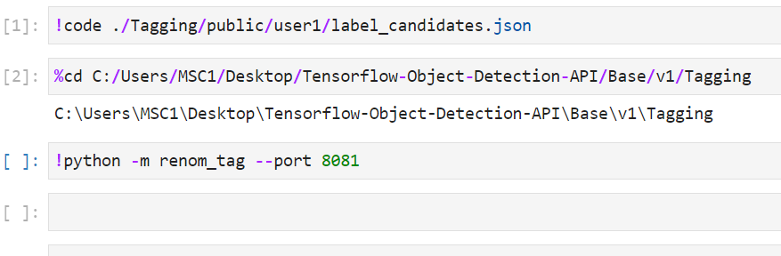

We update the Label Map.

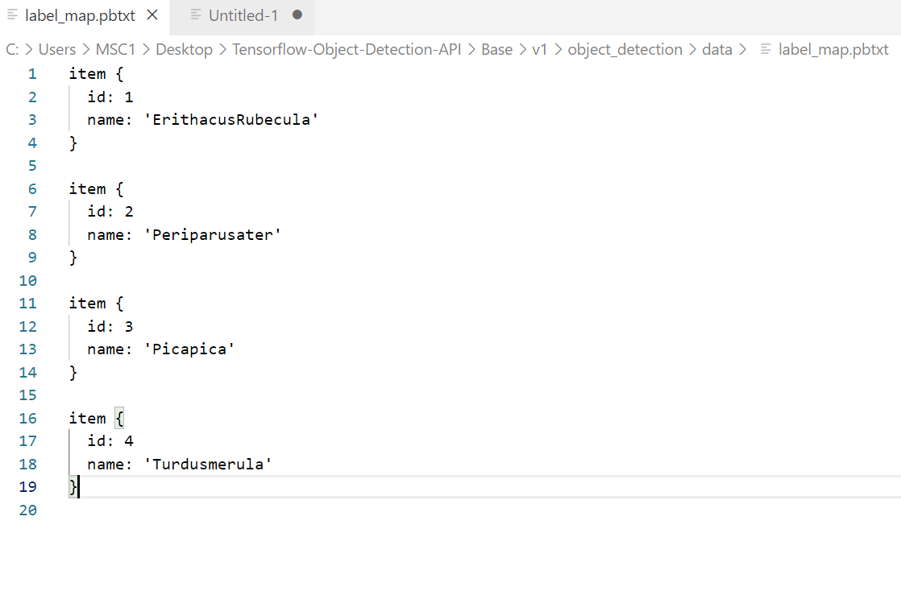

Finally, we annotate the images with bounding boxes.

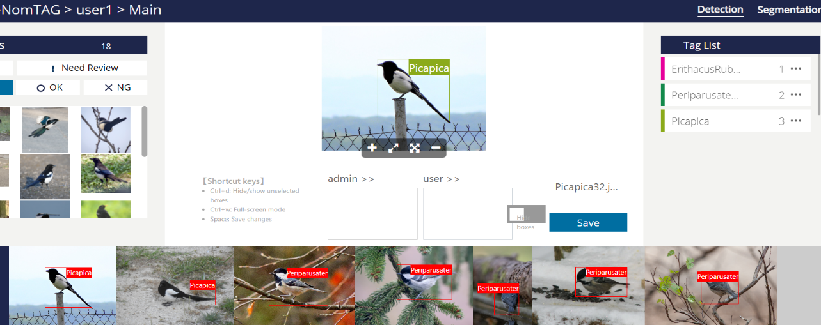

A sample of XML files generated during annotation

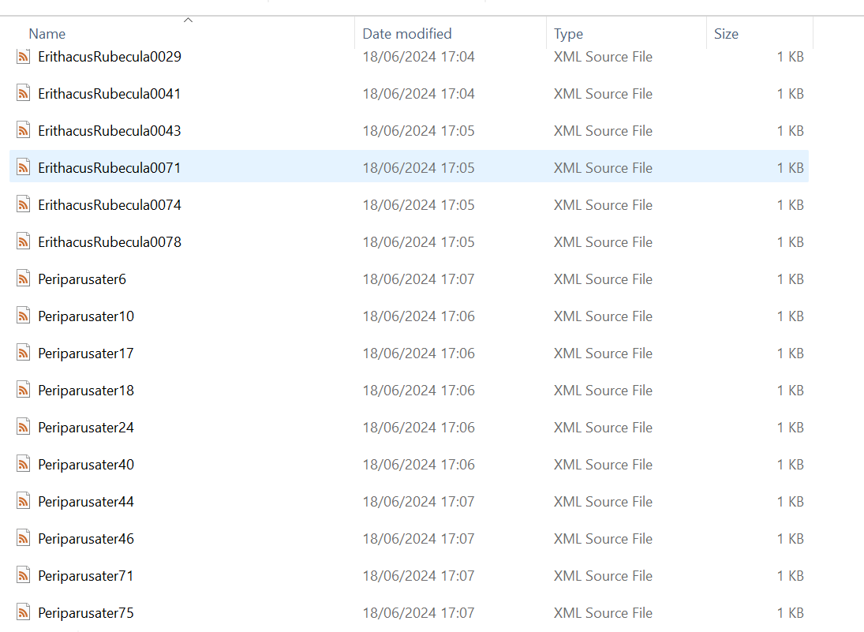

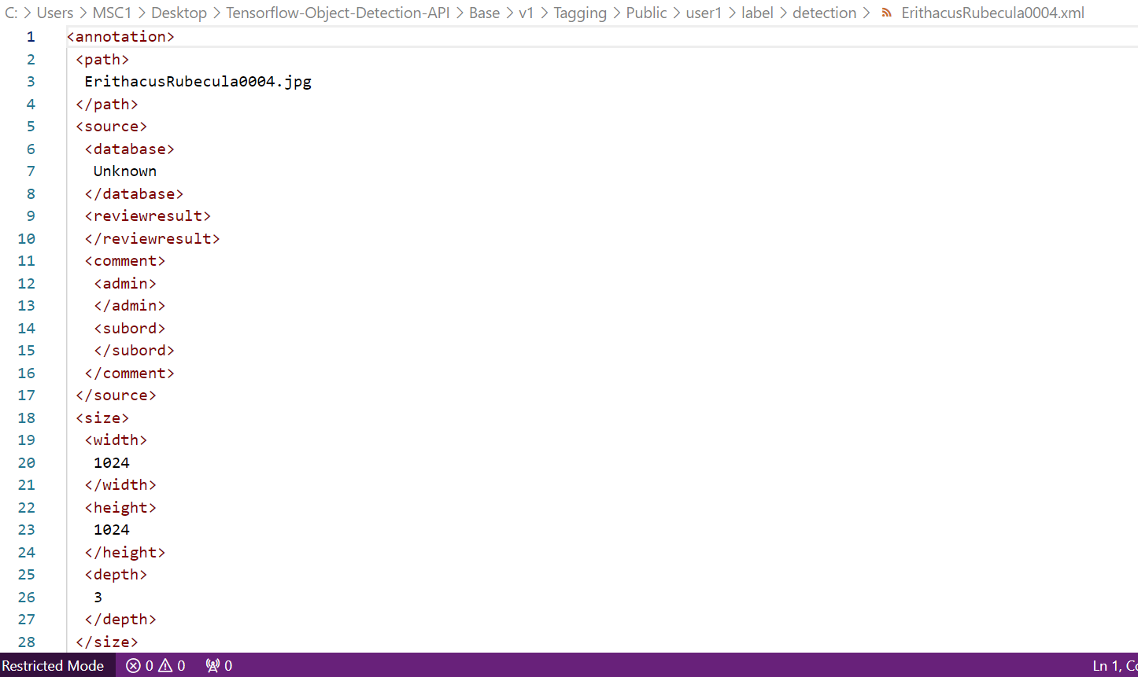

TF Records created:

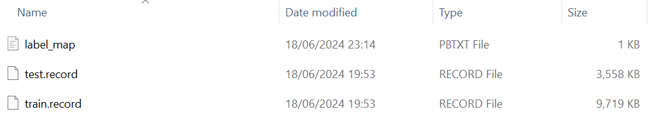

**Full object detection explanation**

1. The images were tagged and labelled; bounding boxes were drawn using RenomTag.
2. We performed Exploratory Data Analysis.
3. After that XML files were cleaned
4. Training and Test splitting with 0.1 test ratio
5. Creating Label map
6. Creating TF Records for Train and Test
7. Selecting our models ( SSD Mobile net v2 and Faster RCNN)
8. Pipeline configuration. We mentioned number of classes, Path of training TF records and testing records and labels. We set checkpoint path.
9. Training the model. Data augmentation was done during model training. It was found that lower batch size increases time for training and higher batch size increases computational requirements. Hence, batch size should be determined considering GPU memory and the higher the number of epochs, loss can be reduced but epochs must not be too high to avoid overfitting and higher training time.
10. Hyperparameter tuning if required.
11. Visualization and evaluation using TensorBoard. This can be done both during training and evaluation.
12. Evaluation. Finding total loss, Precision, Recall, IOU etc.
13. Inference.