**Assignment 2**

Submitted by Athul Jose P

WSU ID 011867566

**Executive Summary**

***Continuation Power Flow***

Steps in main.m function

1. Initializing 14 bus and importing data
2. Making Ybus by calling y_bus_calc.m with taps
3. Calculating the scheduled active power (P) and reactive power (Q)
4. Finding bus types and assigning to vectors
5. Doing Continuation Power Flow by calling CPF.m

Steps in y_bus_calc.m function

1. Initializing Ybus with zeros
2. Calculating diagonal and off diagonal elements
3. Changing terms if tap is present

Steps CPF.m function

1. Initializing Voltage magnitude and angles
2. Initializing Continuation Parameters
3. Finding Initial Values by calling Newton Raphson Function (NR.m)
4. Phase 1: Continuation Parameter as Power (lambda)
   1. Predictor step with increasing power
   2. Corrector step with Newton Raphson method
   3. Looping until NR diverges
5. Phase 2: Continuation Parameter as Voltage
   1. Predictor step with decreasing voltage
   2. Corrector step with augmented Jacobian
   3. Looping until some percentage (75%) of lambda
6. Phase 3: Continuation Parameter as Power (lambda)
   1. Predictor step with decreasing power
   2. Corrector step with Newton Raphson method
   3. Looping until lambda = 0
7. Plotting the PV curve

Steps in NR.m function

1. Initializing indexes and deltas
2. Starting iteration loop which will terminate either if converged or 100 iterations
3. Calling dpdq.m for calculating mismatch
4. Calling J_calc.m for calculating Jacobian
5. Calling fwd_bwd.m for calculating the ΔV and Δδ
6. Updating del_V and del_T (magnitude and angle) for next iteration
7. Updating the error. Here the error is taken as the maximum of absolute of deltas (ΔV and Δδ)

Steps in dpdq.m function

1. Initializing P & Q as zeros
2. Calculating P for PV bus and P & Q for PQ bus

Steps in J_calc.m function

1. Calculating J1 with loops according to limits (n_bus-1, n_bus-1)
2. Calculating J2 with loops according to limits (n_bus-1, n_pq)
3. Calculating J3 with loops according to limits (n_pq, n_bus-1)
4. Calculating J4 with loops according to limits (n_pq, n_pq)
5. Combining all to make J

Steps in fwd_bwd.m function

1. Calling LU.m for calculating Lower and Upper elements
2. Doing the backward substitution
3. Doing the forward substitution

Steps in LU.m function

1. Making the Q matrix
2. Dividing it into L & U matrices

**Results**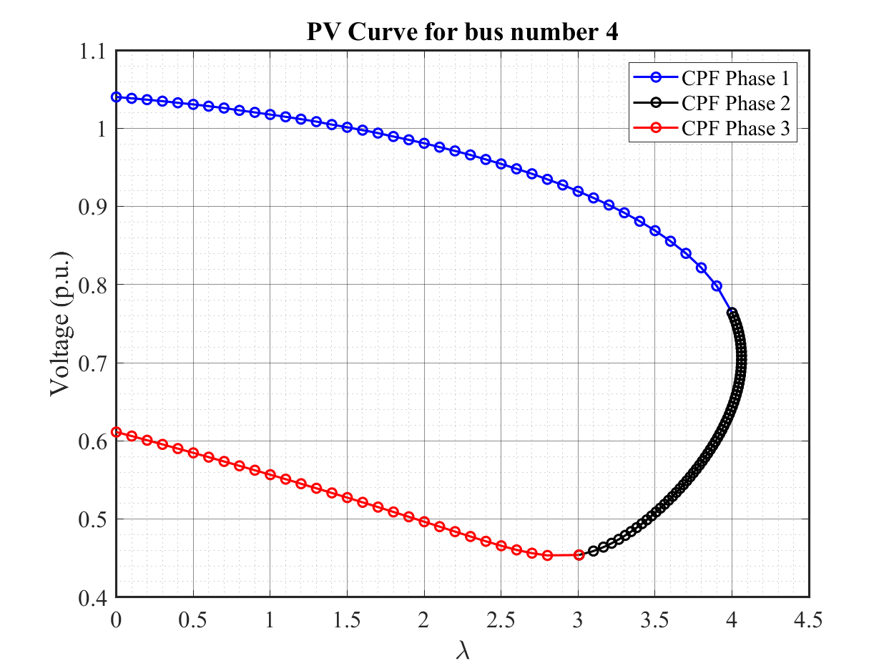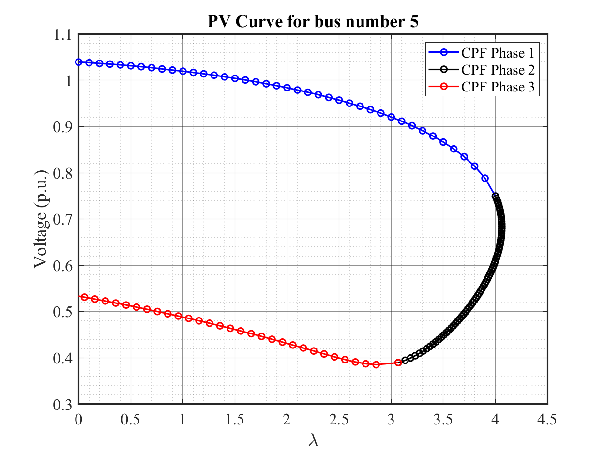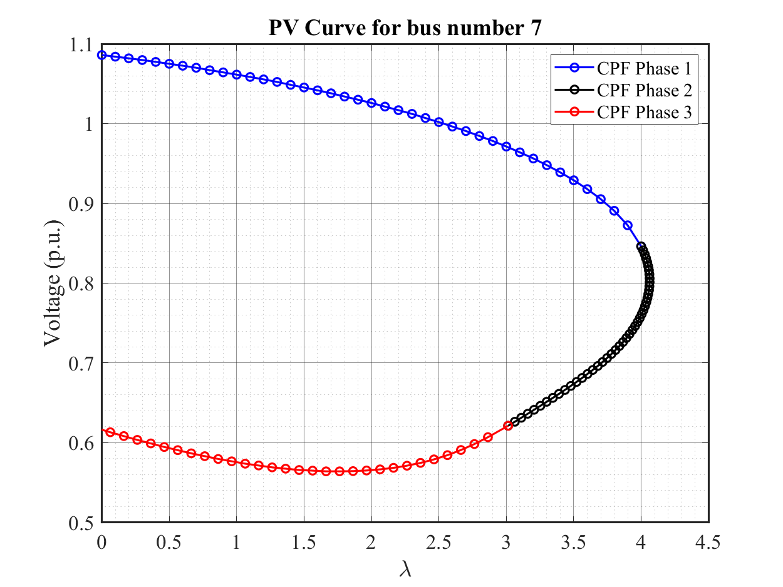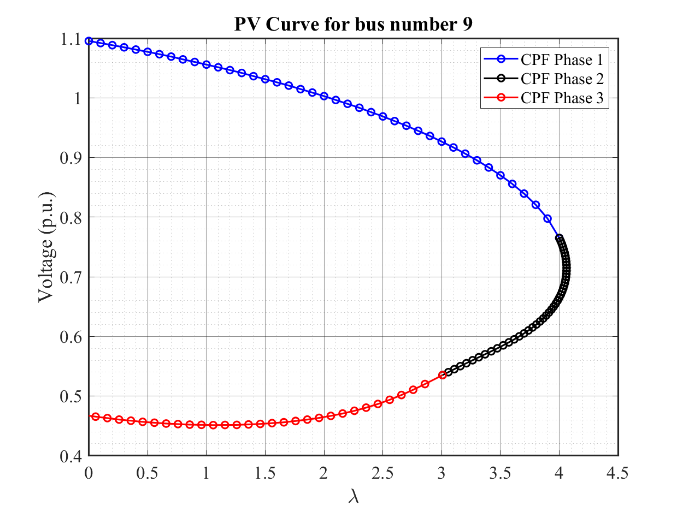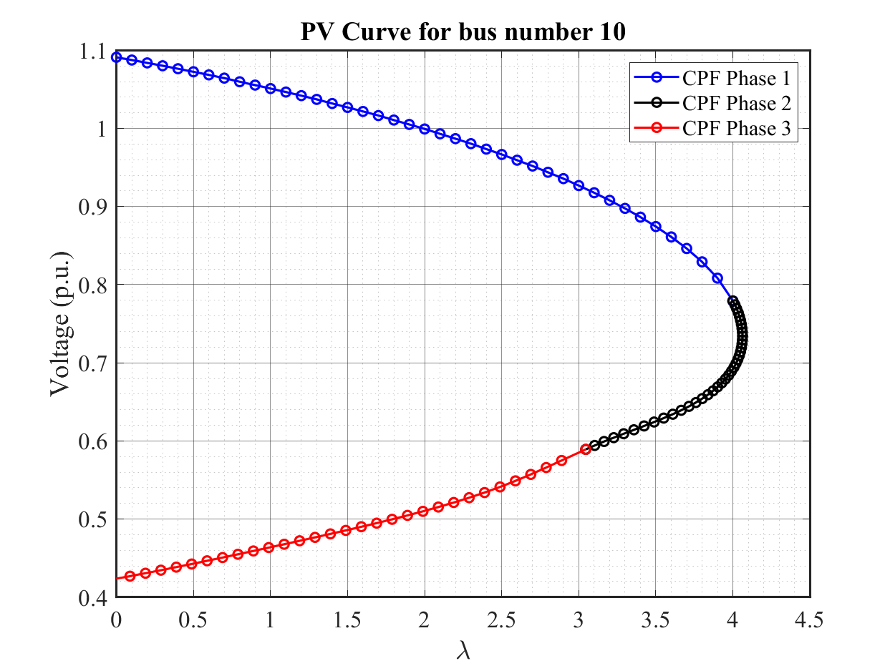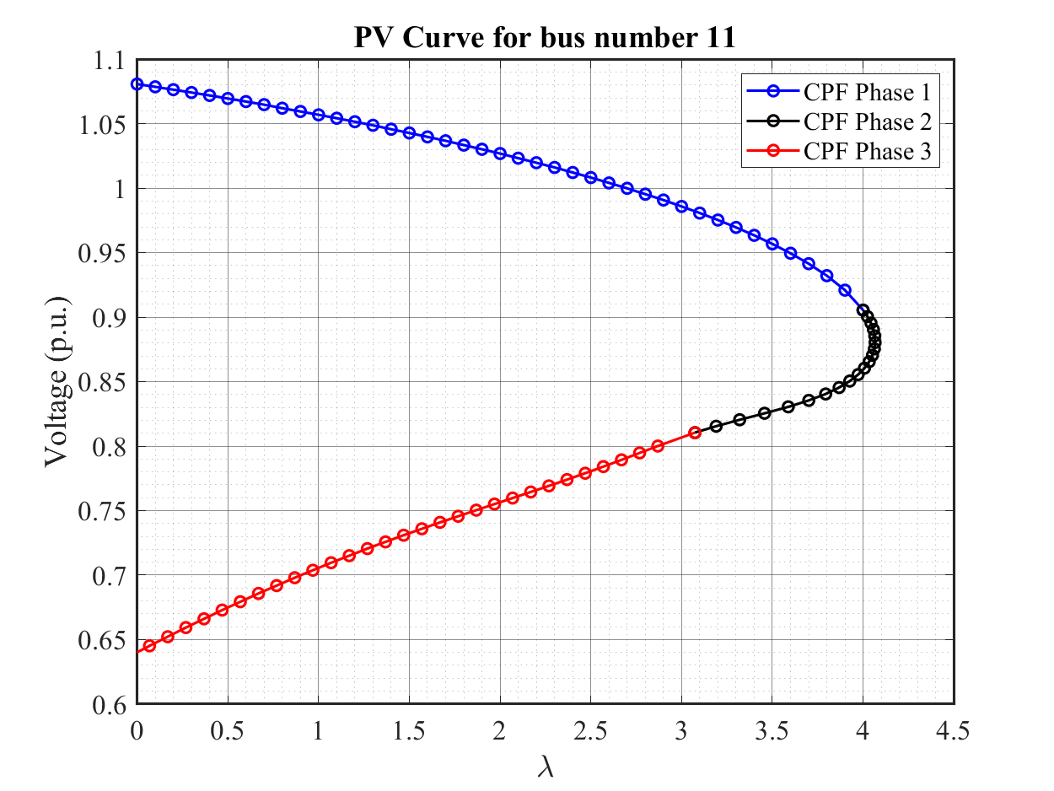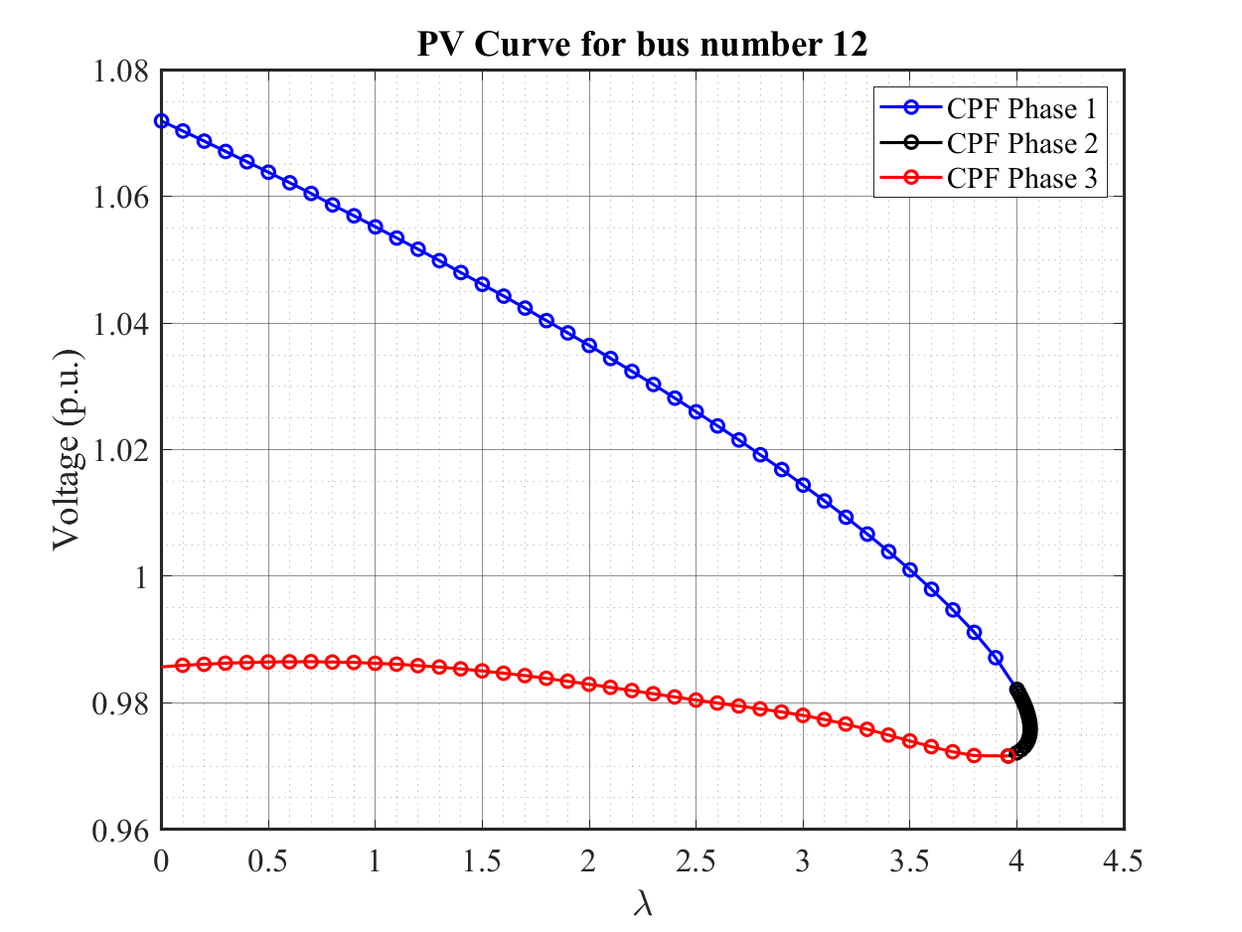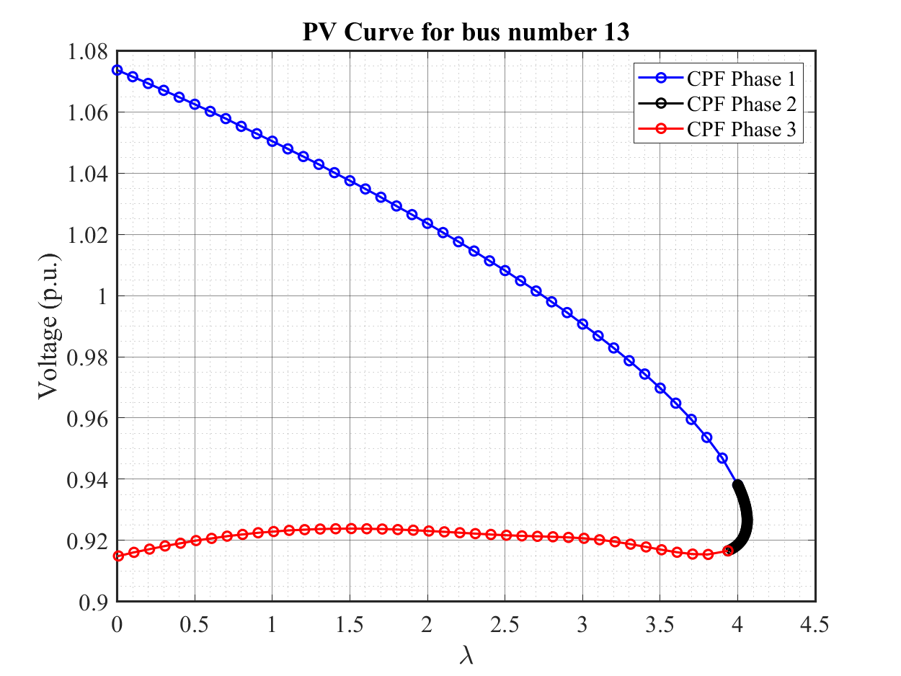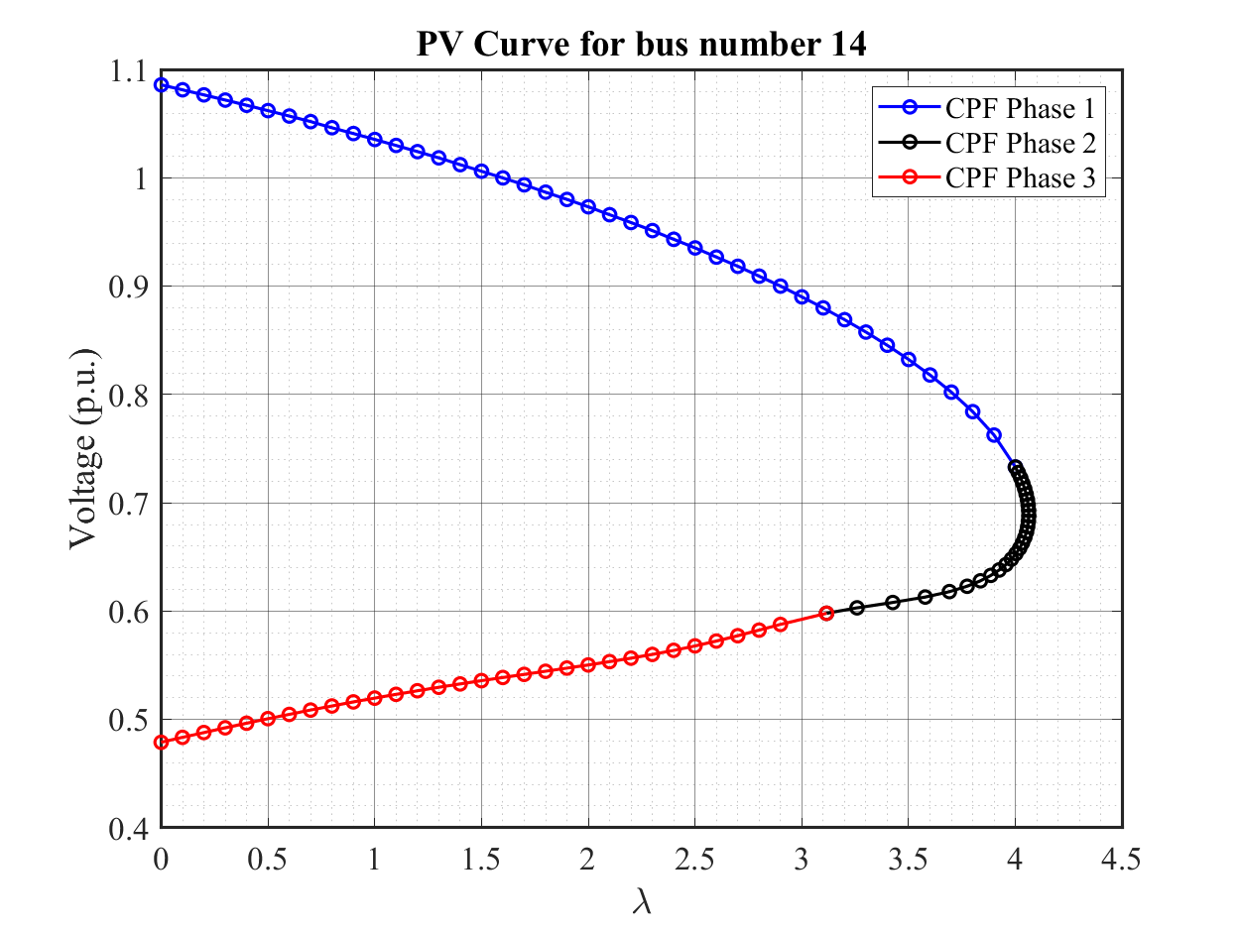

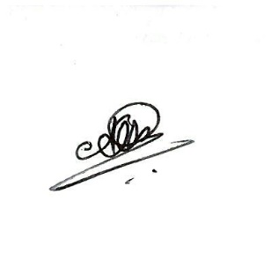Statement

I, Athul Jose P, states that all the code written and submitted here is completely done by me. I have not taken any help from others or any online resources.

Athul Jose P

*Appendix*

**% main.m**

**clc**

**clear all; close all;**

**% Initializing 14 bus and importing data**

**n_bus = 14;**

**bus_data = importdata('ieee14bus.txt').data;**

**branch_data = importdata('ieee14branch.txt').data;**

**% Ybus formation**

**t = 1; % 0 for without tap, 1 for with tap**

**Y = y_bus_calc(n_bus,bus_data,branch_data,t);**

**% Scheduled power calculation**

**base_MVA = 100;**

**P_inj = (bus_data(:,8) - bus_data(:,6)) / base_MVA;**

**Q_inj = (bus_data(:,9) - bus_data(:,7)) / base_MVA;**

**% Finding bus types**

**sl_i = find(bus_data(:,3) == 3);**

**pv_i = find(bus_data(:,3) == 2);**

**pq_i = find(bus_data(:,3) == 0);**

**n_pv = length(pv_i);**

**n_pq = length(pq_i);**

**% Continuation Power Flow for each load bus**

**for i = 1:n_pq**

**n = pq_i(i);**

**CPF(n,n_bus,bus_data,P_inj,Q_inj,Y,sl_i,pq_i,n_pq);**

**end**

**% y_bus_calc.m**

**function Y = y_bus_calc(N_bs,D_bs,D_br,t)**

**Y = zeros(N_bs);**

**% Calculating elements of Ybus**

**for k = 1:size(D_br,1)**

**Y(D_br(k,1),D_br(k,1)) = Y(D_br(k,1),D_br(k,1)) + 1/(D_br(k,7) + i*D_br(k,8)) + i*D_br(k,9)/2;**

**Y(D_br(k,2),D_br(k,2)) = Y(D_br(k,2),D_br(k,2)) + 1/(D_br(k,7) + i*D_br(k,8)) + i*D_br(k,9)/2;**

**Y(D_br(k,1),D_br(k,2)) = -1/(D_br(k,7) + i*D_br(k,8));**

**Y(D_br(k,2),D_br(k,1)) = Y(D_br(k,1),D_br(k,2));**

**end**

**for k = 1:N_bs**

**Y(k,k) = Y(k,k) + D_bs(k,14) + i*D_bs(k,15);**

**end**

**% adjusting for taps**

**if(t == 1)**

**for k = 1:size(D_br,1)**

**if(D_br(k,15) ~= 0)**

**t = D_br(k,15);**

**((t^2) / i*D_br(k,8));**

**Y(D_br(k,1),D_br(k,1)) = Y(D_br(k,1),D_br(k,1)) + Y(D_br(k,1),D_br(k,2)) - (Y(D_br(k,1),D_br(k,2)))/(t^2);**

**Y(D_br(k,1),D_br(k,1));**

**Y(D_br(k,1),D_br(k,2)) = Y(D_br(k,1),D_br(k,2))/t;**

**Y(D_br(k,2),D_br(k,1)) = Y(D_br(k,1),D_br(k,2));**

**end**

**end**

**end**

**end**

**% CPF.m**

**function CPF(n,n_bus,bus_data,P_inj,Q_inj,Y,sl_i,pq_i,n_pq)**

**% Initializing Voltage magnitude and angles**

**V = bus_data(:,11);**

**V(find(V(:)==0)) = 1;**

**T = zeros(n_bus,1);**

**% Initializing Continuation Parameters**

**P_k = P_inj;**

**P_k(sl_i) = [];**

**K = [P_k;Q_inj(pq_i)];**

**ek1 = [zeros(1,n_bus-1+n_pq) 1];**

**ek2 = zeros(1,n_bus+n_pq);**

**ek2_i = find(pq_i == n);**

**ek2(n_bus-1+ek2_i) = -1;**

**ek3 = -ek1;**

**sigma1 = 0.1;**

**sigma2 = 0.005;**

**lambda = 0;**

**i = 1;**

**% Phase 1: Power as Continuation Parameter**

**% Initial value from Newton Raphson Method**

**[V_data,T_data,T1,dvrg] = NR(bus_data,V,T,P_inj*lambda,Q_inj*lambda,n_bus,Y,n_pq,pq_i);**

**V = V_data(:,size(V_data,2));**

**T = T_data(:,size(T_data,2));**

**y(i) = V(n);**

**x(i) = lambda;**

**i = i+1;**

**dvrg = 0;**

**% Iteration for corrector predictor until divergence**

**while(dvrg == 0 & i < 100)**

**% Predictor**

**theta = T(2:n_bus);**

**voltage = V(pq_i);**

**vec = [theta; voltage; lambda];**

**J = J_calc(bus_data,V,T,Y,n_bus,n_pq,pq_i);**

**pre = vec + sigma1*((fwd_bwd([J -K; ek1],ek1))');**

**T = [0; pre(1:n_bus-1)];**

**for j = 1:n_pq**

**V(pq_i(j)) = pre(n_bus+j-1);**

**end**

**lambda = pre(end);**

**% Corrector**

**[V_data,T_data,T1,dvrg] = NR(bus_data,V,T,P_inj*lambda,Q_inj*lambda,n_bus,Y,n_pq,pq_i);**

**if dvrg == 1**

**V = prev_V;**

**T = prev_T;**

**lambda = prev_lambda;**

**ph1 = i-1;**

**else**

**V = V_data(:,size(V_data,2));**

**T = T_data(:,size(T_data,2));**

**prev_V = V;**

**prev_T = T;**

**prev_lambda = lambda;**

**y(i) = V(n);**

**x(i) = lambda;**

**i = i+1;**

**end**

**end**

**% Phase 2: Voltage as Continuation Parameter**

**f_stop = 0.75; % stop factor for second phase**

**% Increased sigma and stop factor for bus 12 & 13**

**if (n == 12 | n ==13)**

**f_stop = 0.98**

**sigma2 = 0.0005**

**end**

**% Iteration for corrector predictor until some percentage of lambda**

**while(lambda > f_stop*prev_lambda & i < 200)**

**% Predictor**

**theta = T(2:n_bus);**

**voltage = V(pq_i);**

**vec = [theta; voltage; lambda];**

**J = J_calc(bus_data,V,T,Y,n_bus,n_pq,pq_i);**

**pre = vec + sigma2*((fwd_bwd([J -K; ek2],ek1))');**

**T = [0; pre(1:n_bus-1)];**

**for j = 1:n_pq**

**V(pq_i(j)) = pre(n_bus+j-1);**

**end**

**lambda = pre(end);**

**% Corrector**

**J = J_calc(bus_data,V,T,Y,n_bus,n_pq,pq_i);**

**[del_P, del_Q] = dpdq_calc(bus_data,V,T,P_inj*lambda,Q_inj*lambda,n_bus,Y);**

**corr = (fwd_bwd([J -lambda*K; ek2],[del_P del_Q 0]'))';**

**lambda = lambda + corr(end);**

**if lambda <= f_stop*prev_lambda**

**V = prev_V;**

**T = prev_T;**

**ph2 = i-1;**

**break;**

**else**

**T = T + [0; corr(1:n_bus-1)];**

**for j = 1:n_pq**

**V(pq_i(j)) = V(pq_i(j)) + corr(n_bus+j-1);**

**end**

**prev_V = V;**

**prev_T = T;**

**y(i) = V(n);**

**x(i) = lambda;**

**i = i+1;**

**end**

**end**

**% Phase 3: Power as Continuation Parameter**

**% Iteration for corrector predictor until negative lambda**

**while(lambda >= 0 & i < 250)**

**% Predictor**

**i;**

**theta = T(2:n_bus);**

**voltage = V(pq_i);**

**vec = [theta; voltage; lambda];**

**J = J_calc(bus_data,V,T,Y,n_bus,n_pq,pq_i);**

**pre = vec + sigma1*((fwd_bwd([J -K; ek3],ek1))');**

**T = [0; pre(1:n_bus-1)];**

**for j = 1:n_pq**

**V(pq_i(j)) = pre(n_bus+j-1);**

**end**

**lambda = pre(end);**

**% Corrector**

**[V_data,T_data,T1,dvrg] = NR(bus_data,V,T,P_inj*lambda,Q_inj*lambda,n_bus,Y,n_pq,pq_i);**

**V = V_data(:,size(V_data,2));**

**T = T_data(:,size(T_data,2));**

**y(i) = V(n);**

**x(i) = lambda;**

**i = i+1;**

**end**

**% plotting CPF curve**

**x_label = '\lambda'; % x axis label**

**y_label = 'Voltage (p.u.)'; % y axis label**

**legend_name = {'CPF Phase 1','CPF Phase 2','CPF Phase 3'}; % legend names**

**title_name = ['PV Curve for bus number ' num2str(n)]; % title name**

**figure('Renderer', 'painters', 'Position', [10 10 800 600])**

**plot(x(1:ph1),y(1:ph1),'-ob','LineWidth',1.5)**

**hold on**

**plot(x(ph1:ph2),y(ph1:ph2),'-ok','LineWidth',1.5)**

**plot(x(ph2:end),y(ph2:end),'-or','LineWidth',1.5)**

**xlabel(x_label,'FontSize',18,'FontName','Times New Roman')**

**ylabel(y_label,'FontSize',18,'FontName','Times New Roman')**

**legend (legend_name,'Location','northeast')**

**set(gca,'fontsize',16,'Fontname','Times New Roman','GridAlpha',0.5)**

**ax = gca**

**xlim([0 4.5])**

**title(title_name)**

**ax.XRuler.Axle.LineWidth = 1.5;**

**ax.YRuler.Axle.LineWidth = 1.5;**

**grid**

**grid minor**

**saveas(gca,[title_name '.png'])**

**end**

**% NR.m**

**function [V_data,T_data] = NR(bus_data,V,T,P_inj,Q_inj,n_bus,Y,n_pq,pq_i)**

**% Initializing index**

**i = 0;**

**Tol = 1;**

**del_T = zeros(n_bus,1);**

**del_V = zeros(n_bus,1);**

**% Iteration loop**

**while(Tol > 1e-5 & i < 100)**

**i = i+1**

**V = V+del_V;**

**T = T+del_T;**

**T_data(:,i) = T;**

**V_data(:,i) = V;**

**[del_P, del_Q] = dpdq_calc(bus_data,V,T,P_inj,Q_inj,n_bus,Y);**

**dpdq = [del_P, del_Q]; % mismatch calculation**

**J = J_calc(bus_data,V,T,Y,n_bus,n_pq,pq_i); % Jacobian calculation**

**delta = fwd_bwd(J,dpdq); % finding errors**

**del_T = [0 delta(1:n_bus-1)]';**

**for j = 1:n_pq**

**del_V(pq_i(j)) = delta(n_bus+j-1);**

**end**

**Tol = max(abs(delta)) % updating error for convergence**

**end**

**end**

**% dpdq.m**

**function [del_P, del_Q] = dpdq_calc(bus_data,V,T,P_inj,Q_inj,n_bus,Y)**

**P = zeros(n_bus,1);**

**Q = zeros(n_bus,1);**

**Pi = 1;**

**Qi = 1;**

**for i = 1:n_bus**

**if(bus_data(i,3) ~= 3)**

**for j = 1:n_bus**

**P(i) = P(i) + V(i)*V(j)*abs(Y(i,j))*cos(T(i)-T(j)-angle(Y(i,j)));**

**Q(i) = Q(i) + V(i)*V(j)*abs(Y(i,j))*sin(T(i)-T(j)-angle(Y(i,j)));**

**end**

**del_P(Pi) = P_inj(i) - P(i);**

**Pi = Pi+1;**

**if(bus_data(i,3) == 0)**

**del_Q(Qi) = Q_inj(i) - Q(i);**

**Qi = Qi+1;**

**end**

**end**

**end**

**end**

**% J_calc.m**

**function J = J_calc(bus_data,V,T,Y,n_bus,n_pq,pq_i)**

**% J1 calculation**

**J1 = zeros(n_bus-1);**

**for i = 1:n_bus**

**for j = 1:n_bus**

**if(bus_data(i,3) ~=3 & bus_data(j,3) ~=3)**

**if(i==j)**

**for k = 1:n_bus**

**J1(i-1,j-1) = J1(i-1,j-1)+(V(i)*V(k)*abs(Y(i,k))*sin(angle(Y(i,k))-T(i)+T(k)));**

**end**

**J1(i-1,j-1) = J1(i-1,j-1) - ((V(i)^2) * (imag(Y(i,i))));**

**else**

**J1(i-1,j-1) = -V(i)*V(j)*abs(Y(i,j))*sin(angle(Y(i,j))-T(i)+T(j));**

**end**

**end**

**end**

**end**

**J1;**

**% J2 calculation**

**J2 = zeros(n_bus-1,n_pq);**

**for i = 2:n_bus**

**for j = 1:n_pq**

**n = pq_i(j);**

**if(n == i)**

**for k = 1:n_bus**

**J2(i-1,j) = J2(i-1,j)+(V(i)*V(k)*abs(Y(i,k))*cos(angle(Y(i,k))-T(i)+T(k)));**

**end**

**J2(i-1,j) = (J2(i-1,j) + ((V(i)^2) * (real(Y(i,i)))))/V(i);**

**else**

**J2(i-1,j) = V(i)*abs(Y(i,n))*cos(angle(Y(i,n))-T(i)+T(n));**

**end**

**end**

**end**

**J2;**

**% J3 calculation**

**J3 = zeros(n_pq,n_bus-1);**

**for i = 1:n_pq**

**n = pq_i(i);**

**for j = 2:n_bus**

**if(n==j)**

**for k = 1:n_bus**

**J3(i,j-1) = J3(i,j-1)+(V(n)*V(k)*abs(Y(n,k))*cos(angle(Y(n,k))-T(n)+T(k)));**

**end**

**J3(i,j-1) = J3(i,j-1) - ((V(n)^2) * (real(Y(n,n))));**

**else**

**J3(i,j-1) = -V(n)*V(j)*abs(Y(n,j))*cos(angle(Y(n,j))-T(n)+T(j));**

**end**

**end**

**end**

**J3;**

**% J4 calculation**

**J4 = zeros(n_pq);**

**for i = 1:n_pq**

**n1 = pq_i(i);**

**for j = 1:n_pq**

**n2 = pq_i(j);**

**if(n1==n2)**

**for k = 1:n_bus**

**J4(i,j) = J4(i,j)+(V(n1)*V(k)*abs(Y(n1,k))*sin(angle(Y(n1,k))-T(n1)+T(k)));**

**end**

**J4(i,j) = (- J4(i,j) - ((V(n1)^2) * (imag(Y(n1,n1)))))/V(n1);**

**else**

**J4(i,j) = -V(n1)*abs(Y(n1,n2))*sin(angle(Y(n1,n2))-T(n1)+T(n2));**

**end**

**end**

**end**

**J4;**

**J = [J1, J2; J3, J4];**

**end**

**% fwd_bwd.m**

**function x = fwd_bwd(A,b)**

**[L, U] = LU(A);**

**% Forward Substitution**

**for k = 1:length(A)**

**s = 0;**

**for j = 1:k-1**

**s = s + (L(k,j)*y(j));**

**end**

**y(k) = (b(k) - s) / L(k,k);**

**end**

**% Backward Substitution**

**for k = length(A):-1:1**

**s = 0;**

**for j = k+1:length(A)**

**s = s + (U(k,j)*x(j));**

**end**

**x(k) = y(k) - s;**

**end**

**end**

**% LU.m**

**function [L, U] = LU(a)**

**Q = zeros(length(a));**

**for j = 1:length(a)**

**for k = j:length(a)**

**s = 0;**

**for m = 1:j-1**

**s = s + (Q(k,m)*Q(m,j));**

**end**

**Q(k,j) = a(k,j) - s;**

**end**

**if j < length(a)**

**for k = j+1:length(a)**

**s = 0;**

**for m = 1:j-1**

**s = s + (Q(j,m)*Q(m,k));**

**end**

**Q(j,k) = (a(j,k) - s) / Q(j,j);**

**end**

**end**

**end**

**L = tril(Q);**

**U = Q - L + eye(length(a));**

**end**

**% FD.m**

**function [V_data,T_data] = FD(bus_data,V,T,P_inj,Q_inj,n_bus,Y,n_pq,pq_i)**

**% Initializing index**

**B = imag(Y);**

**B_T = - B(2:n_bus,2:n_bus);**

**B_V = - B(pq_i,pq_i);**

**i = 0;**

**Tol = 1;**

**del_T = zeros(n_bus,1);**

**del_V = zeros(n_bus,1);**

**% Iteration loop**

**while(Tol > 1e-5 & i < 100)**

**i = i+1**

**V = V+del_V;**

**T = T+del_T;**

**T_data(:,i) = T;**

**V_data(:,i) = V;**

**[del_P, del_Q] = dpdq_calc(bus_data,V,T,P_inj,Q_inj,n_bus,Y);**

**P_T = del_P'./V(2:n_bus);**

**d_T = fwd_bwd(B_T,P_T);**

**Q_V = del_Q'./V(pq_i);**

**d_V = fwd_bwd(B_V,Q_V);**

**del_T = [0 d_T]'; % angle calculation**

**for j = 1:n_pq**

**del_V(pq_i(j)) = d_V(j); % magnitude calculation**

**end**

**Tol = max(abs([del_T; del_V]));**

**end**

**end**