**Homework 1**

Submitted by Athul Jose P

WSU ID 011867566

**Executive Summary**

***Newton Raphson Method***

Steps in main.m function

1. Initializing Kundur 2 area system and importing data
2. Making Ybus by calling y_bus_calc.m (with taps or without taps should be mentioned)
3. Calculating the scheduled active power (P) and reactive power (Q)
4. Finding bus types and assigning to vectors
5. Initializing Voltage magnitude and angles
6. Calling Newton Raphson Function (NR.m)
7. Calculating P & Q after convergence

Steps in y_bus_calc.m function

1. Initializing Ybus with zeros
2. Calculating diagonal and off diagonal elements
3. Changing terms if tap is present

Steps in NR.m function

1. Initializing indexes and deltas
2. Starting iteration loop which will terminate either if converged or 100 iterations
3. Calling dpdq.m for calculating mismatch
4. Calling J_calc.m for calculating Jacobian
5. Calling fwd_bwd.m for calculating the ΔV and Δδ
6. Updating del_V and del_T (magnitude and angle) for next iteration
7. Updating the error. Here the error is taken as the maximum of absolute of deltas (ΔP and ΔQ)

Steps in dpdq.m function

1. Initializing P & Q as zeros
2. Calculating P for PV bus and P & Q for PQ bus

Steps in J_calc.m function

1. Calculating J1 with loops according to limits (n_bus-1, n_bus-1)
2. Calculating J2 with loops according to limits (n_bus-1, n_pq)
3. Calculating J3 with loops according to limits (n_pq, n_bus-1)
4. Calculating J4 with loops according to limits (n_pq, n_pq)
5. Combining all to make J

Steps in fwd_bwd.m function

1. Calling LU.m for calculating Lower and Upper elements
2. Doing the backward substitution
3. Doing the forward substitution

Steps in LU.m function

1. Making the Q matrix
2. Dividing it into L & U matrices

***Fast Decoupled Method***

Steps in main.m function

1. Initializing Kundur 2 area system and importing data
2. Making Ybus by calling y_bus_calc.m (with taps or without taps should be mentioned)
3. Calculating the scheduled active power (P) and reactive power (Q)
4. Finding bus types and assigning to vectors
5. Initializing Voltage magnitude and angles
6. Calling Newton Raphson Function (FD.m)
7. Calculating P & Q after convergence

Steps in y_bus_calc.m function

1. Initializing Ybus with zeros
2. Calculating diagonal and off diagonal elements
3. Changing terms if tap is present

Steps in FD.m function

1. Initializing indexes, deltas and B
2. Starting iteration loop which will terminate either if converged or 100 iterations
3. Calling dpdq.m for calculating mismatch
4. Calling fwd_bwd.m for calculating the ΔV and Δδ
5. Updating del_V and del_T (magnitude and angle) for next iteration
6. Updating the error. Here the error is taken as the maximum of absolute of deltas (ΔP and ΔQ)

Steps in dpdq.m function

1. Initializing P & Q as zeros
2. Calculating P for PV bus and P & Q for PQ bus

Steps in fwd_bwd.m function

1. Calling LU.m for calculating Lower and Upper elements
2. Doing the backward substitution
3. Doing the forward substitution

Steps in LU.m function

1. Making the Q matrix
2. Dividing it into L & U matrices

**Results**

Case 1a: Newton Raphson with Slack, PV, PQ buses

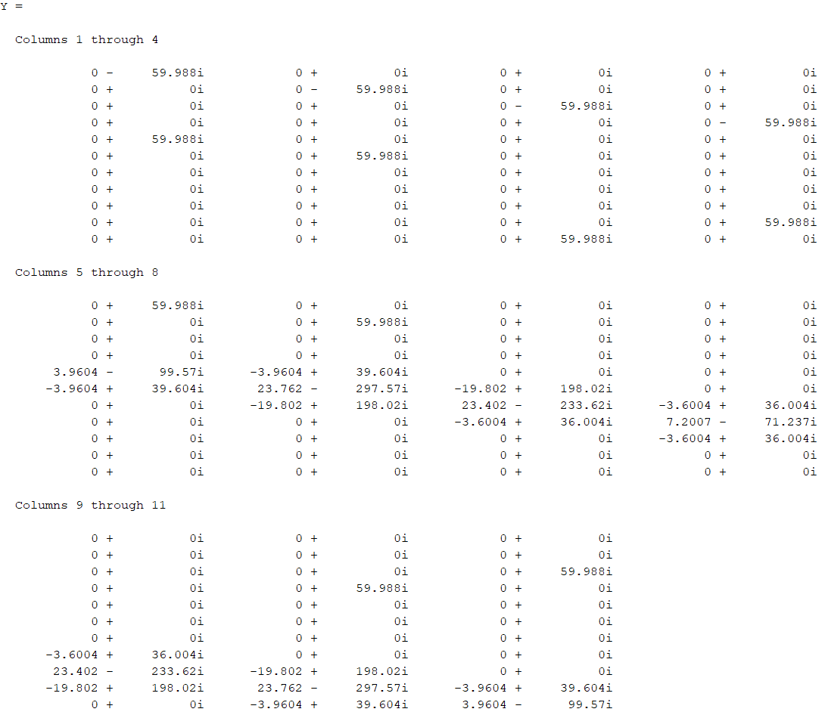For the error tolerance of 1e-3, calculations converged at 4th Iteration

Final results

|  |  |  |
| --- | --- | --- |
| Bus Number | V(magnitude) | V(angle) |
| 1 | 1.0300 | 0 |
| 2 | 1.0100 | -8.7346 |
| 3 | 1.0300 | -10.2582 |
| 4 | 1.0100 | -20.2529 |
| 5 | 1.0193 | -6.0570 |
| 6 | 1.0082 | -15.3147 |
| 7 | 1.0087 | -19.1595 |
| 8 | 1.0172 | -25.0478 |
| 9 | 1.0146 | -30.7797 |
| 10 | 1.0118 | -26.8098 |
| 11 | 1.0198 | -16.8103 |

Case 1b: Fast Decoupled with Slack, PV, PQ buses

For the error tolerance of 1e-3, calculations converged at 10th Iteration

|  |  |  |
| --- | --- | --- |
| Bus Number | V(magnitude) | V(angle) |
| 1 | 1.0300 | 0 |
| 2 | 1.0100 | -8.7345 |
| 3 | 1.0300 | -10.2584 |
| 4 | 1.0100 | -20.2532 |
| 5 | 1.0193 | -6.0570 |
| 6 | 1.0082 | -15.3148 |
| 7 | 1.0087 | -19.1596 |
| 8 | 1.0172 | -25.0481 |
| 9 | 1.0146 | -30.7803 |
| 10 | 1.0118 | -26.8103 |
| 11 | 1.0198 | -16.8106 |

Case 2a: Newton Raphson with Slack & PQ buses

For the error tolerance of 1e-3, calculations converged at 9th Iteration

|  |  |  |
| --- | --- | --- |
| Bus Number | V(magnitude) | V(angle) |
| 1 | 1.03 | 0 |
| 2 | 1.0541 | -8.6594 |
| 3 | 1.1263 | -11.364 |
| 4 | 1.1025 | -19.681 |
| 5 | 1.0371 | -5.907 |
| 6 | 1.0519 | -14.7 |
| 7 | 1.0568 | -18.23 |
| 8 | 1.0872 | -23.551 |
| 9 | 1.1032 | -28.527 |
| 10 | 1.1032 | -25.186 |
| 11 | 1.116 | -16.835 |

Case 2b: Fast Decoupled with Slack & PQ buses

For the error tolerance of 1e-3, calculations are not converging

Convergence Curves

For case 1

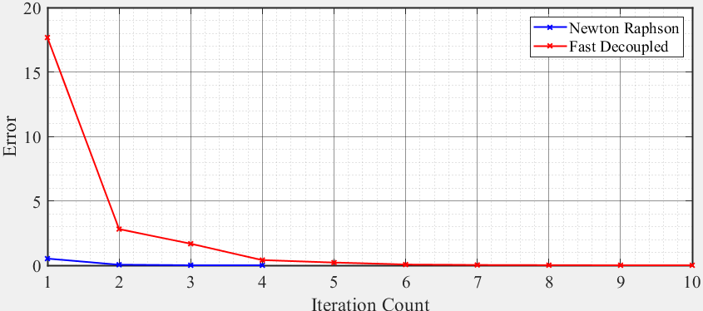

For case 2

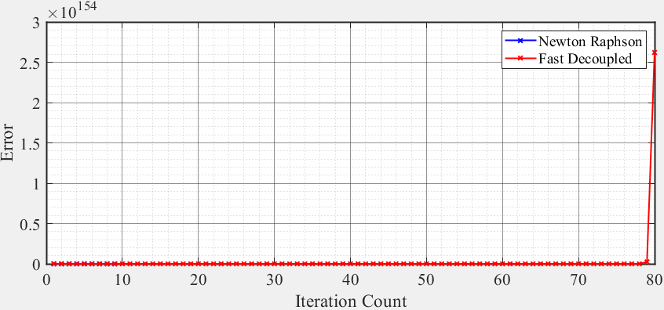

*Appendix*

**% main.m**

**clc**

**clear all; close all;**

**% Initializing Kundur 2 area system and importing data**

**n_bus = 11;**

**bus_data = importdata('ieee11bus.txt').data;**

**% bus_data = importdata('ieee11bus_allPV.txt').data;**

**branch_data = importdata('ieee11branch.txt').data;**

**% Ybus formation**

**t = 1; % 0 for without tap, 1 for with tap**

**Y = y_bus_calc(n_bus,bus_data,branch_data,t);**

**% Scheduled power calculation**

**base_MVA = 100;**

**P_inj = (bus_data(:,8) - bus_data(:,6)) / base_MVA;**

**Q_inj = (bus_data(:,9) - bus_data(:,7)) / base_MVA;**

**% Finding bus types**

**pv_i = find(bus_data(:,3) == 2);**

**pq_i = find(bus_data(:,3) == 0);**

**n_pv = length(pv_i);**

**n_pq = length(pq_i);**

**% Initializing Voltage magnitude and angles**

**V = bus_data(:,11);**

**V(find(V(:)==0)) = 1;**

**T = zeros(n_bus,1);**

**[V_data,T_data] = NR(bus_data,V,T,P_inj,Q_inj,n_bus,Y,n_pq,pq_i);**

**% [V_data,T_data] = FD(bus_data,V,T,P_inj,Q_inj,n_bus,Y,n_pq,pq_i);**

**% P,Q calculation after convergence**

**[P,Q] = PQ_calc(V1_data(:,size(V1_data,2)),T1_data(:,size(T1_data,2)),Y)**

**% plotting convergence curves**

**mplot([1:size(V1_data,2)],T1,[1:size(V2_data,2)],T2)**

**% y_bus_calc.m**

**function Y = y_bus_calc(N_bs,D_bs,D_br,t)**

**Y = zeros(N_bs);**

**% Calculating elements of Ybus**

**for k = 1:size(D_br,1)**

**Y(D_br(k,1),D_br(k,1)) = Y(D_br(k,1),D_br(k,1)) + 1/(D_br(k,7) + i*D_br(k,8)) + i*D_br(k,9)/2;**

**Y(D_br(k,2),D_br(k,2)) = Y(D_br(k,2),D_br(k,2)) + 1/(D_br(k,7) + i*D_br(k,8)) + i*D_br(k,9)/2;**

**Y(D_br(k,1),D_br(k,2)) = -1/(D_br(k,7) + i*D_br(k,8));**

**Y(D_br(k,2),D_br(k,1)) = Y(D_br(k,1),D_br(k,2));**

**end**

**for k = 1:N_bs**

**Y(k,k) = Y(k,k) + D_bs(k,14) + i*D_bs(k,15);**

**end**

**% adjusting for taps**

**if(t == 1)**

**for k = 1:size(D_br,1)**

**if(D_br(k,15) ~= 0)**

**t = D_br(k,15);**

**((t^2) / i*D_br(k,8));**

**Y(D_br(k,1),D_br(k,1)) = Y(D_br(k,1),D_br(k,1)) + Y(D_br(k,1),D_br(k,2)) - (Y(D_br(k,1),D_br(k,2)))/(t^2);**

**Y(D_br(k,1),D_br(k,1));**

**Y(D_br(k,1),D_br(k,2)) = Y(D_br(k,1),D_br(k,2))/t;**

**Y(D_br(k,2),D_br(k,1)) = Y(D_br(k,1),D_br(k,2));**

**end**

**end**

**end**

**end**

**% NR.m**

**function [V_data,T_data] = NR(bus_data,V,T,P_inj,Q_inj,n_bus,Y,n_pq,pq_i)**

**% Initializing index**

**i = 0;**

**Tol = 1;**

**del_T = zeros(n_bus,1);**

**del_V = zeros(n_bus,1);**

**% Iteration loop**

**while(Tol > 1e-3 & i < 100)**

**i = i+1**

**V = V+del_V;**

**T = T+del_T;**

**T_data(:,i) = T;**

**V_data(:,i) = V;**

**[del_P, del_Q] = dpdq_calc(bus_data,V,T,P_inj,Q_inj,n_bus,Y);**

**dpdq = [del_P, del_Q]; % mismatch calculation**

**J = J_calc(bus_data,V,T,Y,n_bus,n_pq,pq_i); % Jacobian calculation**

**delta = fwd_bwd(J,dpdq); % finding errors**

**del_T = [0 delta(1:n_bus-1)]';**

**for j = 1:n_pq**

**del_V(pq_i(j)) = delta(n_bus+j-1);**

**end**

**Tol = max(abs(delta)) % updating error for convergence**

**end**

**end**

**% dpdq.m**

**function [del_P, del_Q] = dpdq_calc(bus_data,V,T,P_inj,Q_inj,n_bus,Y)**

**P = zeros(n_bus,1);**

**Q = zeros(n_bus,1);**

**Pi = 1;**

**Qi = 1;**

**for i = 1:n_bus**

**if(bus_data(i,3) ~= 3)**

**for j = 1:n_bus**

**P(i) = P(i) + V(i)*V(j)*abs(Y(i,j))*cos(T(i)-T(j)-angle(Y(i,j)));**

**Q(i) = Q(i) + V(i)*V(j)*abs(Y(i,j))*sin(T(i)-T(j)-angle(Y(i,j)));**

**end**

**del_P(Pi) = P_inj(i) - P(i);**

**Pi = Pi+1;**

**if(bus_data(i,3) == 0)**

**del_Q(Qi) = Q_inj(i) - Q(i);**

**Qi = Qi+1;**

**end**

**end**

**end**

**end**

**% J_calc.m**

**function J = J_calc(bus_data,V,T,Y,n_bus,n_pq,pq_i)**

**% J1 calculation**

**J1 = zeros(n_bus-1);**

**for i = 1:n_bus**

**for j = 1:n_bus**

**if(bus_data(i,3) ~=3 & bus_data(j,3) ~=3)**

**if(i==j)**

**for k = 1:n_bus**

**J1(i-1,j-1) = J1(i-1,j-1)+(V(i)*V(k)*abs(Y(i,k))*sin(angle(Y(i,k))-T(i)+T(k)));**

**end**

**J1(i-1,j-1) = J1(i-1,j-1) - ((V(i)^2) * (imag(Y(i,i))));**

**else**

**J1(i-1,j-1) = -V(i)*V(j)*abs(Y(i,j))*sin(angle(Y(i,j))-T(i)+T(j));**

**end**

**end**

**end**

**end**

**J1;**

**% J2 calculation**

**J2 = zeros(n_bus-1,n_pq);**

**for i = 2:n_bus**

**for j = 1:n_pq**

**n = pq_i(j);**

**if(n == i)**

**for k = 1:n_bus**

**J2(i-1,j) = J2(i-1,j)+(V(i)*V(k)*abs(Y(i,k))*cos(angle(Y(i,k))-T(i)+T(k)));**

**end**

**J2(i-1,j) = (J2(i-1,j) + ((V(i)^2) * (real(Y(i,i)))))/V(i);**

**else**

**J2(i-1,j) = V(i)*abs(Y(i,n))*cos(angle(Y(i,n))-T(i)+T(n));**

**end**

**end**

**end**

**J2;**

**% J3 calculation**

**J3 = zeros(n_pq,n_bus-1);**

**for i = 1:n_pq**

**n = pq_i(i);**

**for j = 2:n_bus**

**if(n==j)**

**for k = 1:n_bus**

**J3(i,j-1) = J3(i,j-1)+(V(n)*V(k)*abs(Y(n,k))*cos(angle(Y(n,k))-T(n)+T(k)));**

**end**

**J3(i,j-1) = J3(i,j-1) - ((V(n)^2) * (real(Y(n,n))));**

**else**

**J3(i,j-1) = -V(n)*V(j)*abs(Y(n,j))*cos(angle(Y(n,j))-T(n)+T(j));**

**end**

**end**

**end**

**J3;**

**% J4 calculation**

**J4 = zeros(n_pq);**

**for i = 1:n_pq**

**n1 = pq_i(i);**

**for j = 1:n_pq**

**n2 = pq_i(j);**

**if(n1==n2)**

**for k = 1:n_bus**

**J4(i,j) = J4(i,j)+(V(n1)*V(k)*abs(Y(n1,k))*sin(angle(Y(n1,k))-T(n1)+T(k)));**

**end**

**J4(i,j) = - J4(i,j) - ((V(n1)^2) * (imag(Y(n1,n1))));**

**else**

**J4(i,j) = -V(n1)*abs(Y(n1,n2))*sin(angle(Y(n1,n2))-T(n1)+T(n2));**

**end**

**end**

**end**

**J4;**

**J = [J1, J2; J3, J4];**

**end**

**% fwd_bwd.m**

**function x = fwd_bwd(A,b)**

**[L, U] = LU(A);**

**% Forward Substitution**

**for k = 1:length(A)**

**s = 0;**

**for j = 1:k-1**

**s = s + (L(k,j)*y(j));**

**end**

**y(k) = (b(k) - s) / L(k,k);**

**end**

**% Backward Substitution**

**for k = length(A):-1:1**

**s = 0;**

**for j = k+1:length(A)**

**s = s + (U(k,j)*x(j));**

**end**

**x(k) = y(k) - s;**

**end**

**end**

**% LU.m**

**function [L, U] = LU(a)**

**Q = zeros(length(a));**

**for j = 1:length(a)**

**for k = j:length(a)**

**s = 0;**

**for m = 1:j-1**

**s = s + (Q(k,m)*Q(m,j));**

**end**

**Q(k,j) = a(k,j) - s;**

**end**

**if j < length(a)**

**for k = j+1:length(a)**

**s = 0;**

**for m = 1:j-1**

**s = s + (Q(j,m)*Q(m,k));**

**end**

**Q(j,k) = (a(j,k) - s) / Q(j,j);**

**end**

**end**

**end**

**L = tril(Q);**

**U = Q - L + eye(length(a));**

**end**

**% FD.m**

**function [V_data,T_data] = FD(bus_data,V,T,P_inj,Q_inj,n_bus,Y,n_pq,pq_i)**

**% Initializing index**

**B = imag(Y);**

**B_T = - B(2:n_bus,2:n_bus);**

**B_V = - B(pq_i,pq_i);**

**i = 0;**

**Tol = 1;**

**del_T = zeros(n_bus,1);**

**del_V = zeros(n_bus,1);**

**% Iteration loop**

**while(Tol > 1e-5 & i < 100)**

**i = i+1**

**V = V+del_V;**

**T = T+del_T;**

**T_data(:,i) = T;**

**V_data(:,i) = V;**

**[del_P, del_Q] = dpdq_calc(bus_data,V,T,P_inj,Q_inj,n_bus,Y);**

**P_T = del_P'./V(2:n_bus);**

**d_T = fwd_bwd(B_T,P_T);**

**Q_V = del_Q'./V(pq_i);**

**d_V = fwd_bwd(B_V,Q_V);**

**del_T = [0 d_T]'; % angle calculation**

**for j = 1:n_pq**

**del_V(pq_i(j)) = d_V(j); % magnitude calculation**

**end**

**Tol = max(abs([P_T; Q_V]));**

**end**

**end**

**% PQ calc.m**

**function [P,Q] = PQ_calc(V,T,Y)**

**n_bus = size(V,1);**

**P = zeros(n_bus,1);**

**Q = zeros(n_bus,1);**

**for i = 1:n_bus**

**for j = 1:n_bus**

**P(i) = P(i) + V(i)*V(j)*abs(Y(i,j))*cos(T(i)-T(j)-angle(Y(i,j)));**

**Q(i) = Q(i) + V(i)*V(j)*abs(Y(i,j))*sin(T(i)-T(j)-angle(Y(i,j)));**

**end**

**end**

**end**

**% mplot.m**

**function mplot(x1,y1,x2,y2)**

**x_label = 'Iteration Count'; % x axis label**

**y_label = 'Error'; % y axis label**

**legend_name = {'Newton Raphson','Fast Decoupled'}; % legend names**

**figure('Renderer', 'painters', 'Position', [10 10 1000 400])**

**plot(x1,y1,'-xb','LineWidth',1.5)**

**hold on**

**plot(x2,y2,'-xr','LineWidth',1.5)**

**xlabel(x_label,'FontSize',18,'FontName','Times New Roman')**

**ylabel(y_label,'FontSize',18,'FontName','Times New Roman')**

**legend (legend_name,'Location','northeast')**

**set(gca,'fontsize',16,'Fontname','Times New Roman','GridAlpha',0.5)**

**ax = gca**

**ax.XRuler.Axle.LineWidth = 1.5;**

**ax.YRuler.Axle.LineWidth = 1.5;**

**grid**

**grid minor**

**% legend (legend_name,'Location','southeast')**

**saveas(gca,'plot.png')**

**end**

*Input*

Bus data for Case 1

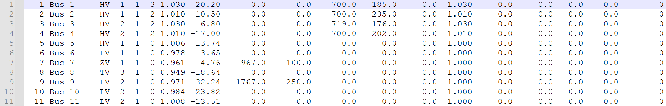

Bus data for Case 2

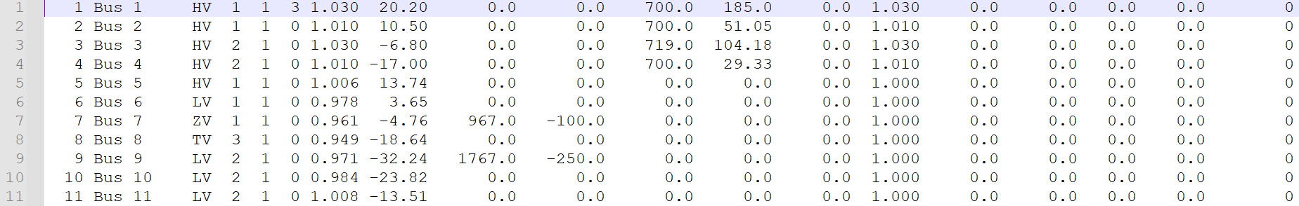

Branch data

