Homework 1

Submitted by Athul Jose P

WSU ID# 011867566

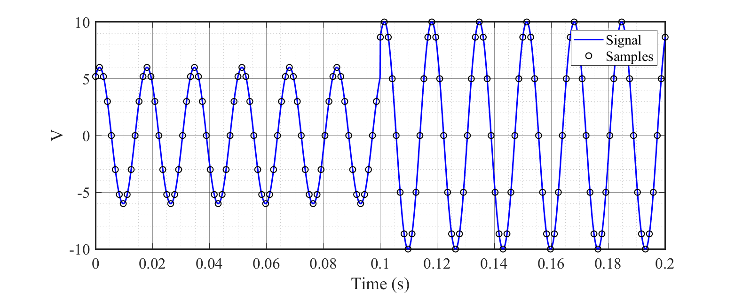a) Plotted the signal with 12 samples per cycle

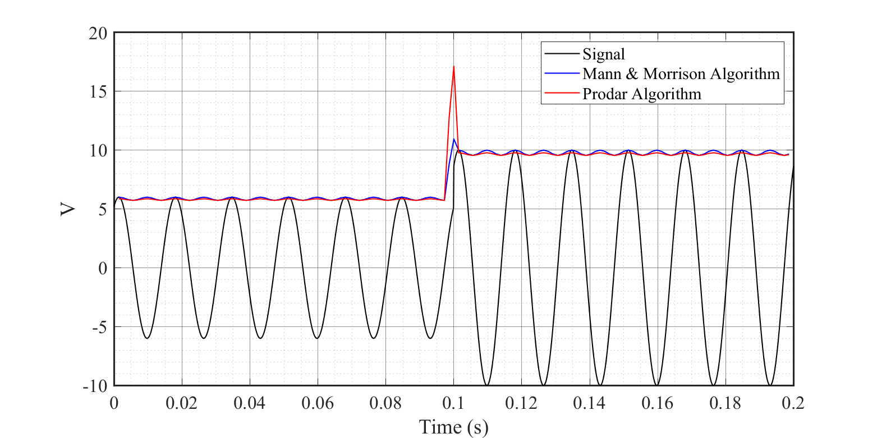b&c) Calculated the amplitude using Mann & Morrison Algorithm and Prodar Algorithm

Both Mann & Morrison Algorithm and Prodar Algorithm estimates the magnitude of the given signal. An oscillatory waveform is observed in both algorithms. However, the oscillations in Prodar is less than Mann & Morrison Algorithm. In Prodar algorithm, there is a large spike observed when the signal goes through a transition. This indicates Prodar is vulnerable to sudden variations/higher harmonics.

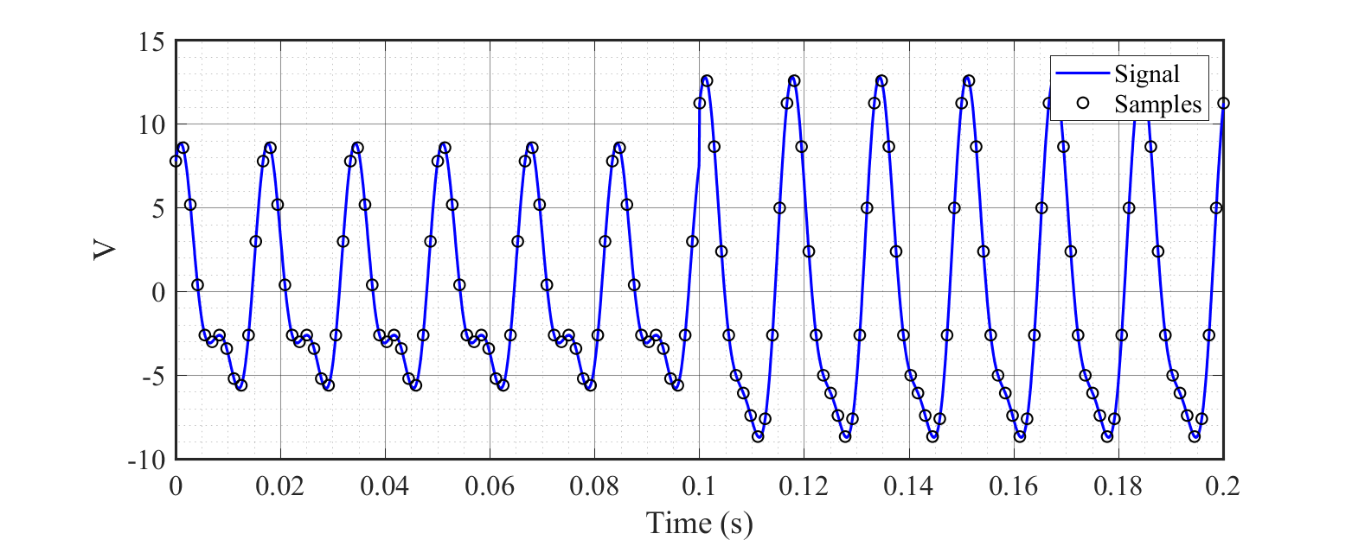d) Added the second harmonic and plotted the signal with 12 samples per cycle.

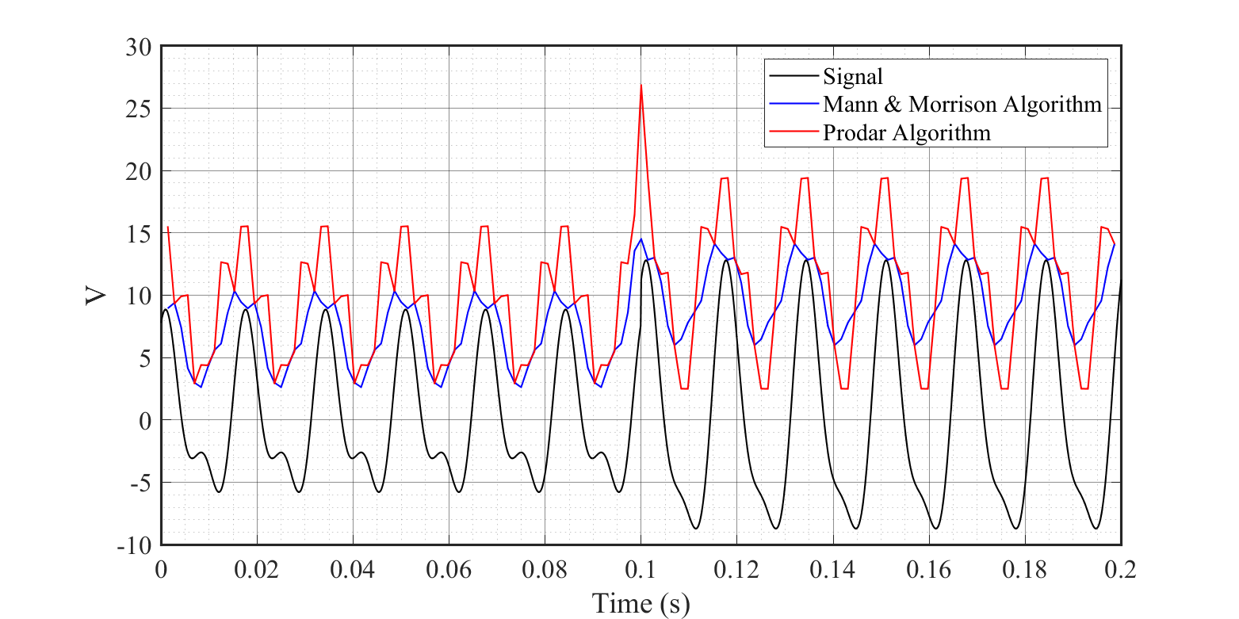

Calculated the amplitude using Mann & Morrison Algorithm and Prodar Algorithm

Addition of second harmonic shows the sensitivity of the algorithm to harmonics. It is evident that both algorithms fails to give amplitude estimates. From the diagram, it is clear that Prodar Algorithm is more vulnerable to harmonics than Mann & Morrison Algorithm

MATLAB Code

**% Function for calculating Mann & Morrison Algorithm**

**% Mann_Morris.m**

**function V_amp = Mann_Morris(v,w,del_T)**

**for i = 2:length(v)-1**

**vcos = (v(i+1)-v(i-1))/(2*w*del_T); % cosine component**

**vsin = v(i); % sine component**

**V_amp(i-1) = sqrt(vcos^2+vsin^2); %amplitude**

**end**

**end**

**% Function for calculating Prodar Algorithm**

**% Prodar.m**

**function V_amp = Prodar(v,w,del_T)**

**for i = 2:length(v)-1**

**vcos = (v(i+1)-v(i-1))/(2*w*del_T); % cosine part**

**vsin = (v(i-1)-(2*v(i))+v(i+1))/((w*del_T)^2); % sine part**

**V_amp(i-1) = sqrt(vcos^2+vsin^2); %amplitude**

**end**

**end**

**% Main code**

**% main.m**

**clc**

**clear all; close all**

**f = 60; % frequency of signal**

**w = 2*pi*f; % angular frequency**

**N = 12; % number of samples**

**del_T = 1/(f*N); % sampling period**

**t = [0:0.0001:0.2]; % time series for plotting original signal**

**Ts = [0:del_T:0.2]; % time series for samples**

**for i = 1:length(t) % generation of signal only for plotting**

**if t(i) < 0.1**

**v1(i) = 6*sin((w*t(i))+(pi/3));**

**v2(i) = 6*sin((w*t(i))+(pi/3)) + 3*sin((2*w*t(i) )+(pi/3));**

**else**

**v1(i) = 10*sin((w*t(i))+(pi/3));**

**v2(i) = 10*sin((w*t(i))+(pi/3))+ 3*sin((2*w*t(i) )+(pi/3));**

**end**

**end**

**for i = 1:length(Ts) % generation of samples**

**if Ts(i) < 0.1**

**vs1(i) = 6*sin((w*Ts(i))+(pi/3));**

**vs2(i) = 6*sin((w*Ts(i))+(pi/3)) + 3*sin((2*w*Ts(i))+(pi/3));**

**else**

**vs1(i) = 10*sin((w*Ts(i))+(pi/3));**

**vs2(i) = 10*sin((w*Ts(i))+(pi/3))+ 3*sin((2*w*Ts(i))+(pi/3));**

**end**

**end**

**T_plot = Ts(2:length(Ts)-1);**

**figure(1) % plot of signal with only fundamental frequency**

**plot(t,v1) % plotting original signal**

**hold on**

**V_Mann = Mann_Morris(vs1,w,del_T);%calling Mann&Morrison Algorithm**

**plot(T_plot,V_Mann) % plotting amplitude**

**V_Prod = Prodar(vs1,w,del_T); %calling Prodar Algorithm**

**plot(T_plot,V_Prod) % plotting amplitude**

**hold off**

**figure(2) % plot with second harmonics**

**plot(t,v1) % plotting original signal**

**hold on**

**V_Mann = Mann_Morris(vs2,w,del_T);%calling Mann&Morrison Algorithm**

**plot(T_plot,V_Mann) % plotting amplitude**

**V_Prod = Prodar(vs2,w,del_T); %calling Prodar Algorithm**

**plot(T_plot,V_Prod) % plotting amplitude**

**hold off**