Homework 2

Submitted by Athul Jose P

WSU ID# 011867566

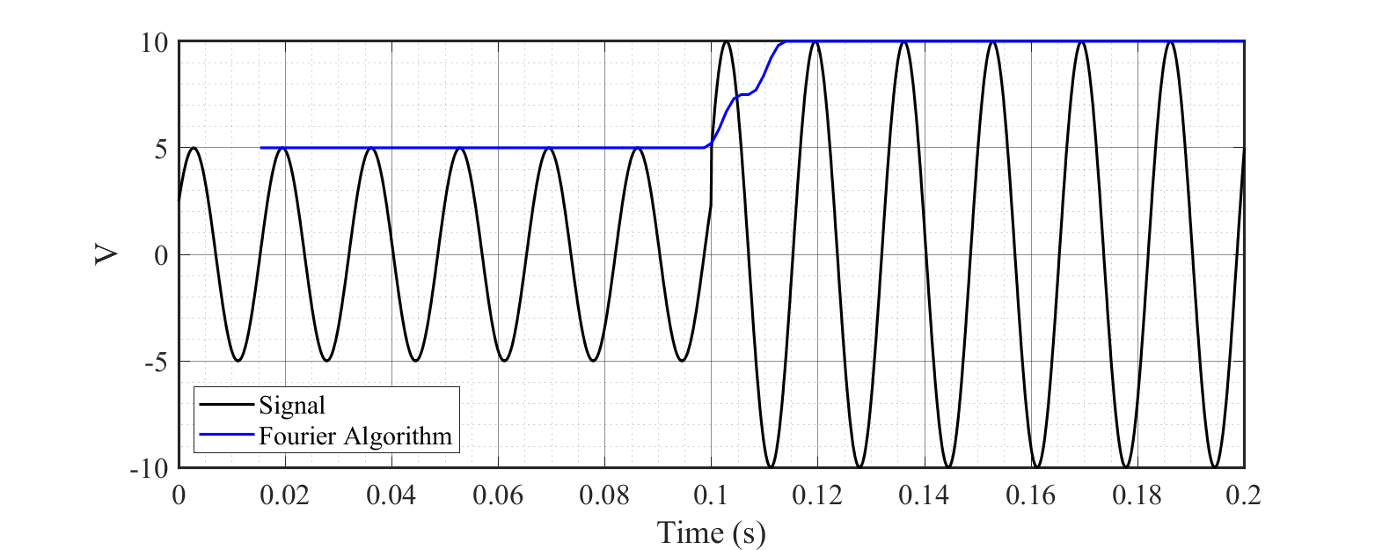a) Plotted the fundamental signal with 12 samples per cycle and applied Fourier Algorithm

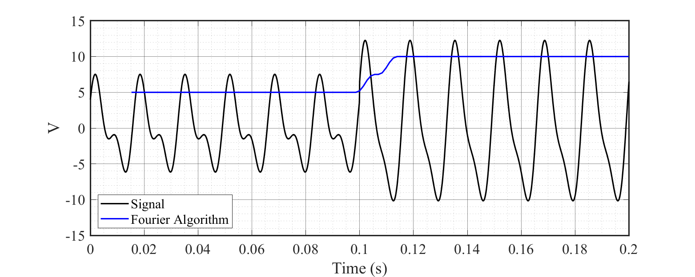b) Plotted the fundamental signal with second harmonic and applied Fourier Algorithm

The results shows that Fourier Algorithm is excellent in calculating the fundamental amplitude of the applied signal. It is clear that the algorithm removes the second harmonic while calculating the signal amplitude. If both amplitudes are compared, similar results are obtained which means the extend of eliminating the second harmonic is successful.

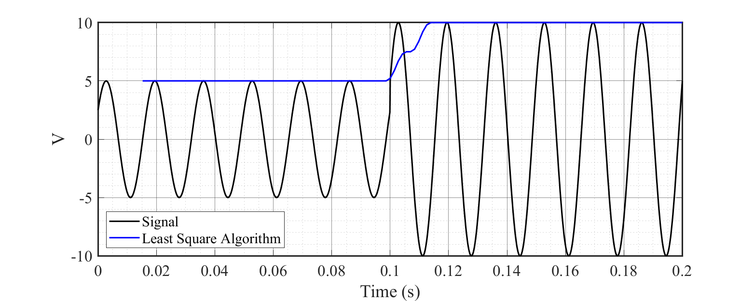c) a. Plotted the fundamental signal and applied Least Square Algorithm

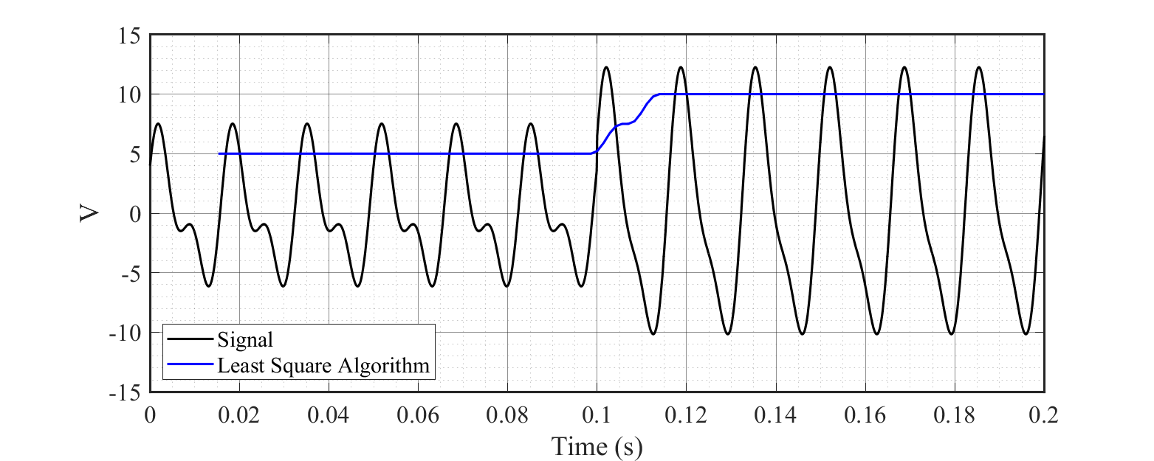c) b. Plotted the fundamental signal with second harmonic and applied Least Square Algorithm

A similar kind of results is obtained in Least Square Algorithm. It is effectively eliminated the second harmonics and calculated the amplitude of the voltage signal. Both algorithms are good in calculating the fundamental amplitude of the given signal.

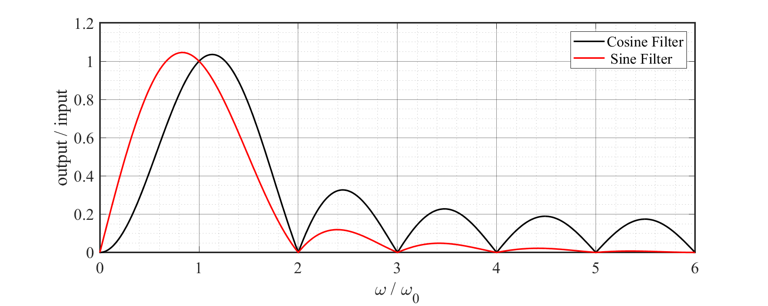d) Drawn the frequency response of Cosine filter of Full-cycle Fourier Algorithm

The cosine filter of full-cycle Fourier algorithm gives a similar response like sine filter. However the magnitude of frequency components is higher in cosine filter. Both filters provide unity magnitude for fundamental frequency and all whole number harmonics are absent. However interharmonics are present in both filters.

**MATLAB Code**

*1. Code for Fourier, Least Sqaure Algorithms*

**% Function for calculating Fourier Algorithm**

**% Fourier.m**

**function V_amp = Fourier(v,w,N)**

**del_T = (2*pi)/(w*N);**

**for i = N:length(v) % Loop for one window**

**vcos = 0; vsin = 0;**

**for j = 0:N-1**

**vcos = vcos + (v(j+i-N+1) * sin((2*pi*j/N)));**

**vsin = vsin + (v(j+i-N+1) * cos((2*pi*j/N)));**

**end**

**vcos = (2/N)*vcos; % cosine component**

**vsin = (2/N)*vsin; % sine component**

**V_amp(i-N+1) = sqrt(vcos^2+vsin^2); % amplitude**

**end**

**end**

**% Function for calculating Least Square Algorithm**

**% LSM.m**

**function V_amp = LSM(v,w,N)**

**del_T = (2*pi)/(w*N);**

**for i = 1:N % Calculating A matrix**

**A(i,1) = sin((2*(i-1)-N+1)*w*del_T/2);**

**A(i,2) = cos((2*(i-1)-N+1)*w*del_T/2);**

**end**

**A_inv = inv(A'*A)*A';**

**for i = N:length(v) % Loop for one window**

**vcos = 0; vsin = 0;**

**b = v(i-N+1:i);**

**x = A_inv * b';**

**vcos = x(1); % cosine component**

**vsin = x(2); % sine component**

**V_amp(i-N+1) = sqrt(vcos^2+vsin^2); % amplitude**

**end**

**end**

**% Main code**

**% main.m**

**clc**

**clear all; close all**

**f = 60; % frequency of signal**

**w = 2*pi*f; % angular frequency**

**N = 12; % number of samples**

**del_T = 1/(f*N); % sampling period**

**t = [0:0.0001:0.2]; % time series for plotting original signal**

**Ts = [0:del_T:0.2]; % time series for samples**

**for i = 1:length(t) % generation of signal only for plotting**

**if t(i) < 0.1**

**v1(i) = 5*sin((w*t(i))+(pi/6));**

**v2(i) = 5*sin((w*t(i))+(pi/6)) + 3*sin((2*w*t(i))+(pi/6));**

**else**

**v1(i) = 10*sin((w*t(i))+(pi/6));**

**v2(i) = 10*sin((w*t(i))+(pi/6))+ 3*sin((2*w*t(i))+(pi/6));**

**end**

**end**

**for i = 1:length(Ts) % generation of samples**

**if Ts(i) < 0.1**

**vs1(i) = 5*sin((w*Ts(i))+(pi/6));**

**vs2(i) = 5*sin((w*Ts(i))+(pi/6)) + 3*sin((2*w*Ts(i))+(pi/6));**

**else**

**vs1(i) = 10*sin((w*Ts(i))+(pi/6));**

**vs2(i) = 10*sin((w*Ts(i))+(pi/6))+ 3*sin((2*w*Ts(i))+(pi/6));**

**end**

**end**

**T_plot = Ts(N:length(Ts));**

**figure(1) % plot of signal with only fundamental frequency**

**plot(t,v1) % plotting original signal**

**hold on**

**V_Fourier = Fourier(vs1,w,N); %calling Fourier Algorithm**

**plot(T_plot,V_Fourier) % plotting amplitude**

**hold off**

**figure(2) % plot with second harmonics**

**plot(t,v2) % plotting original signal**

**hold on**

**V_Fourier = Fourier(vs2,w,N); %calling Fourier Algorithm**

**plot(T_plot,V_Fourier) % plotting amplitude**

**hold off**

**figure(3) % plot of signal with only fundamental frequency**

**plot(t,v1) % plotting original signal**

**hold on**

**V_LSM = LSM(vs1,w,N); %calling Least Square Algorithm**

**plot(T_plot,V_LSM) % plotting amplitude**

**hold off**

**figure(4) % plot with second harmonics**

**plot(t,v2) % plotting original signal**

**hold on**

**V_LSM = LSM(vs2,w,N); %calling Least Square Algorithm**

**plot(T_plot,V_LSM) % plotting amplitude**

**hold off**

*2. Code for Harmonic Response of Cosine Filter of Fourier Algorithm*

**clc**

**clear all; close all;**

**f = 60; % base frequency**

**w0 = 2 * pi * f; % base angular frequency**

**x = [0:0.01:6];**

**w = x * w0; % angular frequency**

**N = 12; % number of samples**

**dT = 1 / (f * N); % sampling period**

**Hc = 0;**

**Hs = 0;**

**for k=1:N % calculating response**

**j = (2*k-N-1)/2;**

**Hc = Hc+(2/N)*cos(j*w0*dT)*exp(1i*w*dT*j); % cosine filter**

**Hs = Hs+(2/N)*sin(j*w0*dT)*exp(1i*w*dT*j); % sine filter**

**end**

**plot(x,abs(Hc),x,abs(Hs)) %plotting responses**