Work Acceptance Letter

From:

To: Altos Technologies,

Carnival Infopark Phase I, Ground Floor,

Infopark Campus, Kakkanad, Kochi, Kerala 682042

Work List:

1. Digital marketing – Download options and new area for details add

Start Date: 20/10/22 End Date:20/10/22

Sir,

I do accept the above mentioned work and I will submit that on or before

deadline without any corrections and errors. In future if any error occurs in my work, it’s my responsibility to solve that. I do here by solemnly affirm and declare that all information and particulars furnished here by me are true and correct to the best of my knowledge.

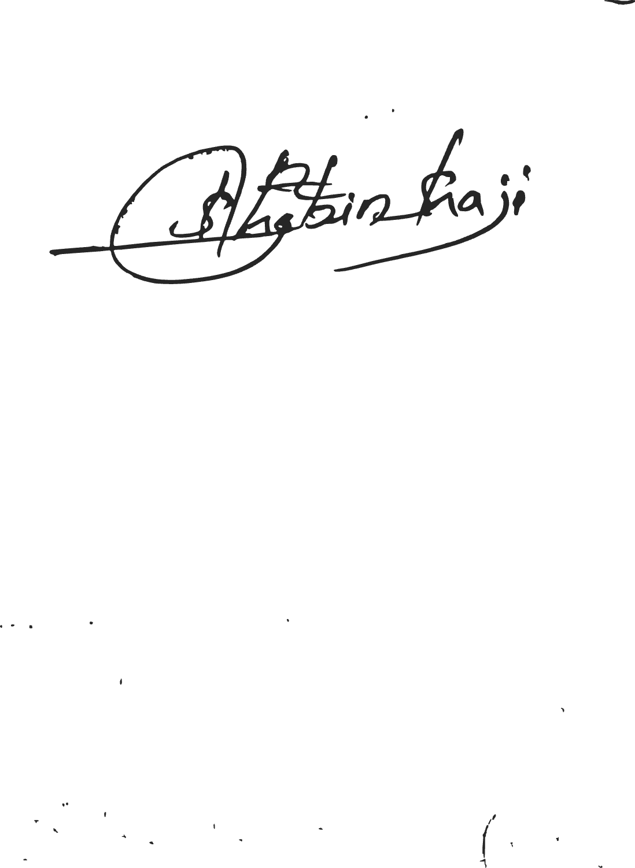Date:20/10/22 Place: Pala

Yours Faithfully

Signature