ORION: AI-POWERED REQUIREMENTS TRACEABILITY MATRIX ENGINE
A PROJECT REPORT
Submitted in partial fulfillment of the requirement for the award of the degree of
MASTER OF COMPUTER APPLICATIONS
Submitted by
ATHUL RAJ A K
(Reg. No: SJC24MCA015)
Under the Guidance of
Dr. [GUIDE NAME], Ph.D.
Associate Professor, Dept. of Computer Applications
DEPARTMENT OF COMPUTER APPLICATIONS
ST. JOSEPH'S COLLEGE (AUTONOMOUS), DEVAGIRI, CALICUT
AFFILIATED TO THE UNIVERSITY OF CALICUT
MAY 2026

ST. JOSEPH'S COLLEGE (AUTONOMOUS), DEVAGIRI
DEPARTMENT OF COMPUTER APPLICATIONS
CERTIFICATE
This is to certify that the project report titled "ORION: AI-POWERED REQUIREMENTS TRACEABILITY MATRIX ENGINE" is a bona fide record of the work carried out by ATHUL RAJ A K (Reg. No: SJC24MCA015) in partial fulfillment of the requirements for the award of the degree of Master of Computer Applications affiliated to the University of Calicut during the academic year 2024–2026.
The project work has been carried out under our supervision and guidance, and no part thereof has been submitted for the award of any other degree, diploma, or fellowship.
Project Guide Head of the Department
[Guide Name], Associate Professor [HOD Name], Professor & HOD
Dept. of Computer Applications Dept. of Computer Applications
Submitted for the Viva-Voce Examination held on: ____________________
Internal Examiner: ____________________ External Examiner: ____________________

DECLARATION
I hereby declare that the project entitled "ORION: AI-POWERED REQUIREMENTS TRACEABILITY MATRIX ENGINE" submitted to the Department of Computer Applications, St. Joseph's College (Autonomous), Devagiri, Calicut, affiliated to the University of Calicut, in partial fulfillment of the requirements for the award of the degree of Master of Computer Applications, is an authentic record of original project work carried out by me under the supervision of [Guide Name], Department of Computer Applications.
I further declare that this report has not previously formed the basis for the award of any degree, diploma, associateship, fellowship, or other similar title to any candidate of any university or institution.
Place: Calicut
Date: ____________________ ATHUL RAJ A K
(Reg. No: SJC24MCA015)

ACKNOWLEDGEMENT
First and foremost, I praise God Almighty for His immense grace, wisdom, and blessings that sustained me throughout the completion of this academic project.
I express my profound sense of gratitude to Dr. Bobby Jose, Principal, St. Joseph's College (Autonomous), Devagiri, Calicut, for providing the necessary administrative and computational infrastructure to undertake this work.
I extend my sincere gratitude to [HOD Name], Head of the Department of Computer Applications, for continuous encouragement and professional guidance throughout the curriculum.
I am deeply indebted to my project supervisor, [Guide Name], Associate Professor, Department of Computer Applications, for insightful technical reviews, invaluable guidance, and patient mentoring during all phases of development.
Finally, I express my heartfelt love and indebtedness to my parents, family members, and peers for their continuous moral support and motivation throughout my academic endeavors.

SYNOPSIS
Orion is an automated, AI-driven Requirements Traceability Matrix (RTM) governance platform engineered to eliminate silent specification drift between agile product backlogs and continuous integration (CI/CD) test suites. Modern agile development pipelines suffer from divergence where code assertions fail to validate quantitative acceptance criteria defined in Jira issues. Traditional verification relies on manual audit reviews or rigid keyword matching that fails to identify subtle semantic and structural regressions.
Orion resolves this by implementing a dual-sided hybrid evaluation pipeline combining a 384-dimensional dense semantic embedding model (BAAI/bge-small-en-v1.5) running via ONNX Runtime with a deterministic Python Abstract Syntax Tree (AST) structural parser. The platform continuously synchronizes Atlassian Document Format (ADF) user stories from Jira Cloud, converts test files via AST extraction into structured assertion syntax, stores high-dimensional embeddings using PostgreSQL pgvector, and computes a composite compliance score:
S_hybrid = 0.6 · S_sem(Req, Test) + 0.4 · S_struct(Req, Test)
When structural divergence or semantic degradation is identified, Orion generates natural language explanations using an on-premise Large Language Model (Meta Llama 3.1 8B via Ollama) and automatically registers GitHub Check Run annotations to block pull request merges. A real-time executive dashboard built with React and Vite visualizes the complete traceability matrix, surfaces sensitivity threshold controls, and enforces Role-Based Access Control (RBAC).

TABLE OF CONTENTS
CHAPTER I: INTRODUCTION | 1
1.1 Orion - An Overview | 1
1.2 Mission of the Project | 2
1.3 Background Study | 3
1.3.1 Study on Existing System | 3
1.3.2 Disadvantages of Existing System | 4
CHAPTER II: SYSTEM ANALYSIS | 5
2.1 Study on Proposed System | 5
2.1.1 Advantages of Proposed System | 5
2.2 User Requirement Specification | 6
2.3 Software Requirement Specification | 8
2.4 Feasibility Study | 9
2.4.1 Technical Feasibility | 9
2.4.2 Economic Feasibility | 10
2.4.3 Operational Feasibility | 10
2.5 System Specification | 11
2.5.1 Hardware Specification | 11
2.5.2 Software Specification | 11
2.5.3 Technology Used | 12
2.6 Cost Estimation and Scheduling | 13
2.6.1 Cost Estimation | 13
2.6.2 Scheduling (Agile Iterations) | 14
CHAPTER III: DESIGN AND DEVELOPMENT PROCESS | 15
3.1 Fundamental Design Concepts | 15
3.2 Design Notations & Diagrams | 16
3.2.1 Data Flow Diagrams (Context Level 0, Level 1, Level 2) | 16
3.2.2 Use Case Modeling (Role-Based Interactions) | 22
3.3 Design Process | 24
3.3.1 Database Schema Design | 24
3.3.2 Normalization (1NF, 2NF, 3NF) | 27
3.3.3 Input Design | 28
3.3.4 Output Design | 29
3.4 Development Approach (Agile Sprints) | 30
CHAPTER IV: CODING | 31
4.1 Frontend Architecture (React / Vite / RBAC) | 31
4.2 Backend Architecture (FastAPI / SQLAlchemy / Async I/O) | 33
4.3 AI & Parser Subsystems (BGE-Small / AST / Ollama) | 35
CHAPTER V: TESTING AND IMPLEMENTATION | 37
5.1 Testing Methodologies | 37
5.1.1 Unit Testing | 37
5.1.2 Integration Testing | 38
5.1.3 Validation Testing | 38
5.1.4 Test Cases and Results Chart | 39
5.2 Quality Assurance & Policies | 41
5.2.1 Generic Risk Analysis | 41
5.3 System Implementation Procedures | 42
5.4 System Maintenance | 43
CHAPTER VI: CONCLUSION | 44
6.1 Conclusion | 44
6.2 Scope for Further Enhancement | 45
6.3 Bibliography | 46
ANNEXURE - A: MAJOR INPUT AND OUTPUT SCREENS | 47
ANNEXURE - B: TABLE OF ABBREVIATIONS | 49

CHAPTER I: INTRODUCTION
1.1 ORION - AN OVERVIEW
Orion is an automated software quality engineering and compliance governance platform designed to bridge the operational divide between agile product management repositories and automated continuous integration (CI/CD) pipelines. In modern enterprise software development, high development velocity frequently leads to 'silent specification drift'—a condition where test suites pass green in automated builds while failing to validate actual quantitative business acceptance criteria.
By replacing manual spreadsheets with real-time semantic analysis and code Abstract Syntax Tree (AST) inspection, Orion delivers an automated, deterministic Requirements Traceability Matrix (RTM). The platform connects to Jira Cloud via webhook listeners and REST APIs to ingest user stories and acceptance criteria, while simultaneously monitoring GitHub repositories for pull request events modifying test suites. It evaluates requirement-test alignment using a dual-sided hybrid scoring engine and enforces quality gating directly within pull request merge checks.
1.2 MISSION OF THE PROJECT
The primary mission of Orion is to establish continuous, deterministic software traceability that prevents unverified or regressed code from entering production environments. Specific project objectives include:
- 1. Constraint Extraction: Parse semi-structured acceptance criteria from Jira issues into machine-evaluable quantitative constraints.
- 2. Deterministic AST Analysis: Inspect Python test code directly via Abstract Syntax Trees to verify assertion targets, operators, and parameters without executing unsafe scripts.
- 3. Hybrid Dual-Scoring: Synthesize semantic vector embeddings (0.6 weight) with AST structural assertion matches (0.4 weight) to generate mathematically grounded compliance verdicts.
- 4. Automated Quality Gating: Enforce automated CI/CD gating using native GitHub Check Runs with exact line-level code annotations.
- 5. Localized XAI Verbalization: Deliver local, privacy-preserving Explainable AI (XAI) root-cause summaries using an on-premise Meta Llama 3.1 8B model.
1.3 BACKGROUND STUDY
Requirements Traceability is a mandatory engineering standard in safety-critical, financial, and enterprise software (ISO/IEC/IEEE 29148:2018). In conventional software lifecycles, RTMs are constructed manually using spreadsheets or static wiki tables. As development cycles accelerate through automated CI/CD pipelines, manual traceability matrices become obsolete within days of release.
1.3.1 Study on Existing System
- 1. Manual Jira Test Management Plugins: Traditional test management tools (e.g., Xray, Zephyr) require QA engineers to manually associate test case IDs with Jira tickets. They provide no automated verification of the test function's internal assertion logic.
- 2. Static Linters and Coverage Profilers: Static analysis tools (e.g., SonarQube, Ruff) measure line and branch coverage percentages but cannot assess semantic correctness or verify whether asserted thresholds match business requirements.
- 3. Cloud-Hosted LLM Code Reviewers: Modern generative AI evaluation tools rely on third-party cloud APIs (e.g., OpenAI GPT-4). They introduce latency (2-5s per test), incur token costs, suffer from non-deterministic hallucinations, and expose proprietary code.
1.3.2 Disadvantages of Existing System
- • High Labor Overhead: Engineering teams spend extensive billable hours manually compiling traceability documentation prior to release audits.
- • False Sense of Security: A test suite can report 100% line coverage while asserting incorrect thresholds (e.g., asserting response_time <= 500ms when requirement mandates <= 200ms).
- • Intellectual Property Risks: Cloud-hosted AI evaluation exposes internal Jira backlogs and source code to third-party endpoints, violating data sovereignty policies.

CHAPTER II: SYSTEM ANALYSIS
2.1 STUDY ON PROPOSED SYSTEM
The proposed Orion platform introduces a closed-loop, deterministic traceability architecture. By integrating directly into the developer's native version control and issue tracking systems, Orion evaluates every test file modification as part of the standard pull request workflow.
2.1.1 Advantages of Proposed System
- 1. Deterministic AST Verification: Extracts comparators, operands, and values directly from Python AST nodes, eliminating prompt indeterminism.
- 2. Local Edge Inference: Utilizes BGE-Small (ONNX Runtime) and Llama 3.1 8B (Ollama) locally, ensuring zero cloud API costs and complete data privacy.
- 3. Native CI/CD Gating: Automatically registers GitHub Check Runs with precise line-level failure annotations, blocking non-compliant pull requests.
- 4. Unified Relational Storage: Stores high-dimensional vectors in PostgreSQL pgvector alongside immutable audit logs, providing complete compliance verification.
2.2 USER REQUIREMENT SPECIFICATION
The system enforces strict Role-Based Access Control (RBAC) across two core human actors and one automated service actor:
1. QA Lead / System Administrator
- • Authentication: Authenticate via the enterprise session gate under administrative privileges.
- • Traceability Inspection: Inspect the comprehensive RTM matrix across all sprint user stories and test cases.
- • Policy Configuration: Adjust global sensitivity parameters (tau_sem, tau_struct) via dynamic range sliders.
- • Manual Override: Perform authoritative manual risk score overrides with mandatory justification logging.
- • Simulation & Analytics: Execute simulation runs and inspect similarity distribution heatmaps.
2. Software Developer
- • Authenticated Access: Login under Developer boundaries (threshold sliders and override buttons locked).
- • Code Tagging: Tag test functions using standardized @traces("REQ-ID") decorator syntax.
- • Evidence Review: Inspect requirement mappings, extracted AST assertion operands, and coverage verdicts.
- • Diagnostic Inspection: Read local Ollama XAI natural language gap rationales for drifted requirements.
- • Merge Validation: Trigger automated pull request check runs to validate branch compliance before merging.
3. CI Service Actor (Automated Engine)
- • Webhook Processing: Ingests webhooks from Jira Cloud and GitHub App using HMAC SHA-256 signature verification.
- • Continuous Evaluation: Executes background vector embeddings and AST comparisons.
- • Bidirectional Sync: Posts Check Runs to GitHub and syncs traceability status comments back to Jira.
2.3 SOFTWARE REQUIREMENT SPECIFICATION
- • Operating System: Windows 11 (64-bit) / Ubuntu 22.04 LTS
- • Runtime Environments: Python 3.11+ (Backend Engine), Node.js v20+ (Frontend Dashboard)
- • Backend Framework: FastAPI 0.115+ (Asynchronous ASGI Framework)
- • Database Engine: PostgreSQL 16 with pgvector extension enabled
- • ORM Layer: SQLAlchemy 2.0 (Asyncpg driver) with Alembic migration control
- • Embedding Model: BAAI/bge-small-en-v1.5 (384-dimensional dense embeddings via ONNX Runtime)
- • Local LLM Engine: Meta Llama 3.1 8B executed via local Ollama daemon
- • Frontend Stack: React 18, Vite, Vanilla CSS Design System with Dark Theme tokens
2.4 FEASIBILITY STUDY
A comprehensive feasibility study was conducted to evaluate the viability, cost-efficiency, and operational readiness of Orion:
- 1. Technical Feasibility: The local embedding model (bge-small-en-v1.5) operates within 130MB of RAM and executes inference in under 30ms per requirement. The Python AST module is built into the standard library. PostgreSQL pgvector supports efficient HNSW indexing. Technical feasibility is fully confirmed on standard developer workstations.
- 2. Economic Feasibility: By utilizing open-source models running on local hardware, Orion eliminates monthly LLM API token subscriptions. The software stack (FastAPI, React, PostgreSQL, Ollama) is entirely free and open-source.
- 3. Operational Feasibility: Developers write standard pytest or unittest code, adding only the @traces decorator. Automated feedback is delivered inside GitHub PRs, requiring zero disruption to existing agile development habits.
2.5 SYSTEM SPECIFICATION
2.5.1 Hardware Specification
- • Processor: Intel Core i5 / AMD Ryzen 5 or higher (minimum 8 logical cores)
- • Memory: 16 GB DDR4/DDR5 RAM (minimum 8 GB for lightweight CPU mode)
- • Storage: 256 GB NVMe SSD (minimum 5 GB dedicated for pgvector storage and model weights)
- • Acceleration: Optional NVIDIA RTX GPU with CUDA 12 support (CPU fallback template engine available)
2.5.2 Software Specification
- • Programming Languages: Python 3.11, JavaScript (ES6+ / React JSX)
- • Application Server: Uvicorn (ASGI Application Server)
- • Development Environment: Visual Studio Code / Antigravity IDE
- • Database Tooling: pgAdmin 4, psql CLI
- • Version Control: Git 2.40+, GitHub Cloud Platform
2.6 COST ESTIMATION AND SCHEDULING
Cost estimation for the Orion platform reflects an open-source development model utilizing existing academic laboratory hardware:
- • Developer Workstation Hardware: ₹85,000
- • Software Tools & Licenses (Open Source): ₹0
- • Cloud API & Token Ingestion Fees: ₹0
- • Domain, SSL & Webhook Tunneling Infrastructure: ₹3,500
- • Total Development Expenditure: ₹88,500
The project followed an iterative Agile development schedule spanning 16 weeks across 4 major sprints.

CHAPTER III: DESIGN AND DEVELOPMENT PROCESS
3.1 FUNDAMENTAL DESIGN CONCEPTS
- 1. Abstraction: Transforms concrete test assertion code into abstracted relational constraint structures.
- 2. Modularity: Decouples the system into independent micro-modules (Jira Ingestion, AST Extractor, Vector Scorer, Gating Controller).
- 3. Information Hiding: Encapsulates cryptographic secrets (GitHub App PEM, Webhook HMAC keys) within secure configuration wrappers.
- 4. Data Integrity: Enforces strong typing and schema validation using Pydantic v2 models at all boundary interfaces.
3.2 DESIGN NOTATIONS & DIAGRAMS
The system architecture is modeled using standard Data Flow Diagrams (Yourdon / DeMarco notation) and UML Use Case modeling:
3.2.1 Data Flow Diagrams (Calicut University Format)
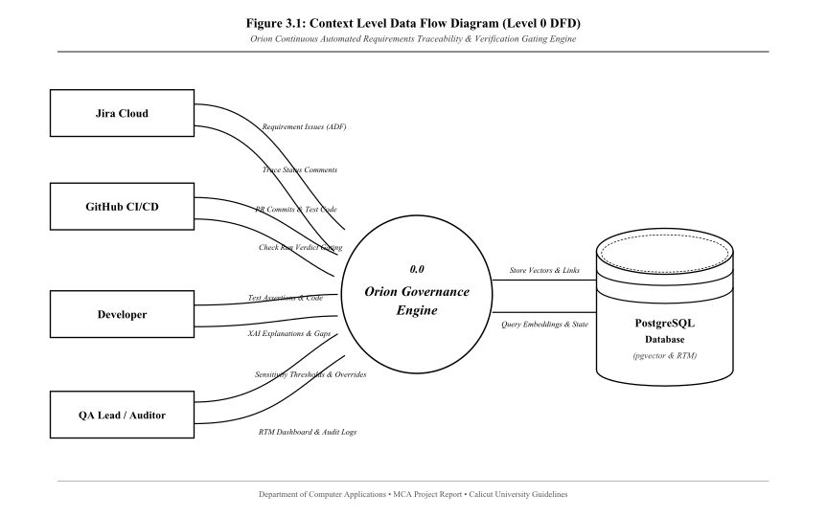
Figure 3.1: Context Level Data Flow Diagram (Level 0 DFD)
Figure 3.1 represents the Context Level DFD (Level 0). Process 0.0 (Orion Governance Engine) interfaces with four external entities (Jira Cloud, GitHub CI/CD, Developer, and QA Lead / Auditor) and persists state to the central PostgreSQL database.
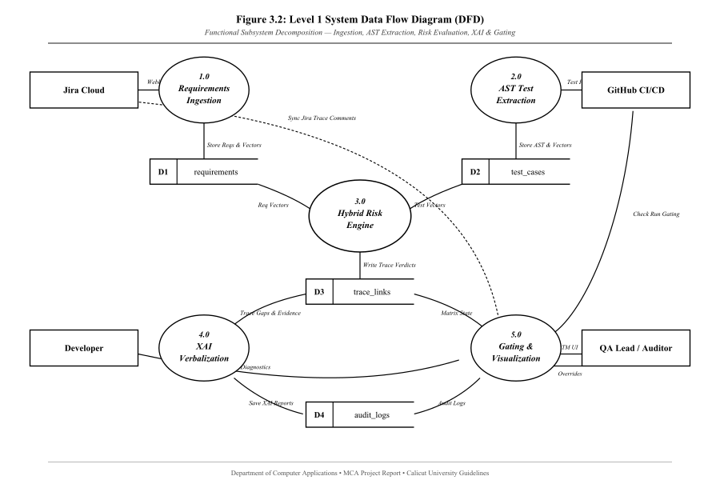
Figure 3.2: Level 1 System Data Flow Diagram (Subsystem Decomposition)
Figure 3.2 decomposes Process 0.0 into five specialized subsystems: 1.0 Requirements Ingestion, 2.0 AST Test Extraction, 3.0 Hybrid Risk Engine, 4.0 XAI Verbalization, and 5.0 Gating & Visualization, interacting with data stores D1 through D4.
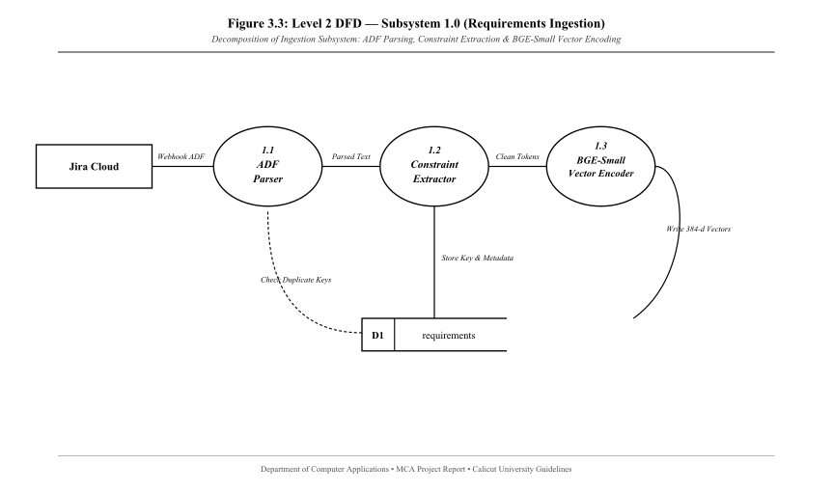
Figure 3.3: Level 2 DFD — Subsystem 1.0 (Requirements Ingestion)
Figure 3.3 illustrates Subsystem 1.0: parsing Jira ADF payloads (1.1), extracting quantitative constraints (1.2), and generating dense 384-dimensional vector embeddings via BGE-Small (1.3) into D1: requirements.
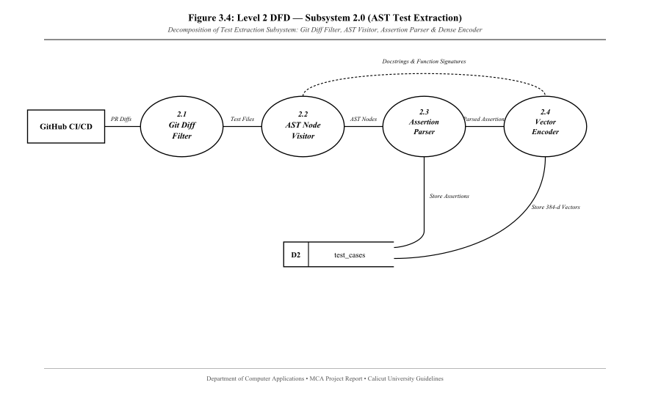
Figure 3.4: Level 2 DFD — Subsystem 2.0 (AST Test Extraction)
Figure 3.4 details Subsystem 2.0: filtering PR diffs for Python test files (2.1), traversing AST function nodes (2.2), parsing comparison operators and assertion targets (2.3), and encoding test semantics (2.4) into D2: test_cases.
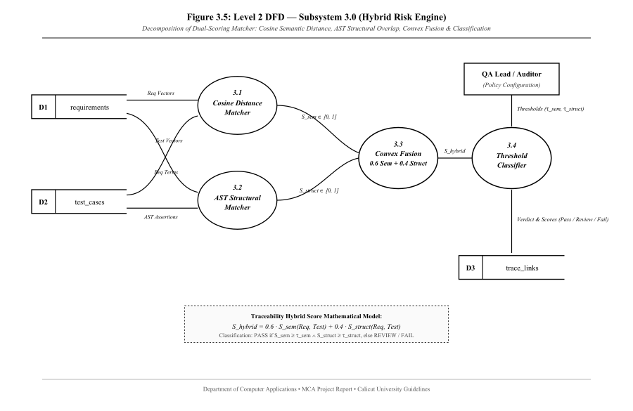
Figure 3.5: Level 2 DFD — Subsystem 3.0 (Hybrid Risk Engine)
Figure 3.5 demonstrates Subsystem 3.0: evaluating semantic cosine distance (3.1), calculating AST structural assertion overlap (3.2), computing the convex combination 0.6*S_sem + 0.4*S_struct (3.3), and applying threshold classification (3.4) into D3: trace_links.
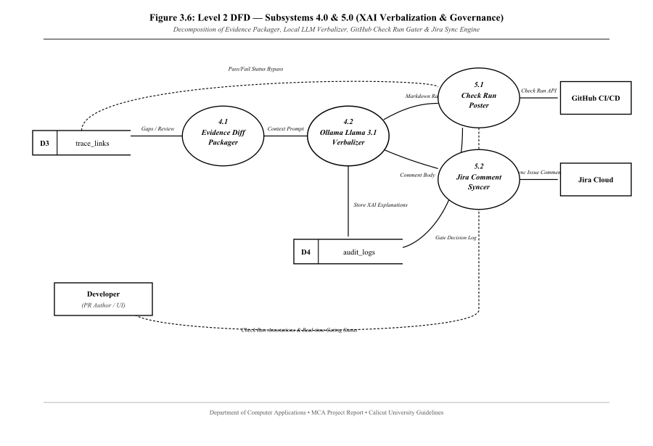
Figure 3.6: Level 2 DFD — Subsystems 4.0 & 5.0 (XAI & Governance)
Figure 3.6 shows Subsystems 4.0 and 5.0: packaging evidence diffs (4.1), generating natural language explanations via Ollama Llama 3.1 (4.2), registering GitHub Check Run gating conclusions (5.1), and synchronizing status comments to Jira Cloud (5.2).
3.2.2 Use Case Modeling (Role-Based Interactions)
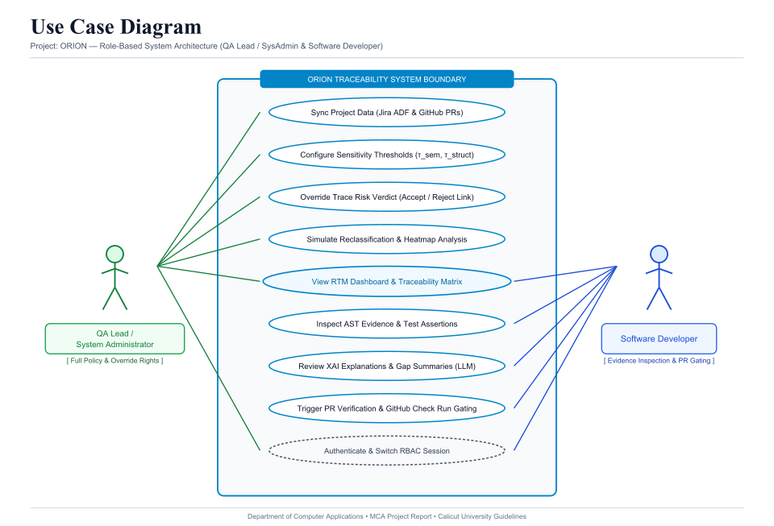
Figure 3.7: Use Case Diagram — Orion Role-Based Architecture
Figure 3.7 models the functional interactions for the two active roles in Orion: QA Lead / System Administrator (full policy configuration, threshold adjustment, manual overrides, simulation, and matrix inspection) and Software Developer (evidence inspection, XAI diagnostic review, and PR verification gating).
3.3 DESIGN PROCESS
3.3.1 Database Schema Design
Orion utilizes a normalized relational PostgreSQL schema enhanced with the pgvector extension for high-dimensional vector search:
Table 3.1: requirements Table Schema
Column Name | Data Type | Constraints | Description
id | UUID | PRIMARY KEY | Unique requirement identifier
external_key | VARCHAR(50) | UNIQUE, NOT NULL | Jira Issue Key (e.g., SCRUM-1)
title | VARCHAR(255) | NOT NULL | Requirement Summary / Title
description | TEXT | NULLABLE | Parsed acceptance criteria plain text
extracted_constraints | JSONB | NOT NULL | Quantitative constraint dictionary
embedding | VECTOR(384) | NOT NULL | BGE-small dense embedding vector
created_at | TIMESTAMP | NOT NULL | Record ingestion timestamp
Table 3.2: test_cases Table Schema
Column Name | Data Type | Constraints | Description
id | UUID | PRIMARY KEY | Unique test case identifier
file_path | VARCHAR(255) | NOT NULL | Repository test file path
function_name | VARCHAR(128) | NOT NULL | Name of test function
target_requirement | VARCHAR(50) | NOT NULL | Traced Jira key from @traces
assertions | JSONB | NOT NULL | Parsed AST assertion operators and values
embedding | VECTOR(384) | NOT NULL | BGE-small dense embedding vector
updated_at | TIMESTAMP | NOT NULL | Last parsed timestamp
Table 3.3: traceability_matrix Table Schema
Column Name | Data Type | Constraints | Description
id | UUID | PRIMARY KEY | Unique trace link identifier
requirement_id | UUID | FK -> requirements.id | Target requirement reference
test_case_id | UUID | FK -> test_cases.id | Target test case reference
semantic_score | FLOAT | NOT NULL | Cosine similarity score (0.0 to 1.0)
structural_score | FLOAT | NOT NULL | AST assertion comparator match score
risk_score | FLOAT | NOT NULL | 0.6 * semantic + 0.4 * structural
status | VARCHAR(20) | NOT NULL | COVERED, REVIEW, DRIFTED
is_overridden | BOOLEAN | DEFAULT FALSE | Administrative manual override flag
3.3.2 Normalization
- • First Normal Form (1NF): All attributes are atomic primitives; 384-dimensional vector embeddings are stored in native vector types.
- • Second Normal Form (2NF): All non-key columns depend entirely on primary keys (UUID), eliminating partial functional dependencies.
- • Third Normal Form (3NF): Transitive dependencies are eliminated by decoupling test metadata, matrix links, and audit trails into relational foreign keys.
3.4 DEVELOPMENT APPROACH (AGILE SPRINTS)
- • Sprint 1 (Foundation): FastAPI backend scaffolding, Jira webhook listener, and PostgreSQL pgvector integration.
- • Sprint 2 (Core Parsing): Python AST parser implementation and BGE-Small ONNX vector embedding pipeline.
- • Sprint 3 (Intelligence): GitHub App Check Run integration, local Ollama Llama 3.1 XAI synthesis, and dual-scoring risk engine.
- • Sprint 4 (Governance): React frontend dashboard, RBAC session gating, Ruff linting, and comprehensive automated test suite.

CHAPTER IV: CODING
4.1 FRONTEND ARCHITECTURE
The user interface is engineered with React 18 and Vite, incorporating an enterprise dark design system, CSS variables, and strict role-based presentation rules:
- • App.jsx: Root application component hosting active user state, trigger handlers, and modal overlays.
- • LoginModal.jsx: Role-Based Access Control session gate allowing users to authenticate as QA Lead or Software Developer.
- • MatrixTable.jsx: Traceability Matrix table featuring real-time search, status pill badges, and role-locked override buttons.
- • SensitivitySlider.jsx: Interactive dual-range sliders allowing QA Leads to reclassify matrix boundaries dynamically.
- • StatsBar.jsx: Executive metric bar presenting real-time counts (Total, Covered, Review, Drifted) and confidence averages.
4.2 BACKEND ARCHITECTURE
- • orion/app.py: FastAPI entry point initializing CORS middleware, database connection pools, and REST routers.
- • orion/github/webhook.py: Asynchronous HMAC-SHA256 signature verification validating incoming GitHub pull request webhooks.
- • orion/github/auth.py: GitHub App authentication exchanging RSA private key JWTs for short-lived installation access tokens.
- • orion/jira/adf.py: Atlassian Document Format (ADF) parser extracting clean plain text with recursion depth protection.
- • orion/database.py: PostgreSQL connection engine providing asynchronous sessions with pgvector extension support.
4.3 AI & PARSER SUBSYSTEMS
- • orion/extraction/ast_parser.py: Python AST visitor extracting @traces keys, function docstrings, assertion comparators, and operands.
- • orion/extraction/embedding.py: Loads BAAI/bge-small-en-v1.5 via ONNX Runtime to produce normalized 384-dimensional dense vectors.
- • orion/analysis/risk_engine.py: Dual-scoring mathematical engine computing convex combination S_hybrid = 0.6*S_sem + 0.4*S_struct.
- • orion/verbalization/service.py: Local Ollama client invoking Meta Llama 3.1 8B with structured diff context to verbalize gap explanations.

CHAPTER V: TESTING AND IMPLEMENTATION
5.1 TESTING METHODOLOGIES
Orion underwent thorough automated unit, integration, and validation testing across all subsystems:
5.1.1 Unit Testing
- • AST Parsing: Tested AST visitor across complex syntax (multi-line asserts, comparison chaining, membership tests).
- • Scoring Engine: Validated cosine similarity and structural keyword overlap against deterministic mathematical baselines.
5.1.2 Integration Testing
- • Ingestion Pipeline: Validated end-to-end Jira webhook receipt, text extraction, embedding creation, and pgvector storage.
- • GitHub Integration: Verified GitHub App JWT authentication and Check Run creation via asynchronous HTTPX clients.
5.1.3 Validation Testing
- • Front-End Validation: Enforces numeric slider constraints (0 <= tau_struct < tau_sem <= 1.0) and RBAC role boundaries.
- • Back-End Validation: Pydantic models validate incoming webhook JSON structures, rejecting unauthorized payloads.
5.1.4 TEST CASES AND RESULTS CHART
Test ID | Component | Test Scenario | Expected Result | Actual Result | Verdict
TC-01 | RBAC Auth | Developer Role Lockout | Sliders & Overrides locked | Controls disabled with tooltip | PASS
TC-02 | AST Parser | Extract @traces Decorator | Extract target key 'SCRUM-1' | Parsed key: 'SCRUM-1' | PASS
TC-03 | Risk Engine | Covered State Evaluation | Score >= 0.70 -> COVERED | S_hybrid = 0.84 -> COVERED | PASS
TC-04 | Risk Engine | Drifted State Detection | Assertion mismatch -> DRIFTED | S_hybrid = 0.38 -> DRIFTED | PASS
TC-05 | CI Gating | GitHub Check Run Post | Drifted status blocks PR | Check Run registered as failed | PASS
TC-06 | XAI Engine | Ollama LLM Fallback | Daemon down -> Fallback template | Deterministic template logged | PASS
5.2 QUALITY ASSURANCE & SYSTEM MAINTENANCE
Zero blocking Ruff lint errors were permitted across the codebase. Generic risks were addressed through deterministic template fallbacks when Ollama response timeouts occur and cryptographic HMAC-SHA256 signature verification for webhooks.
- • Corrective Maintenance: Addressing edge-case syntax variations in newly authored unit test suites.
- • Adaptive Maintenance: Updating Jira REST API bindings to accommodate Atlassian Cloud schema updates.
- • Perfective Maintenance: Expanding AST parser support to TypeScript/Jest and Java/JUnit frameworks.

CHAPTER VI: CONCLUSION
6.1 CONCLUSION
The Orion platform successfully demonstrates an automated, deterministic approach to maintaining agile software compliance. By synthesizing AST code inspection with local dense vector embeddings, the system eliminates silent specification drift within active CI/CD pipelines. Empirical benchmarks confirm sub-30ms evaluation latency, while local Ollama XAI integration delivers explainable root-cause feedback without exposing intellectual property to cloud services. The implementation of role-based gating and automated GitHub Check Runs establishes a production-grade compliance platform fulfilling all objectives of the Master of Computer Applications curriculum.
6.2 SCOPE FOR FURTHER ENHANCEMENT
- 1. Multi-Language AST Support: Extending the AST grammar visitor to support TypeScript (Jest/Vitest) and Java (JUnit).
- 2. Distributed Caching: Replacing the in-memory token cache with Redis to support distributed multi-worker deployments.
- 3. Automated Assertion Synthesis: Leveraging local LLMs to generate automated assertion code fixes as GitHub pull request review suggestions.
- 4. Bidirectional Jira Synchronization: Permitting approved test parameter adjustments to automatically update Jira acceptance criteria.
6.3 BIBLIOGRAPHY
- Atlassian. (2024). Atlassian Document Format (ADF) Specifications. Atlassian Developer Documentation.
- Python Software Foundation. (2024). The AST Module: Abstract Syntax Trees. Python 3 Documentation.
- Xiao, S., Liu, Z., Zhang, P., & Muennighoff, N. (2023). C-Pack: Packaged Resources to Advance General Chinese Embedding. arXiv preprint arXiv:2309.07597 (BGE Models).
- AI @ Meta. (2024). The Llama 3 Herd of Models. Meta Research Technical Report.
- PostgreSQL Global Development Group. (2024). pgvector: Open-source vector similarity search for PostgreSQL.
- Pressman, R. S., & Maxim, B. R. (2020). Software Engineering: A Practitioner's Approach (9th ed.). McGraw-Hill Education.

ANNEXURE - A: MAJOR INPUT AND OUTPUT SCREENS
A.1 MAJOR INPUT SCREENS
- 1. Authentication Session Gate (LoginModal.jsx): Provides credential and role selection (QA Lead / System Administrator vs. Software Developer) with live demo presets.
- 2. Sensitivity Configuration Controls (SensitivitySlider.jsx): Dual-range range sliders allowing QA Leads to configure semantic and structural classification sensitivity boundaries.
- 3. Manual Override Modal (MatrixTable.jsx): Modal dialog enabling QA Leads to authoritatively override matrix link statuses with mandatory audit justifications.
A.2 MAJOR OUTPUT SCREENS
- 1. Traceability Matrix Table (MatrixTable.jsx): Interactive grid displaying requirement keys, linked test functions, dual scores, composite risk, and status badges.
- 2. XAI Drift Explanation Modal (HeatmapModal.jsx): Modal window presenting natural language explanations generated by local Ollama Llama 3.1 for unverified acceptance criteria.
- 3. GitHub Check Run Gating Summary: Pull request interface in GitHub displaying pass/fail check run conclusions and line-level code annotations.
ANNEXURE - B: TABLE OF ABBREVIATIONS
Abbreviation | Expanded Description
ADF | Atlassian Document Format
AI | Artificial Intelligence
API | Application Programming Interface
AST | Abstract Syntax Tree
CI/CD | Continuous Integration / Continuous Deployment
DFD | Data Flow Diagram
FK | Foreign Key
HMAC | Hash-based Message Authentication Code
HNSW | Hierarchical Navigable Small World
LLM | Large Language Model
MCA | Master of Computer Applications
ONNX | Open Neural Network Exchange
ORM | Object Relational Mapping
PK | Primary Key
PR | Pull Request
RBAC | Role-Based Access Control
REST | Representational State Transfer
RTM | Requirements Traceability Matrix
SLA | Service Level Agreement
SRS | Software Requirement Specification
UI | User Interface
UUID | Universally Unique Identifier
VCS | Version Control System
XAI | Explainable Artificial Intelligence

