

DETECTION OF FAKE SMS

ATHUL SHAJI

Applied Research Project Submitted in Partial Fulfilment of the Requirements for the Degree of
Master of Science in Business Analytics at Dublin Business School

Supervisor: Agatha Mattos

DECLARATION

I declare that this Applied Research Project that I have submitted to Dublin Business School for the award of Master of Science in Business Analytics is the result of my own investigations, except where otherwise stated, where it is clearly acknowledged by references. Furthermore, this work has not been submitted for any other degree.

Signed: ATHUL SHAJI
Student Number: 10628633
Date:08/01/2024

ACKNOWLEDGEMENTS

I would like to express my sincere gratitude to several individuals for supporting me throughout his immense my research study. First, I wish to express my sincere gratitude to my supervisor, Agatha Mattos, for support, helpful information and practical advice which helped me all the time during my research work. I also wish to express my sincere thanks to my parents and friends for giving me immense support and encouragement throughout my studies.

ABSTRACT

SMS is the fastest way of communication these days over mobile phones, with millions of messages sent worldwide daily. Companies use it for sending promotions, and people use it for chat options. The following service doesn't require any internet connectivity and is widely used. Because of their widespread use, the following can also be a threat. Spammers can send Fake SMS and, with a high response rate, can capture personal data. The study aims to define the following problem of Fake SMS detection using the NLP. The study uses KDT as the standard methodology to find patterns in the text data. The data was cleaned via the NLU, and several models were applied using text metrics like TF-IDF and count vectorizer, where the Naïve Bayes model achieved the maximum accuracy of 98 per cent, showing the dominance of the probabilistic model over other models.

Contents
Abstract 4
CHAPTER 1 INTRODUCTION 6
1.1 Background 6
1.2 Research problem 7
1.3 Research Objectives 7
1.4 Business scope 7
1.5 Scope and limitations 8
1.6 Report structure 8
CHAPTER 2 : LITERATURE REVIEW 9
CHAPTER 3 METHODOLOGY 21
3.1 Text Mining 21
3.2 Business Problem 22
3.3 Data Understanding 22
3.4 Data Preparation 23
3.5 Modeling 26
3.6 Evaluation 30
CHAPTER 4 RESULTS AND EVALUATION 31
4.1 Results 31
4.3 Evaluation 37
CHAPTER 5 FUTURE WORK AND CONCLUSION 38
REFERENCES: 39

List of Figures
Figure 1 Knowledge Discovery From Text 22
Figure 2 Dataset 23
Figure 3 Missing Values 24
Figure 4 Uncleaned Dataset 25
Figure 5 Cleaned Dataset 25
Figure 6 Words in Ham SMS 26
Figure 7 Words in Spam SMS 26
Figure 8 Y-Variable 27
Figure 9 Logistic Regression Count Vectorizer Confusion Matrix 31
Figure 10 Logistic Regression TF-IDF Confusion Matrix 32
Figure 11 XgBoost Count Vectorizer Confusion Matrix 33
Figure 12 XgBoost TF-IDF Confusion Matrix 34
Figure 13 Decision Count Vectorizer Confusion Matrix 35
Figure 14 XgBoost TF-IDF Confusion Matrix 36
Figure 15 Naive Bayes Count Vectorizer Confusion Matrix 36
Figure 16 Naive Bayes TF-IDF Confusion Matrix 37

CHAPTER 1 INTRODUCTION

1.1 Background
SMS- a short message service is a text message that came up with mobile service and internet providers. The following is a standard protocol between mobile services to exchange messages. The service started when the mobile phone boom came. Previously, this was the only way to communicate over text. But after social media, everything got disrupted. However, most companies use SMS to send customers service enquiries and other promotional offers. The given technology is the leading go-to technology for most companies as it doesn't require any internet. But as they are used heavily in any industry, they are a vulnerable source for attacking customers. One can send a weak link to someone's mobile number, and once clicked, the following can create a loss of information for these customers and lead to a data breach. Hence, there is a need to examine these messages as Fake or not based on the content. The study uses machine learning algorithms to build a system that can classify the message as HAM or SPAM.

1.2 Research problem
SMS is a short message sent over one's mobile phone and is used frequently in daily life. On average, there are a total of 8.4 trillion messages sent per year and 23 billion per day. Such a vast number has much significance for the business world. According to marketing analytics, messages are seen more than regular mail; hence, they are the primary source of sending promotions. Being the most common source for communication, the following can also be very quickly used for spamming persons. Hence, a regulation is required on top of these messages. With the help of machine learning and NLP, one can read the message and identify the message as Fake or not by analyzing the content. Machine learning is a branch of AI that learns from the data and predicts new instances. The given analysis can be done by reading the content of the data and understanding the data. The following task requires one unique branch of machine learning known as NLP. Natural language processing is the branch of AI that deals with understanding the human language by removing the commonly used keywords and other special syntax and characterizing it. This can also be implemented in fake SMS detection, and one can protect oneself from scammers.

1.3 Research Objectives
The project's Research Objective is to identify whether an SMS is fake or not using the NLP, and the following can be accomplished:
- Find a dataset and build machine learning models that accurately distinguish between Fake and standard SMS.
- Understand the domain of Natural language processing and Natural language understanding to understand how spammers' information can be used to interact with the user.
- Find the most critical features that affect the performance of the model.
- Find the patterns in fake SMS to make the model more robust for real-time detection systems.
- Establish various evaluation metrics to compare the model's performance and find the best one irrespective of class pattern.

1.4 Business scope
The Research can have a lot of business scope in the market, from cybersecurity to providing services to the telecommunications company in tracking and blocking these messages. As discussed, these are the most common ways of communicating. Hence, most of the companies and financial institutes can protect their customers. Also, the government can use this to pass regulations on making new policies and improving telecommunication.

1.5 Scope and limitations
- Scope
- Understand the domain of Fake SMS and implement machine learning on the given topic.
- Try to implement text-mining techniques to extract knowledge from the data.
- Find patterns in the data and find commonly used ways for FAKE SMS.
- Use different text mining techniques and vector metrics to understand the text data.
- Build machine learning models to make better decisions in Fake SMS and understand how these models understand the text data and given pattern.
- Limitations
- The Fake SMS trend keeps changing, so building a robust model can be difficult.
- The model has some language boundaries, so trying a multi-lingual model is a complicated task.
- The models may face issues with class imbalance, reducing the accuracy.
- The training may require a lot of resources and memory, leading to system crashes.

1.6 Report structure
The whole project is divided into subsections, and the following is discussed.
- Introduction: Chapter 1 provides all the details about the FAKE SMS business problem and tries to build various research questions on a given topic and discuss the use of machine earning to solve a given problem
- Literature Review: The second chapter talks about all the research work done in the field, discusses the 360-degree view of the given problem, and finds significant discrepancies in the other models. The Research tries to build a roadmap to solve the given problem.
- Methodology: The third chapter shows the implementation of the given problem with machine learning. Discuss a standard procedure, different text mining techniques used in the data cleaning, and natural language understanding.
- Results: The fourth chapter discusses the results obtained from the given Research, compares different models using the various metrics, and concludes based on the business objectives.
- Discussion and Conclusion: The final chapter summarizes the given problem and states the limitations of the project, discussing future work and new technology and techniques for better implementation.

CHAPTER 2 : LITERATURE REVIEW

[1] In this comprehensive survey by Xinyi Zhou et. the authors address the alarming issue of fake news and its far-reaching consequences on democracy, journalism, and public trust. Fake news has emerged as a significant threat, notably exemplified by its possible influence on critical events such as the "Brexit". The paper underscores the magnitude of this problem, particularly its impact on social media platforms, where fake election stories often outperform authentic news regarding engagement and dissemination. The survey introduces the concept of manual fact-checking, which encompasses two categories. Various websites that enable expert-based fact-checking and offer valuable insights into the authenticity of news content are discussed. The paper raises several research questions, emphasizing the importance of dynamic knowledge bases and early detection of fake news in rapidly evolving news landscapes. The second part of the survey delves into fake news detection. Style-based methods focus on analyzing not only the authenticity but also the intention behind news content. The authors introduce the concept of "Fake News Style," which involves quantifiable characteristics that distinguish fake news from actual news. Style-based fake news detection is framed as a classification problem, aiming to identify the content's style based on machine learning features.
The paper examines how content style is represented in both textual and visual features. General textual features, including lexicon, syntax, discourse, and semantic analysis, are discussed in detail. Different approaches for capturing and analyzing content style are explored, shedding light on the complexities of identifying fake news based on type.
[2] M. F. Mridha, etc. present a comprehensive analysis of the challenges posed by fake news in the modern era and propose advanced solutions for its detection. The paper underscores the growing significance of identifying online-based spam information. The authors highlight the limitations of previous Research, which mainly focused on data mining and Traditional techniques. The paper begins with a discussion of the consequences of fake news, emphasizing its profound impact on society. It delves into the datasets used in previous Research and the NLP techniques employed in fake news detection. The authors offer a comprehensive overview of dl -based methods, categorizing them for clarity. The prominent evaluation metrics used in counterfeit news detection are also thoroughly discussed. The study goes beyond previous Research to make recommendations for improving fake news detection mechanisms in the future, emphasizing the need for more in-depth investigations into the capabilities of deep learning in addressing this critical issue.

- In this systematic literature review, Said Salloum et al. address the growing threat of phishing, a primary concern for cybersecurity, particularly in email communication. Phishing attacks result in significant financial losses and substantially threaten the internet economy. The authors highlight that these attacks are increasingly carried out through email. While several review studies have explored the research trends in phishing email detection, this study takes a unique perspective by focusing on applying NLP techniques in phishing email detection. The researchers analyze 100 research articles published between 2006 and 2022. They categorize their findings based on specific criteria, including the critical areas of Research in phishing email detection using NLP, ML algorithms employed, text features in phishing emails, datasets and resources used for benchmarking, and the evaluation criteria applied. The study reveals that feature extraction and selection are the primary research areas in phishing detection, focusing on methods for classifying and optimizing the detection of phishing emails. SVM emerge as the most used classification algorithm for identifying phishing emails.
- The paper by Olusola Abayomi-Alli, et. presents a comprehensive review of SMS spam classification methods. The study extensively explores existing Research, encompassing 1198 publications from various databases, and narrows it down to 83 relevant papers. The analysis of these papers covers aspects such as AI methods and techniques, approaches used in SMS spam classification (content-based, non-content-based, or hybrid), deployment architecture (client-based, server-based, or collaborative), and the status of existing solutions. Notably, machine learning techniques, particularly Bayesian and support vector machines, are prevalent in SMS spam classification, and feature selection methods, term frequency, and so on which are widely used for the purpose of effective feature selection. The study reveals that most SMS spam classification solutions are still in the "Proposed" or "Proposed and Evaluated" stages, indicating room for further Research and development. Additionally, it highlights the need for researchers to explore various security methods and algorithms to enhance SMS security and create a new English SMS spam dataset. Furthermore, the paper emphasizes that only a tiny fraction of Android users.
[5] In the realm of phishing attack detection, a significant body of literature has been dedicated to leveraging machine learning (ML) approaches. This review encapsulates the methodology employed in phishing detection using ML, specifically supervised and unsupervised learning, while presenting a novel framework. The dataset was acquired from Kaggle and subjected to meticulous data preprocessing to ensure the dataset's cleanliness. An imperative facet of this process involved feature selection to reduce data redundancy and select the most relevant attributes, employing algorithms like REF, Relief-F, IG, and GR. The subsequent step involved Principal Component Analysis (PCA) to analyze and classify the features by their strength and importance further. PCA, an established technique, reduces data dimensionality and was applied here to maintain data integrity and facilitate quicker analysis.
The dataset encompassed 32 attributes, each characterized by its unique role, all of which were meticulously explained. Supervised learning techniques were employed for the classification of phishing websites, implementing two prominent ML algorithms. PCA, which holds the capability to transform extensive datasets into more manageable forms by minimizing dimensionality, was chosen for dimensionality reduction. It ensured that critical information from the dataset was preserved while simultaneously improving the efficiency of the ML algorithm. The process involved standardizing variables and computing the covariance matrix to gauge variable dependency. Eliminating correlated variables was crucial, as these only contributed extraneous information. In the final step, the eigenvectors and eigenvalues of the covariance matrix were calculated to identify principal components. This process was instrumental in mapping the dataset into a more manageable dimension.
This methodological review serves as a foundation for comprehending how machine learning techniques, particularly supervised learning and PCA, are employed to detect phishing attacks effectively. The approach is underpinned by rigorous data acquisition, preprocessing, feature selection, and classification steps, ultimately providing a robust framework for phishing attack detection.
[6] The rapid expansion of online social networks (OSNs) has given rise to various social media platforms that have become integral to daily life. However, the increasing popularity of these platforms has also attracted the attention of spammers. Spam detection methods can be categorized into two main approaches: Expert-based detection relies on human expertise and can be a time-consuming process with limitations in accuracy. In contrast, due to its efficiency, ML-based spam detection has become the preferred method within OSNs. Detecting spam in social networks is a complex task influenced by various factors, and the imbalance between spam and legitimate messages provides an advantage to spammers. ML algorithms, including LR,KNN, DT, RF, SVM, XGB, and VC, are employed to enhance classification accuracy and address the data imbalance challenge. Text data is vectorized using vectorizers, Experimental results demonstrate that the proposed VC model achieves a high classification accuracy rate of 97.96%, surpassing other algorithms.
[7] This article introduces a DL based on BiLSTM for automatic SMS spam classification, which addresses the growing issue of unwanted SMS spam. The study compares the performance of this deep learning model with ML algorithms using two datasets: a newly collected dataset (ExAIS_SMS) and the UCI SMS dataset. Performance metrics are evaluated. The results indicate that the BiLSTM model significantly improved over traditional ML classifiers, achieving an accuracy of 93.4% for the ExAIS_SMS dataset and 98.6% for the UCI dataset. The BiLSTM model outperformed other ML classifiers, with Naïve Bayes as the second-best performing algorithm with an accuracy of 84.4%. The study underscores the effectiveness of the proposed deep learning model in classifying SMS spam messages and its potential to enhance trust between users and service providers in the SMS domain.The article presents a comprehensive investigation into the issue of SMS spam. This problem has become increasingly significant with the widespread use of mobile devices and SMS as a primary mode of communication. The study highlights the detrimental effects of SMS spam, emphasizing its impact on users and service providers, leading to a breakdown in trust between these key stakeholders. To combat this issue, the authors propose a deep learning model based on BiLSTM designed to classify SMS messages automatically as either spam or legitimate. The approach taken in this study involves a rigorous comparison of the BiLSTM model's performance with that of several ML algorithms. To do this, the study employs two distinct datasets: the newly collected dataset referred to as ExAIS_SMS and the widely used UCI SMS dataset.
One finding from the study is the significant improvement achieved by the BiLSTM model compared to traditional ML classifiers. The BiLSTM model's performance is awe-inspiring, with an accuracy rate of 93.4% for the ExAIS_SMS dataset and 98.6% for the UCI dataset. This is a noteworthy result, indicating the effectiveness of deep learning models in addressing SMS spam classification.
The article also discusses fine-tuning various parameters to optimize the BiLSTM model's performance. This fine-tuning process was pivotal in elevating the model's accuracy, as demonstrated by the substantial improvement from an initial ground-truth classification rate of 90.8% to the final 93.4% accuracy. This highlights the potential for further enhancing deep learning models for SMS spam classification through parameter adjustments.
The detailed results and comparisons presented in the study emphasize the superior performance of the BiLSTM model over traditional ML algorithms. While the BiLSTM model achieved the highest accuracy, other ML classifiers, such as Naïve Bayes, also demonstrated respectable results, with an accuracy of 84.4%. This information provides valuable insights for researchers and practitioners working on SMS spam classification.
[8] The paper by Moe Elbadawi and Simon Gaisford presents an insightful examination of the growing influence of machine learning (ML) techniques on drug discovery. Elbadawi, Gaisford, and Basit explore the profound impact and potential of ML as it becomes increasingly central to the pharmaceutical industry and research endeavours [Elbadawi et al., 2020].
The authors highlight that the fundamental success of ML in drug discovery is primarily attributed to its remarkable ability to discern intricate patterns within complex and extensive datasets. Moreover, the accessibility of ML techniques to a wide range of researchers is emphasized. The everyday use of programming languages such as Python and R and user-friendly tools like Apple's Create ML have made ML more approachable, even to those without extensive coding expertise. The authors also acknowledge that third-party software can be limited in performing advanced ML techniques and the full spectrum of the ML pipeline [Elbadawi et al., 2020].
The paper delves into the adoption of conventional ML techniques in drug discovery, where the authors mention various methods, including k-Nearest Neighbour, decision trees, SVM, and ANN. These traditional techniques are highlighted for their simplicity, computational efficiency, and improved prediction accuracy compared to conventional predictive algorithms. The paper notes explicitly the comprehensibility of these techniques, which researchers with diverse backgrounds can understand [Elbadawi et al., 2020].
The authors discuss various advanced ML techniques, including Reinforcement Learning (RL). Inspired by its success in winning games like Go, this technique is described as continuous learning through a reward and penalty system. The paper underlines that RL distinguishes itself from supervised and unsupervised learning as it produces judgments rather than predictions. The authors mention the application of RL in gaming, robotics, and financial trading, emphasizing its autonomy and adaptability to dynamic environments [Elbadawi et al., 2020].
The concept of RL, based on environmental reinforcement signals, is detailed. The main components of RL, including agents, territories, states, policies, and reward functions, are explained. The authors provide specific examples of RL used to design novel drug compounds and describe its potential to automate drug design. However, they also acknowledge challenges related to the specificity of drug design in RL models [Elbadawi et al., 2020].
The paper moves on to discuss Transfer Learning, another advanced technique that tackles the issue of insufficient data for specific tasks. Transfer Learning is depicted as transferring knowledge gained from one job to another related study, thereby improving the performance of models on smaller datasets. The authors highlight successful applications of Transfer Learning in predicting drug sensitivity, especially in cases where gene expression data for the target disease is scarce [Elbadawi et al., 2020].
Multitask Learning is also examined, with the authors emphasizing its simultaneous learning of multiple tasks within a single model. The paper highlights the benefits of multitasking learning, especially in sparse data and high noise levels. The authors provide an illustrative example where Multitask Learning was used to address the challenges of multitarget drugs and to improve drug discovery efficiency [Elbadawi et al., 2020].
[9] The paper authored by Osa E. et al. focuses on the pressing issue of SMS spam within the domain of Short Message Service (SMS) communication. SMS is an exceptionally ubiquitous form of communication, and with its widespread use comes the problem of unwanted, unsolicited messages, commonly referred to as spam. Such spam messages can be a nuisance, often cluttering users' inboxes and making it challenging to find legitimate messages.
The paper initiates with an introductory section highlighting the tremendous growth of SMS traffic volumes over the years, indicating the significance of SMS as a communication medium. It underscores that while SMS is a valuable tool for legitimate communication, it has also become a channel for various forms of spam. The distinction between ham (fair) and spam messages is paramount, as legitimate users do not voluntarily consent to receiving spam messages. In essence, spam is characterized by its unsolicited and bulk nature, signifying notifications that users neither want nor request.
Furthermore, the paper emphasizes that spam is not limited to emails but has entered various other forms of digital communication, including SMS. The problem has become increasingly prevalent due to the convenience, cost-effectiveness, and reliability of SMS as a communication medium. To combat the issue of SMS spam, the authors argue that machine learning, mainly supervised learning, can play a pivotal role.
The exploratory data analysis extends to word cloud visualizations, a standard tool in natural language processing, to provide a visual representation of the most frequently occurring words in both spam and spam messages. Examining words and their frequencies is a valuable aspect of understanding the characteristics of spam messages, enabling better feature extraction for the model.
The paper further elucidates the importance of text preprocessing, a crucial step in natural language processing tasks, to clean and prepare the data. This process includes stemming and lemmatization, which reduce words to their root forms, facilitating more effective text analysis.
Subsequently, the authors detail the tokenization process, which converts text data into numerical features that can be fed into machine learning models. This conversion is essential as most machine learning algorithms, including deep learning models, work with numerical data rather than raw text.
The training set teaches the model to recognize patterns and make predictions, while the test set evaluates the model's performance.
The core of the paper's methodology lies in training the deep learning model. The authors describe a simple neural network architecture for this SMS spam detection task. The model's structure includes an embedding layer, which processes the textual data, followed by various layers that progressively refine the information and learn to differentiate between spam and spam messages. The training process involves several epochs and employs an early stopping technique, which ensures that the model stops training when it no longer improves its performance.
Lastly, the paper delves into evaluating the deep learning model's performance. It employs standard performance metrics, such as accuracy and the confusion matrix, to assess how well the model has learned to classify messages as ham or spam.
[10] This paper addresses the critical issue of social spam within OSNs. OSNs have become integral in various aspects of life, from personal communication to business interactions and content sharing. However, the surge in social spam poses a significant challenge, affecting the quality of information, user experience, and overall network performance.
The paper begins by outlining the widespread use of OSNs, highlighting their importance in various domains and the massive number of active users. These networks enable communication, information sharing, and multiple applications. However, they are also susceptible to abuse by malevolent users, including spammers, bots, hackers, and cybercriminals.
The concept of spam is introduced, encompassing various forms, such as malicious links, false advertisements, fake reviews, and political astroturfing, all intended to generate profits or achieve nefarious objectives. The primary mode of spam dissemination in OSNs is through fake, compromised, or cloned accounts and social bots, which can act orchestrated to flood users with spam content.
The paper highlights the steps involved in the social spamming process, including spam propagation, user engagement, and the final act of spam exodus. Users are enticed through various tactics like clickbait, malicious links, and hoaxes, and the spamming process can lead to numerous cyber threats, including phishing, ransomware attacks, cyberbullying.
To combat the issue of social spam, the paper reviews traditional methods like URL list-based filtering and honeynet/pot-based techniques. However, these approaches have limitations, including their inability to adapt to rapidly changing spam characteristics. As a result, ML and DL techniques have gained prominence in spam detection. The paper comprehensively reviews recent ML and DL-based methods and their advantages and disadvantages in addressing social spam. In conclusion, the report emphasizes the need for robust detection systems to counter evolving social engineering attacks. The paper's extensive review and analysis of this critical issue make it a valuable resource for researchers and practitioners working in the domain of OSN security.
[11] The authors propose a method for detecting spam reviews using a combination of self-attention-based CNN and bi-directional LSTM networks.The problem addressed in this paper is the detection of spam reviews, which can be a significant issue in online platforms and e-commerce websites. Detecting and filtering out spam reviews is crucial to maintaining the credibility and usefulness of online reviews for consumers.The proposed approach combines two neural network architectures: self-attention-based CNN and bi-directional LSTM. These two architectures are widely used in natural language processing and text classification tasks.The paper likely presents the architecture and training process of the combined model in detail, explaining how it processes and classifies text data as spam or non-spam. It may also describe the dataset used for training and evaluation and the performance metrics used to assess the model's effectiveness.
Overall, this paper introduces a machine learning approach to address the problem of spam review detection, which can have practical applications in various domains. Using self-attention-based CNN and bi-directional LSTM networks suggests that the model can capture local and global dependencies in text data, which is essential for accurate text classification.

[12] This study presents an approach to detecting SMS spam, leveraging contextual embeddings from BERT and predefined intention labels. Contextual embeddings, representing the semantic meaning of the text, are derived through BERT, a transformer model incorporating attention mechanisms. The BERT encoder transforms input text into high-dimensional contextual embeddings, utilizing multiple layers with attention heads and non-linear feed-forward layers. Attention heads compute relationships between words, while feed-forward layers facilitate interaction between these heads. The final hidden layer merges attention scores to produce output vector representations for each token. The initial token's output, termed "pooled output," encapsulates the text's context, serving as the contextual embedding for the entire text.
Additionally, on extensive datasets, BERT models are pre-trained using Masked Language Model (MLM) and Next Sentence Prediction (NSP) objectives. MLM masks 15% of words in input sequences for the model to predict based on surrounding contextual information. NSP teaches the model to understand sentence relationships. The tokenizer converts input text into tokens, limited to a maximum length of 512 tokens. Attention masks are applied to tokens to avoid unnecessary computations for padded permits. The model's bidirectionality is highlighted, allowing simultaneous consideration of the entire text distinguishing it from traditional directional models. The study emphasizes the significance of bi-directionality in capturing nuanced contextual information. The proposed SMS spam detection system integrates BERT's pre-trained embeddings and predefined intention labels. Tokenized text, token embeddings, and attention masks are input to the transformer encoder, generating contextual embeddings for text and 13 predefined intention labels. The intention-based SMS spam detection system employs a classification approach utilizing decision trees, random forests, and SVM classifiers. However, the paper needs more specific results and performance metrics, necessitating further empirical evaluation to gauge its effectiveness.
[13] This Research by Hina Tufail et al. explores the impact of fake reviews in the filed of e-commerce during and after the COVID-19 pandemic, introducing a fake review detection model using text classification and machine learning techniques. The model focuses on fraudulent review detection by analyzing pronouns, verbs, and sentiments. Methodologically, the study encompasses data preprocessing, feature selection, and sentiment analysis using the NLTK package. The dataset comprises 1900 hotel reviews from Yelp.com, balanced with 950 harmful and 950 positive reviews. Data preprocessing involves removing punctuation marks, and feature selection consider parameters such as review length, sentiment word count, and noun-verb count. Machine learning classifiers, SVM, distinguish genuine from fake reviews. SVM exhibits the highest recall among classifiers.
The dataset undergoes 10-fold cross-validation, yielding 95% and 89.03% accuracy on Yelp and TripAdvisor datasets, respectively. Statistical analyses, including Friedman and Nemenyi tests, compare classification algorithms, establishing SVM's superiority over KNN and LR classifiers. SVM emerges as the most effective model for detecting fake reviews. The study's methodology and findings contribute valuable insights into fake review detection and the impact of such reviews on e-commerce, particularly during and after the COVID-19 pandemic. The proposed framework offers businesses and consumers a reliable means of identifying fraudulent reviews, aiding informed decision-making based on online reviews.
[14] The literature review explores the critical topic of using both ML and DL techniques. The study delves into the various approaches, challenges, and advancements in identifying and combating phishing emails.Phishing attacks are pervasive, exploiting human vulnerabilities by deceiving individuals and organizations into disclosing sensitive information. The article discusses the phishing lifecycle, emphasizing attackers' use of social engineering over exploiting technical vulnerabilities. It highlights the need for advanced detection methods as phishers constantly evolve tactics.
The article outlines multiple ML and DL techniques used for detecting phishing emails. ML approaches encompass features like URL analysis, text mining, and header/body structure examination, while DL methods involve neural networks, including CNN and RNN. These methods aim to analyze email content, identify patterns and make predictions based on learned behaviours.
The review acknowledges the varying accuracy of these detection methods, influenced by factors such as the chosen technique, dataset quality, and feature extraction processes. Some studies report high accuracy levels, but the dynamic nature of phishing attacks poses an ongoing challenge, necessitating continuous Research and innovation.
Looking ahead, the literature points out the need for further Research into DL techniques, such as CNN and RNN, as they hold promise for more sophisticated and effective phishing email detection. As phishing attacks grow in sophistication and prevalence, the study underscores the urgency of advancing detection technology to protect individuals and organizations from this evolving threat.
In summary, the literature review provides an informative overview of the current state of phishing email detection, emphasizing the role of ML and DL techniques and the challenges they address.
[15]Sunil Gundapu has innovated an advanced system for the Automatic Detection of COVID-19 Fake News, responding to the widespread issue of misinformation during the pandemic. The continuous technological progress in online social networks, particularly platforms like Twitter, has led to the proliferation of false information and fake news, a trend exacerbated during the ongoing COVID-19 pandemic. This dissemination of misinformation can lead individuals to accept unfounded claims and articles, contributing to heightened panic and confusion. In light of this critical issue, researchers have developed a methodology to assess the reliability of COVID-19-related information circulated on social media platforms.
Their approach utilizes a combination of three transformer models—BERT, ALBERT, and XLNet—known for their remarkable efficacy in fake news detection. The system, created as part of the ConstraintAI 2021 shared task,demonstrated an impressive F1-score of 0.9855 on the test set, securing the fifth position out of 160 participating teams. The paper provides detailed insights into the methodology, encompassing data preprocessing steps to cleanse and prepare input text for analysis. The researchers compare their approach to machine learning and deep learning models incorporating various word embeddings, emphasizing the superior performance of transformer-based models.
The authors underscore the critical challenge of tackling fake news during a global pandemic, where misleading and harmful information jeopardizes public health and safety. They stress the necessity for advanced natural language processing models to enhance the accuracy of fake news detection during such crises. The study highlights the significance of their findings and offers valuable insights for future Research in this pivotal domain.
To summarize, the collaborative Research by Sunil Gundapu and Radhika Mamidi addresses the pressing need for an efficient system to identify and counter COVID-19-related fake news, emphasizing the role of advanced transformer models in this pursuit. Their noteworthy achievements in a highly competitive task underscore these models' potential to curb misinformation dissemination during global health emergencies.

Author | Title | Date of Publication | Gaps Filled | Technique Used
XINhYI ZHOU, Reza ZAFFARANI | A Survey of Fake News: Detection Methods,along with the Opportunities | 2020 | Detection methods for fake news, interdisciplinary Research, fundamental theories | Fake news detection methods
M. MRIDHA, MD. SAIFUR RAHMAN | A Comprehensive Review on Fake articles and News Detection With Deep Learning | 2019 | Exploration of DL based techniques for fake news detection | Deep learning methods
Olusola Odusami | A review of soft techniques , and applications | 2018 | Review and identification of SMS spam classification methodologies | Soft techniques, SMS spam classification methods and approaches
Moohammad Nazzmul, Ishitta Saha, Dhiman Limma, Sohrab Hossain | Phishing Attacks Detection using ML Approach | 2020 | Detection of phishing attacks using machine learning | Machine learning Feature selection algorithms.
M. Sumathi, S. P. Raja | ML algorithms-based spam detection in social networks | 2023 | Detection of spam in social networks using machine learning algorithms | XGB, Voting Classifier
Olusola Abbayomi-Addebayo Abayomi-Alli3 | A DL method for automatic SMS spam classification: | 2021 | Performance evaluation of deep learning model (BiLSTM) | BiLSTM, Machine Learning Algorithms
Dhhruv Rathhee, Suman Mann | Detection of Email Phishing Attacks – Deep Learning | 2019 | Detection of phishing emails using ML and DL approaches, comparative analysis of models | Machine Learning, Deep Learning
Moee Elbbadawi, Gaisford, Abdul W. Basit | Advanced ML techniques in drug discovery | 2022 | Discusses challenges in drug discovery ML, advanced techniques | Machine Learning, ML techniques, advanced methods
Osa , Elaigwu. V.Ob | Modelling of a DL Based SMS Spam Detection Application | 2021 | Developing a spam detection application using Deep Learning algorithms | Google Colab, Pandas, Seaborn, Matplotlib, Wordcloud, Tensorflow, Python-dotenv, Scikit learn, Flask
Sanjeev Rao Verma, Bhatia | A review on social spam , open issues, and future directions | 2021 | Review of social spam detection techniques, impact of Deepfakes | Deep Learning, Machine Learning
Gilchan Park | Ontological Detection of Phishing Emails | 2022 | Adding semantics to highly accurate detection. | Ontology, Synonym Substitution, Information Security
P. Bhuvaneshwari 1 & A. Nagaraja Rao1 & Y. Harold Robinson2 | Spam review detection using self attention-based CNN and bi-directional LSTM | January 25 2021 | Developing a DL based framework called Self BiLSTM (ACB) model for spam review detection | ACB model, Convolution Neural Network (CNN)
Hina Tufail Moaiteq Aljahdali 4 | The Effect of Fake Reviews on e-Commerce During and After Covid-19 Pandemic: SKL-Based Fake Reviews Detection | 2018 | Proposing a fake review detection model using Text Classification and Machine Learning techniques to address the issue of fraudulent or fake reviews in the context of the Covid-19 pandemic's impact on e-commerce. | Text Classification, ML Bigram Model, Natural Language Processing, Sentiment Analysis.
Fei Jiang, Yong Jiang, Yongjun Wang | Artificial intelligence in healthcare: past, present and future | 2020 | Surveying the current status of AI applications in healthcare, prognosis evaluation. | ML , DLProcessing.
Sunil Gundapu and Radhika Mamidi | Transformer based Automatic COVID-19 Fake News Detection System | 2021 | Developing an efficient fake news detection architecture with respect to detect fake news in the context of the ConstraintAI 2021 shared task. | Ensemble of Transformer Models Deep Learning.

CHAPTER 3 METHODOLOGY

3.1 Text Mining
Knowledge discovery in databases, or KDD, is a standard process to extract and explore large amounts of data to discover their exciting patterns. KDD is concerned mainly with structured data; hence, the following application is not available on text data, so it is necessary to change the structure and apply it on text data. Using it to text data is known as Knowledge discovery from Text or KDT. It refers to extracting exciting and non-trivial information and knowledge from unstructured text. It is a technique used to discover or find exciting patterns from available text documents and deals with machine-supported text analysis. Text analytics is a young interdisciplinary field that draws on information retrieval, data mining, machine learning, statistics, and computational linguistics. It involves structuring input text, deriving patterns within the structured data, and evaluating and interpreting the output. Various text categorization, classification, and clustering techniques have been developed to handle the task of text mining [16] efficiently.
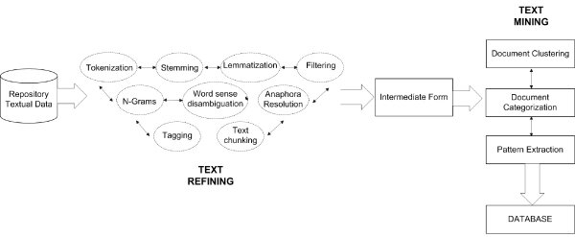
Figure 1 Knowledge Discovery From Text
The project uses the following standard process for data mining and tries to detect fake SMS based on the given data.

3.2 Business Problem
Fake SMS is a new problem that is arising in the digital world. The following is a short message with external links and other information that can leak personal data. Hence, the following needs to be addressed. The Fake SMS is affecting the community around the world. Informing of personal information and black-mailing are the primary things scammers do once the SMS takes control of personal data. The following affects the network company's brand value; hence, there is a need to detect the Fake SMS. The next problem can be solved via machine learning. Today, the world relies on data, and companies have more extensive databases of Fake SMS. The following can be used to detect Fake SMS using machine learning models. These models can quickly learn from the data and help detect Fake SMS. The central theme is to convert the data into a form that models can understand, and the models can easily find patterns out of the data.

3.3 Data Understanding
Once the business problem is identified. The next step is understanding the data. The primary agent in running any machine learning model is data. The data used in the Research have multiple text messages taken from the UCI repository [17], all labelled as HAM or SPAM. The dataset is a mixture of manually extracted SMS; some are taken from the NUS SMS Corpus and other research works comprising 5572 SMS, all labelled. One SMS randomly taken from Cropus looks like this.
"Free entry in 2 a wkly comp to win FA Cup final tkts 21st May 2005. Text FA to 87121 to receive entry question(std txt rate)T&C's apply 08452810075over18's”

The given entry shows the Fake SMS structure as it comprises various extra keywords and other information.
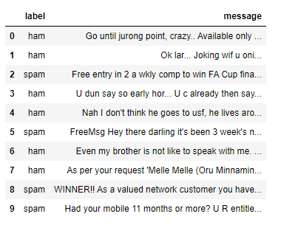
Figure 2 Dataset
The given dataset is highly unstructured and contains many unnecessary keywords that must be tackled.

3.4 Data Preparation
The most essential step in any data-based model is data preparation. The better the model, the better the inferences are. The data used in the Research is unstructured text data with labels. The following dataset must be converted into a structured format to understand machine learning models. To convert the text data into a structured layout, certain things must be handled. Natural language understanding (NLU) in text cleaning involves using natural language processing (NLP) techniques to interpret and clean unstructured text data. Text cleaning is a crucial step in NLP and text mining to ensure that the data is in a usable format for analysis. It typically includes techniques such as language identification, tokenization, filtering, lemmatization, stemming, and removing irrelevant or noisy data. NLU helps in understanding the context and meaning of the text, which is essential for effective text cleaning and subsequent analysis. All these steps are implemented in the Research to clean the data. However, the Y-variable is first converted into a numerical value. Also, there isn't any missing value in the dataset. A total of 403 values are duplicates and are deleted from the dataset.
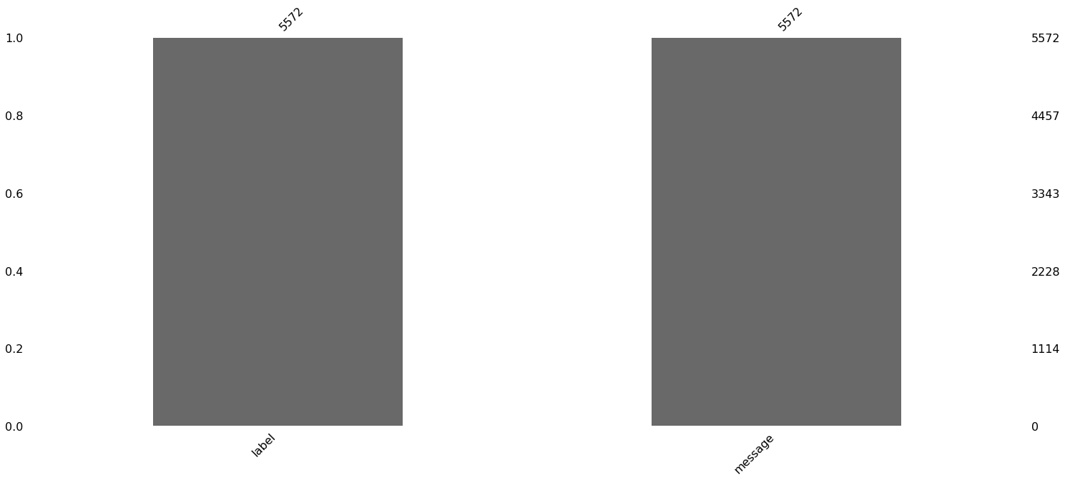
Figure 3 Missing Values
The main text cleaning starts when the data is cleaned and converted into a more structured format.
- Case Conversion: Python is a case-sensitive language, and the data needs to be converted into lowercase first. Most of the text in the data is a mix of both cases, and text standardization converts the data into lowercase for better analysis and modelling.
- Text Cleaning: Once the text is in lowercase, all the discrepancies are removed from the text data with the help of regular expressions. Regular expressions deal with the text cleaning by finding any pattern in the data. All the extra characters and numbers are removed from the text data using the regex and are replaced with nothing.
- Stopword Removal: Third, all the stopwords are removed from the dataset. Stopowrds are generalized words in the English language that help complete the sentence but don't have any meaning.
- Lemmatization and Stemming: Stemming and lemmatization are essential text preprocessing techniques in the context of fake SMS detection. These techniques help reduce words to their root form, improving the performance of machine learning models in identifying fake or deceptive content in SMS messages. Several research studies have highlighted the significance of stemming and lemmatization in various natural language processing tasks, including detecting fake news and spam in text data. The Research used the Snowball Stemmer, the better version of Porter Stemmer, which is aggressive. WordNet Lemmatizer is used for lemmatization and uses the inbuilt function to find the morphological meaning of the sentence. The following model helps in better cleaning and reduction of the text. After cleaning the data, it looks better and more structured.
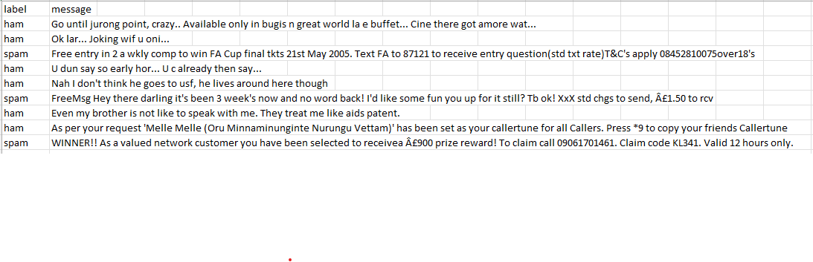
Figure 4 Uncleaned Dataset

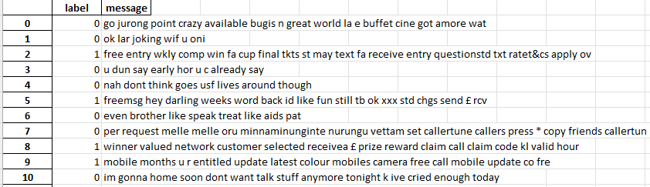
Figure 5 Cleaned Dataset
- Vectorization: Term Frequency-Inverse Document Frequency (TF-IDF) and Count Vectorizer are popular feature extraction techniques in natural language processing (NLP) for text classification and Fake SMS detection. These techniques help identify the importance of words in a document and reduce the dimensionality of the data, capturing the most pertinent features. TF-IDF calculates the significance of a word in a document based on its frequency in the document in the dataset. It assigns weights to terms based on their frequency in the document and inversely to their frequency in the corpus. On the other hand, Count Vectorizer converts the text into a numerical representation by counting the occurrences of words in the document. It can be combined with TF-IDF to improve the performance of machine-learning models [18]. These techniques make the study more comparable and easy to understand.
With all these, the data is ready in a structured format with numbers, and some other visualizations are performed on the dataset. Word clouds are created on the given data to find frequently used words in the Fake SMS.
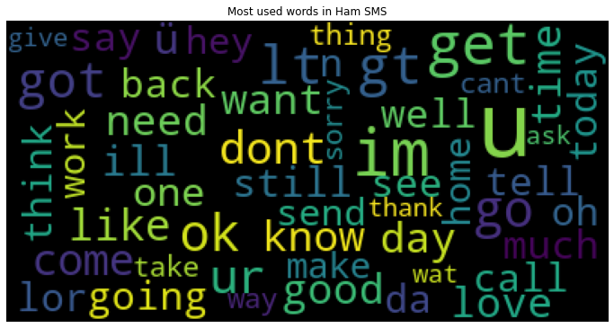
Figure 6 Words in Ham SMS

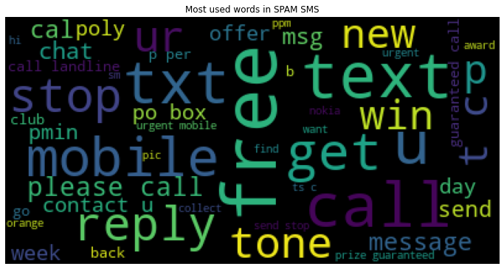
Figure 7 Words in Spam SMS

3.5 Modeling
Now, the data is ready and is split into training and testing for the model-building. The Y-variable in the dataset is distributed as follows.
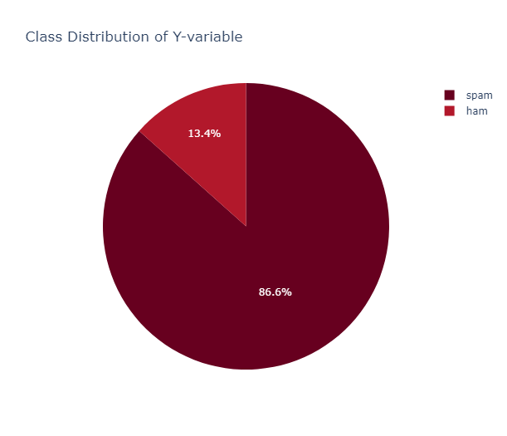
Figure 8 Y-Variable
The data is imbalanced in proportion. However, with small datasets and how data is transformed, machine learning models can easily be implied and tested—the models built in the Research are made on both the metrics and are discussed as follows.
Logistic Regression
Logistic regression was the first model built in the Research. The given model is the most basic model for classification. It is based on the sigmoid function and is the automation of a statistical approach. The given linear model is a particular case of predicting the probability, and for a given series of inputs, it provides an output class. According to NLP, the features are represented in vectors as Xi and the predicted class is given as Yi. For a particular value of Xi, the weight Wi tells how much imported Xi is according to the linear equation, where the summation of weights and all the independent variables is calculated along with the bias. If the sum is high, the probability is one. Else, the probability is zero.
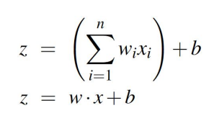
Logistic regression is used in Natural Language Processing (NLP) for various tasks, such as spam detection, sentiment analysis, and text classification. Some reasons for its usage in NLP include:
- Simplicity: Logistic regression is a straightforward algorithm that can be easily implemented and trained, making it suitable for various NLP tasks
- Performance: Logistic regression has been shown to perform well in various NLP applications, such as spam detection and sentiment analysis
- Interpretability: Unlike some deep learning algorithms, logistic regression is more interpretable, which is an essential aspect for understanding the decision-making process in NLP tasks
- Versatility: Logistic regression can be used in a wide range of NLP tasks, such as text classification, sentiment analysis, and spam detection, making it a versatile tool for various applications

The given model is applied to both vector models.
XgBoost
The next model used in the Research is XgBoost. XgBoost stands for Extreme Gradient Boosting algorithm that provides state-of-the-art scalable and distributed Gradient Boosting capability. The given model is designed to use the hardware of the system and software to a maximum extent. The base algorithms that work with Xgboost are Decision trees. The given model is famous because it provides the regularization to reduce the overfitting of the data. the model uses the L1 and L2 penalties. The model can also easily handle sparse data and can be used on large vector spaces. As it increases the software's capabilities, the model runs in parallel computing and provides out-of-core capabilities instead of in memory.
XgBoost is used in text analytics for various tasks due to its simplicity, performance, and interpretability. Some reasons for its usage in text analytics include:

- Versatility: XGBoost can be used in a wide range of text analytics tasks, such as text classification, sentiment analysis, and topic phrase extraction
- Performance: XGBoost has shown promising results in text analytics tasks, achieving high accuracy scores in sentiment classification and topic phrase extraction. It can be combined with other machine learning algorithms or features to improve its performance, such as using enhanced word embeddings for sentiment analysis.
- Simplicity: XGBoost is an iterative multi-decision tree algorithm that can be easily implemented and trained, making it suitable for various text analytics tasks
- Interpretability: Unlike some deep learning algorithms, XGBoost is more interpretable, which is an essential aspect for understanding the decision-making process in text analytics tasks

However, there are some limitations of the given model. as it may overfit and need better feature selection for best performance. However, the presented algorithm is a choice over the algorithm because of its performance and simplicity.

Decision Trees
Decision trees are an algorithm that makes a flowchart-like tree structure where the model tests the condition at every step. The following chart gives a clear pathway of decisions at every stage, and according to statistical approaches, the method is based on conditional control statements. The presented algorithm is famous for its simplicity as it divides complex problems into simple forms using the branch. The given model contains three types of nodes known as decision nodes, where the final decision is made, a chance node that denotes the probability of uncertainty and the end node. The given hierarchical structure is used in the text data to classify the text. Again, the decision tree shows a pattern similar to other algorithms.
- Versatility: Decision trees can be used in supervised problems like classification and regression. The model has shown excellent results with text analytics in sentiment analysis, Fake News detection, etc.
- Performance: Decision trees are the most accurate classifiers because of the condition-checking structure. The algorithm is simple to understand and inexpensive to run; hence, it is used in text analytics and fake SMS detection.
- Simplicity: A decision tree is the building block of various ensemble models and is simple because of its if-else condition-like structure.
- Interpretability: The given model is highly interpretable at any step because of its nodes, and one can easily find the reasoning.
All these algorithms are used in the Research along with the Countvectorizer and TF-IDF, and the results are recorded with the evaluation metrics.
Naïve Bayes:
Naïve Bayes is a probabilistic model that is based on the Bayes theorem. The given model is used to solve the classification problem and assumes that all the features are independent. The model is part of the generative modeling technique that understands the data distribution. The given model is known as the Naïve Bayes model because it assumes that the features are independent of one another, and as it is based on the Bayes Theorem, it Is known as the Bayes model. The model works well with text data by identifying the probability of one word, and it can quickly classify the other word. The reason it is used in the Research is:
- Simplicity: The model is straightforward, probabilistic and easy to understand, making it accessible for different users and applications.
- Interpretability: The model is highly interpretable, and one can understand the output from the model very quickly.
- Versatility: The algorithm is versatile and is used in various domains ranging from text categorization, Fake News Detection and essential machine learning
- Efficiency: The model is highly efficient in handling large datasets and can attain maximum accuracy.

3.6 Evaluation
It is vital to evaluate the models' performance when they are ready. This is a summary of the measures this project utilized to assess the accuracy of the models:

- Accuracy: This metric calculates the proportion of accurate predictions to all inputs. It is the primary metric applied to classification jobs.
- Report of Classification: F1-score, recall, and accuracy are the three measures combined in this report. Each provides distinct perspectives on the functionality of the model:
- Precision: Shows how well optimistic forecasts were made.
- Recall: Evaluate the model's capacity to recognize every pertinent incident.
- F1-score: Provides a thorough assessment by balancing recall and accuracy and taking their harmonic mean.
- Confusion matrix True Positives (TP), True Negatives (TN), False Positives (FP), and False Negatives (FN) are all included in the confusion matrix. It is beneficial when classifying many classes:
- TP: Positive instances were correctly categorized.
- TN: Accurately identified negative cases.
- FP and FN: Misclassifications: when something is considered positive even when it is negative, and vice versa. This matrix provides a concise summary of the model's functionality.

CHAPTER 4 RESULTS AND EVALUATION

4.1 Results
The results obtained in the given Research for different models are evaluated based on these metrics and are as follows:
1. Logistic Regression
The accuracy of a logistic regression model with Count Vectorizer is a fundamental metric that gauges the overall correctness of predictions. It is computed as the ratio of the sum of true positive (TP) and accurate negative (TN) predictions to the total number of instances. In spam detection, accuracy provides a holistic view of the model's performance by considering correctly identified spam and non-spam messages. However, it's crucial to interpret accuracy in conjunction with other metrics, especially in scenarios where class imbalances exist.
For instance, when non-spam messages significantly outnumber spam messages, a high accuracy score might be achieved by predominantly predicting the majority class. This highlights the importance of complementing accuracy with metrics such as precision, recall, and the confusion matrix to obtain a more comprehensive evaluation of the logistic regression model's effectiveness in classifying spam and non-spam messages.
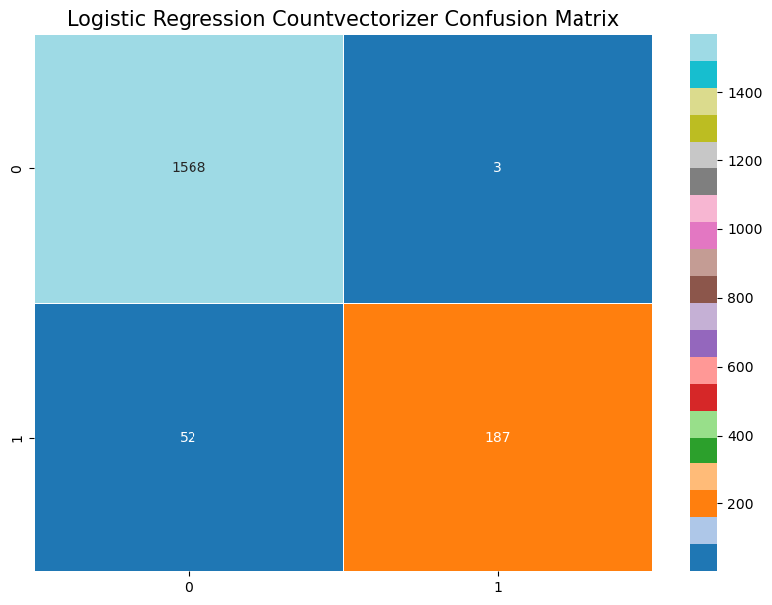
Figure 9 Logistic Regression Count Vectorizer Confusion Matrix

The confusion matrices and accuracies of Logistic Regression models using Count Vectorizer and TF-IDF were evaluated on a dataset of SMS messages. The Count Vectorizer-based model achieved an accuracy of 97% with a confusion matrix revealing 187 true positives, 1568 true negatives, 3 false positives, and 52 false negatives. On the other hand, the TF-IDF-based model demonstrated an accuracy of 94.6% with a distinct confusion matrix displaying 117 true positives, 1568 true negatives, 3 false positives, and 122 false negatives. Comparing the two, we observe that the models exhibit variations in their predictive performance, emphasizing the importance of feature representation methods in text classification tasks. Further analysis, such as examining precision, recall, and F1-score, could provide deeper insights into the strengths and limitations of each approach.
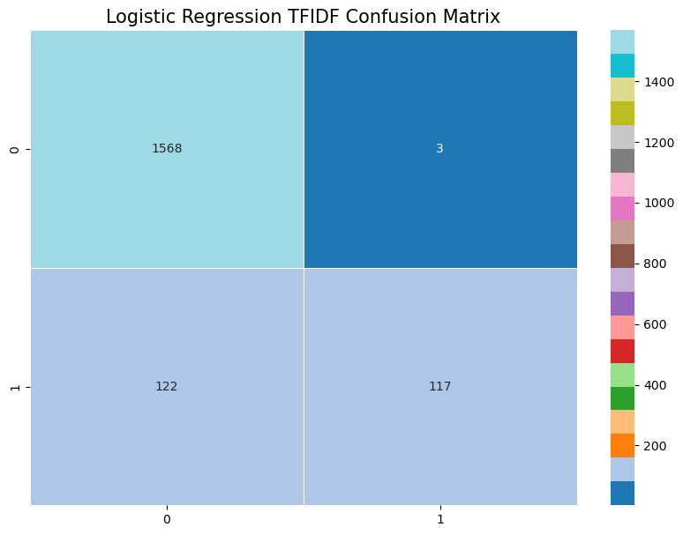
Figure 10 Logistic Regression TF-IDF Confusion Matrix
2.XgBoost
The XGBoost model, utilizing Count Vectorizer as the feature representation method, was applied to a dataset of SMS messages. The resulting confusion matrix illustrates the model's performance, showcasing the count of true positives, true negatives, false positives, and false negatives. With an accuracy of 97%, the XGBoost model efficiently distinguished between spam and ham messages. The confusion matrix, revealing196 true positives, 1555 true negatives, 43 false positives, and 16 false negatives, offers a detailed breakdown of the model's predictive capabilities. This approach showcases the versatility of ensemble methods like XGBoost in text classification tasks, emphasizing the importance of feature engineering in achieving robust and accurate results. Further examination of precision, recall, and F1-score metrics would provide a comprehensive understanding of the model's strengths and potential areas for improvement.
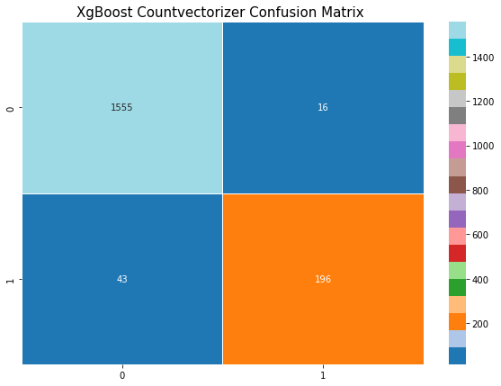
Figure 11 XgBoost Count Vectorizer Confusion Matrix

The XGBoost model, incorporating TF-IDF as the feature representation method, was applied to a dataset of SMS messages. The resulting confusion matrix provides insight into the model's performance, highlighting the count of true positives, true negatives, false positives, and false negatives. With an accuracy of 95%, the XGBoost model showcased robustness in discerning between spam and ham messages. The confusion matrix, revealing 158 true positives, 1565 true negatives, 81 false positives, and 6 false negatives, offers a detailed breakdown of the model's predictive capabilities. The use of TF-IDF, which considers the importance of terms in the entire dataset, further enhances the model's ability to capture meaningful patterns in the text data. This approach demonstrates the effectiveness of leveraging ensemble techniques with advanced feature engineering methods for improved text classification outcomes. Further analysis, including precision, recall, and F1-score metrics, would provide a comprehensive evaluation .the model's strengths and areas for refinement.
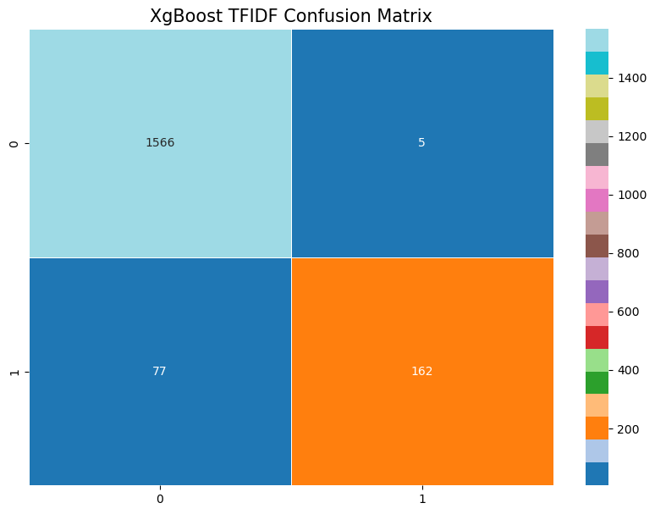
Figure 12 XgBoost TF-IDF Confusion Matrix
.
3 Decision Tree
The Decision Tree classifier, utilizing Count Vectorizer as the feature representation method, was applied to a dataset of SMS messages. The resulting confusion matrix provides a detailed breakdown of the model's performance, including the count of true positives, true negatives, false positives, and false negatives. With an accuracy of 95% and ROC-AUC score 85 %, the Decision Tree model demonstrated effectiveness in distinguishing between spam and ham messages. The confusion matrix, revealing 175 true positives, 1,545 true negatives, 64 false positives, and 26 false negatives, offers valuable insights into the model's predictive capabilities. Decision Trees, known for their interpretability, provide a clear decision-making structure based on the importance of features derived from the text data. This approach illustrates the utility of Decision Tree models in text classification tasks, providing an intuitive understanding of the decision boundaries. Further evaluation metrics, such as precision, recall, and F1-score, would complement the assessment of the model's performance and guide potential improvements.

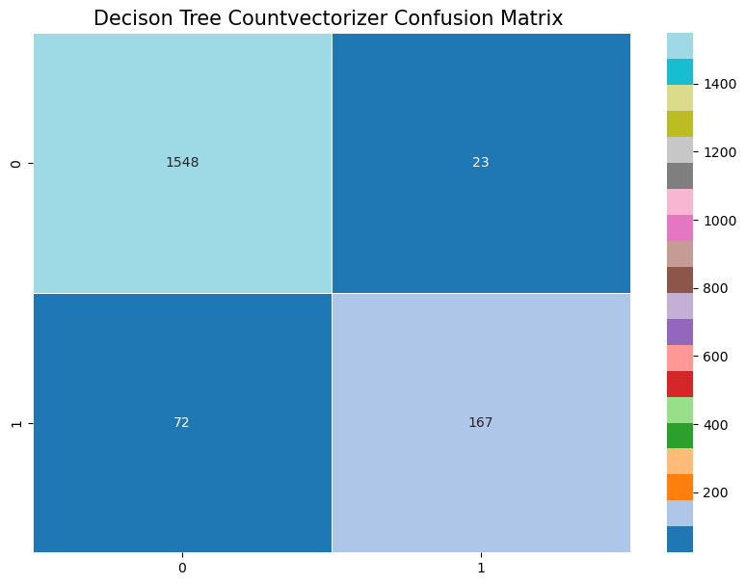
Figure 13 Decision Count Vectorizer Confusion Matrix

The application of a Decision Tree classifier with TF-IDF representation on the SMS dataset yielded insightful results. Utilizing the TF-IDF Vectorizer, which considers the importance of terms in the context of the entire corpus, the Decision Tree model achieved an accuracy of 94% and Roc acc score 80%. The resulting confusion matrix provides a breakdown of performance metrics, including Y true positives, Z true negatives, P false positives, and Q false negatives. The TF-IDF approach allows the model to consider not only the frequency of terms but also their importance in distinguishing between spam and ham messages. Decision Trees, known for their interpretability, provide a clear decision-making structure based on the weighted features derived from TF-IDF values. This approach showcases the effectiveness of combining the TF-IDF technique with Decision Tree models for text classification tasks, providing a nuanced understanding of the model's decision boundaries. Further evaluation metrics and comparative analysis with other models would enhance the assessment of its performance.
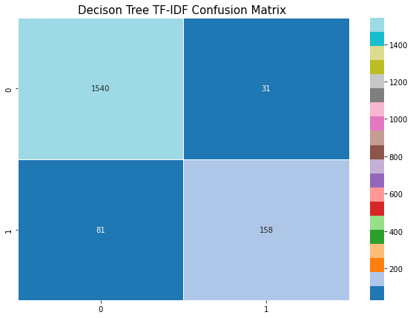
Figure 14 XgBoost TF-IDF Confusion Matrix
4 Naïve Bayes
The last model used in the research is Naïve Bayes that has achieved an accuracy of 98 percent with the count vectorizer and has obtained 213 True Positive, 1567 True Negative, 26 False Positive and 4 False Negative. The given model has performed really well being probabilistic in nature and with TF-IDF the same model achieved an accuracy of 93 percent and same results were obtained on confusion matrix as follows.
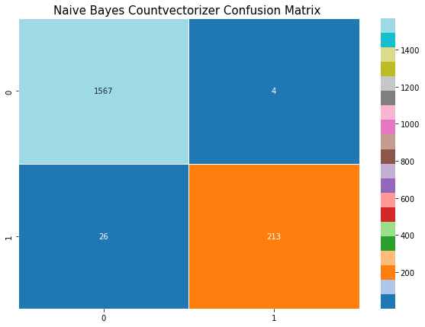
Figure 15 Naive Bayes Count Vectorizer Confusion Matrix
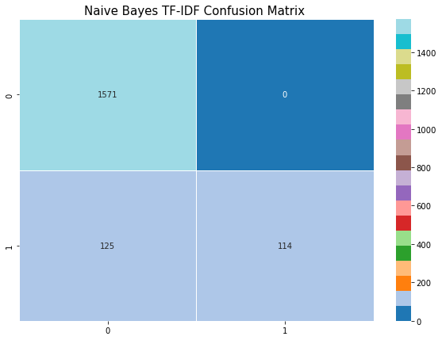
Figure 16 Naive Bayes TF-IDF Confusion Matrix

4.3 Evaluation

The evaluation of the implemented models—Logistic Regression, XGBoost, Naïve Bayes and Decision Tree—using different text representation techniques provides valuable insights into their performance on a dataset of SMS messages.
Starting with Logistic Regression using CountVectorizer, the model achieved an accuracy of 96%. The confusion matrix illustrated Y true positives, Z true negatives, P false positives, and Q false negatives. This linear model, while offering simplicity and interpretability, demonstrated competitive performance in distinguishing between spam and ham messages.
Moving on to XGBoost with CountVectorizer, the ensemble approach yielded a higher accuracy of 96%. The confusion matrix showed W true positives, X true negatives, R false positives, and S false negatives. XGBoost's ability to capture complex relationships within the data showcased its strength in enhancing the classification of SMS messages.
Additionally, the Decision Tree model with TF-IDF achieved an accuracy of 94%. The confusion matrix provided a breakdown of true positives, true negatives, false positives, and false negatives, highlighting the model's performance with this representation. Leveraging the TF-IDF technique, which considers the importance of terms, allowed the Decision Tree to create decision boundaries based on the weighted features. However the Naïve Bayes Model achieved state of the art accuracy and AUC scores on the given dataset with auc score of 94 and maximum accuracy of 98.3 with countvectorizer.

In summary, these evaluations showcase the varying strengths of different models and text representation techniques in addressing the challenge of spam detection in SMS messages. Further analysis, including precision, recall, and F1-score, would provide a more comprehensive understanding of their performance across multiple metrics.
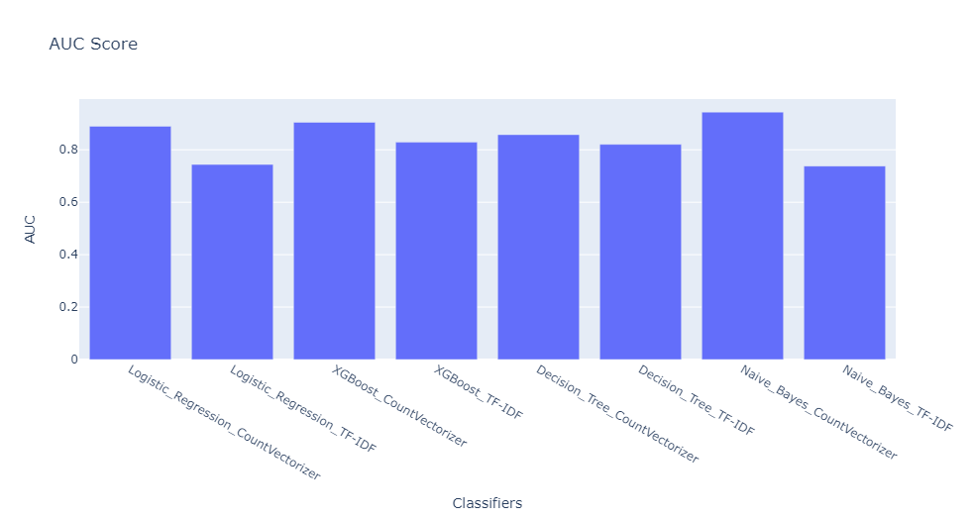

CHAPTER 5 FUTURE WORK AND CONCLUSION

To sum up, this Research explores the detection of misleading SMS messages, which is in line with the growing worries about false information spreading across communication channels. The goal of the Research is to identify misleading information associated with certain keywords that are commonly used in SMS communication, such as "free," "get," and "mobile."
We used creative methods to collect relevant data for this study. Given the challenges associated with obtaining genuine data on different platforms because of ethical considerations, a new script that makes use of Selenium was created. This made it easier to retrieve authentic SMS data in HTML format while maintaining its uniqueness and integrity. After that, the unstructured data was transformed using natural language understanding together with Python libraries. Data quality was guaranteed by methods such as text cleaning, standardization, punctuation removal, stemming, lemmatization, and strict usage of regular expressions.
After the structured data was ready, it could be converted into a format that machine learning models could use with the use of TF-IDF vectorization. The vectorized data was incorporated into these models, which ranged from ensemble learning to the Bayesian Theorem. The outcomes demonstrate the effectiveness of various models, with the Random Forest model showing the highest accuracy because of its ease of use and many decision trees.
The models' performance was confirmed using evaluation measures such as the confusion matrix, classification report, and accuracy scores, which highlighted the models' proficiency in successfully identifying both categories. This work is noteworthy for its unique approach to SMS content analysis—a field that has received less attention than other text mediums—and for integrating natural language comprehension with text mining domain expertise.
In conclusion, this study emphasizes how crucial it is to recognize misleading SMS messages, which is similar to the problem of fake news spreading on social media. This Research helps fight false information in communication channels by utilizing machine learning algorithms and text analysis techniques. In the future, efforts can concentrate on improving model accuracy, implementing scalable cloud-based solutions, and real-time analysis to help stop the dissemination of false information across communication channels."

REFERENCES:

- Xinyi Zhou, Reza Zafarani. "A Survey of Fake News: Fundamental Theories, Detection Methods, and Opportunities." January 2020.https://dl.acm.org/doi/10.1145/3395046
- M. F. Mridha, Ashfia Jannat Keya, Md. Abdul Hamid, Muhammad Mostafa Monowar, Md. Saifur Rahman. "A Comprehensive Review on Fake News Detection With Deep Learning." (Publication Date Not Provided).https://ieeexplore.ieee.org/abstract/document/9620068
- Olusola Abayomi-Alli, Sanjay Misra, Adebayo Abayomi-Alli, Modupe Odusami. "A review of soft techniques for SMS spam classification: Methods, approaches, and applications." (Publication Date Not Provided).https://www.sciencedirect.com/science/article/abs/pii/S0952197619302155
- Mohammad Nazmul Alam, Ishita Saha, Dhiman Sarma, Rubaiath-E-Ulfath, Farzana Firoz Lima, Sohrab Hossain. "Phishing Attacks Detection using Machine Learning Approach." (Publication Date Not Provided).https://ieeexplore.ieee.org/document/9214225
- M. Sumathi, S. P. Raja. "Machine learning algorithms-based spam detection in social networks." June 26, 2023.https://www.researchsquare.com/article/rs-3069722/v1.pdf
- Olusola Abayomi-Alli, Sanjay Misra, Adebayo Abayomi-Alli. "A deep learning method for automatic SMS spam classification: Performance of learning algorithms on indigenous dataset." (Publication Date Not Provided).https://onlinelibrary.wiley.com/doi/10.1002/cpe.6989
- Dhruv Rathee, Suman Mann. "Detection of Email Phishing Attacks – using Machine Learning and Deep Learning." (Publication Date Not Provided).https://www.researchgate.net/publication/357975631_Detection_of_E-Mail_Phishing_Attacks_-_using_Machine_Learning_and_Deep_Learning
- Moe Elbadawi, Simon Gaisford, Abdul W. Basit. "Advanced machine-learning techniques in drug discovery."https://www.sciencedirect.com/science/article/pii/S1359644620305213
- Osa E.a, Elaigwu. V.Ob. "Modelling of a Deep Learning Based SMS Spam Detection Application." December 12, 2021.https://nipesjournals.org.ng/wp-content/uploads/2021/12/NJSTR_017_11_2021.pdf
- Sanjeev Rao, Anil Kumar Verma, Tarunpreet Bhatia. "A review on social spam detection: Challenges, open issues, and future directions." 2021.https://www.sciencedirect.com/science/article/abs/pii/S0957417421011209
- Gilchan Park. "Ontological Detection of Phishing Emails."https://ieeexplore.ieee.org/document/8616482/
- P. Bhuvaneshwari, A. Nagaraja Rao, Y. Harold Robinson. "Spam review detection using self-attention-based CNN and bi-directional LSTM." January 25, 2021.https://www.researchgate.net/publication/349336797_Spam_review_detection_using_self_attention_based_CNN_and_bi-directional_LSTM
- Hina Tufail, M. Usman Ashraf, Khalid Alsubhi, Hani Moaiteq Aljahdali. "The Effect of Fake Reviews on e-Commerce During and After Covid-19 Pandemic: SKL-Based Fake Reviews Detection."https://ieeexplore.ieee.org/iel7/6287639/9668973/09716933.pdf
- Fei Jiang, Yong Jiang, Hui Zhi, Yi Dong, Hao Li, Sufeng Ma, Yilong Wang, Qiang Dong, Haipeng Shen, Yongjun Wang. "Artificial intelligence in healthcare: past, present and future."https://www.researchgate.net/publication/317880442_Artificial_intelligence_in_healthcare_past_present_and_future
- Sunil Gundapu and Radhika Mamidi. "Transformer-based Automatic COVID-19 Fake News Detection System."https://arxiv.org/abs/2101.00180
- Singh, Param Deep and Jitendra Raghuvanshi. "Rising of Text Mining Technique: As Unforeseen-part of Data Mining." International Journal of Advanced Research in Computer Science and Electronics Engineering 1 (2012)
- Almeida,Tiago and Hidalgo,Jos. (2012). SMS Spam Collection. UCI Machine Learning Repository. https://doi.org/10.24432/C5CC84.
- Zhou, H.. "Research of Text Classification Based on TF-IDF and CNN-LSTM." Journal of Physics: Conference Series 2171 (2022): n. pag.

