**NETWORKING & SYSTEM ADMINISTRATION LAB**

**Name: ATHUL VINAYAKUMAR**

**Roll No: 5**

**Batch: MCA B**

**Date:05/05/22**

**Experiment No.: 11**

**Aim**

Write a shell script to print the largest of three numbers.

**Procedure**

#!/bin/bash

echo "Enter the first number"

read num1

echo "Enter the second number"

read num2

echo "Enter the third number"

read num3

if [ $num1 -gt $num2 -o $num1 -gt $num3 ]

then

echo $num1 "is greater"

elif [ $num2 -gt $num3 ]

then

echo $num2 "is greater"

else

echo $num3 "is greater"

fi

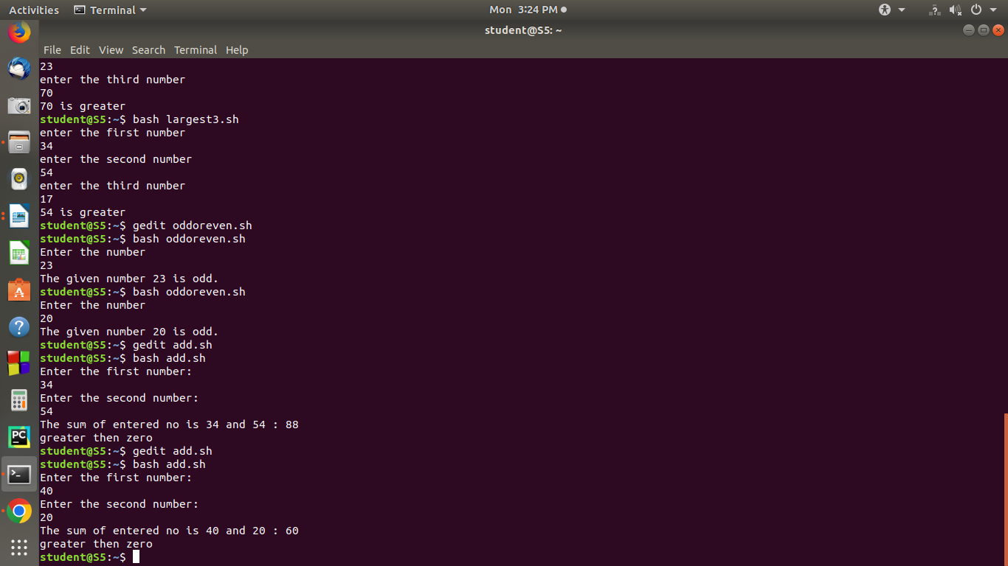**Output Screenshot**