**NETWORKING & SYSTEM ADMINISTRATION LAB**

**Name: ATHUL VINAYAKUMAR**

**Roll No: 5**

**Batch: MCA B**

**Date:05/05/22**

**Experiment No.: 12**

**Aim**

Write a shell script to check whether the given number is even or odd.

**Procedure**

#!/bin/bash

echo "Enter the number"

read num

if [ $sum %2 == 0 ]

then

echo "The given number" $num "is even."

else

echo "The given number" $num "is odd."

fi

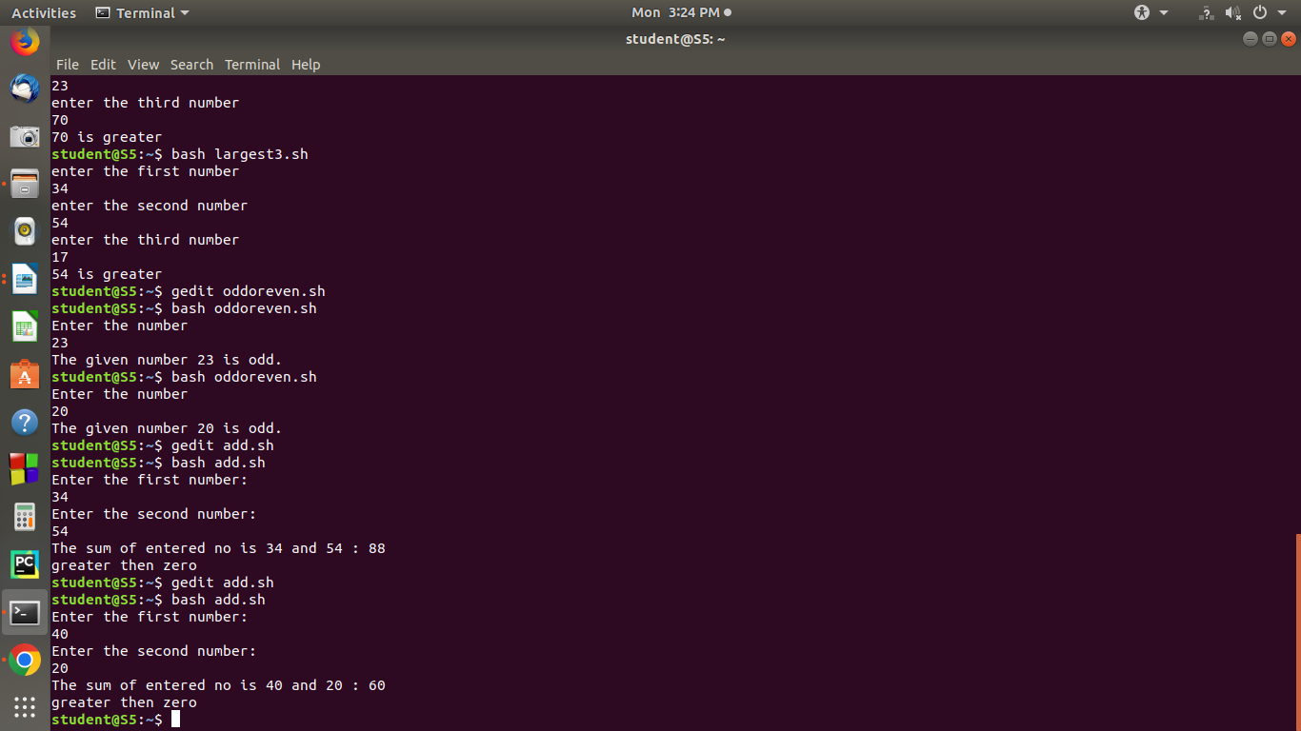**Output Screenshot**