**NETWORKING & SYSTEM ADMINISTRATION LAB**

**Name: ATHUL VINAYAKUMAR**

**Roll No: 5**

**Batch: MCA B**

**Date:09/05/22**

**Experiment No.: 15**

**Aim**

Write a shell script to find the sum of first 10 numbers.

**Procedure**

#!\bin\bash

echo "Enter the limit :"

read limit

sum=0

echo "Enter the number:"

for ((i=1;i<=limit;i++))

do

read num

sum=$((sum+num))

done

echo "sum is" $sum

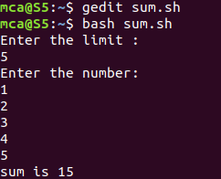**Output Screenshot**