**NETWORKING & SYSTEM ADMINISTRATION LAB**

**Name: ATHUL VINAYAKUMAR**

**Roll No: 5**

**Batch: MCA B**

**Date:09/05/22**

**Experiment No.: 19**

**Aim**

Write a shell script to check it is leap year or not.

**Procedure**

echo "Enter the year"

read leap

if [ `expr $leap % 400` -eq 0 ]

then

echo leap year

elif [ `expr $leap % 100` -eq 0 ]

then

echo not a leap year

elif [ `expr $leap % 4` -eq 0 ]

then

echo leap year

else

echo not a leap year

fi

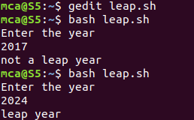**Output Screenshot**