**NETWORKING&SYSTEM ADMINISTRATION LAB**

**Name: ATHUL VINAYAKUMAR**

**Roll No: 5 Batch: MCA B**

**Date: 21-04-2022**

**Experiment No.: 7**

**Aim**

Familiarization of Linux Commands

**Procedure**

1. **read**

To read the content of a line to a variable

**Syntax :**

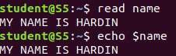

1. **locate**

The Locate command is used to find the files by name

1. **locate -i**

The locate -i command is used for display the file name that is in both capital and small letters

**Syntax :**

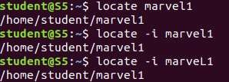

1. **find**

The find command is used to search and locate the list of files and directories based on conditions you specify for files that match the argument.

**Syntax :**



1. **grep**

The grep command will let you search through all the text in a given file.

**Syntax :**



1. **grep -A1**

To display the line after the result.

**Syntax :**



1. **grep -B1**

To display the line before the result.

**Syntax :**



1. **grep -C1**

To display both the line before and after the result.

**Syntax :**

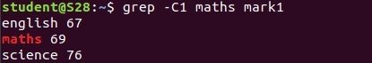

1. **grep -i**

This command is used for an case insesitive search

**Syntax :**



1. **grep -v**

This command is used for an inverted search (it excluding the line that contains the particular word)

**Syntax :**

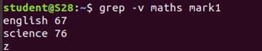

1. **df**

The df command is used to get a report on system disk space usage.

**Syntax :**

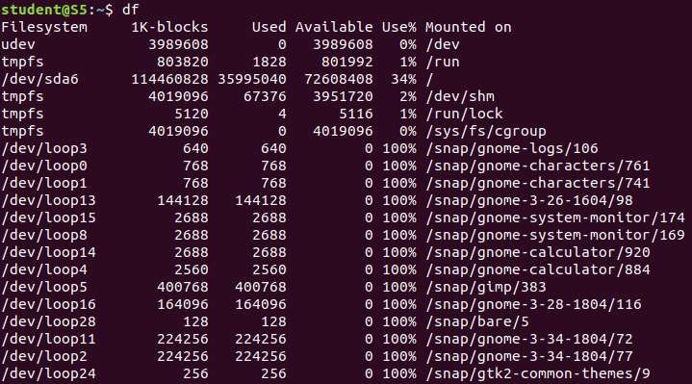

1. **df -m**

This command is used to see the reports in mega bytes.

**Syntax :**

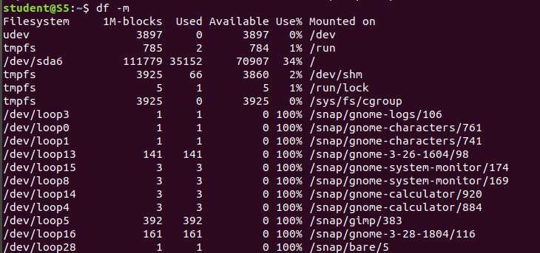

1. **du**

This command is used to check how much space a file or directory takes.

**Syntax :**

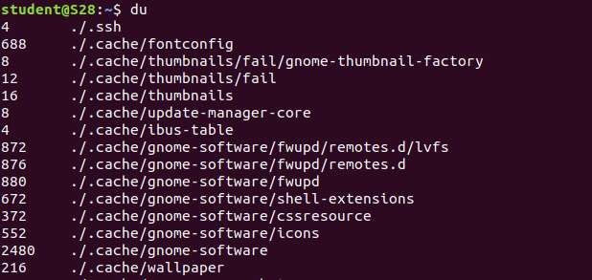

1. **wc**

This command is used for counting purpose, it is used to find the number of lines, the number of words, the number of characters and the number of bytes.

1. **wc -w**

This command is used for finding the number of words.

1. **wc -m**

This command is used for finding the number of bytes.

1. **wc -l**

This command is used for finding the number of lines.

1. **wc -c**

This command is used for finding the number of characters.

