**NETWORKING & SYSTEM ADMINISTRATION LAB**

**Name: ATHUL VINAYAKUMAR**

**Roll No: 5**

**Batch: MCA B**

**Date:05/05/22**

**Experiment No.: 9**

**Aim**

Write a shell script to print the sum of two numbers.

**Procedure**

#!bin/bash

echo "Enter the first number:"

read num1

echo "Enter the second number:"

read num2

sum=$(($num1+$num2))

echo "The sum of entered no is" $num1 "and" $num2 ":" $sum

if [ $sum -ge 0 ]

then

echo "greater then zero"

else

echo "less than zero"

fi

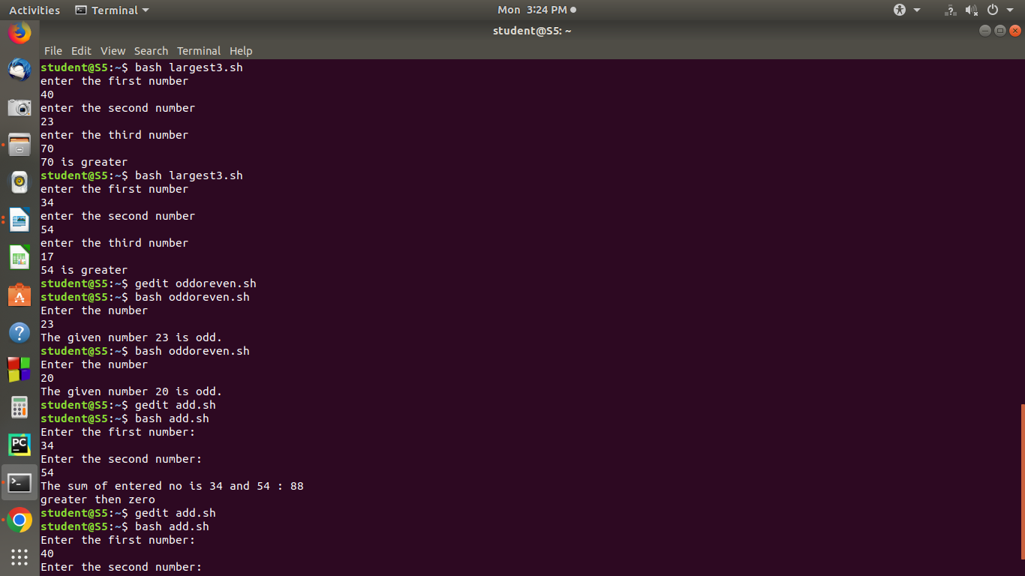**Output Screenshot**