ACTIVITY MAIN.XML

<RelativeLayout android:layout_width="match_parent"
xmlns:android="http://schemas.android.com/apk/res/android"
android:layout_height="match_parent">
<TextView
android:id="@+id/tv1"
android:layout_width="wrap_content"
android:layout_height="wrap_content"
android:text="Name:"
android:textSize="20dp"
android:textStyle="bold"
/>
<EditText
android:layout_width="wrap_content"
android:layout_height="wrap_content"
android:hint="name"
android:layout_marginLeft="100dp"
android:id="@+id/et1"/>
<TextView
android:id="@+id/tv2"
android:layout_width="wrap_content"
android:layout_height="wrap_content"
android:text="Email:"
android:textSize="20dp"
android:textStyle="bold"
android:layout_below="@+id/et1"
/>
<EditText
android:layout_width="wrap_content"
android:layout_height="wrap_content"
android:hint="email"
android:id="@+id/et2"
android:layout_marginLeft="100dp"
android:layout_below="@+id/et1"/>
<TextView
android:id="@+id/tv3"
android:layout_width="wrap_content"
android:layout_height="wrap_content"
android:text="Password:"
android:textSize="20dp"
android:textStyle="bold"
android:layout_below="@+id/et2"
/>
<EditText
android:layout_width="wrap_content"
android:layout_height="wrap_content"
android:hint="password"
android:id="@+id/et3"
android:layout_marginLeft="100dp"
android:layout_below="@+id/et2"/>
<TextView
android:layout_width="wrap_content"
android:layout_height="wrap_content"
android:text="Language Known:"
android:textSize="20dp"
android:textStyle="bold"
android:id="@+id/tv4"
android:layout_below="@+id/et3"
/>
<LinearLayout
android:layout_width="wrap_content"
android:layout_height="wrap_content"
android:orientation="horizontal"
android:layout_margin="10dp"
android:layout_below="@+id/tv4"
android:id="@+id/l1">
<CheckBox
android:layout_width="wrap_content"
android:layout_height="wrap_content"
android:text="hindi"/>
<CheckBox
android:layout_width="wrap_content"
android:layout_height="wrap_content"
android:text="english"/>
<CheckBox
android:layout_width="wrap_content"
android:layout_height="wrap_content"
android:text="others"/>
</LinearLayout>
<TextView
android:layout_width="wrap_content"
android:layout_height="wrap_content"
android:text="Gender:"
android:textSize="20dp"
android:textStyle="bold"
android:id="@+id/tv5"
android:layout_below="@+id/l1"
/>
<RadioGroup
android:layout_width="wrap_content"
android:layout_height="wrap_content"
android:layout_below="@+id/tv5"
android:orientation="horizontal">
<RadioButton
android:layout_width="wrap_content"
android:layout_height="wrap_content"
android:id="@+id/r1"
android:text="male"/>
<RadioButton
android:layout_width="wrap_content"
android:layout_height="wrap_content"
android:id="@+id/r2"
android:text="female"/>
</RadioGroup>
<LinearLayout
android:layout_width="wrap_content"
android:layout_height="wrap_content"
android:orientation="horizontal"
android:layout_below="@+id/l1">
<Button
android:layout_width="wrap_content"
android:layout_height="wrap_content"
android:text="Cancel"
android:layout_marginTop="100dp"/>
<Button
android:layout_width="wrap_content"
android:layout_height="wrap_content"
android:text="Register"
android:onClick="register"
android:layout_marginTop="100dp"
/>
</LinearLayout>
</RelativeLayout>

MAIN ACTIVITY.JAVA

package com.example.sjcet.validation;
import android.content.Intent;
import android.support.v7.app.AppCompatActivity;
import android.os.Bundle;
import android.view.View;
import android.widget.EditText;
import android.widget.Toast;
public class MainActivity extends AppCompatActivity {
EditText nameedt;
EditText emailedt;
EditText passedt;
protected void onCreate(Bundle savedInstanceState) {
super.onCreate(savedInstanceState);
setContentView(R.layout.activity_main);
}
public void register(View view) {
nameedt=(EditText)findViewById(R.id.et1);
emailedt=(EditText)findViewById(R.id.et2);
passedt=(EditText)findViewById(R.id.et3);
String userName = nameedt.getText().toString();
String password = emailedt.getText().toString();
if(checkAll()){
Intent i= new Intent(getApplicationContext(),Main2Activity.class);
startActivity(i);
}
else{
Toast.makeText(this, "login failed", Toast.LENGTH_SHORT).show();
}
}
private boolean checkAll(){
if (nameedt.length() == 0){
nameedt.setError("This field is required");
return false;
}
if(emailedt.length() == 0 ){
emailedt.setError("This field required");
return false;
}
if(passedt.length() == 0 ){
passedt.setError("This field required");
return false;
}
return true;
}
}

MAIN2ACTIVITY.JAVA

<?xml version="1.0" encoding="utf-8"?>
<android.support.constraint.ConstraintLayout xmlns:android="http://schemas.android.com/apk/res/android"
xmlns:app="http://schemas.android.com/apk/res-auto"
xmlns:tools="http://schemas.android.com/tools"
android:layout_width="match_parent"
android:layout_height="match_parent"
tools:context=".Main2Activity">
</android.support.constraint.ConstraintLayout>

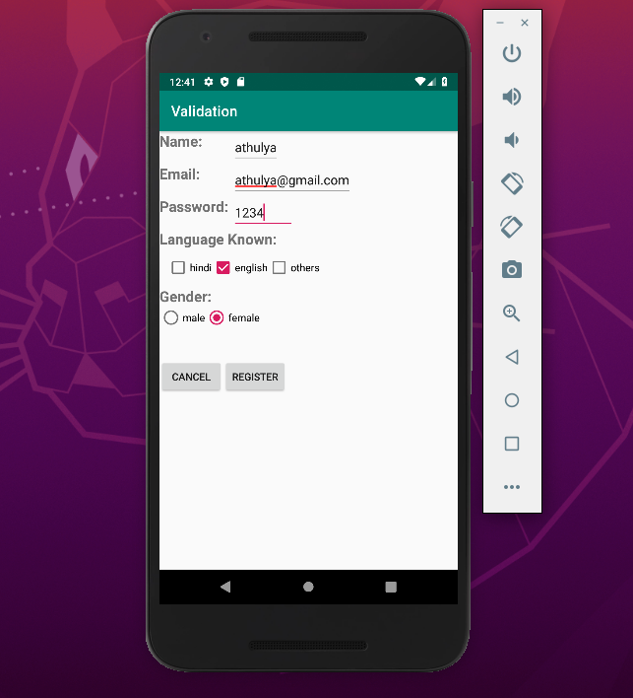
OUTPUT

