Mainactivity.xml

<RelativeLayout android:layout_width="match_parent"
xmlns:android="http://schemas.android.com/apk/res/android"
android:layout_height="match_parent"
android:background="#3b5998"
android:orientation="vertical">

<ImageView
android:layout_width="300dp"
android:layout_height="80dp"
android:layout_gravity="center"

android:src="@drawable/logo"
android:id="@+id/im1"
android:layout_marginLeft="60dp"
android:layout_marginTop="60dp"
android:layout_marginRight="20dp"
/>

<!--EditText for user name or email address-->
<EditText
android:layout_width="match_parent"
android:layout_height="wrap_content"
android:layout_marginLeft="20dp"
android:layout_marginTop="80dp"
android:layout_marginRight="20dp"
android:backgroundTint="#d3d3d3"
android:hint="Username or Email"
android:inputType="textEmailAddress"
android:maxLines="1"
android:padding="10dp"
android:textColor="#ffffff"
android:textColorHint="#d3d3d3"
android:id="@+id/ed1"
android:layout_below="@+id/im1"/>

<!--EditText for user password-->
<EditText
android:layout_width="match_parent"
android:layout_height="wrap_content"
android:layout_marginLeft="20dp"
android:layout_marginTop="10dp"
android:layout_marginRight="20dp"
android:backgroundTint="#d3d3d3"
android:hint="Password"
android:inputType="textPassword"
android:maxLines="1"
android:padding="10dp"
android:textColor="#ffffff"
android:textColorHint="#d3d3d3"
android:id="@+id/ed2"
android:layout_below="@+id/ed1"/>

<!-- Login Button for Facebook Log In-->
<Button
android:id="@+id/btnLogin"
android:layout_width="match_parent"
android:layout_height="wrap_content"
android:layout_marginLeft="20dp"
android:layout_marginTop="35dp"
android:layout_marginRight="20dp"
android:backgroundTint="#5c6bc0"
android:padding="10dp"
android:text="Log In"
android:textColor="#ffffff"
android:textSize="16sp"
android:textStyle="bold"
android:layout_below="@+id/ed2"/>
</RelativeLayout>

Mainactivity.java

package com.example.sjcet.facebook;

import android.support.v7.app.AppCompatActivity;
import android.os.Bundle;

public class MainActivity extends AppCompatActivity {

@Override
protected void onCreate(Bundle savedInstanceState) {
super.onCreate(savedInstanceState);
setContentView(R.layout.activity_main);
}
}

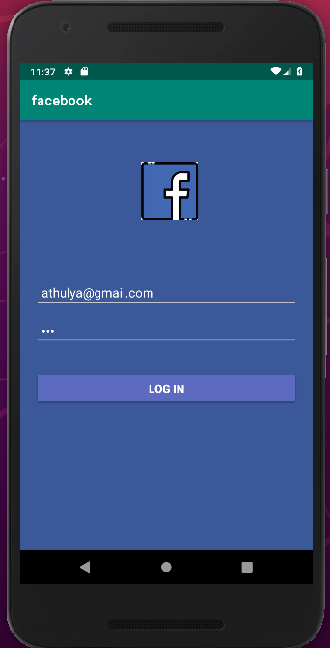
OUTPUT

