CLOUD SECURITY PBL
UNIT 2 — Evidence & Explanation Report
IAM & Least Privilege Enforcement

Student Details
Name: Atharva Pawar
Registration No.: 2124UCSM1004
Email: raosaheb.atharva24@sanjivani.edu.in

Included Evidence
- PBL-Admins, PBL-Developers and PBL-Auditors groups
- Administrator group-based permissions
- Developer and Auditor least-privilege policies
- EC2-to-S3 IAM role and instance profile
- Admin MFA device assignment evidence

Submission Status
MFA device assignment for pbl-terraform-admin is now included.
If the instructor requires policy-level deny-without-MFA enforcement, that separate policy evidence is not shown in the supplied screenshots.

Prepared from the supplied project evidence. No university name included.

No. | Evidence | Purpose / Section | Status
1 | Initial Admin Group Creation | Unit 2 → IAM Groups | Current evidence
2 | IAM Groups — Admins, Auditors and Developers | Unit 2 → IAM Groups | Current evidence
3 | IAM Users | Unit 2 → IAM Users | Current evidence
4 | Terraform Administrator User | Unit 2 → Admin User / Group-Based Permissions | Current evidence
5 | Auditor and Developer Least-Privilege Policies | Unit 2 → Least-Privilege Policies | Current evidence
6 | Developer, EC2-S3 Policies and EC2 Role | Unit 2 → Custom Policies and EC2 Role | Current evidence
7 | EC2 Role Policy Attachments | Unit 2 → EC2 IAM Role | Current evidence
8 | EC2 Role Policy Attachments — Duplicate Evidence | Unit 2 → EC2 IAM Role | Duplicate/reference
9 | Least-Privilege Policy Plan — Reference Copy | Unit 2 → Least-Privilege Policies | Duplicate/reference
10 | Custom IAM Policy Plan — Reference Copy | Unit 2 → Custom Policies | Duplicate/reference

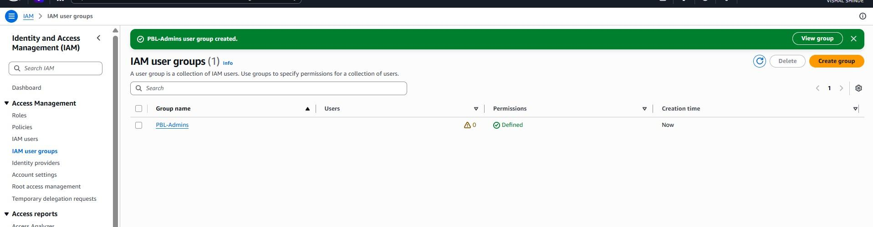
Figure 1: Initial Admin Group Creation.

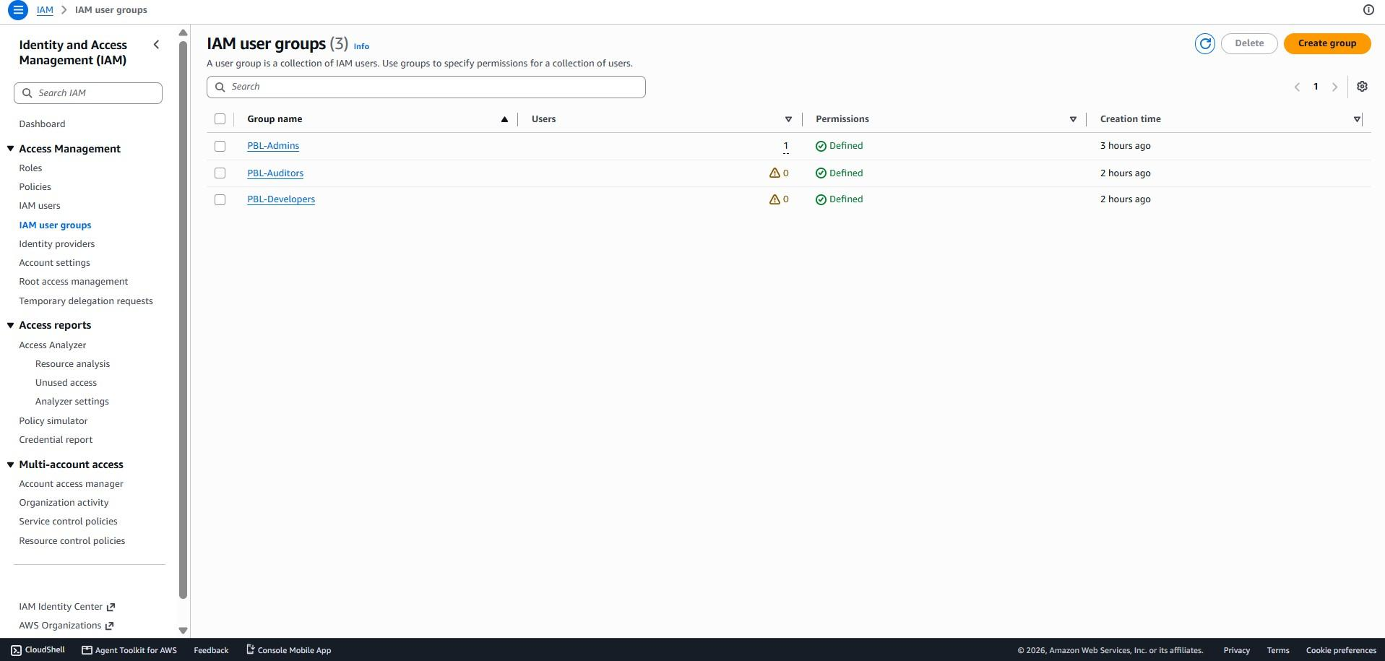
Figure 2: IAM Groups — Admins, Auditors and Developers.

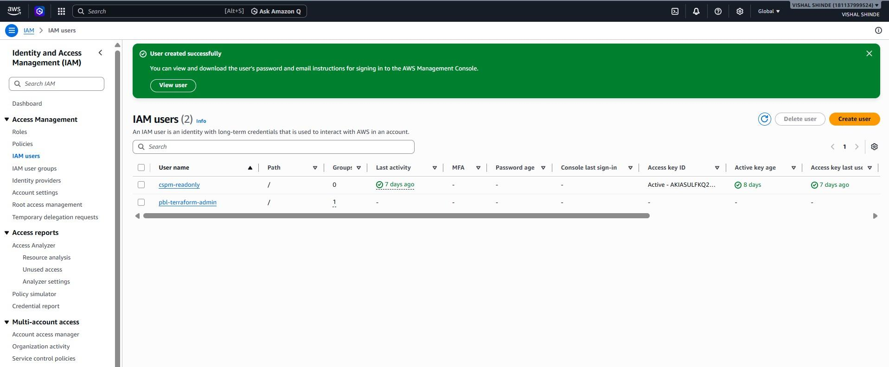
Figure 3: IAM Users.
group.
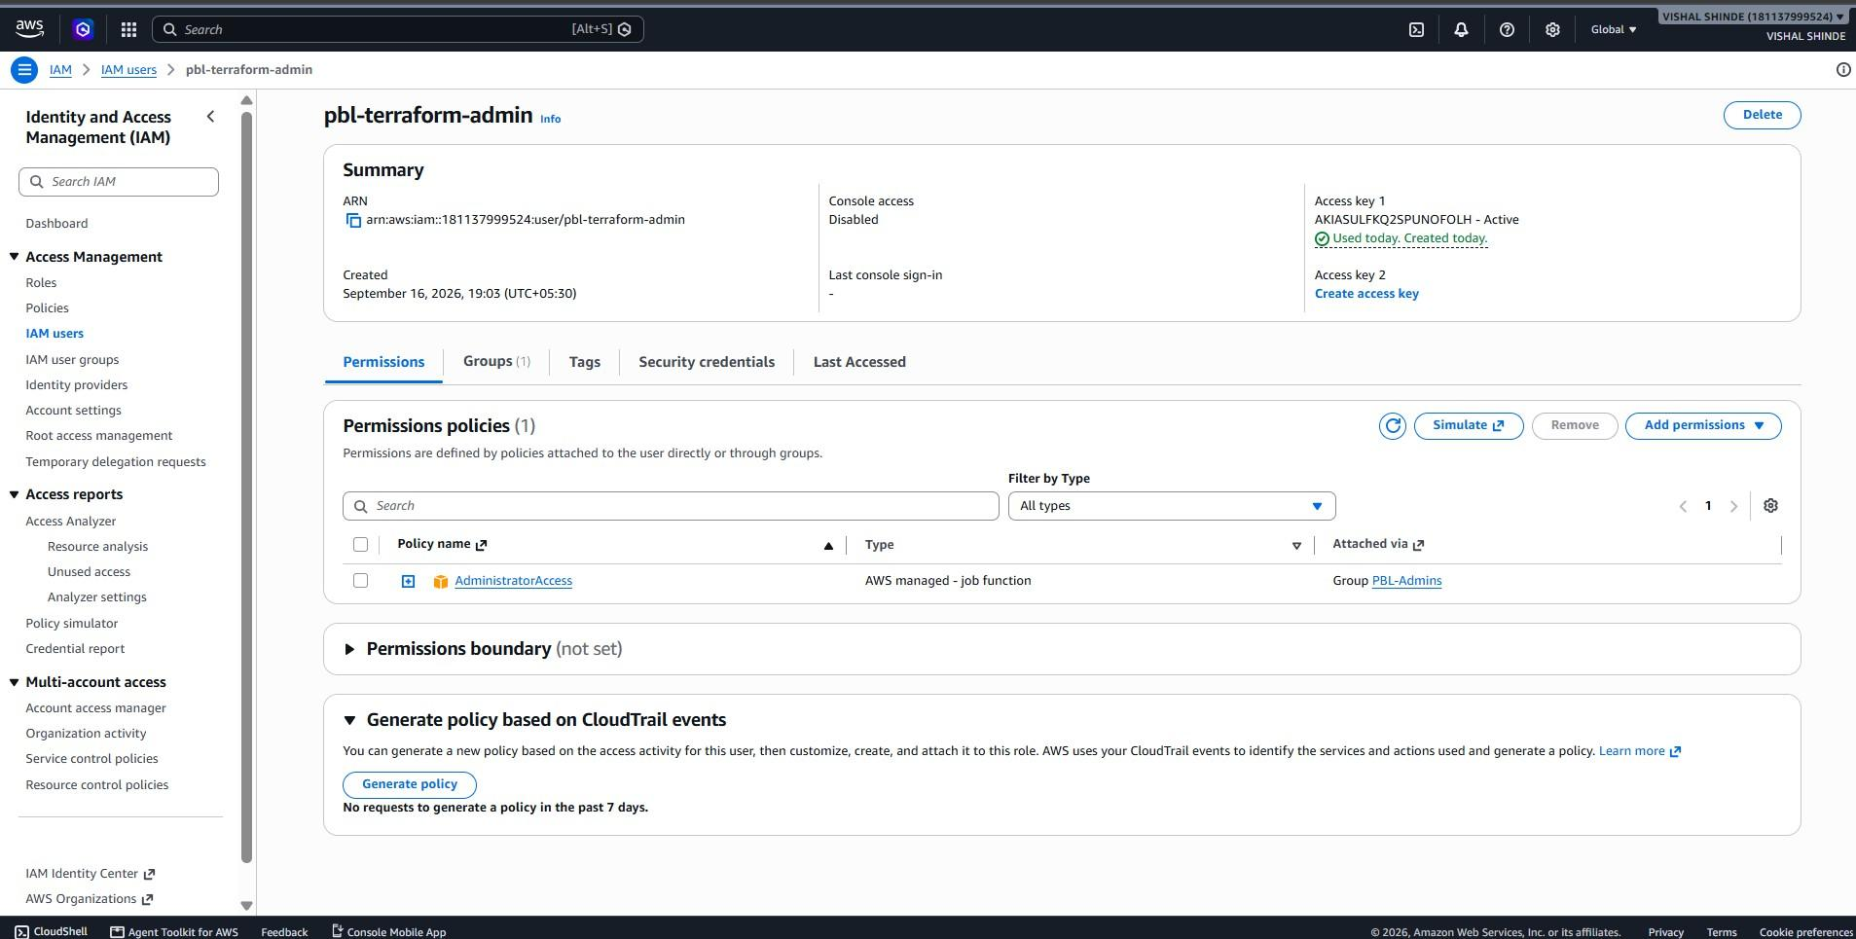
Figure 4: Terraform Administrator User.
What it proves: Shows Terraform definitions for PBL-Auditor-ReadOnly and PBL-Developer-LeastPrivilege and their group attachments.
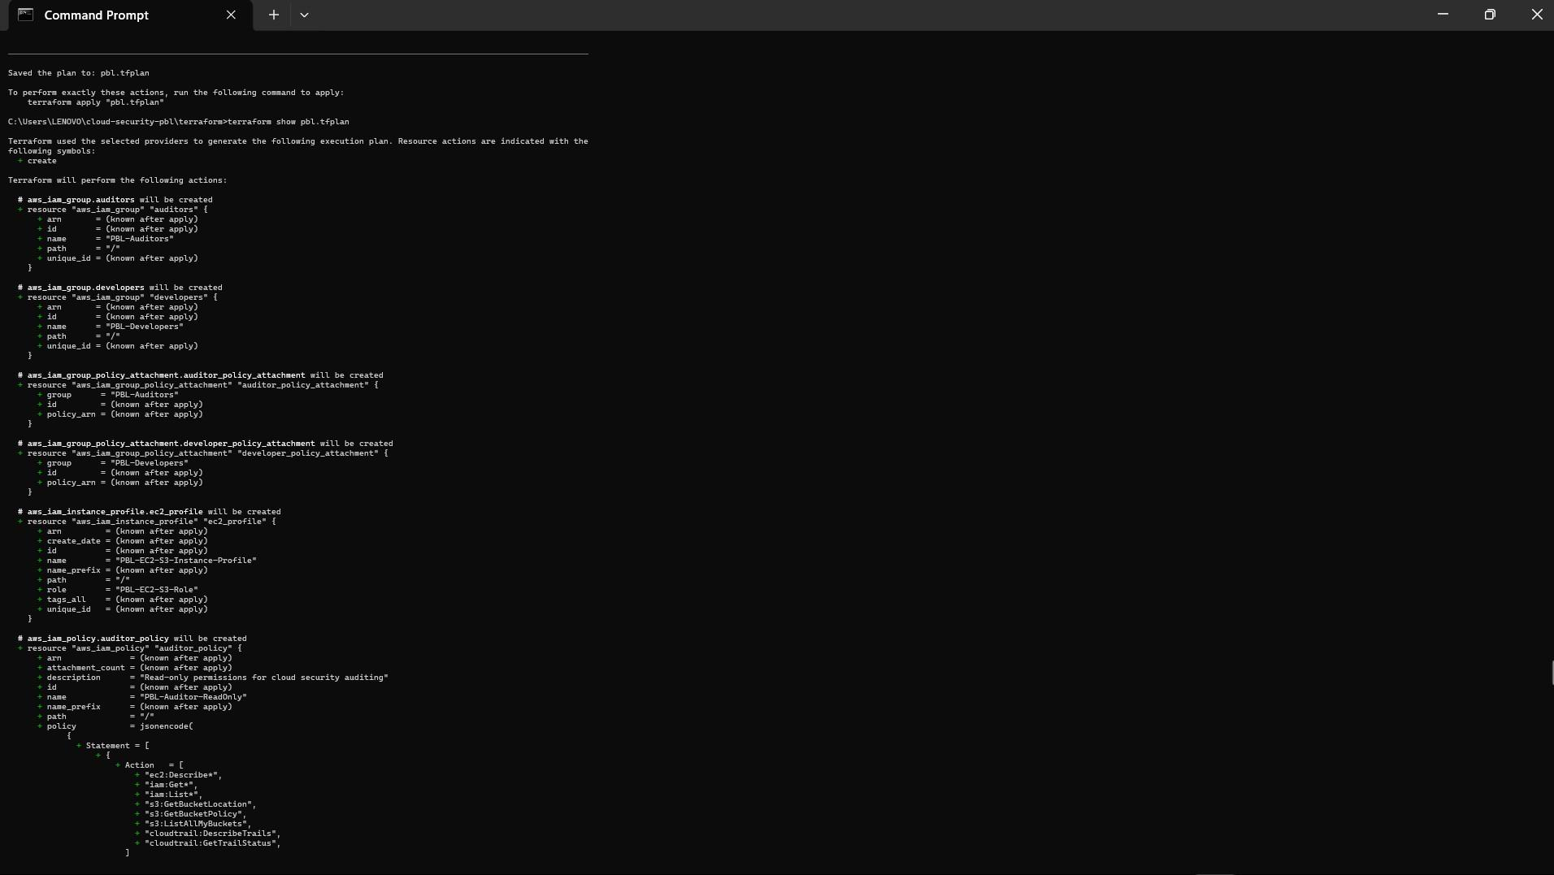
Figure 5: Auditor and Developer Least-Privilege Policies.
relationship.
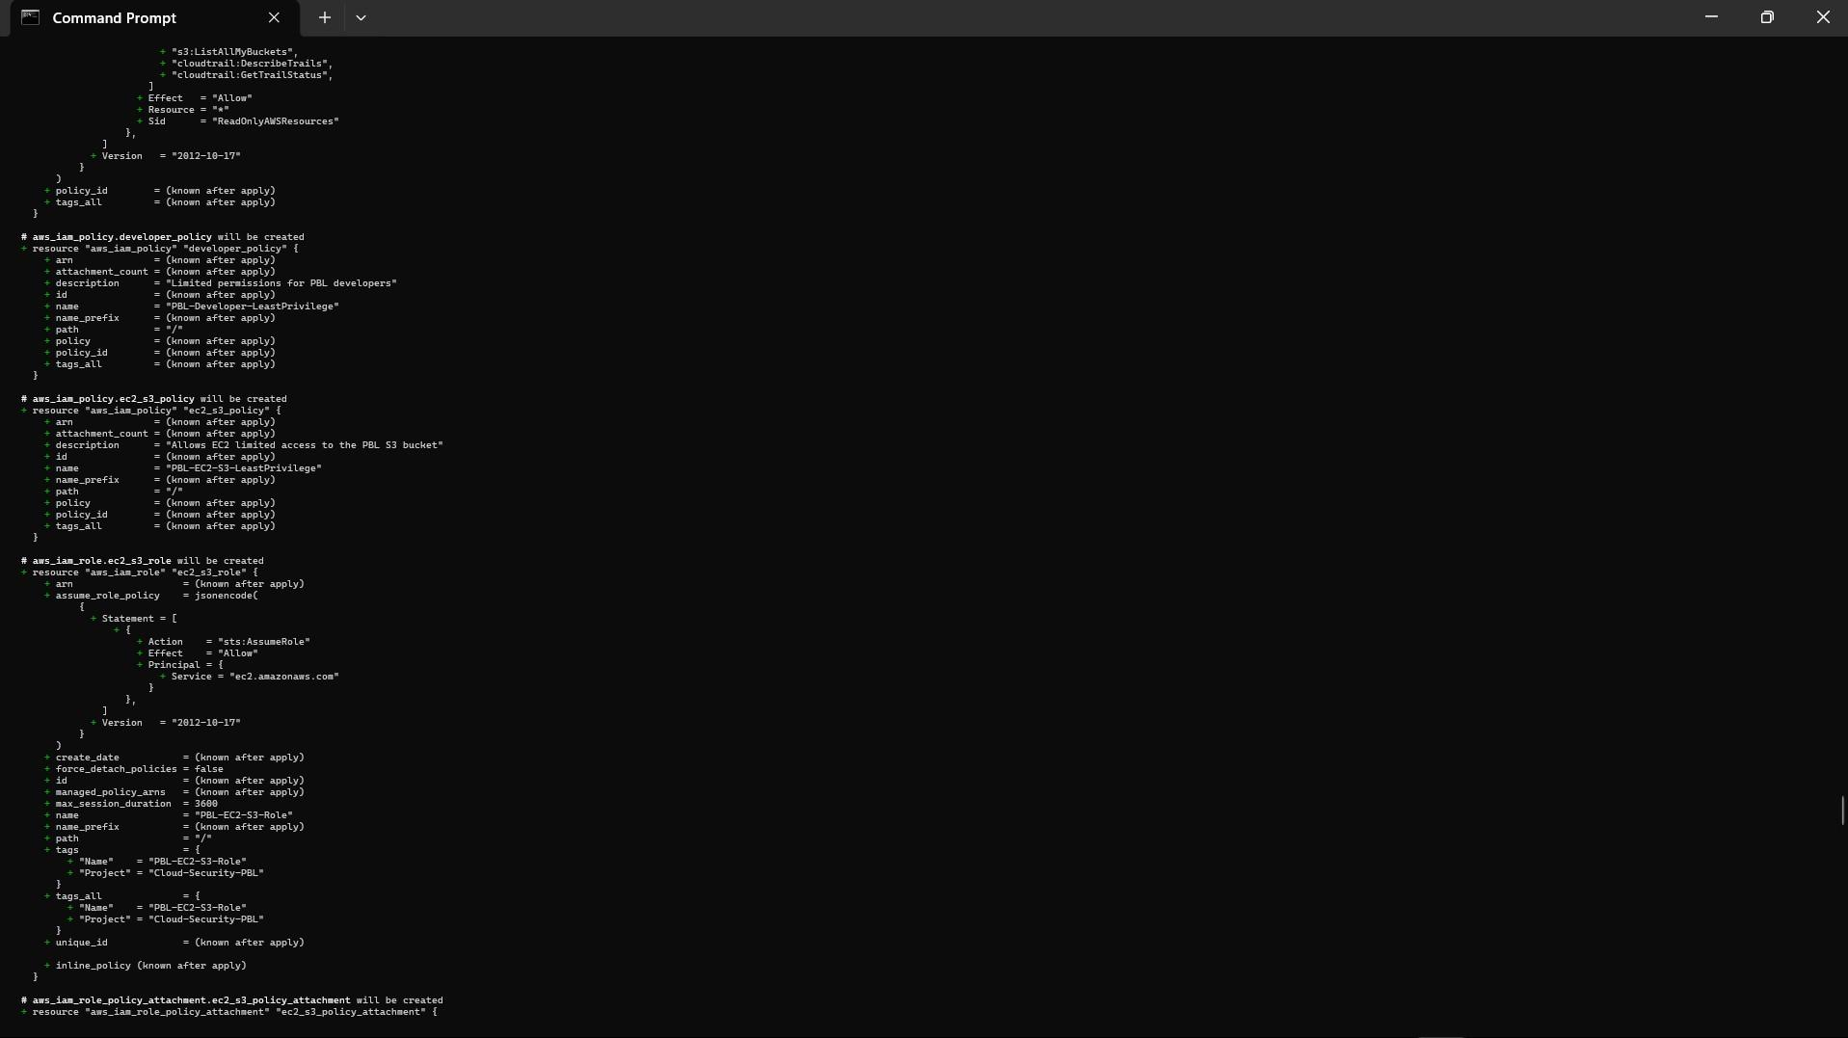
Figure 6: Developer, EC2-S3 Policies and EC2 Role.

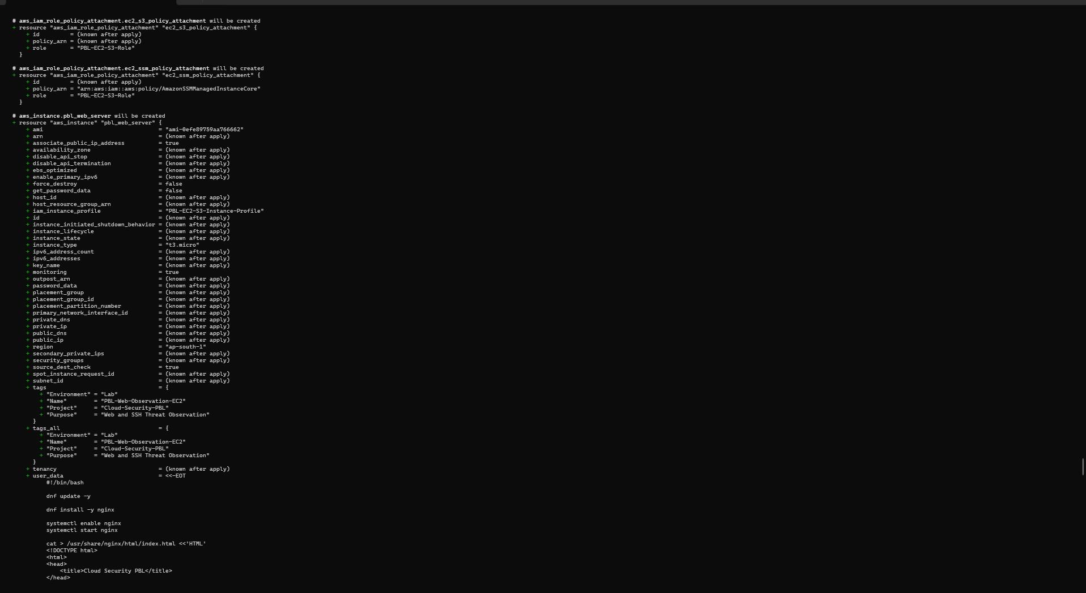
Figure 7: EC2 Role Policy Attachments.

UNIT 2 — Submission Notes

Unit 2 evidence covers IAM groups, users, group-based administrator access, least-privilege policies, EC2 IAM role/instance profile, and Admin MFA.

Admin MFA evidence:
pbl-terraform-admin has one passkey/security-key MFA device assigned,
as shown in the AWS IAM Security Credentials screenshot on the next page.

Important accuracy note:
The supplied screenshot proves MFA device assignment. It does not, by itself, prove a policy-level DenyWithoutMFA enforcement rule. Add that policy screenshot only if the instructor explicitly requires policy-level enforcement.

Security note: do not publish AWS access-key material or other credentials.

UNIT 2 — Admin MFA Evidence
User: pbl-terraform-admin | Security Credentials

