Last Updated: 11/01/17

**Recreating Figures in:**

**“Understanding Variation in Macrophage Cell Death Following *M. tuberculosis* Infection: A Systems Biology Approach (Crutcher, 2017).**

**Figures 1-6 are not plots, but rather equations and diagrams.**

**Figure 7(a): generated using model_Syt7.py**

from run_model_Syt7at import *

chg_val(m.PKA_0,0) #figure 7a compares the relationship between mitochondrial calcium loading and MPT by scanning abundances of ER calcium stores, so I just turn off any inhibitory effect of PKA here

W,X,Y,Z = create_phase() #you'll notice this function is really just designed for this figure and 7c

pl.ion()

fig = pl.figure()

pl.plot(W,X)

plt.xlabel('log Mito Ca++')

plt.ylabel('% MPT')

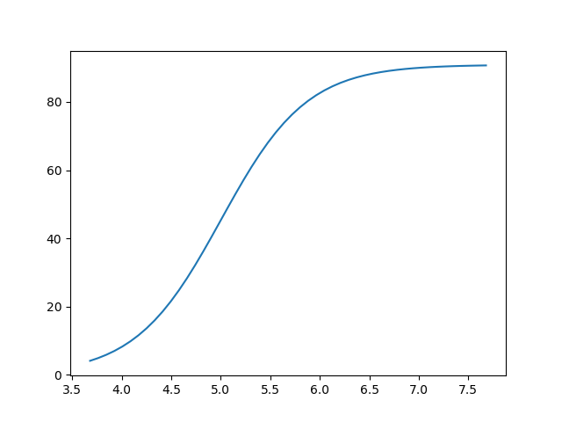

**Figure 7(b): generated using model_Syt7.py**

chg_val(m.eCa_0,7e6) #if you've just done 7a and scanned ER calcium store abundances up to 1e8, this resets to default value

chg_val(m.PKA_MIM_b_kf,2e-5) #oops! I noted a discrepancy between this initial condition as coded in the model_Syt7 file and the reaction list in my report. This is the correct value and renders the correct figure.

a,X,Y,Z = create_phase2(m.PKA_0,[0,5]) #this function is a generalization of create_phase() in that it allows you to choose the parameter you want to scan, but the outputs are mostly the same.

pl.plot(a,X)

plt.xlabel('log PKA (Copies)')

plt.ylabel('% MPT')

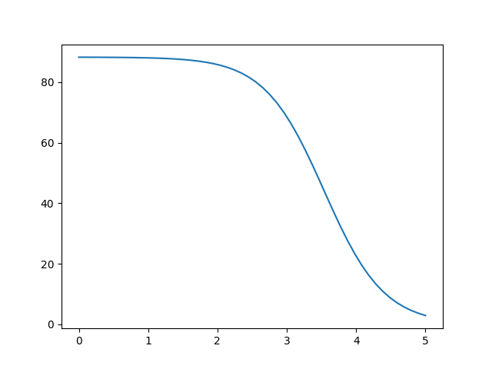

**Figure 7(c): generated using model_Syt7.py**

chg_val(m.synth_ROS_k,0.1)

W,X,Y,Z = create_phase()

pl.ion()

pl.figure()

pl.plot(X,Z)

chg_val(m.synth_ROS_k,0)

W,X,Y,Z = create_phase()

pl.plot(X,Z)

chg_val(m.synth_ROS_k,0.05)

W,X,Y,Z = create_phase()

pl.plot(X,Z)

chg_val(m.synth_ROS_k,0.01)

W,X,Y,Z = create_phase()

import matplotlib.pyplot as plt

pl.plot(X,Z)

plt.xlabel('% MPT')

plt.ylabel('Osmotic Stress (fold [Na] increase from baseline)')

Plt.legend(['Mem Damage (ROS_ks = 0.1)','No Mem Damage (ROS_ks = 0)','ROS_ks = 0.05','ROS_ks = 0.01'])

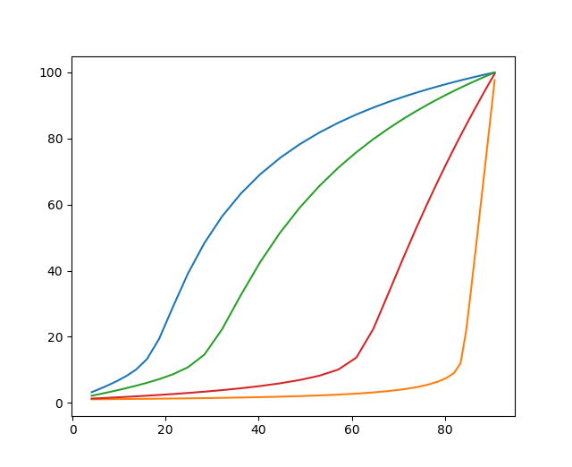

**Figure 7(d): generated using model_Necrosis.py**

from run_model_Necrosisat import *

chg_val(m.Syt7_0,0)

a,X,Y,Z = create_phase2(m.PKA_0,[0,5])

pl.figure()

pl.plot(a,Z)

chg_val(m.Syt7_0,2500)

a,X,Y,Z = create_phase2(m.PKA_0,[0,5])

pl.plot(a,Z)

chg_val (m.Syt7_0,5000)

a,X,Y,Z = create_phase2(m.PKA_0,[0,5])

pl.plot(a,Z)

chg_val (m.Syt7_0,7500)

a,X,Y,Z = create_phase2(m.PKA_0,[0,5])

pl.plot(a,Z)

chg_val(m.Syt7_0,10000)

a,X,Y,Z = create_phase2(m.PKA_0,[0,5])

pl.plot(a,Z)

import matplotlib.pyplot as plt

plt.scatter(a,Z,s=None,c='k',marker='X')

plt.legend(['Syt7 = 0','Syt7 = 2500','Syt7 =5000','Syt7 =7500','Syt7 =10000','No Mem Damage'])

plt.xlabel('Log PKA (Copies)')

plt.ylabel('Osmotic Stress (Fold [Na] Increase from Baseline)')

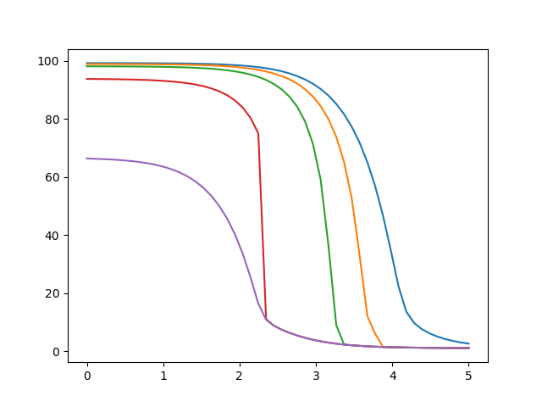

**Figure 9(a): generated using Frontside.py**

Chg_val(m.LO_AA_b_kf, 1e-08)

scan_custom(m.p38p_HSP27_b_kf,[-7,-5],'o_Cox')

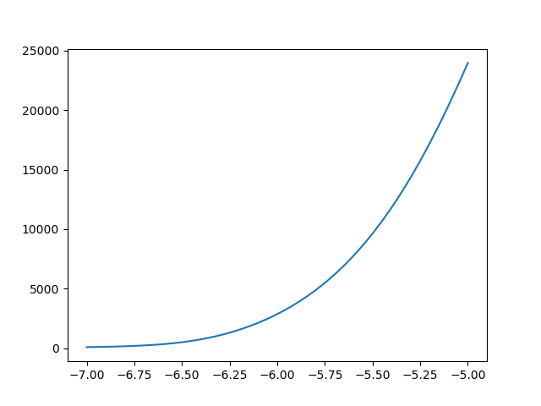

**Figure 9(b): generated using Frontside.py**

chg_val(p38p_HSP27_b_kf,3e-6)

scan_custom(m.synth_PIP3_k,[-4,0],'o_Cox')

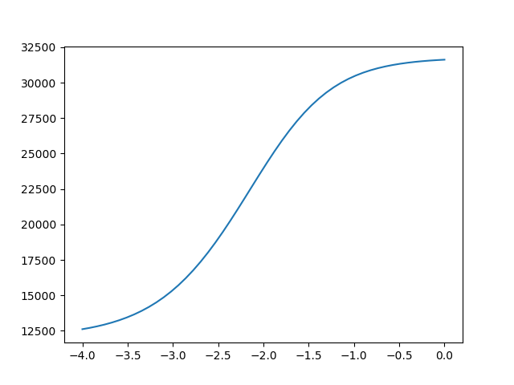

**Figure 10(a): generated using Frontside.py**

chg_val(m.LO_AA_b_kf,1e-5)

from run_Frontside import *

chg_val(m.LO_0,1e5)

graph('o_LXA4')

chg_val(m.LO_0,1e4)

graph('o_LXA4',prep_fig=False)

chg_val(m.LO_0,5e3)

graph('o_LXA4',prep_fig=False)

chg_val(m.LO_0,1e3)

graph('o_LXA4',prep_fig=False)

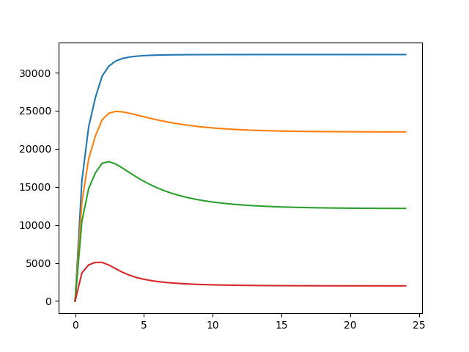

**Figure 10(b): generated using Frontside.py**

chg_val(m.LO_0,1e3)

pl.figure()

s.run()

output = s.yobs['o_PGE2'] + s.yobs['o_EP2'] + s.yobs['o_EP4']

pl.plot(t/3600,output)

chg_val(m.LO_0,5e3)

s.run()

output = s.yobs['o_PGE2'] + s.yobs['o_EP2'] + s.yobs['o_EP4']

pl.plot(t/3600,output)

chg_val(m.LO_0,1e4)

s.run()

output = s.yobs['o_PGE2'] + s.yobs['o_EP2'] + s.yobs['o_EP4']

pl.plot(t/3600,output)

chg_val(m.LO_0,1e5)

s.run()

output = s.yobs['o_PGE2'] + s.yobs['o_EP2'] + s.yobs['o_EP4']

pl.plot(t/3600,output)

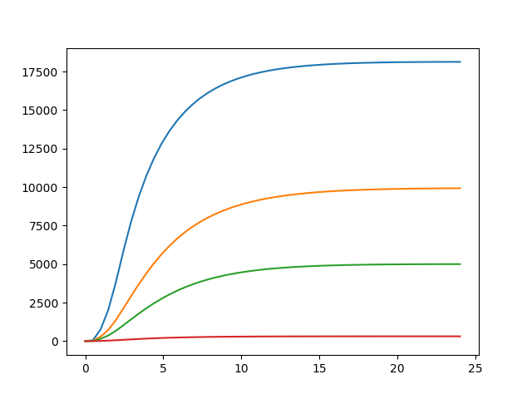

**Figure 10(c): generated using Frontside.py**

chg_val(m.LO_0,1e3)

graph('o_NFkB')

chg_val(m.LO_0,5e3)

graph('o_NFkB',prep_fig=False)

chg_val(m.LO_0,1e4)

graph('o_NFkB',prep_fig=False)

chg_val(m.LO_0,1e5)

graph('o_NFkB',prep_fig=False)

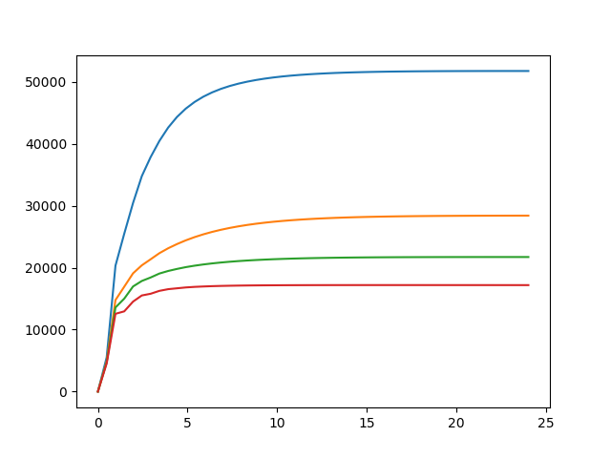

**Figure 11: generated using Frontside.py**

***Runs very slow.

LO_wrap([3,5],'o_NFkB',norm=True)

comp_LO_TNF([3,5],norm=True)

LO_wrap([3,5],'o_Cox',norm=True)

LO_wrap([3,5],'o_Syt7',norm=True)

comp_LO_PGE2([3,5],norm=True)

LO_wrap([3,5],'o_PKA',norm=True)

LO_wrap([3,5],'o_DISC',norm=True)

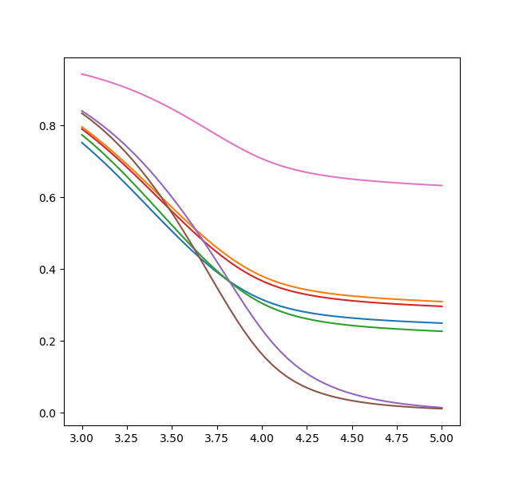

**Figure 12(a): generated using Frontside.py**

chg_val(m.synth_AA_k, 0.05)

comp_LO_PGE2([3,5])

chg_val(m.synth_AA_k, 0.01)

comp_LO_PGE2([3,5])

chg_val(m.synth_AA_k, 0.002)

comp_LO_PGE2([3,5])

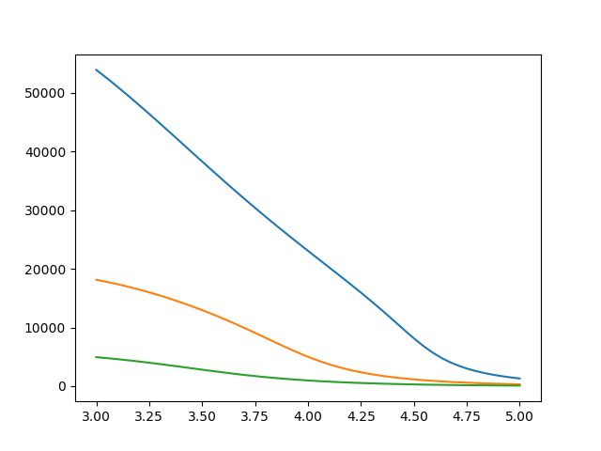

**Figure 12(b): generated using Frontside.py**

chg_val(m.synth_AA_k, 0.05)

LO_wrap([3,5],'o_LXA4')

chg_val(m.synth_AA_k, 0.01)

LO_wrap([3,5],'o_LXA4')

chg_val(m.synth_AA_k, 0.002)

LO_wrap([3,5],'o_LXA4')

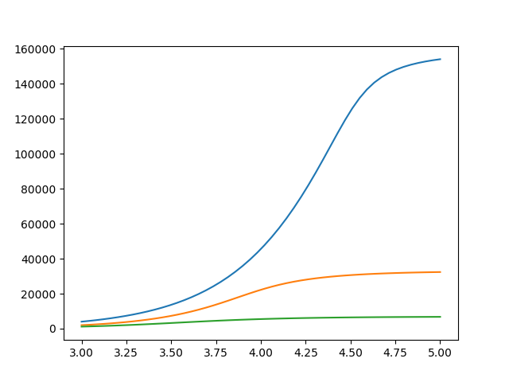

**Figure 12(c): generated using Frontside.py**

chg_val(m.synth_AA_k, 0.05)

LO_wrap([3,5],'o_PKA')

chg_val(m.synth_AA_k, 0.01)

LO_wrap([3,5],'o_PKA')

chg_val(m.synth_AA_k, 0.002)

LO_wrap([3,5],'o_PKA')

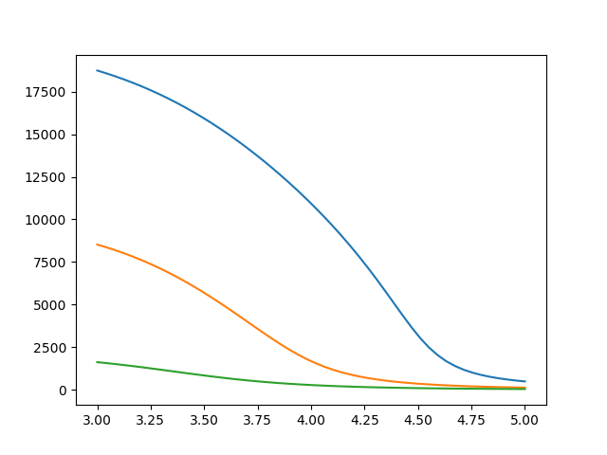

**Figure 12(d): generated using Frontside.py**

chg_val(m.synth_AA_k, 0.05)

LO_wrap([3,5],'o_Syt7')

chg_val(m.synth_AA_k, 0.01)

LO_wrap([3,5],'o_Syt7')

chg_val(m.synth_AA_k, 0.002)

LO_wrap([3,5],'o_Syt7')

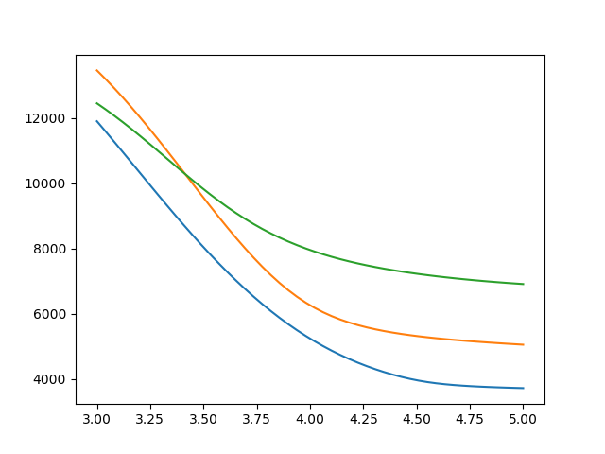

**Figure 13: generated using FullModel.py**

from run_FullModelat import *

Osm_LO([3,5])

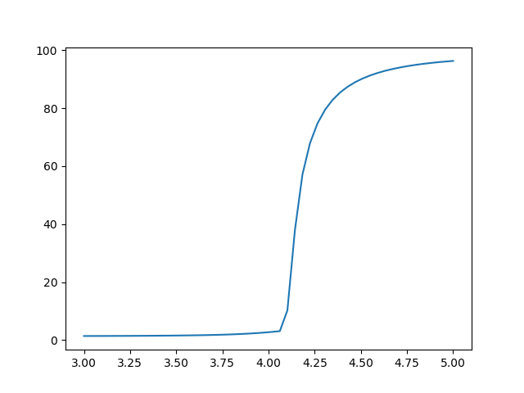

**Figure 14: generated using FullModel.py**

chg_val(m.Pol_dBcl2_p_kf,1e-8)

time_to_nec([3.0,5.0],'b')

chg_val(m.Pol_dBcl2_p_kf,3e-8)

time_to_nec([3.0,5.0],'g')

chg_val(m.Pol_dBcl2_p_kf,5e-8)

time_to_nec([3.0,5.0],'r')

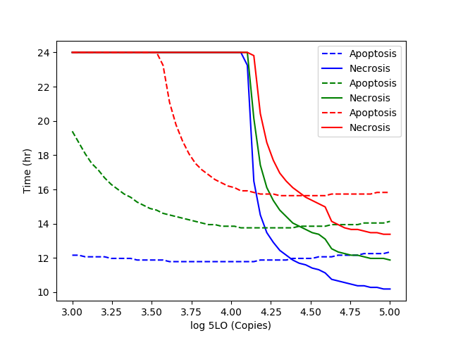

**Figure 15(a): generated using Frontside.py**

chg_val(m.LO_AA_b_kf,1e-5)

LO_wrap([3,5],'o_PKA')

chg_val(m.synth_TNF_k,60)

LO_wrap([3,5],'o_PKA')

chg_val(m.synth_TNF_k,0)

chg_val(m.synth_TNFR2_k, 60)

LO_wrap([3,5],'o_PKA')

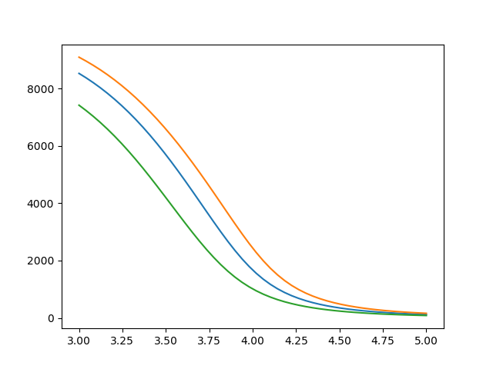

**Figure 15(b): generated using Frontside.py**

chg_val(m.LO_AA_b_kf,1e-5)

LO_wrap([3,5],'o_Syt7')

chg_val(m.synth_TNF_k,60)

LO_wrap([3,5],'o_Syt7')

chg_val(m.synth_TNF_k,0)

LO_wrap([3,5],'o_Syt7')

chg_val(m.synth_TNFR2_k, 60)

LO_wrap([3,5],'o_Syt7')

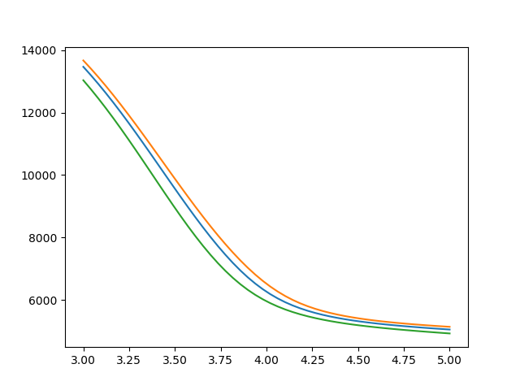

**Figure 15(c): generated using FullModel.py**

chg_val(m.LO_AA_b_kf,1e-5)

time_to_nec([3.0,5.0],'b')

chg_val(m.synth_TNF_k,60)

time_to_nec([3.0,5.0],'r')

chg_val(m.synth_TNF_k,0)

chg_val(m.synth_TNFR2_k, 60)

time_to_nec([3.0,5.0],'g')

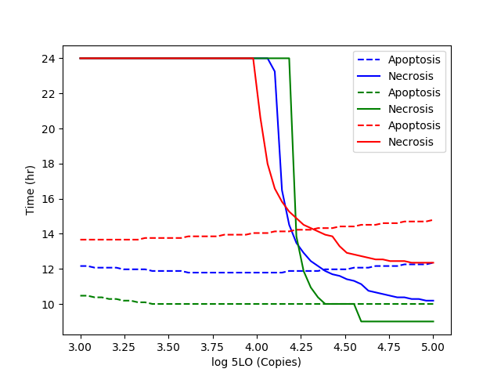

**Figure 16(a): generated using Frontside.py**

chg_val(m.LO_AA_b_kf,1e-5)

chg_val(m.synth_p50_k,45)

LO_wrap([3,5],'o_PKA')

chg_val(m.synth_p50_k,75)

stable_kB()

LO_wrap([3,5],'o_PKA')

chg_val(m.synth_p50_k,30)

stable_kB()

LO_wrap([3,5], 'o_PKA')

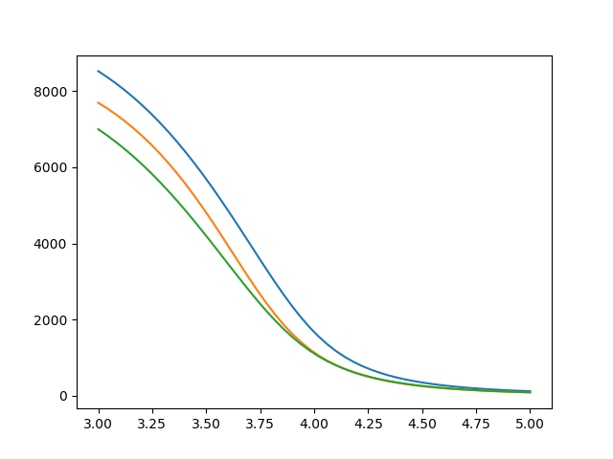

**Figure 16(b): generated using Frontside.py**

chg_val(m.LO_AA_b_kf,1e-5)

chg_val(m.synth_p50_k,45)

LO_wrap([3,5],'o_Syt7')

chg_val(m.synth_p50_k,75)

stable_kB()

LO_wrap([3,5],'o_Syt7')

chg_val(m.synth_p50_k,30)

stable_kB()

LO_wrap([3,5],'o_Syt7')

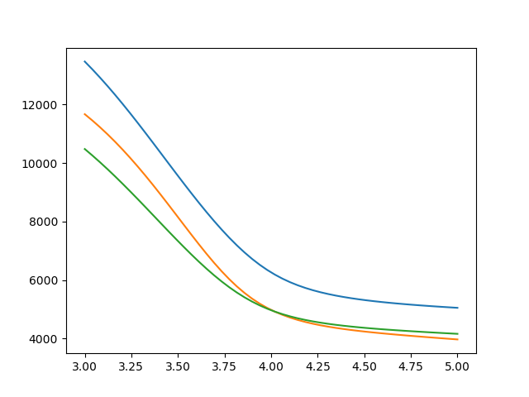

**Figure 16(c): generated using FullModel.py**

chg_val(m.LO_AA_b_kf,1e-5)

chg_val(m.synth_p50_k,45)

time_to_nec([3.0,5.0],'b')

chg_val(m.synth_p50_k,75)

stable_kB()

time_to_nec([3.0,5.0],'g')

chg_val(m.synth_p50_k,30)

stable_kB()

time_to_nec([3.0,5.0],'r')