Heather Huang, Mitchell Kennedy, Anh Vo, Ricky Wan

May 27, 2015

CSE 490 Class Project

**Introduction**

The purpose of our program is to analyze the population variations that occur from changes in the food chain progression. A **food chain** is a linear sequence of links in a foodweb starting from "producer" species and ending at apex predator species, detritivores, or decomposer species [1]. In using our program, scientists will be able to analyze and predict variations of population size for a wide array of species, from events directly. These events vary from weather influenced population boom/bust(s), and political policies of species conservation, which lead to compounding effects on the food chain progression (The effect influenced on one species, will have an exponential effect on species below/above the food chain).

**Functional Specification**

User profile:

The targeted users that will use the marine ecosystem models are marine enthusiasts, biologists, and for the one high school student that knows how to use terminal. The user should know how to run the .py files in terminal and call the functions.

Use cases:

The user should have a CSV file that lists the parameters estimates for the five species. There will be a Read method where the CSV file will be read after the user inputs the file name. After the CSV file is read, the data will be organized and each parameters will be sorted respectively. The original CSV data will be solved and plotted as line graphs. The line graph will show the population trend over span of years for each species displayed with different color lines/symbols for easy comparison. The user can then enter in another CSV file with altered parameters which would be read, analyzed and plotted against the original ecosystem data. This will display ecosystem comparisons before and after the parameter changes. Any unknowns that are not specified will be solved using systems of linear equations before any plot is generated.

Interactions details:

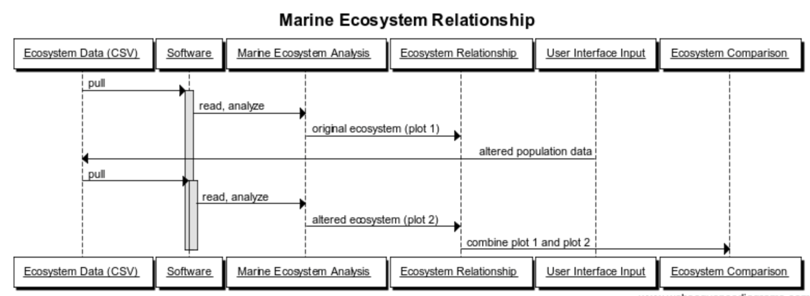

**Ecosystem**

The selected ecosystem is in a marine environment. The five species selected are harbor seals, pacific cod, shrimp, microzooplankton, and benthic microalgae. These species are interrelated by a food chain where seal eats the cod, cod eats the shrimp, and so on. The ecosystem model was selected where there are no cross consumption of multiple species in the same chain, allowing easier analysis of steady state relationships between species over a sufficiently long period of time.

**Parameter Estimates**

Steady State Biomass of Species (i: Bi)

--> Sum of the mass (in kilograms) of all members of the species in the ecosystem

Production Ration per Year: (P/B)i

-->Ratio of mass produced each year to steady-state biomass

Consumption ratio per year: (*Q*/*B*)*i*

-->Ratio of mass consumed to steady-state biomass

Diet percentage: *DCji*

-->Fraction (by mass) of *i*'s diet that is members of species *j*

Additions to the ecosystem per year: *Ai*

-->Mass of new members that enter the ecosystem (e.g., from immigration, "stocking")

Removals from the ecosystem per year: *Ri*

-->Mass of new members that leave the ecosystem (e.g., from immigration, "stocking")

System of Linear Equations used to model the ecosystem:

Another method to estimate parameters:

where , where *T* is in degrees K of mean annual temperature of the ecosystem; is the maximum weight of an individual, is for a predator (and 0 otherwise); and is 1 for a herbivore (and 0 otherwise).

where is the lifespan of species *i*.

The parameter values should be reasonable and taken from published literature and peer reviewed sources. Source for equations used is indicated in references [2].

**Parameter Values:**

|  |  |  |  |  |  |  |  |
| --- | --- | --- | --- | --- | --- | --- | --- |
| Species | TL | B (mt km-2) | P/B (yr-1) | Q/B (yr-1) | EE | BA (yr-1) | P/Q |
| Harbor Seals | 4.44 | 0.0240 | 0.126 | 24.594 | 0.397 | 0 | 0.005 |
| Pacific Cod | 4.07 | 0.2000 | 0.260 | 3.784 | 0.520 | 0 | 0.069 |
| Shrimp | 2.94 | 8.134 | 2.250 | 12.000 | 0.900 | 0 | 0.344 |
| Microzooplankton | 2.05 | 5.343 | 100.000 | 285.714 | 0.800 | 0 | 0.200 |
| Benthic Microalgae | 1.00 | 4.298 | 100.000 | NA | 0.500 | 0 | NA |

**References**

1. Wikipedia,. 'Food Chain'. N.p., 2015. Web. 27 May 2015.
2. Harvey C. J., Bartz K. K., Davies J., Francis T. B., Good T. P., Guerry A. D., Hanson B., et al. A mass-balance model for evaluating food web structure and community-scale indicators in the central basin of Puget Sound. U.S. Dept. Commerce, NOAA Technical Memorandum NMFS-NWFSC-106 2010. 18