INTERNSHIP PROJECT REPORT

NDVI-Based Crop Lifecycle Detection and Multi-Crop Classification
A Signal-Processing and Machine-Learning Pipeline for Crop Phenology and Classification from Sentinel-2 Time Series

Github : https://github.com/athxrvxaa/crop_predictor

Submitted by
Atharva Raskar

Internship Organisation
Vasundharaa Geo Technologies Pvt. Ltd.
May 2026 – August 2026

Project Guide:
Mr. Vamsi Vaddadi, Vasundharaa Geo Technologies

Acknowledgement
I would like to thank Vasundharaa Geo Technologies for giving me the opportunity to work on this crop classification project during my internship. The problem itself - figuring out what is growing on a farm using nothing but a satellite-derived greenness signal - turned out to be considerably more involved than it sounds on paper, and I am grateful for the guidance and the freedom I was given to work through it properly rather than being handed a fixed recipe to follow.
I am grateful to my company mentor Mr. Vamsi Vaddadi and my team lead Prasad for their feedback at various stages of this work, especially around the points where the pipeline needed to be rethought - the Sugarcane validation rule revision and the GEE geometry fix being the two clearest examples. I would also like to thank Fergusson College for the academic grounding in statistics, programming, and machine learning that made it possible to approach a genuinely applied problem like this one with some confidence.

Abstract
Knowing which crop is growing in a given field, at a given time, is one of those pieces of information that sits underneath a lot of agricultural decision-making - insurance, irrigation planning, yield forecasting, subsidy verification - and yet the only truly reliable way to get it has historically been to send someone to look at the field. That does not scale past a few hundred farms. Satellite remote sensing offers a way around the problem: as a crop grows, the Normalized Difference Vegetation Index (NDVI) computed from its canopy rises and falls in a pattern that is fairly characteristic of that crop's growth habit, and this pattern can be read from freely available Sentinel-2 imagery without ever visiting the field.
This report documents an internship project carried out at Vasundharaa Geo Technologies that turns this idea into a working pipeline. NDVI time series were extracted for some individually surveyed farm points across six crops - Onion, Tomato, Sugarcane, Banana, Grapes, and Paddy - using Google Earth Engine on Sentinel-2 surface-reflectance imagery. The datasets spanned Junnar and Otur (Onion), Nashik and Kolhapur (Sugarcane), Jalgaon (Banana), Nashik (Grapes), Punjab (Paddy), and Karnataka (Tomato).
From the raw NDVI records, a pipeline was built that removes duplicates, applies per-crop rolling-mean smoothing, detects peaks using scipy.signal.find_peaks with per-crop prominence thresholds, and extracts a sowing-to-harvest lifecycle for each farm. Detected lifecycles are validated against agronomic rules specific to Maharashtra growing calendars. From each accepted lifecycle, 13 features are extracted describing timing, shape, area, growth and decline rates. A Random Forest classifier trained on this feature matrix achieved 90.24% accuracy on the latest unseen evaluation of 41 valid lifecycle samples, with 0.9766 weighted precision and 0.9304 weighted F1-score. A Flask web application was built on top of the trained model that fetches Sentinel-2 NDVI live from GEE for a user-supplied coordinate and date and returns a crop prediction with a lifecycle chart.

Table of Contents
Acknowledgement
Abstract
1. Introduction
2. Literature Review
3. Problem Statement
4. Objectives
5. Study Area and Dataset
6. Data Preprocessing
7. GEE Extraction Pipeline
8. Lifecycle Detection
8.1 Smoothing
8.2 Peak and Valley Detection
8.3 Agronomic Validation
9. Feature Engineering
10. Model Development
10.1 Train / Val / Test Split
10.2 Classifier
11. Results and Discussion
11.1 Model Performance
11.2 Why Certain Crops Are Harder
12. Web Application
The current implementation now includes a modular Flask prediction service: the browser submits coordinates and a reference date, Sentinel-2 NDVI is fetched from Google Earth Engine, the lifecycle pipeline detects sowing, peak, and harvest candidates, and the classifier returns the crop prediction with confidence and an NDVI chart.
Model selection uses GridSearchCV with StratifiedGroupKFold grouped by farm and macro-F1 scoring. The saved Random Forest uses balanced class weights; the current model contains 120 trees with maximum depth 2 and uses 13 lifecycle and NDVI features.
The unseen-data evaluation also exports prediction results, the source rows for misclassified farms, and lifecycle plots for error analysis.

12.1 Current Implementation Update
13. Challenges Faced
14. Limitations
15. Future Scope
16. Conclusion
17. References

1. Introduction
Precision agriculture depends, at a basic level, on knowing what is planted where and when. That single piece of information feeds into yield estimation, irrigation scheduling, crop insurance claims, subsidy verification, and regional monitoring of cropping patterns. Field surveys can supply it, but they are slow, expensive, and simply do not scale to the thousands of farms that a state-level or company-level monitoring effort would need to cover.
Remote sensing offers an alternative that scales in a way manual surveys cannot. The Sentinel-2 satellite constellation revisits the same location roughly every five days and captures optical imagery from which the Normalized Difference Vegetation Index (NDVI) can be computed - a simple ratio of near-infrared to red reflectance that tracks how green and photosynthetically active the vegetation at a point is. Over a single growing season, a crop's NDVI typically follows a recognisable arc: it rises as the canopy develops, peaks around maximum ground cover, and falls again as the crop matures, senesces, and is harvested. Because different crops grow for different lengths of time and rise and fall at different rates, this NDVI curve carries information about which crop produced it.
This internship, carried out at Vasundharaa Geo Technologies, focused on building the pipeline that turns raw, farm-level NDVI observations into a trained crop-classification model. That pipeline covers: cleaning and deduplicating noisy time-series data; detecting the sowing-to-harvest window for each farm automatically from the NDVI signal; engineering a set of lifecycle features; training a Random Forest classifier; and deploying the result behind a web interface that fetches NDVI live and returns predictions in real time.

1.1 Why NDVI and Not a Direct Crop-Type Product
Off-the-shelf agricultural land-cover products exist, but they are typically produced at coarse spatial resolution, updated on institutional timelines that do not match a single season, and are not built to explain themselves at the level of an individual field's growth curve. Building the classification bottom-up from a single farm's NDVI trace keeps the pipeline transparent - every prediction can be traced back to a specific sowing date, peak date, and harvest date that a person can sanity-check - and keeps the door open to retraining on new crops or new regions without depending on someone else's labelling schedule.

2. Literature Review
Vegetation indices derived from optical satellite imagery have been used for crop monitoring for decades. NDVI in particular has remained a workhorse metric because it is simple to compute, robust across sensors, and correlates reasonably well with canopy greenness and biomass. Tucker's early work on red/near-infrared vegetation indices established the basic relationship this project leans on: healthy, dense vegetation reflects strongly in the near-infrared band while absorbing red light for photosynthesis, and the normalised difference between the two bands captures that contrast in a single bounded number.
Time-series NDVI analysis for crop-type mapping has typically followed one of two broad approaches. The first fits parametric curves - double-logistic functions, asymmetric Gaussians - to a season's NDVI trajectory and derives phenological markers from the fitted curve. The second, which this project follows, works directly off the smoothed empirical signal using peak and valley detection rather than assuming a fixed functional form, which is more forgiving when the crop mix is heterogeneous: a fast three-month Onion cycle and a slow ten-to-twelve month Sugarcane cycle do not fit a single parametric template well.
On the modelling side, tree-ensemble classifiers (Random Forest) have become a standard choice for tabular, feature-engineered agricultural datasets of the size typically available from field surveys - usually a few hundred to a few thousand labelled examples, well short of what would justify a deep sequence model trained directly on the raw time series. Their appeal is threefold: they handle a mix of feature scales and mild collinearity without much preprocessing; they expose feature-importance rankings that make it possible to sanity-check whether the model is learning something agronomically sensible; and they are inexpensive to retrain and to serialise into a small artifact suitable for a lightweight prediction service.

3. Problem Statement
Given a time series of NDVI observations for a farm, collected over roughly one growing season, predict the crop being grown, from six possible classes: Onion, Tomato, Sugarcane, Banana, Grapes, and Paddy. Stated this way the problem sounds like an ordinary multi-class classification exercise, but several properties of the data make it considerably less tidy than that framing suggests.
- NDVI observations are irregular in spacing and affected by cloud cover, introducing noise and occasional gaps in an individual farm's time series.
- Farms are not surveyed on the same calendar dates, so raw time series across farms are not aligned to a common clock.
- Crops differ hugely in lifecycle length: Tomato finishes inside two to three months, while Sugarcane can run close to a year. A fixed-length observation window does not suit every crop equally well.
- Perennial and semi-perennial crops (Banana, Grapes, Sugarcane) do not exhibit the strong seasonal peak-and-trough pattern that annual crops do. Their NDVI varies slowly and the lifecycle boundaries are genuinely ambiguous from the signal alone.

4. Objectives
- Build a repeatable pipeline that extracts, cleans, and organises farm-level Sentinel-2 NDVI time series from Google Earth Engine into a structured per-farm database.
- Design a lifecycle detection scheme that adapts to a farm's own crop type, using per-crop smoothing windows, search windows, and prominence thresholds rather than a single fixed setting.
- Automatically detect a plausible sowing-to-harvest lifecycle for each farm and validate it against Maharashtra-specific agronomic rules, so that clearly wrong extractions are rejected rather than silently fed forward.
- Engineer a feature set of 13 descriptors covering lifecycle timing, shape, growth and decline rates, and NDVI statistics.
- Train a Random Forest classifier with farm-level train/val/test splits to prevent data leakage, and evaluate on a completely unseen test set.
- Package the trained pipeline behind a Flask web application that fetches NDVI live from GEE and returns crop predictions with a lifecycle chart.

5. Study Area and Dataset

5.1 Farm Point Datasets
Two farm point datasets were assembled for this project, both collected from field surveys rather than taken from a pre-existing benchmark.
Dataset | Farms | Crops | Region | Period
onion | 50 | Onion | Junnar/Otur, Maharashtra | Oct 2023–May 2024
common | 269 | Onion, Tomato, Sugarcane, Banana, Grapes, Paddy | Maharashtra + Karnataka | 2022–2026

5.2 Data Collection via Google Earth Engine
NDVI time series were pulled directly from Google Earth Engine (GEE) rather than downloaded from a pre-existing dataset. For each farm, a single representative coordinate - the farm centroid or a manually verified point - was used to sample the Sentinel-2 surface-reflectance NDVI time series at 10 m resolution. The extraction used the COPERNICUS/S2_SR_HARMONIZED collection, which provides atmospherically corrected surface reflectance harmonised across the Sentinel-2A and 2B sensors.
For the common dataset, a per-farm date window of ±6 months around each farm's ground truth visit date was used to limit the extraction to the relevant portion of the NDVI record. This was both a quality improvement - fewer irrelevant observations - and a practical necessity, since extracting 4 years of data for 269 farms across a wide geographic area hit GEE's computation limits.
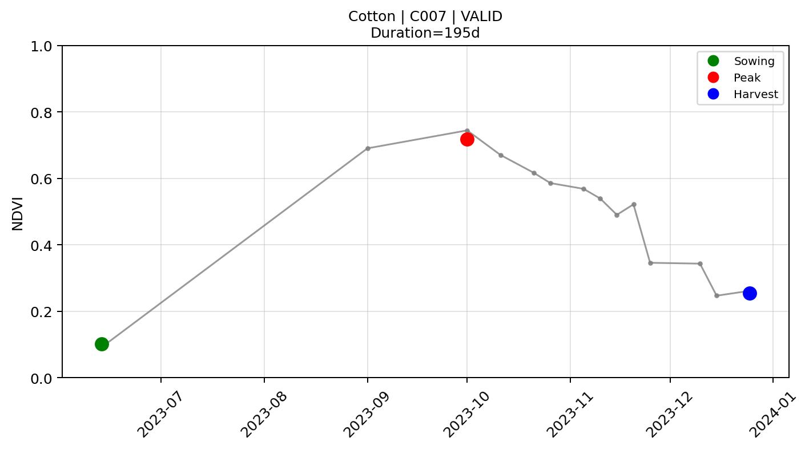
Figure 1: Temporal variation in NDVI for Cotton Farm C007, highlighting key crop growth stages from sowing to harvest(Valid Lifecycle).

5.3 Ground Truth
Each farm carries a crop label and a ground truth visit date recorded during field collection - the month and year the surveyor was on site. This date was used for two purposes: as the centre of the per-farm extraction window, and as a validation reference for checking that the automatically detected lifecycle contains the ground truth date within its sowing-to-harvest span.

6. Data Preprocessing
The raw CSV exports from GEE required several preprocessing steps before lifecycle detection could proceed. These are listed in the order they were applied:
- Column normalisation: GEE exports used inconsistent column names across datasets ('crop name' vs 'Crop', 'Sentinel_Date' vs 'Date'). All column names were mapped to a consistent internal schema.
- Date parsing: Sentinel_Date was parsed to datetime. Ground truth dates in 'Sept 2022', 'June 2023' format were normalised (non-standard abbreviations replaced) and parsed via multiple format strings.
- NDVI cleaning: NDVI values below zero were removed as cloud, shadow, or water artefacts that slipped through the SCL mask. Values were cast to float64 and non-numeric entries dropped.
- Duplicate handling: Same farm, same date, multiple NDVI values arose from overlapping Sentinel-2 tiles. Resolved by grouping on (Farm_ID, Date) and taking the mean NDVI.
- DMS conversion: 45 Tomato farm coordinates were in degrees-minutes-seconds format (e.g. 13°33'17.56"N). A regex-based parser converted these to decimal degrees, handling spacing and hemisphere indicator variations.
- Farm ID assignment: For the kanda dataset, Farm IDs were assigned by matching unique lat/lon pairs, since GEE had not propagated the Farm_ID property through sampleRegions(). For the common dataset, sequential IDs were assigned at the hardcoded-coordinates stage in the GEE script.

7. GEE Extraction Pipeline
The GEE extraction was implemented in JavaScript using the Code Editor API. The extraction proceeded as follows: load farm coordinates, build a FeatureCollection of Point geometries, filter the Sentinel-2 collection by bounds and date range, apply per-pixel SCL cloud masking, compute NDVI, extract at each farm point with sampleRegions(), and export to Google Drive as CSV.
A critical design decision was to drop the image-level CLOUDY_PIXEL_PERCENTAGE filter entirely and rely only on the SCL pixel-level mask. The image-level filter rejected entire scenes if any part of the scene - potentially far from the farm points - was cloudy, which was too aggressive for a dataset spanning multiple districts with different local cloud conditions.

function maskS2clouds(image) {
var scl = image.select('SCL');
var mask = scl.neq(3) // cloud shadow
.and(scl.neq(8)) // cloud medium probability
.and(scl.neq(9)) // cloud high probability
.and(scl.neq(10)); // cirrus
return image.updateMask(mask);
}

function addNDVI(image) {
return image.addBands(
image.normalizedDifference(['B8','B4']).rename('NDVI'));
}
An interactive inspector UI was also built inside GEE - a farm dropdown, prev/next date navigation, and toggleable Raw RGB, Masked RGB, NDVI, and SCL layers - to visually verify cloud masking quality for any farm on any date.

8. Lifecycle Detection

8.1 Smoothing
Each farm's NDVI time series was smoothed with a rolling mean before peak detection. The window size was set per crop, reflecting the different temporal scales of each crop's growth arc: 2 for Onion (short, sharp cycle), 6 for Sugarcane and Banana (slow, gradual variation), and 3 for Tomato and Paddy. A rolling mean rather than Savitzky-Golay was used here because the observation spacing was irregular - Savitzky-Golay assumes uniform spacing - and the rolling mean with min_periods=1 handled gaps gracefully.

8.2 Peak and Valley Detection
Peaks were detected on the smoothed series using scipy.signal.find_peaks with a minimum distance between peaks (to prevent detecting the same growth event twice) and, for crops where it was appropriate, a minimum prominence threshold. Prominence measures how much a peak stands out from its surrounding valleys; for perennial crops like Sugarcane and Banana where the NDVI does not drop dramatically between cycles, a low prominence threshold (0.05–0.08) was necessary to detect any valid peak at all.

Crop | Smooth Window | Max Cycles | Search Months | Prominence
Onion | 2 | 1 | 3 | None (height ≥ 0.3)
Tomato | 3 | 3 | 2 | None
Sugarcane | 6 | 1 | 8 | 0.08
Banana | 6 | 1 | 7 | 0.06
Grapes | 3 | 2 | 3 | 0.10
Paddy | 3 | 2 | 3 | 0.15
Table 2. Per-crop lifecycle detection configuration.
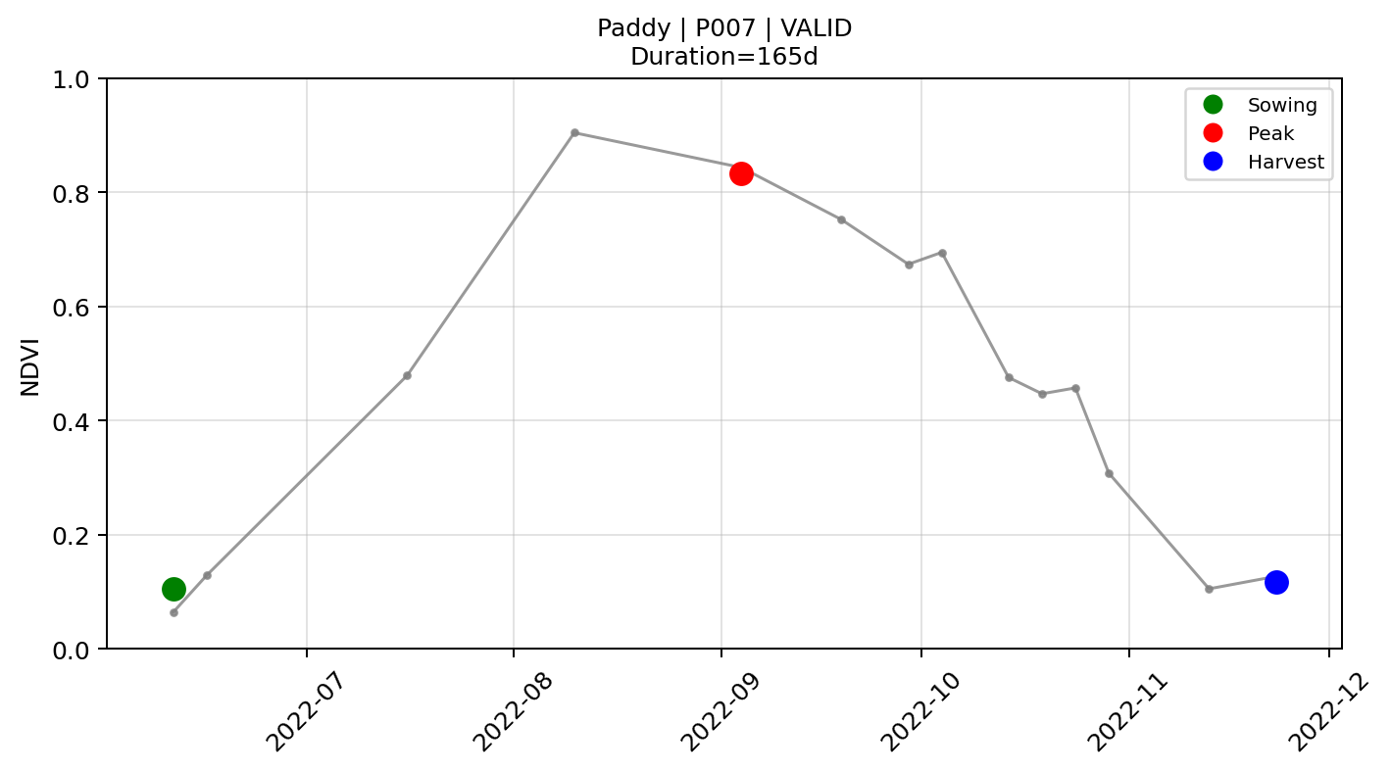
For each detected peak, the pipeline searched left (toward sowing) and right (toward harvest) within the crop-specific search window to find the corresponding NDVI minimum, giving the complete sowing → peak → harvest triplet.

Figure 2: NDVI time-series profile of Paddy Farm P007, showing the detected sowing, peak growth, and harvest stages across the crop lifecycle.

8.3 Agronomic Validation
Each detected cycle was validated against a set of crop-specific agronomic rules. Cycles that failed any rule were flagged Invalid and excluded from the feature dataset. The rules checked:
- Sowing month falls within the expected planting window for that crop
- Harvest month falls within the expected harvest window
- Lifecycle duration (sowing to harvest) is within the crop-specific min-max range
- Peak NDVI minus Harvest NDVI exceeds a minimum drop threshold (confirming senescence)
- Peak NDVI minus Sowing NDVI exceeds a minimum rise threshold (confirming green-up)
Crop | Sow Months | Harv Months | Min Days | Max Days
Onion | May–Jan | Jan–May, Oct–Dec | 85 | 180
Tomato | All months | All months | 55 | 130
Sugarcane | All months | All months | 90 | 450
Banana | All months | All months | 180 | 450
Grapes | All months | All months | 60 | 300
Paddy | May–Aug | Sep–Jan | 90 | 180
Table 3. Agronomic validation rules per crop.
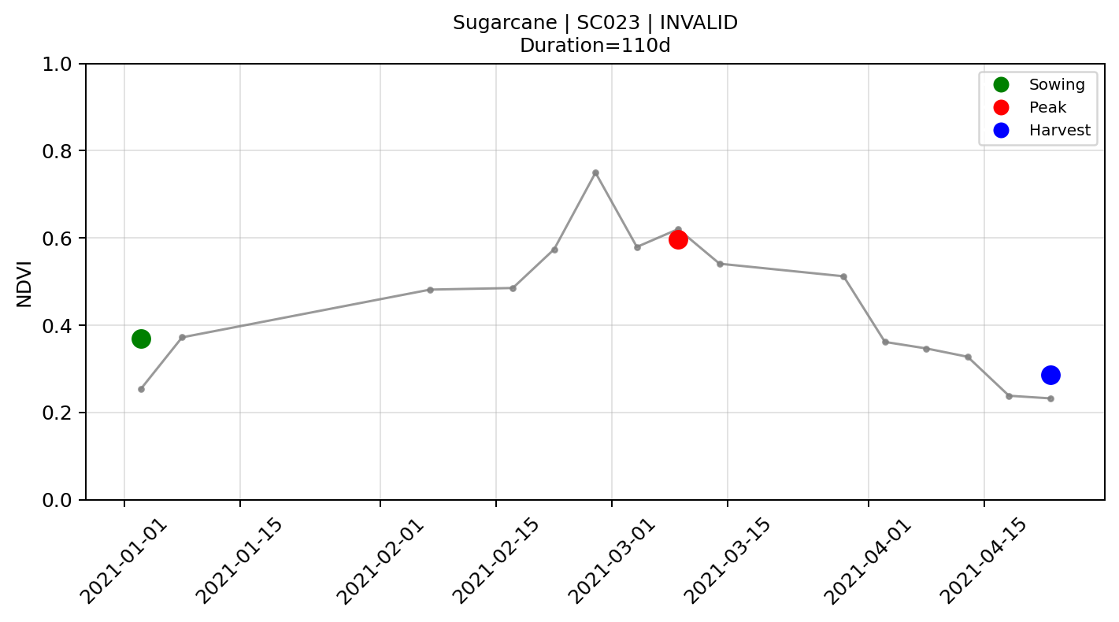
Figure 3: NDVI time-series profile of Sugarcane Farm SC023, illustrating the detected crop stages and its rejection following agronomic validation.

9. Feature Engineering
From each valid lifecycle cycle, 13 features were extracted to represent it as a fixed-length vector for the classifier. These features were designed to capture the timing, shape, magnitude, and growth dynamics of the cycle.
Feature | Description
Duration_Days | Total days from sowing to harvest
Peak_NDVI | Maximum smoothed NDVI in the cycle
Peak_Month | Calendar month of peak growth (1–12)
Sowing_NDVI | Smoothed NDVI at sowing date
Sowing_Month | Calendar month of sowing (1–12)
Harvest_NDVI | Smoothed NDVI at harvest date
Harvest_Month | Calendar month of harvest (1–12)
AUC | Area under the NDVI curve from sowing to harvest (trapezoid rule)
Mean_NDVI | Mean raw NDVI over the lifecycle segment
Std_NDVI | Standard deviation of raw NDVI over the segment
NDVI_range | Peak NDVI minus minimum NDVI in the segment
Rise_rate | (Peak NDVI − Sowing NDVI) / days from sowing to peak
Fall_rate | (Peak NDVI − Harvest NDVI) / days from peak to harvest
Table 4. Lifecycle features used as classifier inputs.
The month features (Peak_Month, Sowing_Month, Harvest_Month) are particularly discriminative for crops with fixed seasonal calendars - Paddy always peaks in September–October, Onion peaks in January–February - while duration and rate features are more useful for crops that can be planted year-round but differ in growth speed.

10. Model Development

10.1 Train / Val / Test Split
A farm-level split was used throughout to prevent data leakage. In a row-level split, all cycles from the same farm could appear in both training and test sets, which would inflate test accuracy by allowing the model to essentially memorise farm-specific NDVI patterns. Farm-level splitting ensures that every cycle from a given farm goes entirely into one split.
StratifiedShuffleSplit from scikit-learn is used at the farm level to maintain per-crop balance without leakage. The current training script assigns 50% of farms to training and 50% to test; GridSearchCV performs three-fold grouped cross-validation within the training farms.

10.2 Classifier
A Random Forest Classifier was trained on the 13-feature matrix with class_weight='balanced'. GridSearchCV was used for model selection with StratifiedGroupKFold grouped by farm, three folds, and macro-F1 scoring. The saved best estimator currently uses 120 trees and maximum depth 2.

from sklearn.ensemble import RandomForestClassifier
base_rf = RandomForestClassifier(class_weight='balanced', random_state=42, n_jobs=1)
grid_search = GridSearchCV(base_rf, param_grid=param_grid, scoring='f1_macro', cv=cv)
grid_search.fit(X_train, y_train, groups=train_df['Farm'].values)
clf = grid_search.best_estimator_

The trained model was serialised with joblib and stored as model/crop_classifier.pkl for use by the prediction service.

11. Results and Discussion

11.1 Model Performance
The model was evaluated on a completely unseen set of 41 valid lifecycle samples using test_unseen.py. The latest run achieved 90.24% accuracy, 0.9766 weighted precision, 0.9024 weighted recall, and 0.9304 weighted F1-score.
Metric | Score
Samples evaluated | 41
Accuracy | 0.9024 (90.24%)
Precision (weighted) | 0.9766
Recall (weighted) | 0.9024
F1-Score (weighted) | 0.9304
Table 5. Unseen test set performance.
The latest run maintains very high weighted precision (0.9766) and improves overall accuracy to 90.24%. Paddy and Sugarcane were classified reliably in this evaluation, while Cotton accounted for the four errors: one predicted as Paddy and three as Onion. Onion had no valid evaluation samples in this split, so its class metrics are not conclusive.

11.2 Why Certain Crops Are Harder
- Sugarcane and Banana: Both are perennial/semi-perennial with slowly varying NDVI. Their features overlap significantly in AUC and duration, making them the most frequently confused pair.
- Grapes: The Nashik Grapes data showed atypical NDVI patterns compared to textbook descriptions - likely due to drip-irrigated vineyards that maintain greenness year-round. The pruning cycle is visible as a sharp NDVI drop rather than a smooth senescence.
- Paddy: The strongest seasonal signal of all six crops. The Kharif pattern (June sowing, October peak, November harvest) is very distinct, and Paddy was among the best-classified crops.
- Tomato: Short cycle (55–90 days), multiple cycles per year possible, and strong cloud contamination in the Karnataka region during the 2022 monsoon season. Some farms had gaps that made lifecycle detection unreliable.

12. Web Application
A Flask web application was built to expose the prediction pipeline through a browser interface. The application fetches Sentinel-2 NDVI live from GEE via the Python API for a user-supplied coordinate and date, runs the lifecycle detection pipeline on the fetched series, extracts features, and returns a prediction from the trained model - all within a single HTTP request.
The frontend was built as a single-page HTML/JavaScript application served by Flask, with Chart.js for the NDVI time series chart. The UI includes: a combined lat/lon coordinate input field, a date picker for the ground truth visit date, an optional crop name field for accuracy checking, a prediction card with lifecycle timeline and top-3 confidence bars, and an NDVI chart with sowing/peak/harvest events marked as coloured dots.
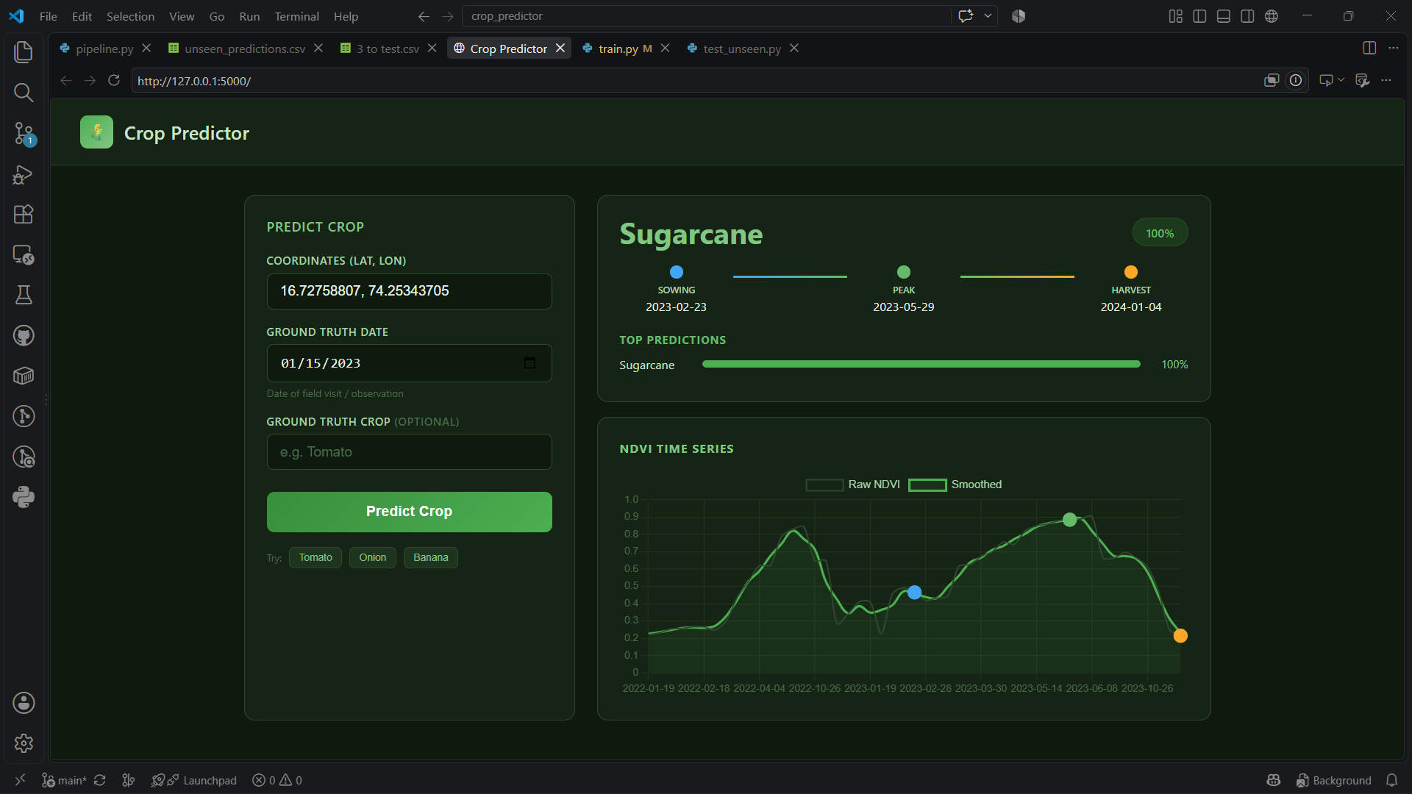
Figure 4: User interface of the Crop Predictor application, displaying crop prediction results, lifecycle stages, and the corresponding NDVI time-series visualization.

13. Challenges Faced
- GEE MultiPoint geometry: CSV asset ingestion grouped duplicate coordinates into MultiPoint geometries, causing filterBounds() to return zero images. Diagnosed after significant debugging; resolved by hardcoding all coordinates directly in the GEE script.
- Sugarcane lifecycle detection: Flat, slowly varying NDVI resisted all standard peak detection approaches. Required three iterations on the validation rules and two on the per-crop config before a usable valid-cycle count was achieved.
- DMS coordinates: 45 Tomato farm coordinates were in DMS format with inconsistent spacing and hemisphere indicators. Required a regex-based parser with edge-case handling.
- GEE computation limits: Extracting 4 years of data for 269 farms across a wide area hit GEE's per-request computation time limits. Resolved by switching to per-farm date windows of ±6 months.
- Small dataset: 269 farms across 6 crops, with not all producing valid cycles, is a small dataset for a multi-class problem. The latest unseen evaluation achieved 90.24% accuracy, but further labelled farm data is still needed to establish stronger generalisation.

14. Limitations
- The dataset is small. Accuracy and generalisation will improve as more labelled farm data is collected.
- The lifecycle detection is rule-based and crop-specific. Adding a new crop requires manually defining its config and validation rules, which depends on agronomic domain knowledge.
- Cloud contamination over some regions (Karnataka in monsoon season) caused significant gaps in the Tomato time series, reducing valid cycle detection rates.
- The Sugarcane and Banana classification remains weaker than the annual crops due to the flat NDVI profiles of perennial crops and their feature overlap.
- The web application fetches NDVI live from GEE, which adds latency (typically 10–30 seconds per prediction). Caching extracted time series per coordinate would significantly speed this up.

15. Future Scope
- Expand the farm point collection to cover more districts and more crops - Cotton, Soybean, Jowar, Bajra, Turmeric are the immediate candidates.
- Add DTW-based shape similarity classification alongside the feature-based RF, and compare the two on a larger dataset where reliable reference templates can be built.
- Implement a multi-index approach combining NDVI with EVI, LSWI, and NDWI for better crop separation, especially for perennial crops.
- Add crop health monitoring: compare an incoming NDVI series against a reference template for the predicted crop and flag anomalies - delayed sowing, suppressed peak, unusually early harvest.
- Extend the web application to accept a CSV of farm coordinates and return batch predictions, rather than one at a time.
- Cache GEE extractions by coordinate and date range to reduce prediction latency.

16. Conclusion
This project built a working end-to-end pipeline for NDVI-based crop lifecycle detection and multi-crop classification using Sentinel-2 satellite imagery. Starting from raw farm GPS coordinates, the system extracts NDVI time series from Google Earth Engine, detects phenological events per farm, validates cycles against agronomic calendars, engineers 13 lifecycle features, and classifies crop types using a Random Forest model. The latest unseen evaluation achieved 90.24% accuracy on 41 valid lifecycle samples.
The pipeline covers six crops (Onion, Tomato, Sugarcane, Banana, Grapes, Paddy) across three states, is modular enough to add new crops by defining a config and rule set, and is deployed behind a Flask web application that makes predictions in real time from any browser. The work demonstrates that satellite-derived NDVI, combined with careful lifecycle extraction and feature engineering, can reliably identify crop types at the farm level - without ever visiting the field.

17. References
- Tucker, C.J. Red and photographic infrared linear combinations for monitoring vegetation. Remote Sensing of Environment, 8(2), 127–150, 1979.
- European Space Agency. Sentinel-2 User Handbook. ESA Standard Document, 2015.
- Google Earth Engine. COPERNICUS/S2_SR_HARMONIZED Dataset Documentation. developers.google.com/earth-engine/datasets
- Breiman, L. Random Forests. Machine Learning, 45(1), 5–32, 2001.
- Pedregosa et al. Scikit-learn: Machine Learning in Python. JMLR 12, pp. 2825–2830, 2011.
- Virtanen et al. SciPy 1.0: Fundamental Algorithms for Scientific Computing in Python. Nature Methods, 2020.
- Cai et al. A high-performance and in-season classification system of field-level crop types using time-series Landsat data and a machine learning approach. Remote Sensing of Environment, 2018.
- Zhong et al. Efficient corn and soybean mapping with temporal extendability: A multi-year experiment using Landsat imagery. Remote Sensing of Environment, 2014.

