I choose Python for interview (also we can use C etc.)

Solutions codes presented in zip file.

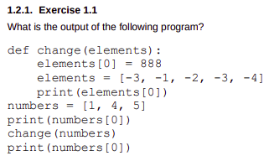

Aswer:

1

-3

888

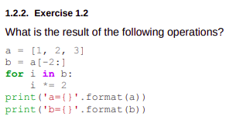

Answer:

a=[1, 2, 3]

b=[2, 3]

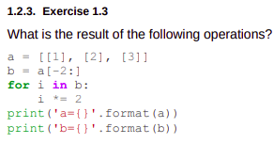

Answer:

a=[[1], [2, 2], [3, 3]]

b=[[2, 2], [3, 3]]

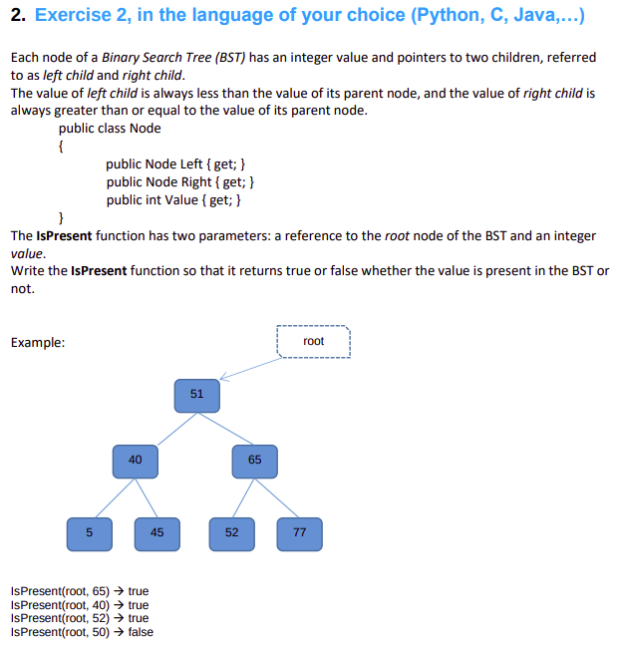

Answer (with Class):

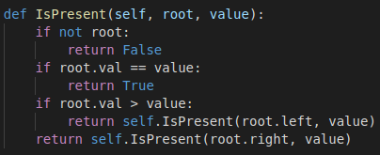

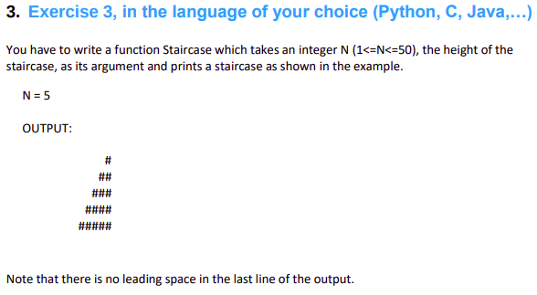

Answer:

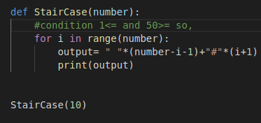

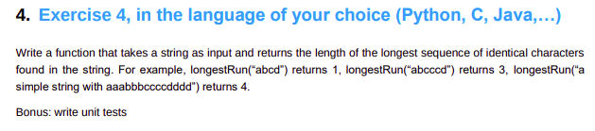

Answer:

