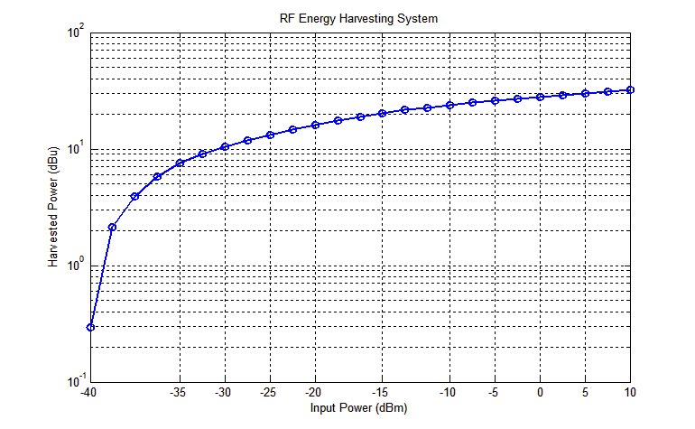

%% Constands

% Inputs, Outputs

Input_dBm=[-11,-10,-9,-8,-7,-6,-5,-4,-3,-2,-1,0,1,2,3,4,5,6,7,8,9,10];

Output_available_uPower=[3.78206478122059,5.75999999438698,7.96038996034141,11.0013555966224,15.2040070356233,21.0121223615618,29.0390082760932,40.1322620889368,55.4632735753951,76.6509176303600,105.932499018282,146.400000093588,187.300878345750,239.628545127481,306.575389005463,392.225680349766,501.804743116857,641.997739643223,821.357516764296,1050.82639499653,1344.40373392028,1720.00000036615];

Pharv=Output_available_uPower;

% Xbee constands (T:ms, and P: micro Power(uPower) )

Tb=12.98;Tbet=13.1;Tnbt=22; % ms

Ps=3.3;Pb=56.3069E+3;Pbet=63.303E+3;Pnbt=91.7352E+3; % micro power (uP)

%%%%%

%%%%%

%% Beacon - Enable Network

for i=1:length( Pharv ) % harvesting values

for n=0:999 % beacon quantity in a period

% T beacon enable total sleep (ms) = n*Ts1 + Ts2

Tbets((n+1),i)= ( n*Tb*(Pb-Pharv(i))+Tbet*(Pbet-Pharv(i) ) )./( Pharv(i)-Ps );

Tbep ((n+1),i) = n*Tb+Tbets((n+1),i)+Tbet;

Comm_be_minute((n+1),i)=1000/Tbep ((n+1),i);

Comm_be_hour((n+1),i)=(1000*60)/Tbep ((n+1),i);

Comm_be_day((n+1),i)=(1000*60*24)/Tbep ((n+1),i);

Comm_be_week((n+1),i)=(1000*60*24*7)/Tbep ((n+1),i);

Comm_be_mouth((n+1),i)=(1000*60*24*30)/Tbep ((n+1),i);

Comm_be_year((n+1),i)=(1000*60*24*365)/Tbep ((n+1),i);

end

end

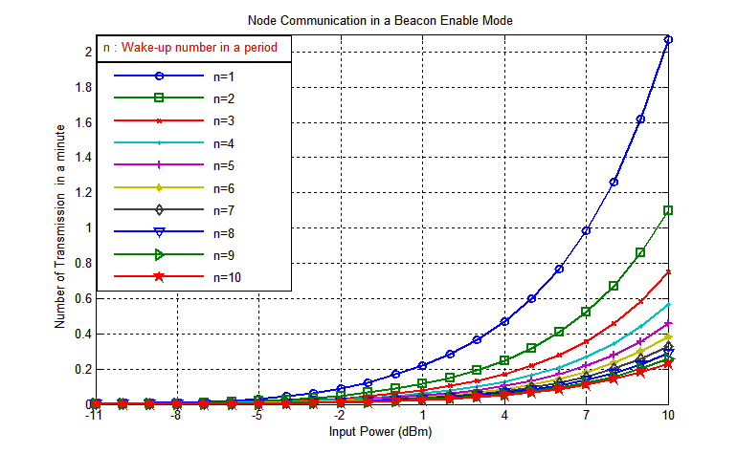

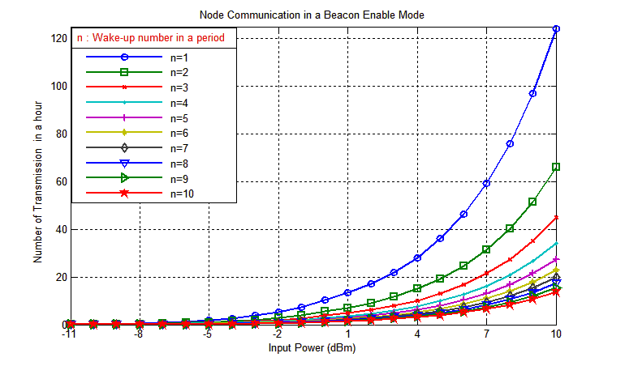 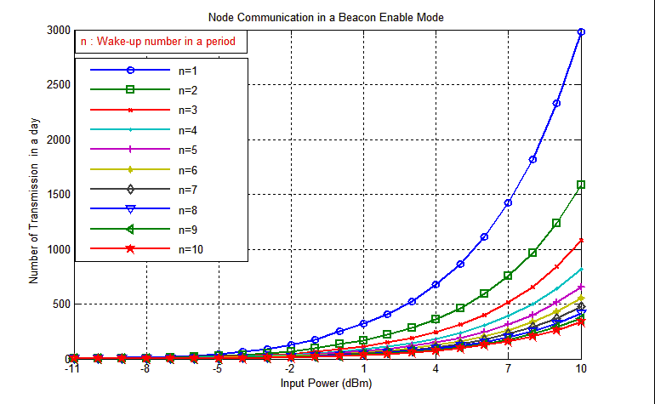

%% NoN-Beacon-Enable

for i=1:length(Pharv)

Tnbs(i)= Tnbt*(Pnbt-Pharv(i))./( Pharv(i) - Ps ); %non-beacon sleep times, ms

Tnbp(i) = Tnbt + Tnbs(i) ;% Non-beacon period (ms)

Comm_nb_minute(i)=1000/Tnbp(i);

Comm_nb_hour(i)=(1000*60)/Tnbp(i);

Comm_nb_day(i)=(1000*60*24)/Tnbp(i);

Comm_nb_week(i)=(1000*60*24*7)/Tnbp(i);

Comm_nb_mouth(i)=(1000*60*24*30)/Tnbp(i);

Comm_nb_year(i)=(1000*60*24*365)/Tnbp(i);

end;

