Büyük dil modelleri giriş

# Resume Atilla Özgür

* polyglot programmer
* database developer
* build engineer
* researcher

## Resume Atilla Özgür Professional

* Started programming in 1991, high school
* Graduated in Electrical Engineering in 2003 from best Technical University in Turkey METU
* 22 years of Professional Software Development experience
* 6 years is Project Management and Team Leading experience
* 7 years of Database Administration experience
* 6 years of AI and optimization Algorithm development for Steel Factories
* 1.5 years of GenAI-LLM experience

## Resume Atilla Özgür Professional

* Worked with different web application development platforms and Database Systems
* I have numerous Microsoft certifications (MCPD,MCSD,MCT)
* I am certified in Oracle (OCA 11g) and SQL Server (2000-2008) Databases.
* Worked with a lot of different programming languages professionally and academically
  + C#
  + Java
  + Python
  + Visual Basic
  + javascript
  + SQL
  + R

## Resume Atilla Özgür Academic

* Bachelor Degree in Electrical Engineering in 2003 from best Technical University in Turkey, Middle of Technical University
* Master of Science in Computer Engineering in 2008 from Atilim University, Turkey
* PhD in Electrical Engineering in 2017 from Baskent University, Turkey
* My thesis was was about machine learning, optimization and intrusion detection systems
* I used python, matlab, groovy, weka in my thesis
* My first post-doc work was about machine learning and optimization for steel production systems.
* My second,current, post-doc work in Constructor University is about LLMs for requirement management/contract handling

## Education

| University | Department | Degree | Start | End |
| --- | --- | --- | --- | --- |
| Middle East Technical University | Electrical Engineering | Bachelor | 1995 | 2003 |
| Atılım University | Computer Engineering | Master | 2004 | 2007 |
| Middle East Technical University | Medical Informatics (Incomplete) | Master | 2005 | 2008 |
| Başkent University | Electrical Engineering | PHD | 2007 | 2017 |

## Employment History

| Title | Company | Start | End |
| --- | --- | --- | --- |
| Postdoctoral Researcher | Constructor University Bremen - Mathematics and Logistics | 04/2024 | - |
| Adjunct Professor (Part time) | Ankara Science University | 09-2024 | 02-2025 |
| Senior Developer | SMS Digital | 02-2022 | 03-2024 |
| Adjunct Professor (Part time) | Constructor University | 09-2022 | 02-2024 |
| Assistant Professor | Ankara Yıldırım Beyazıd University - Computer Engineering | 06/2021 | 02/2022 |
| Postdoctoral Researcher | Jacobs University Bremen - Mathematics and Logistics | 01/2018 | 01/2022 |
| Database Administrator | Turkish Labor Agency | 07/2011 | 12/2017 |
| Software Developer and Build/DevOps Engineer | Milsoft | 05/2010 | 07/2011 |
| Senior Software Developer | Tilda Telekom | 10/2009 | 05/2010 |
| Software Trainer | Freelance | 06/2009 | 10/2009 |
| Software Project Manager | Turksat | 07/2008 | 06/2009 |
| Software Project Manager | Simetri | 09/2006 | 04/2008 |
| Software Trainer | Netsoft | 10/2005 | 12/2006 |
| Software Developer | Kale Yazılım | 10/2004 | 10/2005 |
| Software Developer | Veripark | 06/2003 | 10/2004 |

# Broader AI

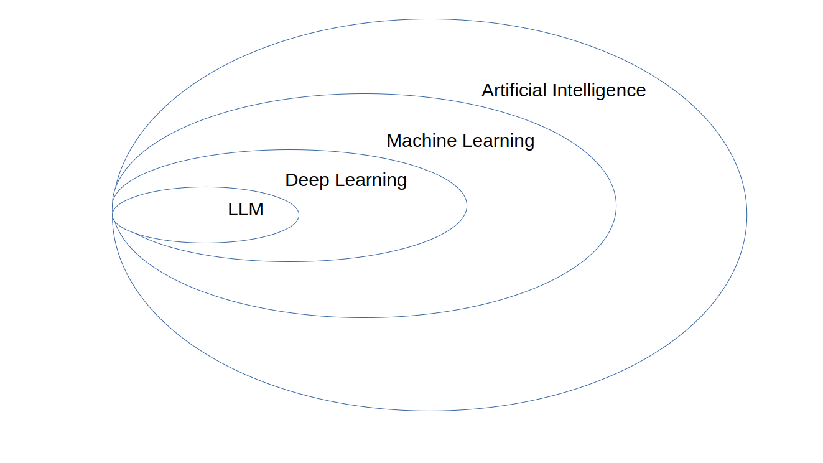

# Course contents for LLM

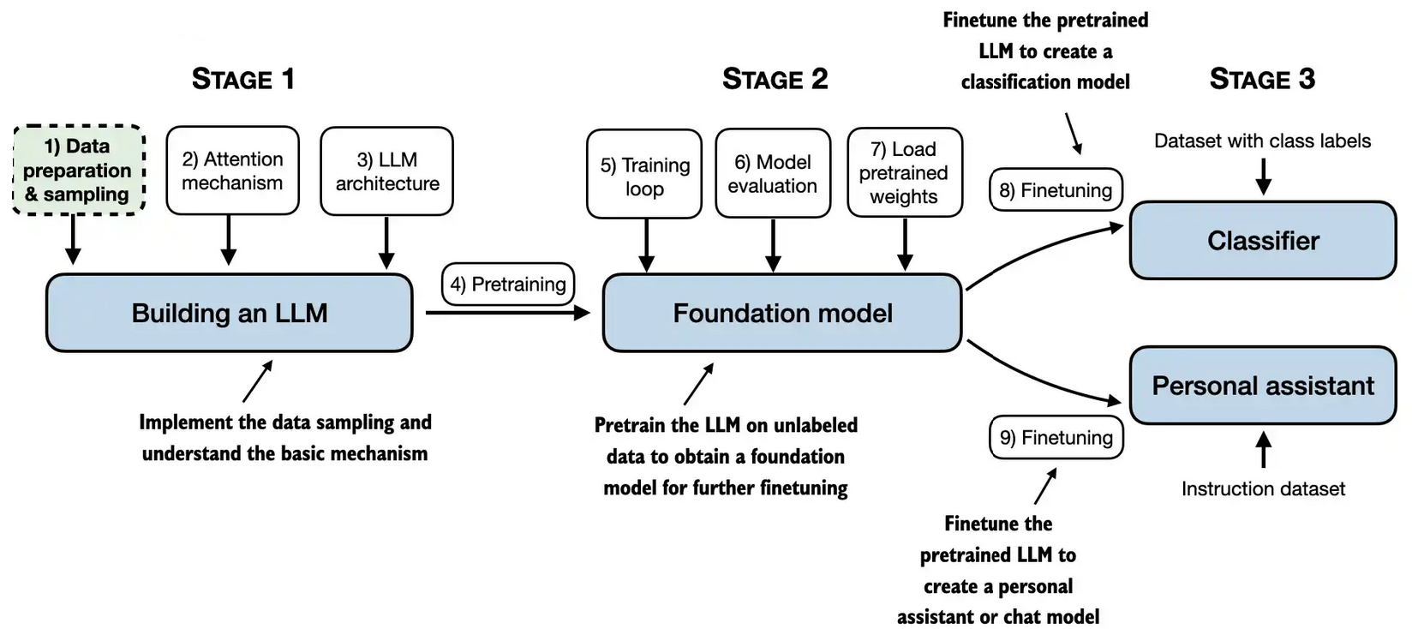

## Course book

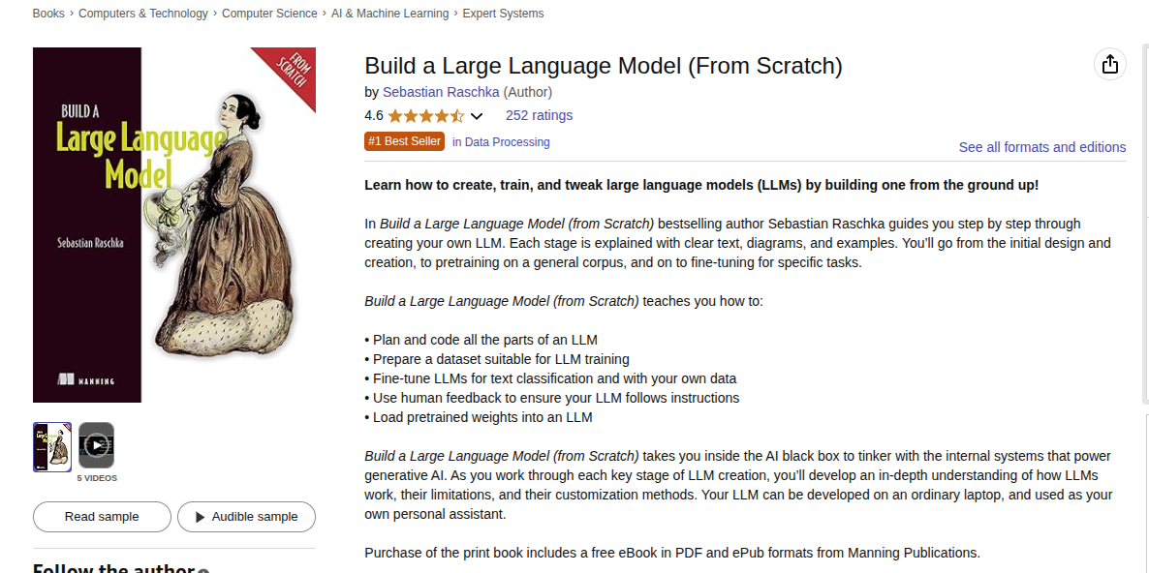

# How Large Language Models (LLMs) work

LLMs are built using supervised learning. They repeatedly predict next words using previous words.

**My favorite food is a Döner with spicy souse**

| Input A | Output |
| --- | --- |
| My | favorite |
| My favorite | food |
| My favorite food | is |
| My favorite food is | a |
| My favorite food is a | Döner |
| My favorite food is a Döner | with |
| My favorite food is a Döner with | spicy |
| My favorite food is a Döner with spicy | souse |

## How Large Language Models (LLMs) work 2

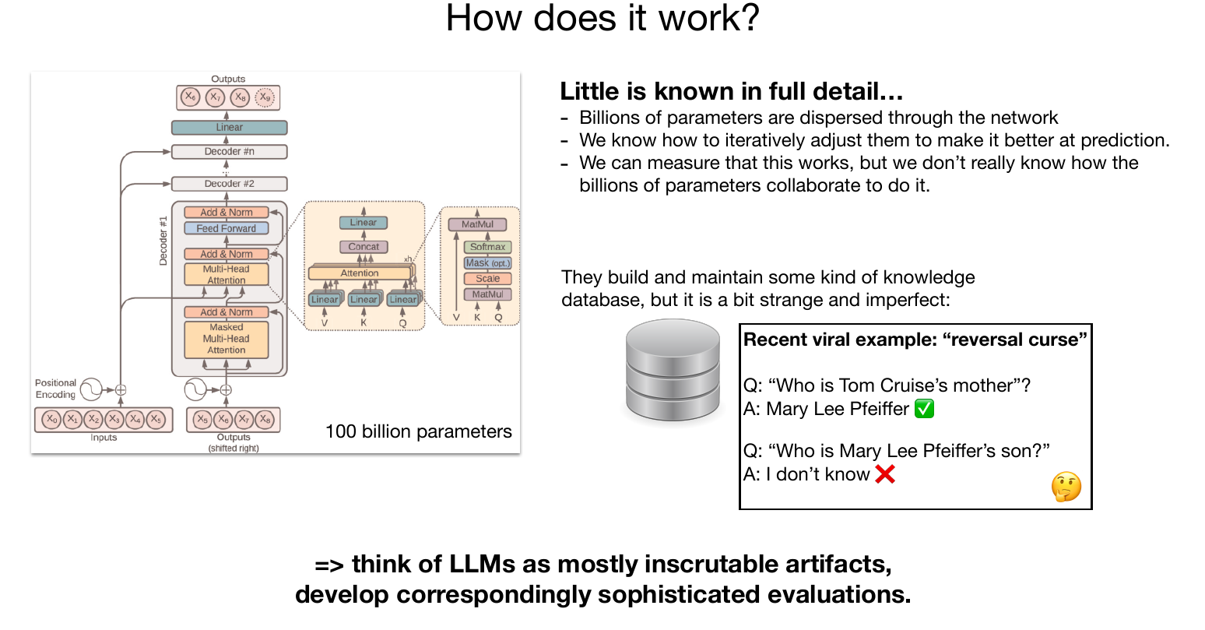

[source Andrej Karpathy: Deep Dive into LLMs like ChatGPT](https://www.youtube.com/watch?v=7xTGNNLPyMI)

## Stochastic Parrots

* the term stochastic parrot is a disparaging metaphor, introduced by Emily M. Bender and colleagues in a 2021 paper, that frames large language models as systems that statistically mimic text without real understanding.

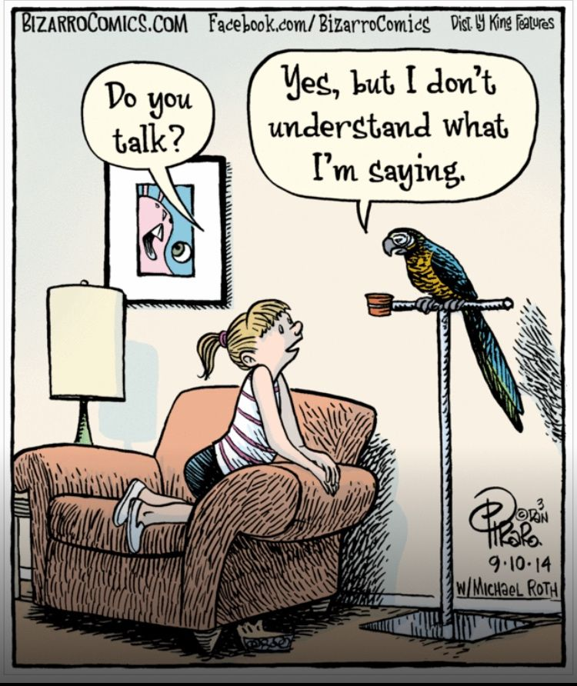

## Neural networks

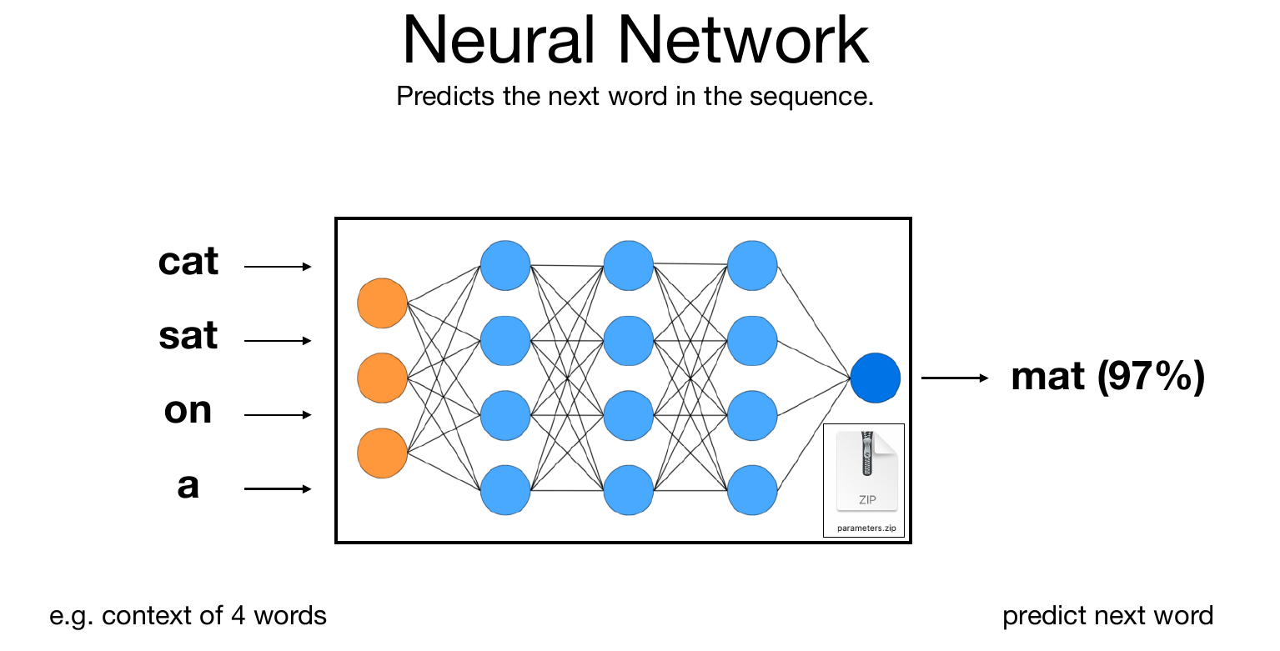

[Source Andrej Karpathy: 1hr Talk Intro to Large Language Models](https://www.youtube.com/watch?v=zjkBMFhNj_g)

## Single Neuron

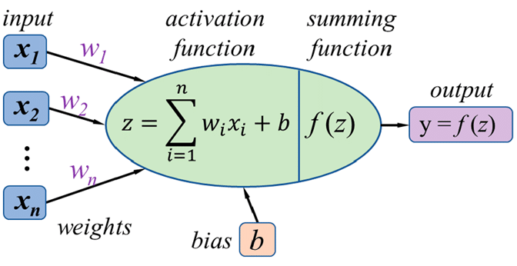

[source](https://discuss.pytorch.org/t/how-to-separate-each-neurons-weights-and-bias-values-for-convolution-and-fc-layers/136800/2)

## Different activation functions

* Sigmoid, widely used in old NN papers, is not here
* GELU, GPT activation function, is not here also
* More than 20 activation functions exist
* More activation functions are proposed continuously

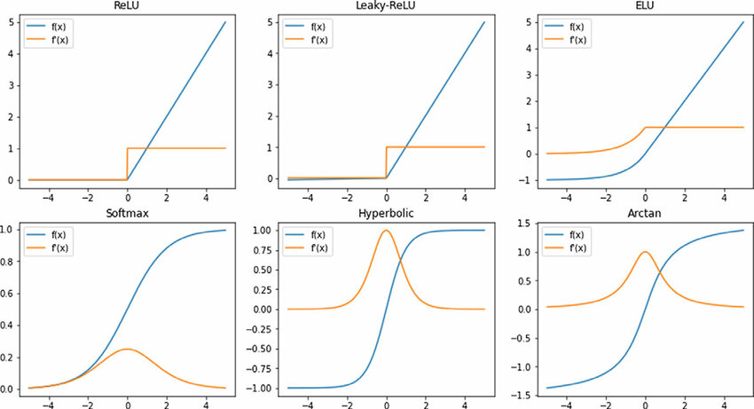

[source: A scalable species-based genetic algorithm for reinforcement learning problems](https://www.cambridge.org/core/journals/knowledge-engineering-review/article/scalable-speciesbased-genetic-algorithm-for-reinforcement-learning-problems/F81D312989BA030713E7CC2E87D20AC7#figures-tab)

## Neural networks internals

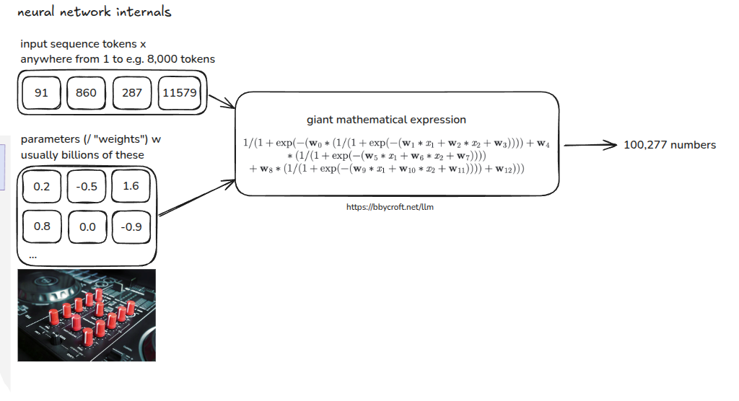

[source Andrej Karpathy: Deep Dive into LLMs like ChatGPT](https://www.youtube.com/watch?v=7xTGNNLPyMI)

## Sources

### Andrej Karpathy

* [Video: 1hr Talk Intro to Large Language Models](https://www.youtube.com/watch?v=zjkBMFhNj_g)
* [slides: 1hr Talk Intro to Large Language Models](https://drive.google.com/file/d/1pxx_ZI7O-Nwl7ZLNk5hI3WzAsTLwvNU7/view)
* [Video: Deep Dive into LLMs like ChatGPT](https://www.youtube.com/watch?v=7xTGNNLPyMI)
* [Slides:](todo%20add)

-[source Andrej Karpathy: Deep Dive into LLMs like ChatGPT](https://www.youtube.com/watch?v=7xTGNNLPyMI)