1.

a. log(4)

b. log(4, base = 4)

c. log(-3)

This message was returned because the log function is only defined for positive inputs. (x>0)

d. sqrt(7)



2.

a. x<- rnorm(15, 0, 1)

x

mean(x)

sd(x)

b. x<- rnorm(15, 10, 2)

x

mean(x)

sd(x)

c.

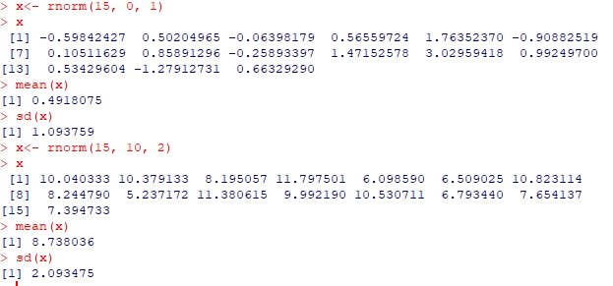

3.

c. w <- c(60, 72, 57, 90, 95, 72)

h <- c(1.80, 1.85, 1.72, 1.90, 1.74, 1.91)

people<-data.frame(w,h)

people

plot(w, h, main = "Weight vs Height Correlation",

+ xlab = "Weight (kg)", ylab = "Height (m)", frame = FALSE)

abline(lm(h ~ w, data = people), col = "blue")

sd_top<- function(w){

+

+ mean(w) - w

+

+ }

options(scipen = 999, digits = 4)

bmi <-function(w,h){

+ w/(h^2)

+ }

people$bmi = bmi(people$w,people$h)

people$mean_of_weight = mean(w)

people

people$diff =(people$w)

print(people)

sd_top<- function(w){

+

+ mean(w) - w

+

+ }

people$diff = sd_top(people$w)

print(people)

sum(people$diff)

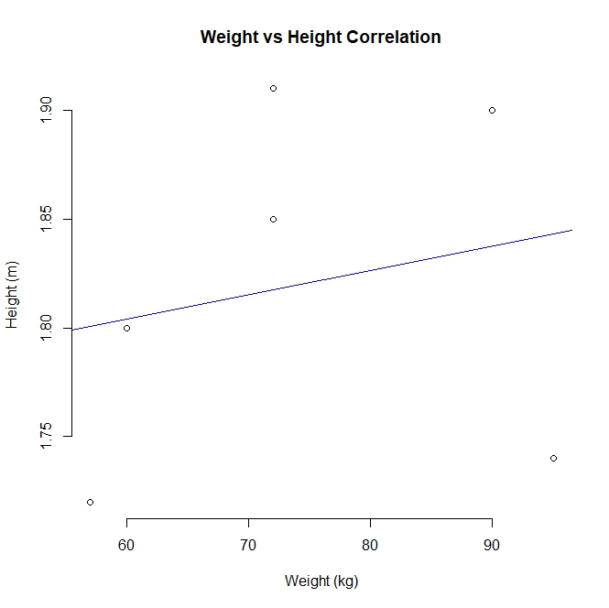

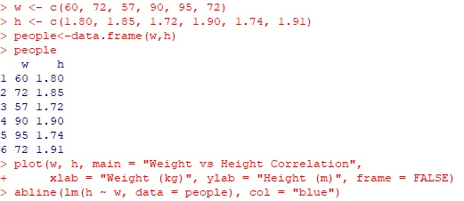

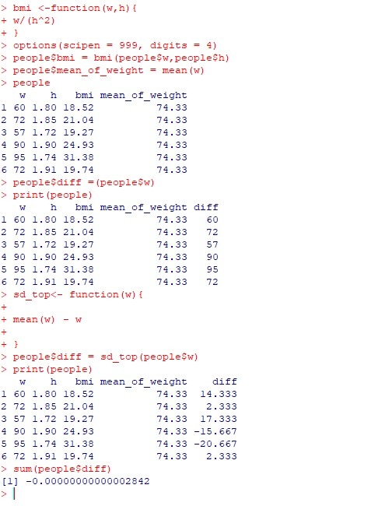

4. Audrene <- read.table(file = "profile.csv",header = T,sep = ",")

barplot(Audrene$Ranking,names.arg=Audrene$Categories,xlab="Skills",ylab="Ranking",col="blue",

+ main="Data Science Profile",border="red")



