**Software practicum update- Week2**

**Project Concept**

My project idea for this class is to develop a web-based Online Learning Management System (LMS). This LMS will serve as a centralized platform for educators and students to facilitate efficient and effective online learning experiences. I will adopt a 3-tier architecture comprising a user interface, a backend server handling logic and data processing, and a database to store all relevant information securely. This architecture will ensure scalability, maintainability, and separation of concerns throughout the development process. Key features of the system will include user and course management, student management, a discussion forums, grading and analytics/reports.

I will strive to adhere to the best and latest practices in software engineering including but not limited to documentation, modular design, scalability and code reusability. Overall, the main idea behind this project is to address the evolving needs of educators and students in the digital age, providing a robust platform for online learning that fosters engagement, collaboration, and continuous improvement.

Web Server Install

I successfully managed to install the apache2 web server in my ubuntu desktop environment through the following commands: ‘sudo apt update’ followed by ‘sudo apt install apache2’. Output from from the second command is show below:

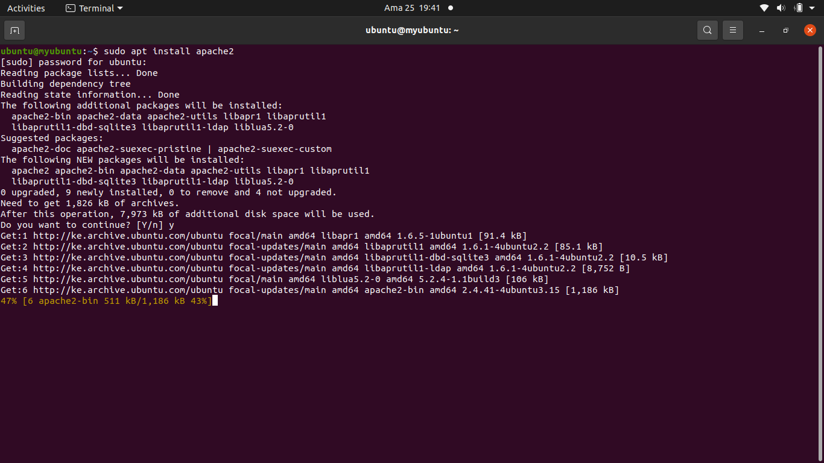

AFter installing, I was able to start the server through the command: ‘sudo systemctl start apache2’ then checked the status of the server via the command: ‘sudo systemctl status apache2’ as shown below. '

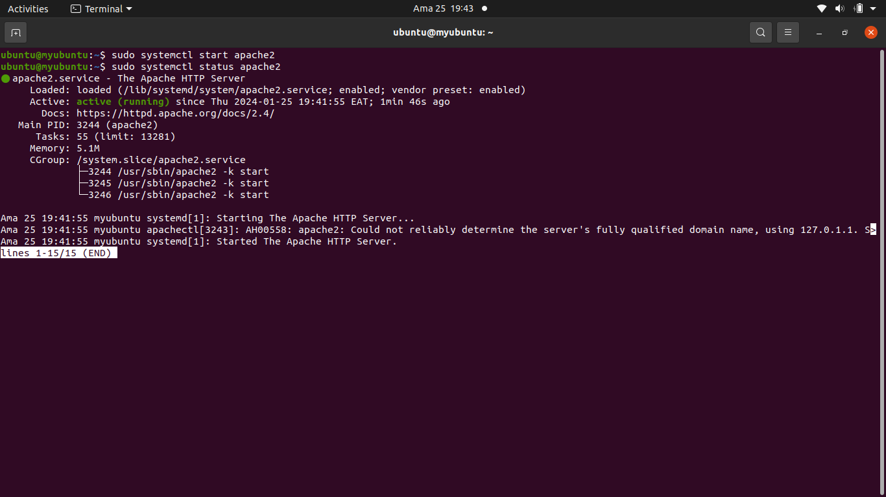

These are the fields notes that i had made for the installation process:

1. Sudo apt update (update package repository)
2. sudo apt install apache2 (install apache)
3. sudo systemctl start apache2 (start apache)
4. sudo systemctl status apache2 (check apache status)