DxMed — CDR Mediation Platform
  - High-Level Design (HLD) — version 1.0
17 October 2026
Table of Contents

Item | Value
Document | DxMed HLD, version 1.0 (as built)
Date | 17 October 2026
Status | Approved on 16 October 2026 with the default decisions D1–D8 (§15); updated to match release 1.0
Companions | DxMed_LLD.md (low-level design), DxMed_Operations_Guide.md (install, run, use)
Source | Go module dxmed + Next.js UI in ui/
Change history
Version | Date | Change
0.9 | 16 Oct 2026 | Design for approval
1.0 | 17 Oct 2026 | Approved as is. Updated to the implemented system: component layout, pipeline order, release-1.0 scope table (§3.3), UI screenshots (§8), measured coverage (§12), resolved decisions (§15)

1. Purpose and scope
DxMed is an offline (batch, file-based) CDR mediation platform. It collects raw CDR files from network elements, decodes them (ASN.1 BER, binary blocks, fixed-width, CSV, tagged text, JSON, XML), validates, filters, de-duplicates, sorts and merges partial records, enriches them, and writes classified output files such as roaming, local, MVNO, rejected and duplicate files for billing and other downstream systems.
Everything that Readg configured through Oracle tables and tab-separated rule files is configured from a web UI, using templates: decoding templates, rule sets, transform groups, lookup tables, merge profiles, routes and output templates. Configuration is versioned, can be tested offline against sample files (Template Lab) and is published to the engine without code changes or restarts.
In scope: collection, decoding, validation, filtering and transformation, record and file de-duplication, sort and merge, enrichment by lookups, output generation and post-actions, statistics, reporting, logging, audit, alarms, the web UI and the operations CLI.
Out of scope: online/real-time charging (Diameter Gy/Ro), rating, invoicing, TAP3 rating logic.

2. The “cocktail”: what we take from each reference
Both references were studied: Readg 6.11 (C / Oracle Pro*C) and CGRateS (Go). DxMed is a clean-room implementation: no source code from either was copied.
Capability | Readg 6.11 | CGRateS (ERs/EEs/FilterS) | DxMed
Binary / ASN.1 decoding | Strong. Tag table (CDR_DEF) with ~60 data types, header/trailer, blocks, EBCDIC | None | Readg model as a typed BER/TLV and binary-block decoder driven by a template tree; 28 data types
Text formats | Lines, CSV, tagged ASCII | CSV, FWV, XML, JSON with field templates | CGRateS-style field templates for CSV, FWV, tagged, JSON and XML
Field mapping | Fixed positions in an 800-byte ASCII record | Named paths | Named fields with dotted paths (location.lac)
Filtering | Strong. Call type → ordered conditions (OR) → items (AND); actions, reason codes, transform groups, stop/continue/error | Rich operator set (*prefix, *regex, *ipnet…) | Readg rule structure with the CGRateS operator set added (37 operators)
Field transforms | CDR_FILTER_GROUP functions | Converters | Union of both: 40 functions
Sort & merge | Strong. SORT, RELATE, MERGE_COND, MERGE_RULE, close times, COL/UNCOL stages | Partial cache TTL and expiry action | Readg algorithm + CGRateS TTL/expiry, crash-safe state in PostgreSQL
Duplicates | File level: sequence and date range per exchange | Record level by origin id | Both: file level (name, checksum, sequence range, time range, gap) and record level (hashed key)
Output routing | Per action suffix: directory, format, header/trailer; post-actions | Many exporters | Readg routing by action; writers CSV, FWV, lines, JSON lines, XML, BER; post-actions checksum, gzip, copy, move, delete
Statistics | Per file × call type × action × reason | Stats/metrics services | Readg statistics model + Prometheus metrics + UI reports
Config & ops | Oracle tables; one process per instance | JSON config, API, HA | UI + REST API, versioned config and immutable releases in PostgreSQL, multi-worker with row leasing
Licence note. CGRateS is licensed AGPL-3.0. DxMed uses it as a design reference only: no CGRateS code is copied or linked, and the reference clone is never committed or shipped.

3. Requirements

3.1 Functional requirements
ID | Requirement
FR-01 | Collect files from source directories; detect complete files (stable size and time, or done-marker); register each file with its SHA-256
FR-02 | Decode ASN.1 BER (definite and indefinite length, multi-byte tags, constructed types), fixed-length binary blocks with header/trailer, EBCDIC, tagged text, CSV, fixed-width text, JSON and XML
FR-03 | Decoding is template based and edited from the UI
FR-04 | Validate records (mandatory, kind, range, regex); invalid records go to the error route with a reason code instead of failing the file
FR-05 | Filter with rule sets edited in the UI: call type, ordered conditions, AND items, operators, value lists and lookups; actions route / drop / error / hold-for-merge / multi-route; reason code; transform group; stop/continue/error flow
FR-06 | Three filter stages like Readg: PRE (after decode), COL (merged records), UNCOL (partials that expired without completing)
FR-07 | Field transform library usable in rules
FR-08 | File-level duplicate and gap detection; record-level duplicate detection with a configurable key and retention
FR-09 | Sort and merge (collapse) of partial CDRs with relate keys, end conditions, merge rules, close times, TTL and maximum partials; pending partials survive restarts
FR-10 | Enrichment by lookup tables managed in the UI
FR-11 | Outputs by route with formats, header/trailer aggregates, naming patterns and gap-free sequence numbers
FR-12 | Output post-actions
FR-13 | Statistics per file × stage × call type × action × reason (count, duration, volume)
FR-14 | Configuration versioning: draft → validate → test → publish → rollback
FR-15 | Template Lab: run a sample file through draft configuration without touching production; saved cases gate publishing
FR-16 | Operations from UI: file explorer, reprocess, hold/release, cancel, re-drive, pending partials, manual close
FR-17 | Reports: volumes and reconciliation by day and stream, routes, reasons; CSV export
FR-18 | Logs and audit in the UI: log search, live tail, audit trail of every change
FR-19 | Alarms shown in the UI and exposed as metrics
FR-20 | Users and roles (viewer, operator, configurator, publisher, admin)

3.2 Non-functional requirements
ID | Requirement | Target
NFR-01 | Throughput | ≥ 50,000 records/s per worker for ~300-byte ASN.1 CDRs (benchmark pending, §3.3)
NFR-02 | Horizontal scale | N workers on one or more hosts share the queue; no double processing
NFR-03 | Correctness | Exactly-once per input file: outputs, statistics, dedupe keys and merge state commit together or not at all
NFR-04 | Recovery | A crash at any point resumes cleanly; no partial output file is ever visible downstream
NFR-05 | Config change | A publish takes effect at the next file, without restart
NFR-06 | Security | TLS on every listener, RBAC, audit, secrets never logged, no shell execution
NFR-07 | Test coverage | 100% statements on engine packages; ≥ 95% Go overall; ≥ 90% UI
NFR-08 | Platforms | macOS 13+ and Ubuntu 22.04/24.04
NFR-09 | Offline operation | No internet needed at run time; all UI assets served locally

3.3 Release 1.0 scope
ID | Status | Notes
FR-01 | Delivered (directory) | SFTP pull is planned; today an external sftp/rsync job can feed the source directory
FR-02, FR-03 | Delivered | Formats ber, binblock, csv, fwv, tagged, json, xml; 28 data types incl. EBCDIC
FR-04 … FR-09 | Delivered
FR-10 | Delivered | Lookup tables (set, map, prefix) are configuration objects, so they are versioned and released with the stream. CSV import is planned
FR-11 | Delivered | Writers csv, fwv, lines, jsonl, xml, ber. Database-table output is planned
FR-12 | Delivered (local) | checksum, gzip, copy, move, delete. SFTP push is planned; hooks are deliberately not provided
FR-13 | Delivered
FR-14 | Delivered | Version history per object, immutable releases, activate an older release (rollback), bundle export (JSON). Bundle import is planned
FR-15 | Delivered | Decoded samples, rule trace, output previews, reconciliation check; saved cases gate publishing
FR-16 | Delivered
FR-17 | Delivered | Volume, routes and reasons reports with CSV export. XLSX/PDF export is planned
FR-18 | Delivered | Live tail over Server-Sent Events
FR-19 | Delivered | Rules queue_depth, dead_files, seq_gap; acknowledge from the UI. Disk-space and “no file in N minutes” rules are planned
FR-20 | Delivered
NFR-01 | Open | Benchmarks per stage still to be written and run
NFR-02 … NFR-06, NFR-09 | Delivered
NFR-07 | Delivered | Measured: Go 97.3% overall, every engine package 100%; UI 99.85% statements (§12)
NFR-08 | Delivered on macOS | Ubuntu scripts follow the DxPS conventions but were not run in this release

4. Architecture overview
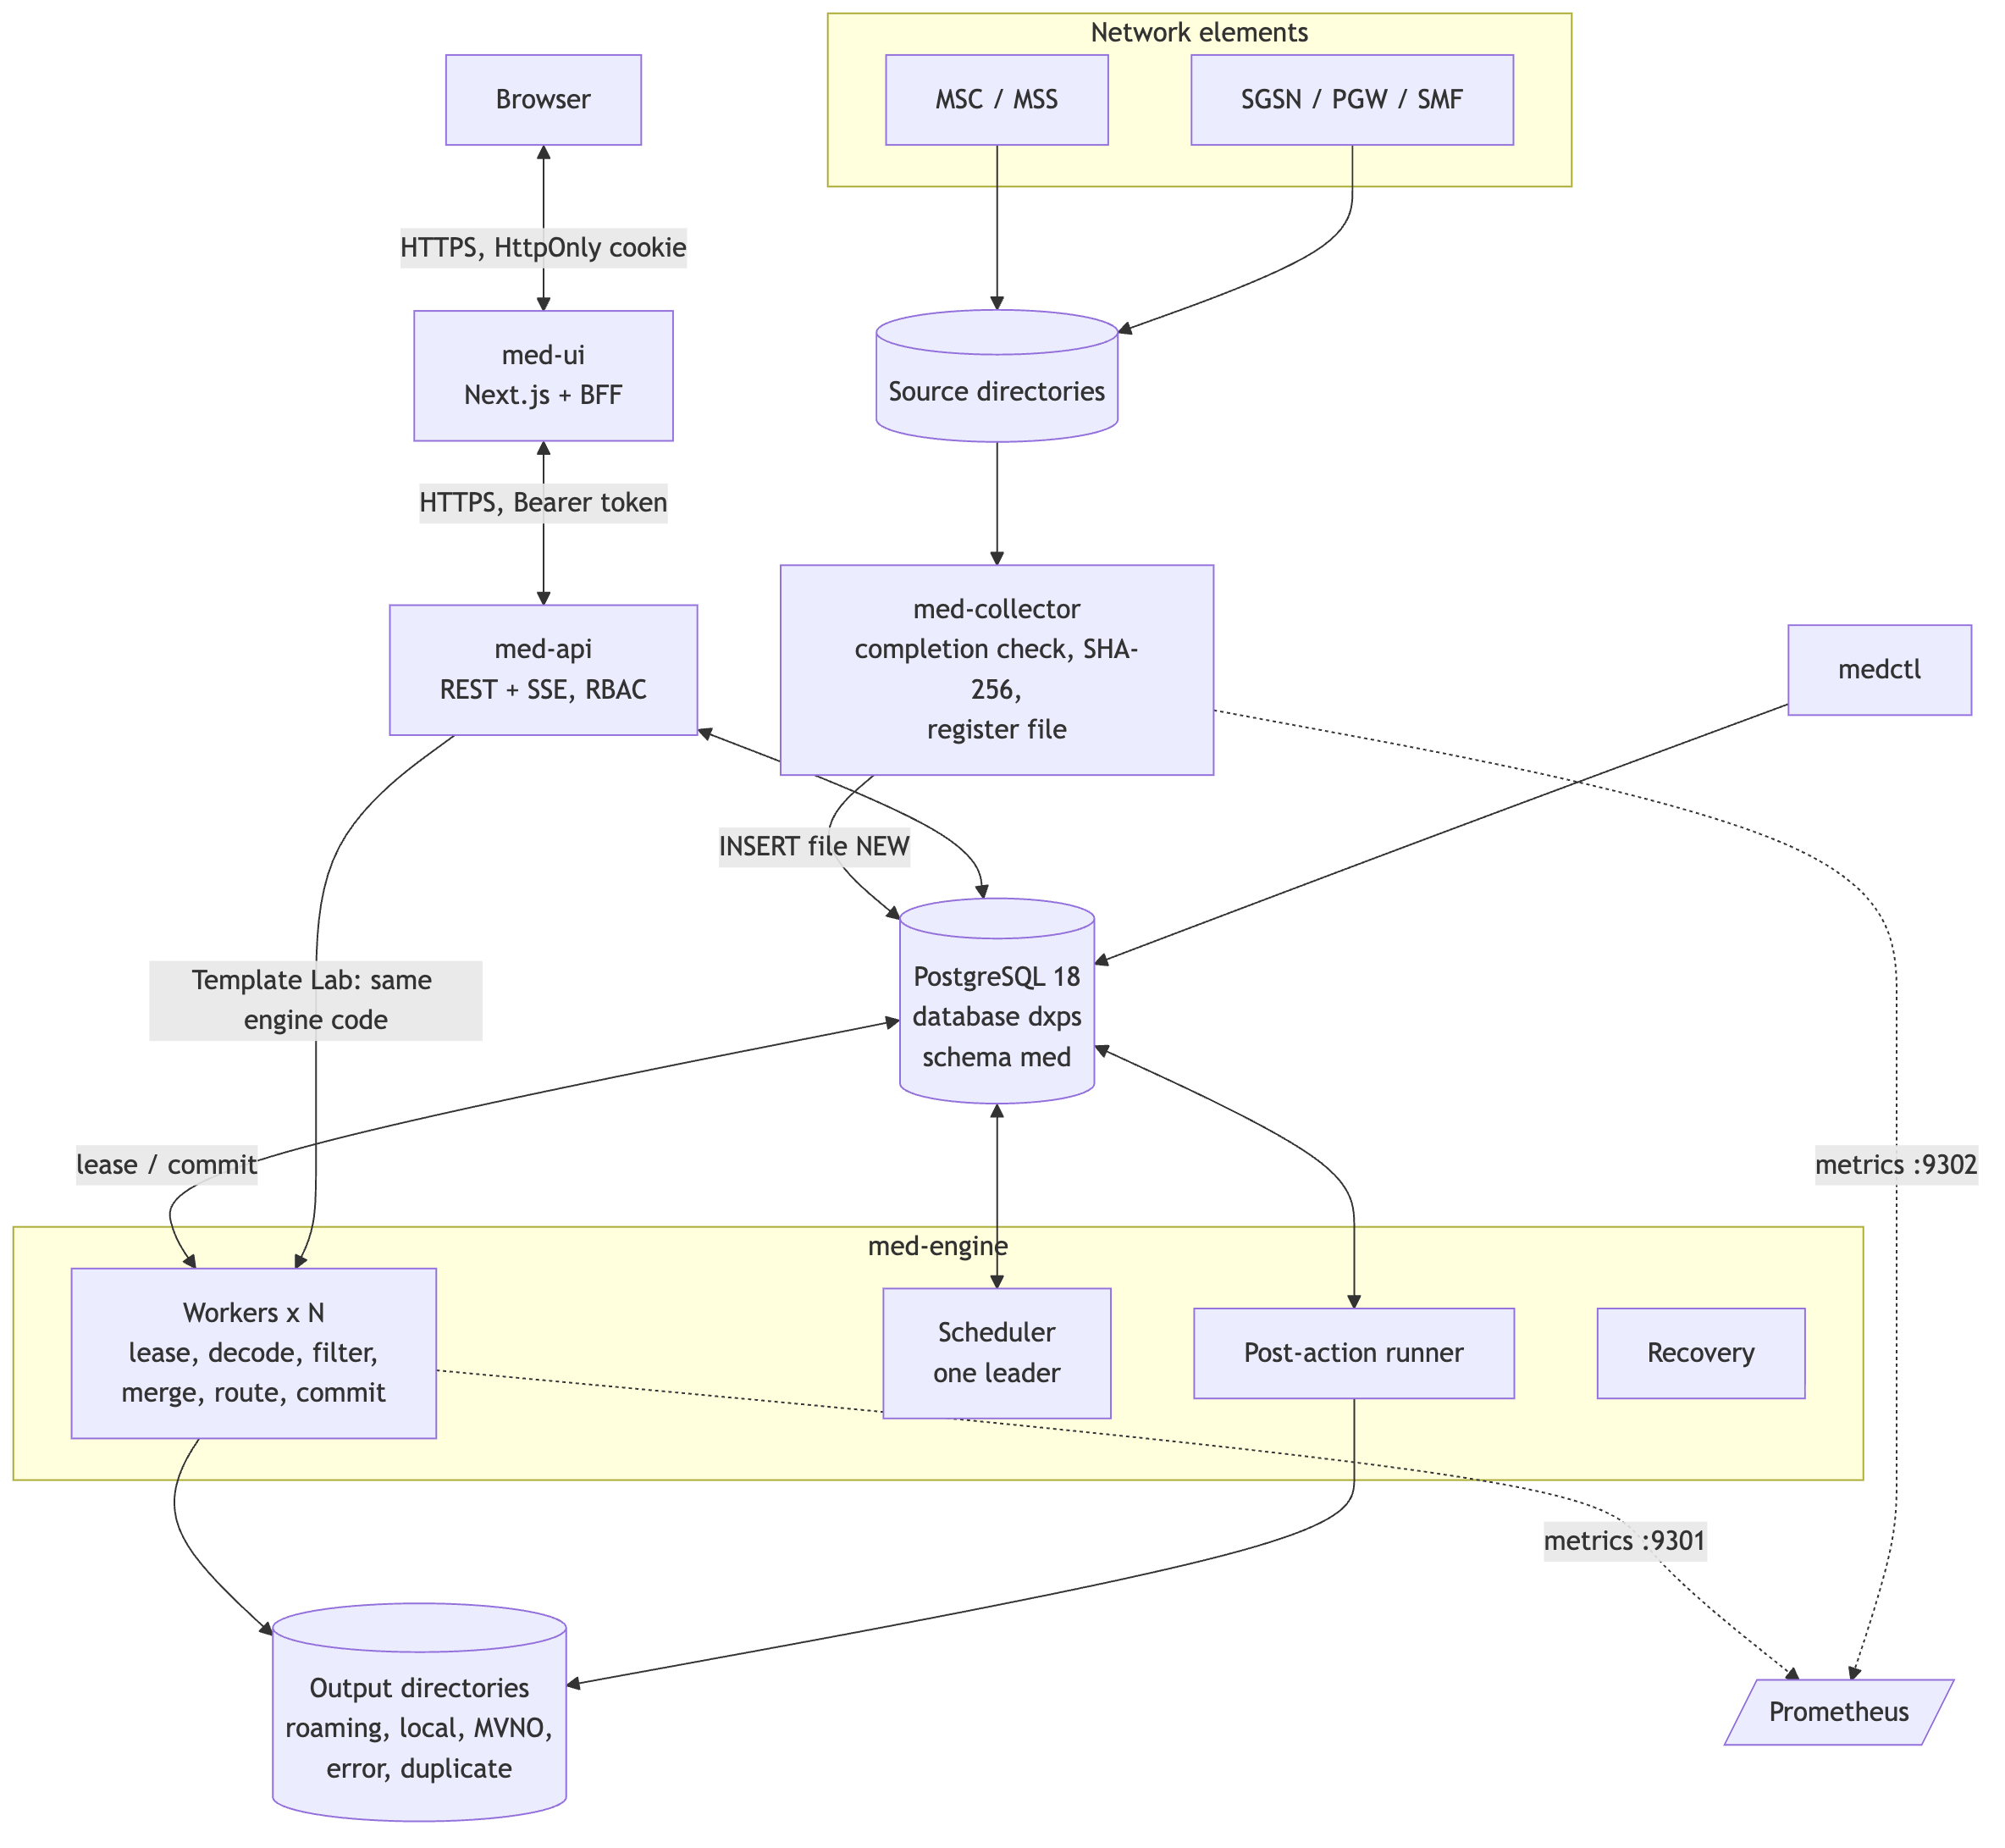

4.1 Components
Component | Language | Role
med-collector | Go | Scans each enabled stream’s source directory, waits until a file is complete, computes SHA-256 and registers it as NEW
med-engine | Go | Runs N workers that lease files and run the pipeline (§5); also the post-action runner, crash recovery and the scheduler. Several engines may run; one is scheduler leader
Scheduler (inside med-engine) | Go | Leader by lease row in med.leader. Resets expired leases, retries failed files with back-off, marks files POSTED, keeps daily partitions 7 days ahead, applies retention, flushes expired partials, evaluates alarms
med-api | Go | REST API for configuration, releases, Template Lab, operations, reports, logs (SSE), alarms, users and settings; authentication and RBAC; audit
med-ui | TypeScript (Next.js 16, React 19) | Web console. Its server is a backend-for-frontend: it holds the session in an HttpOnly cookie and forwards calls to med-api
medctl | Go | CLI: migrate, bootstrap, seed, publish, user, gen (sample CDR files), partitions, status
PostgreSQL 18 | — | Same cluster and database as DxPS (localhost:5433, database dxps), schema med, own roles
All Go components come from one Go module and share the engine packages. Template Lab in med-api runs the same pipeline code as the workers, so a Lab result is what production will do.

5. Processing pipeline

Part 1 — intake, decoding and the PRE stage
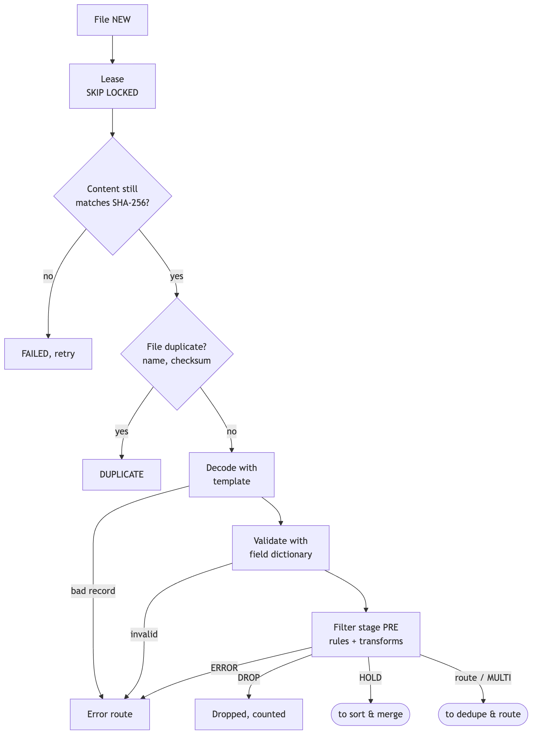

Part 2 — sort & merge, dedupe, routing and commit
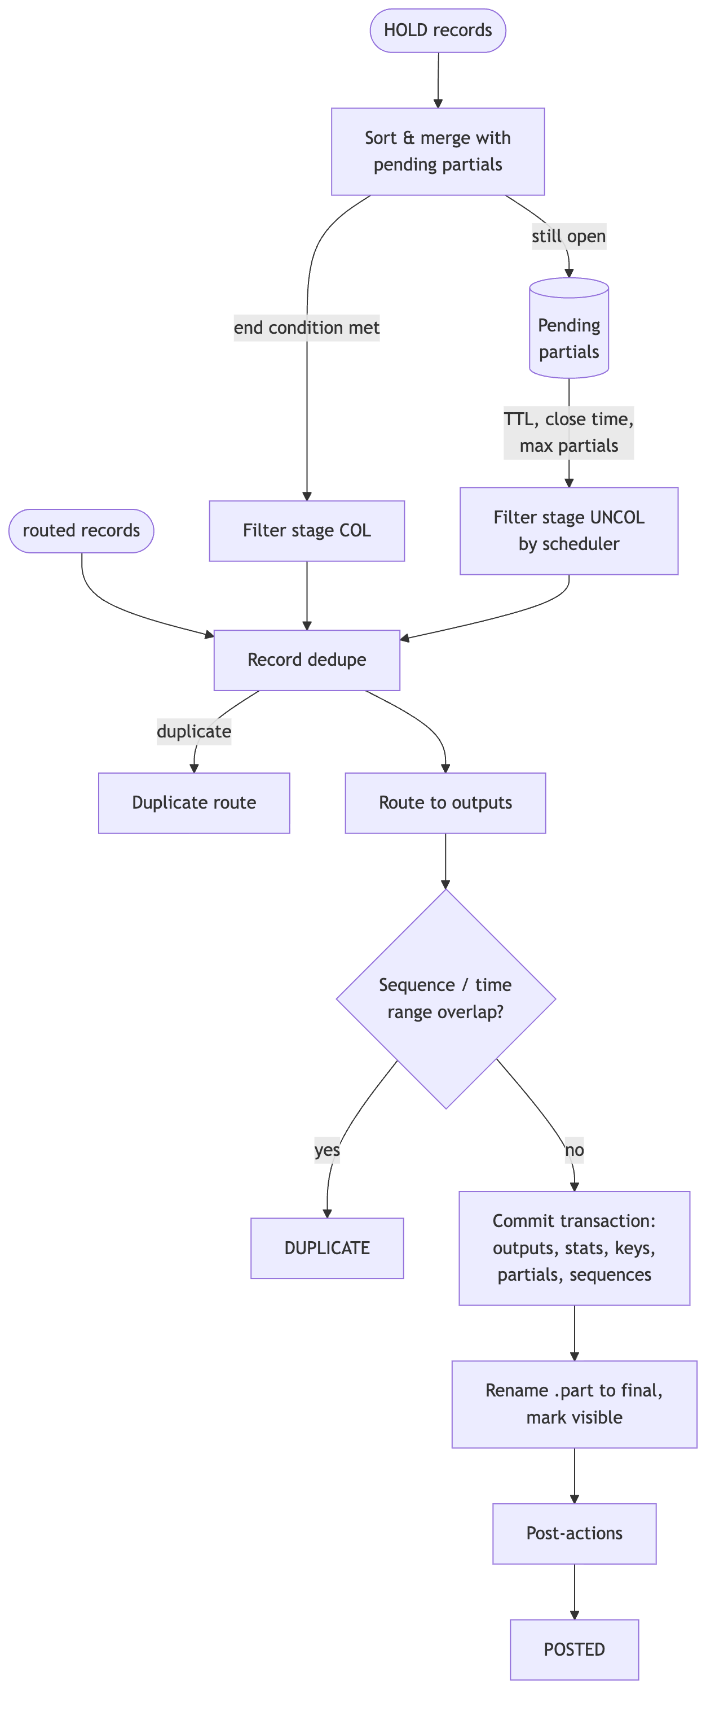
Key behaviours:
- Stream. Every source belongs to a stream (Readg’s association). A stream binds source → decoding template → field dictionary → rule set → merge profile → lookups → routes.
- Per-record error isolation. A bad record never fails the file; it goes to the error route with a reason code (DECODE:…, VALIDATION:…, NO_RULE, or the rule’s reason). A file fails only on structural problems (unreadable, content changed, no plan) or when a rule with flow error fires.
- Two-pass rules (from Readg): the general block (*any) runs first; then the block of the record’s call type, unless a general condition stopped evaluation.
- Sort & merge holds partials across files until the end condition, a close time, the TTL or the partial limit. Files of a merge stream are processed one at a time (advisory lock) so partial state stays consistent.
- Commit protocol: outputs are written as .part files in <dir>/.tmp; one transaction stores output rows, statistics, dedupe keys, partial state and route sequences; then files are renamed into place. Downstream systems never see a half-written file (LLD §9).
- Reconciliation: for every file in = out + err + drop + held + dup; the reports page shows it per day.

5.1 File lifecycle
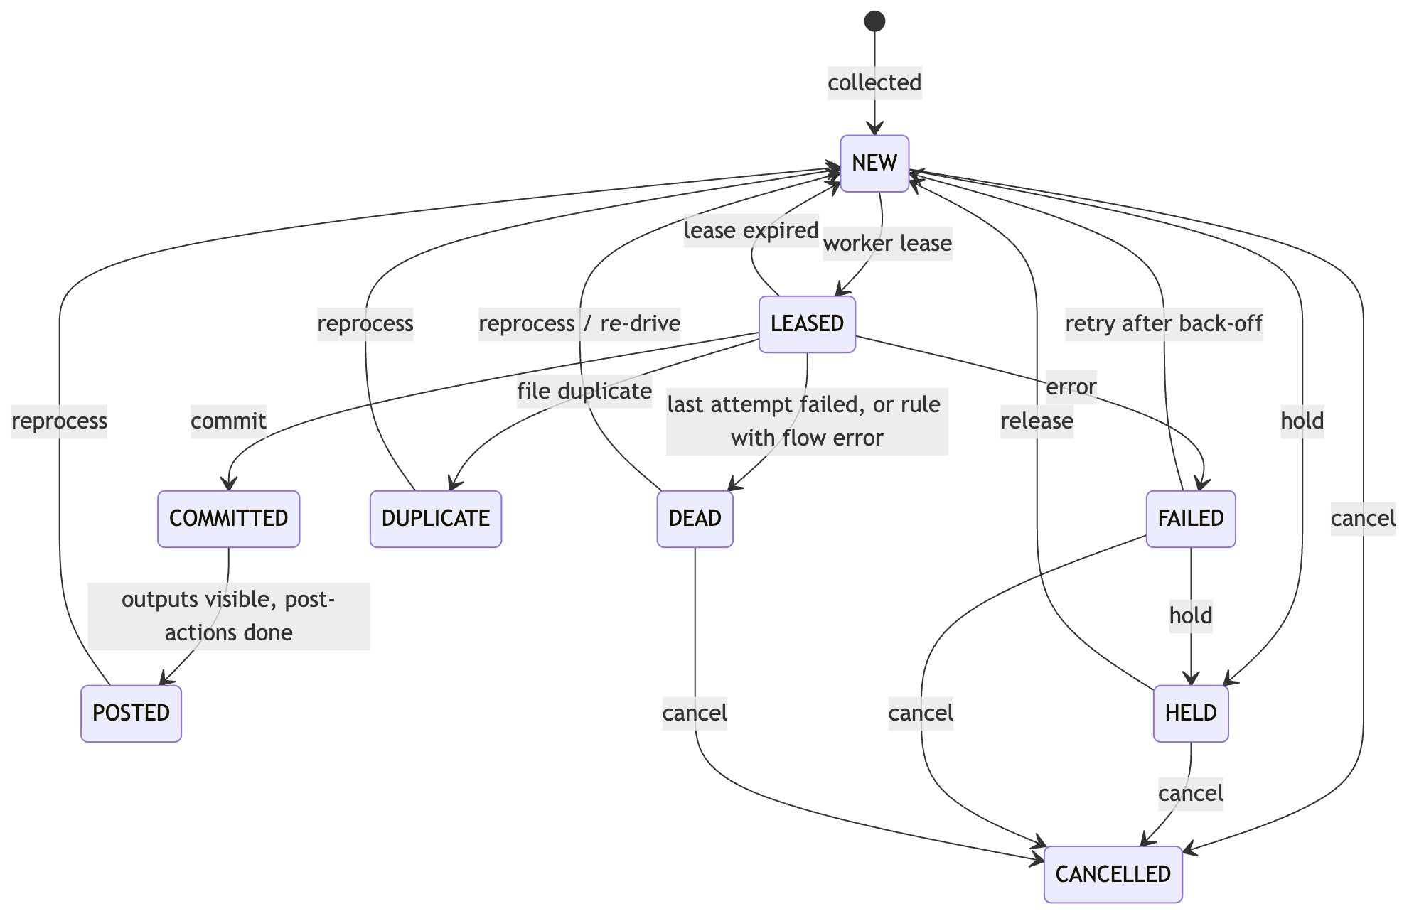

6. Configuration model
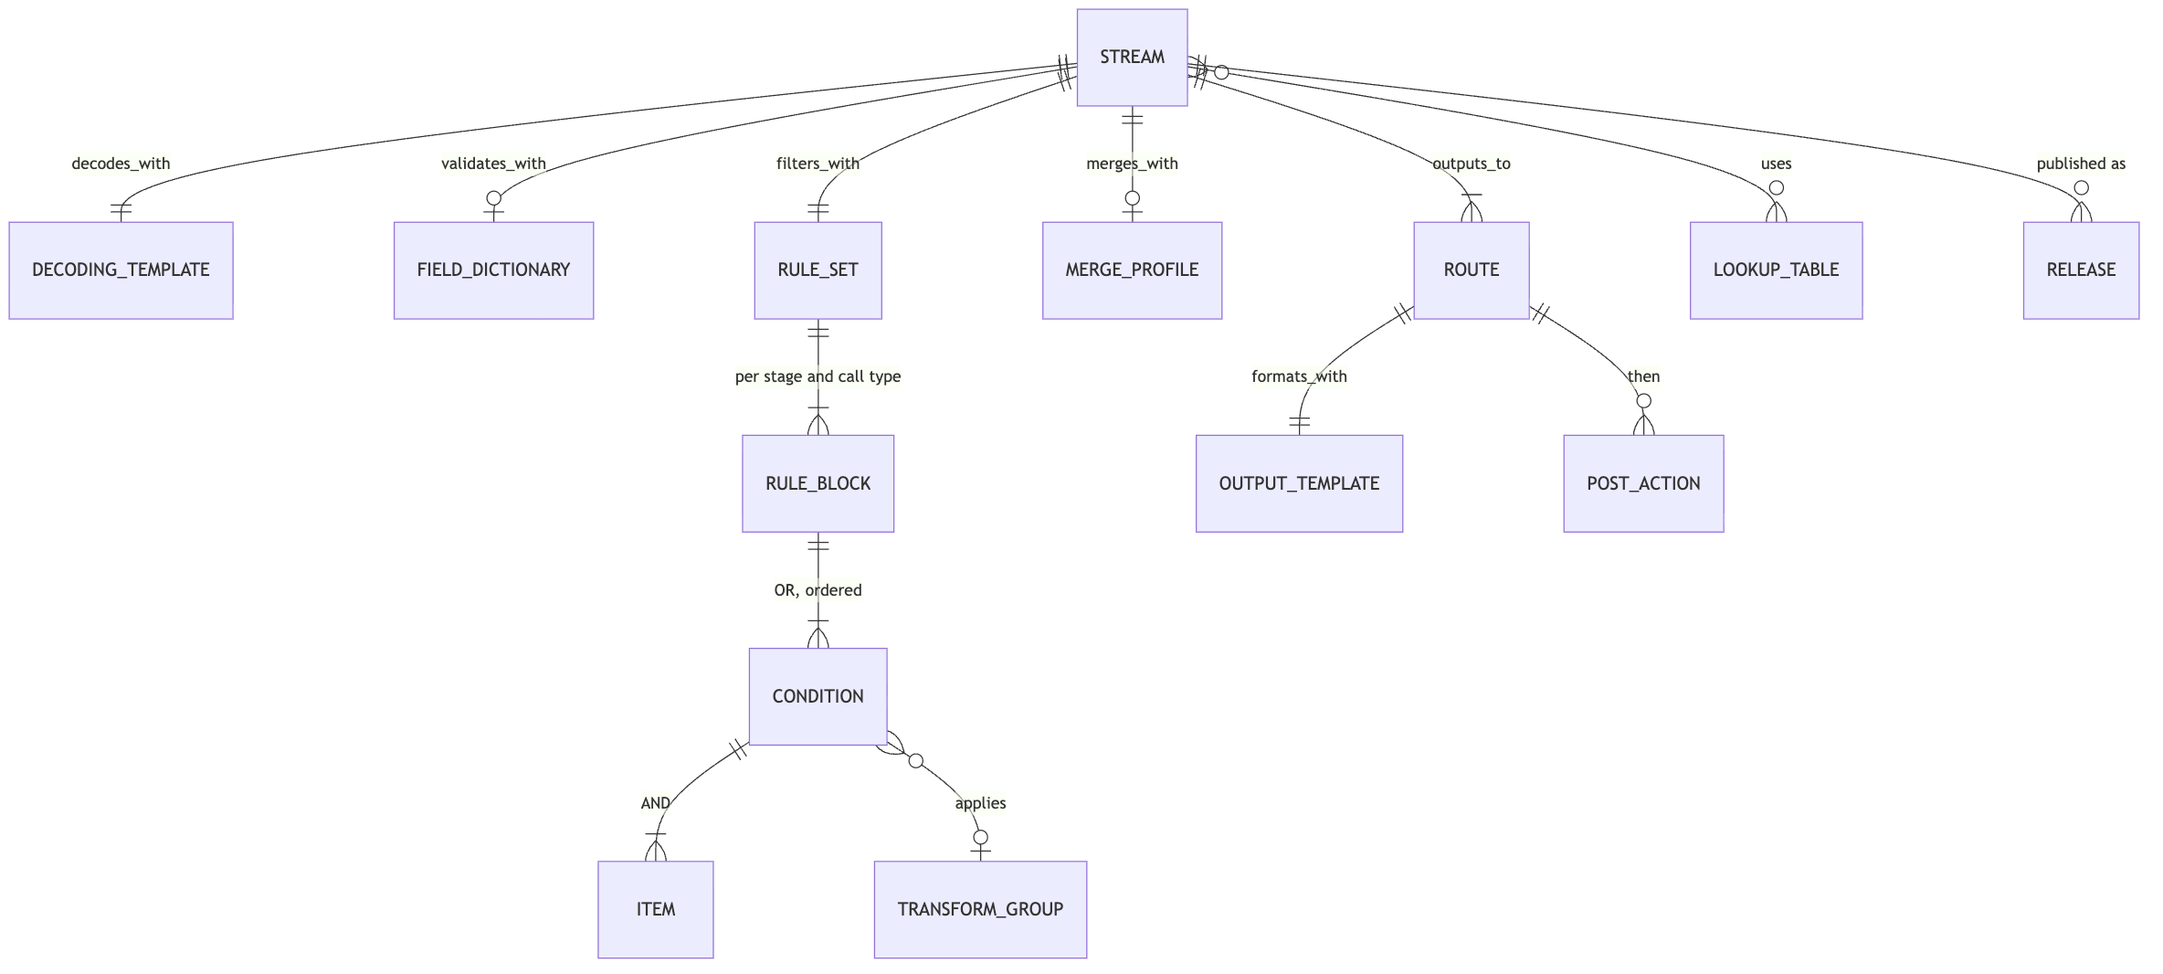
Object (kind) | Readg equivalent | Purpose
stream | Association, CDR_INFO | Source directory and pattern, completion rule, objects used, dedupe policy, error and duplicate routes
decoding_template | CDR_DEF, CDR_HEADER_TRAILER | Format, header/trailer/blocks, tag/field tree with data types, exchange id and sequence from the file name
field_dictionary | Output positions | Field names with kind, mandatory, range and regex checks
rule_set | CDR_FILTER_HEAD, CDR_FILTER | Ordered rules per stage (PRE, COL, UNCOL) and call type
transform_group | CDR_FILTER_GROUP | Ordered field functions applied when a rule fires
lookup_table | VALIN, VALDB, LOOKP | set, map or prefix (longest match) tables
merge_profile | CDR_GROUP_DATA_SETUP, CDR_CLOSING_PARAMETERS | Sort, relate, end condition, merge rules, close times, TTL, max partials, expiry policy
route | CDR_PROCESSING_OUTPUT | Action code → output template, directory, naming, rotation, post-actions
output_template | Output layouts | Writer format, fields, header/trailer with aggregates
Versioning. Every save creates a new version of the object (history kept, any version can be loaded back). Publishing a stream validates all referenced objects, runs the stream’s saved Template Lab cases, then stores an immutable release (a bundle of all objects with its SHA-256) and activates it. Every processed file records the release it used. Activating an older release is the rollback.
Example — roaming vs local split (stream MSC_ERICSSON, stage PRE, call type 1):
Cond | Field | Operator | Value | Action | Reason
general 1 | duration_s | = | 0 | DROP | ZERO_DUR
general 2 | cause_for_term | *in | 98, 99 | ERROR | ABNORMAL_TERM
1 | served_imsi | *notprefix | lookup home_plmn | R (outbound roaming) | ROAM_OUT
2 | msc_id | *notin | lookup home_msc | I (inbound roamer) | ROAM_IN
3 | served_msisdn | *prefix | lookup mvno_ranges | MVNO + transform TG_MVNO | MVNO
default | — | — | — | L (local) | LOCAL_MO

7. Data and database
Same PostgreSQL as DxPS: cluster localhost:5433 (TLS, verify-full against the DxPS CA, SCRAM-SHA-256), database dxps, schema med. DxMed never reads DxPS tables (decision D3).
Role | Rights
med_owner | Owns schema med, runs migrations
med_app | Run-time read/write (engine, collector, API)
med_ops | Operations tasks; member of med_reader
med_reader | Read-only for reporting tools
Table groups (DDL in LLD §10):
- Configuration: config_object (all versions), view config_current, release, lab_case, setting.
- Processing: file (job queue and lifecycle), file_event, file_seq_range, file_stat, output_file, route_seq, record_key, partial_record, error_record, post_action_job.
- Observability and security: event_log, audit_log, alarm, app_user, session, worker, leader.
High-volume tables (file_stat, record_key, error_record, event_log) are partitioned by day; the scheduler creates partitions 7 days ahead and drops old ones by retention. CDR contents live in output files, not in the database; only rejected records keep their raw bytes (for the hex view).

8. User interface
Next.js 16 / React 19 / TypeScript, served over HTTPS on https://localhost:8090. The browser only talks to the UI server; the UI server forwards /bff/* to med-api with the user’s token. Pages are shown or hidden by role, and the API enforces the same roles.
Area | Pages
Operations | Dashboard, Files (and file detail), Outputs, Rejected records, Partials, Alarms
Configuration | Streams & releases, Configuration objects (list, JSON editor with version history, copy from template), Template Lab
Insight | Reports (volume, routes, reasons; CSV), Logs (search, live tail), Workers, Audit trail
Administration | Users, Settings, My account (password change)
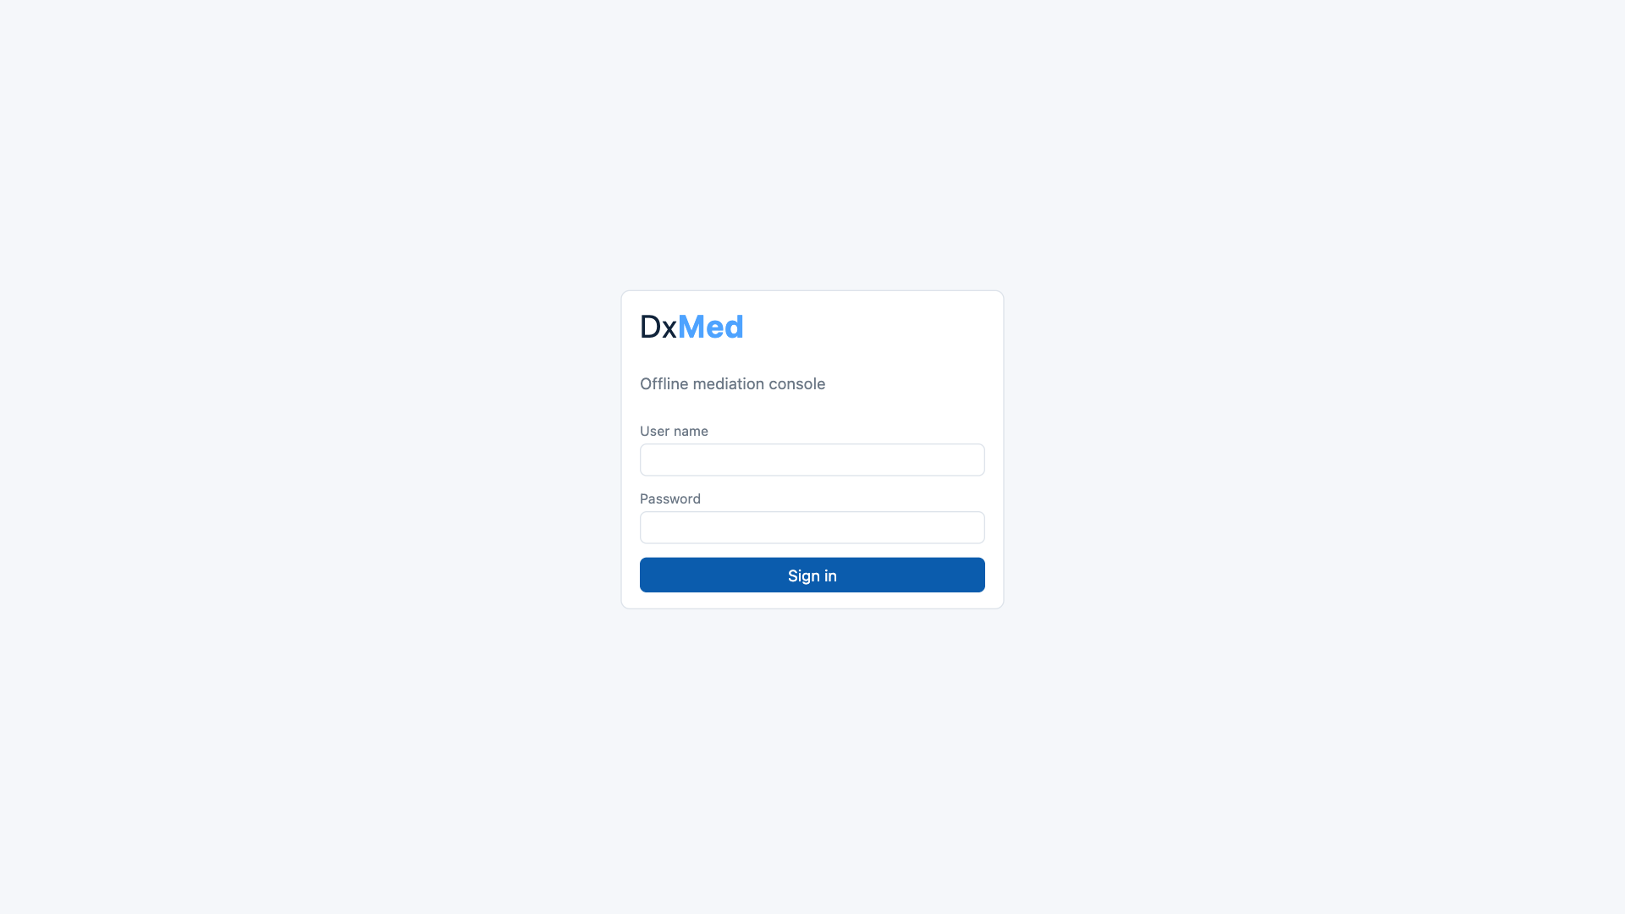
Sign-in page
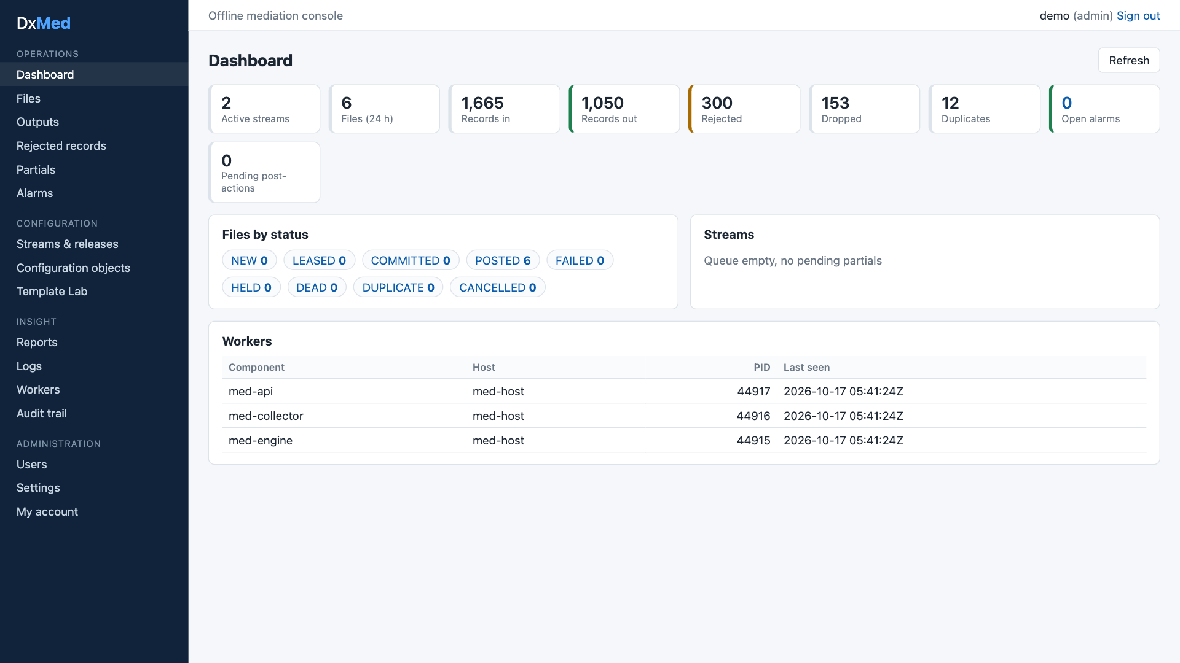
Dashboard: totals, files by status, workers
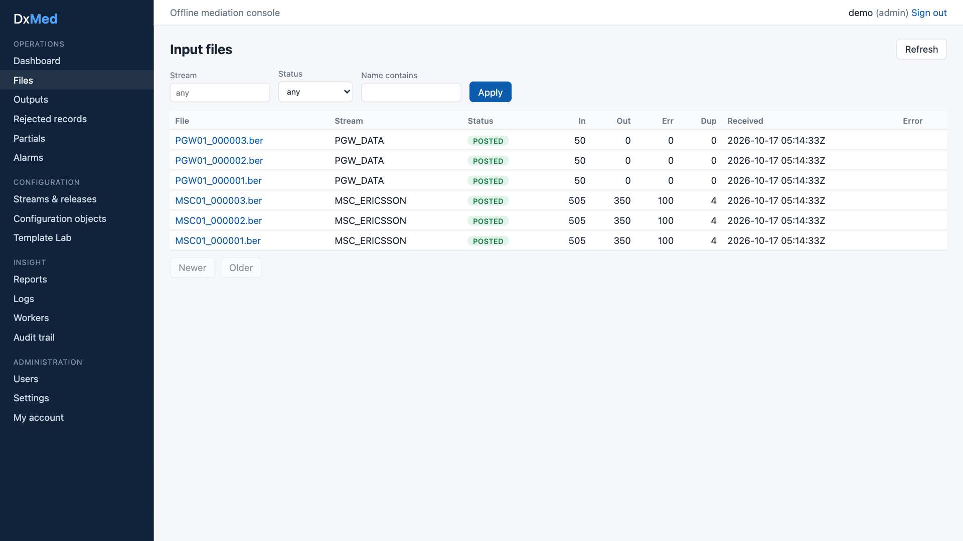
Input files with reconciliation counters
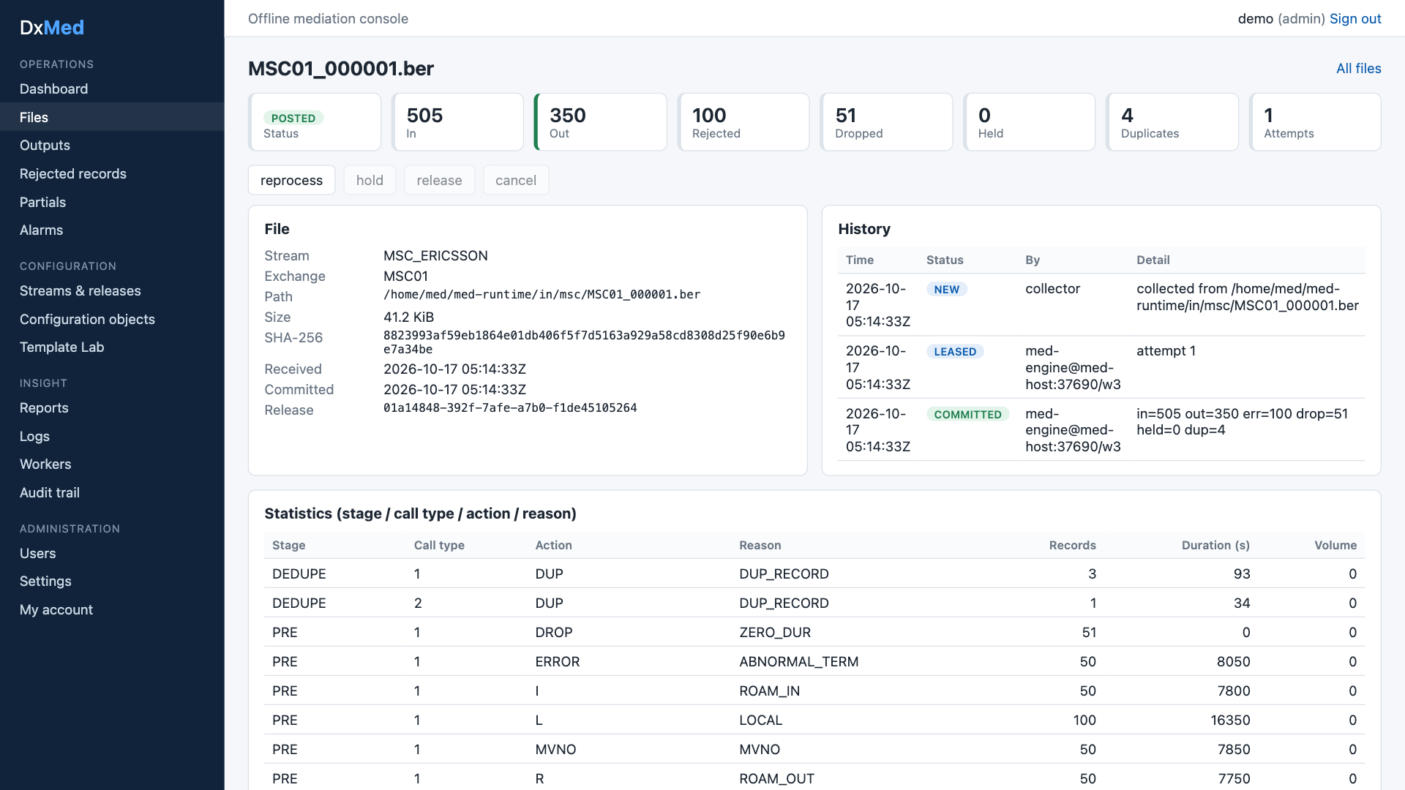
File detail: counters, history, per-stage statistics, output files
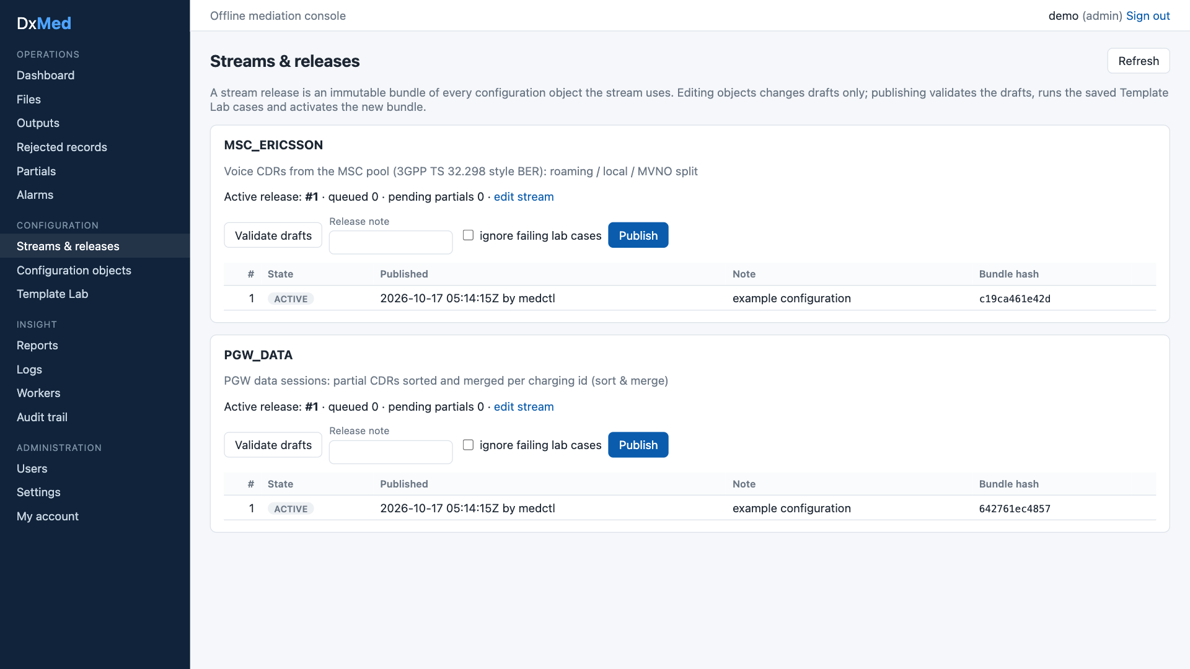
Streams & releases: validate, publish, release history
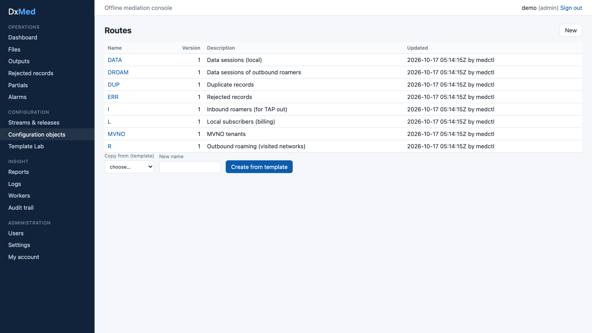
Configuration objects: routes
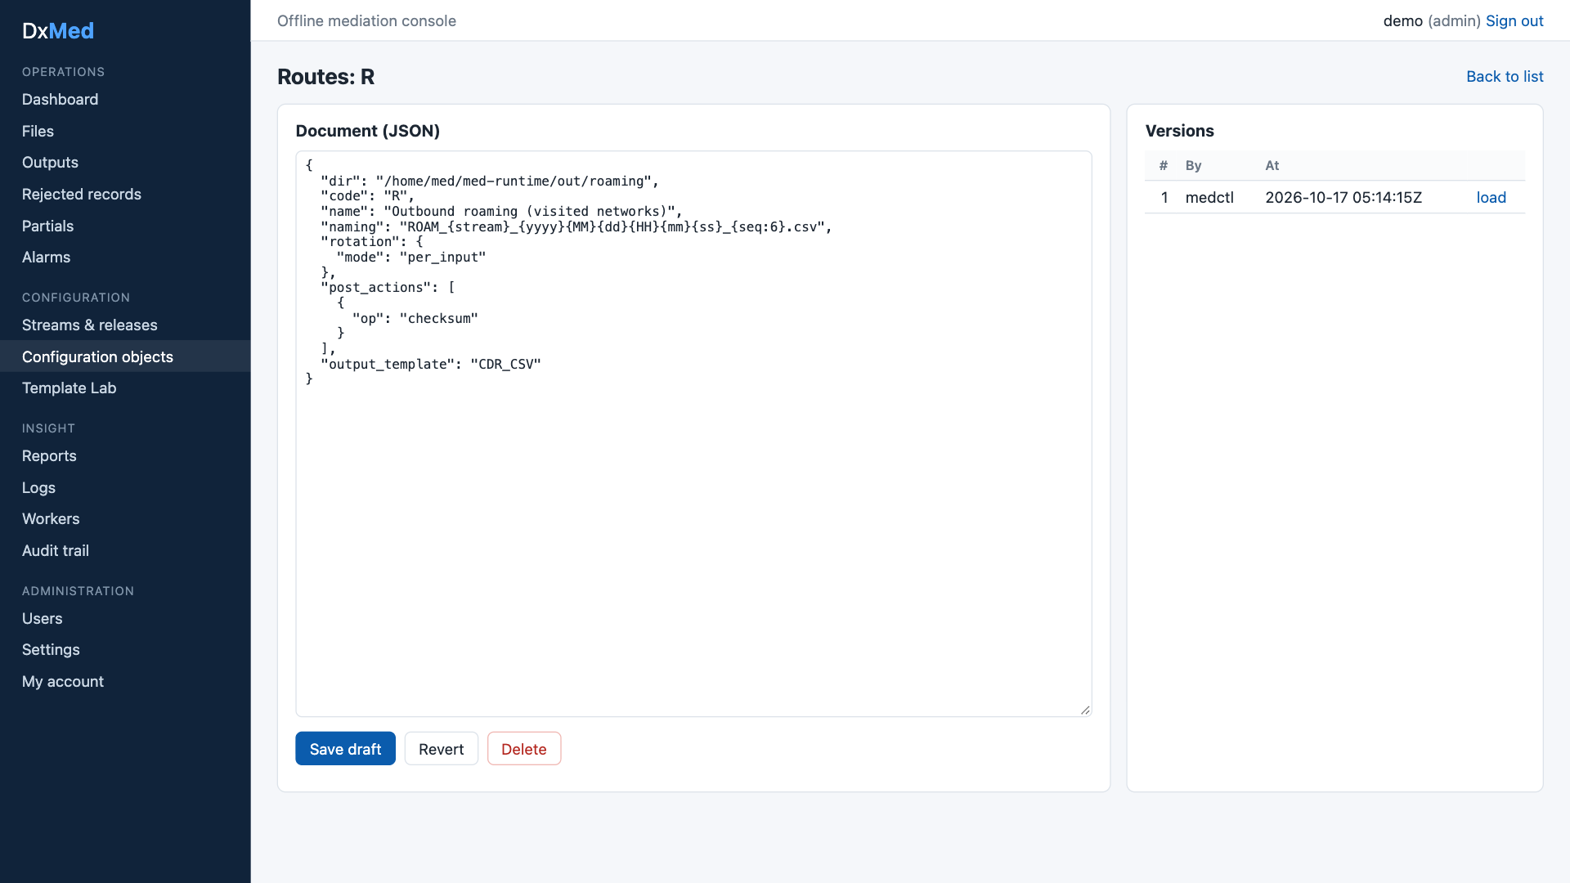
Configuration editor with version history
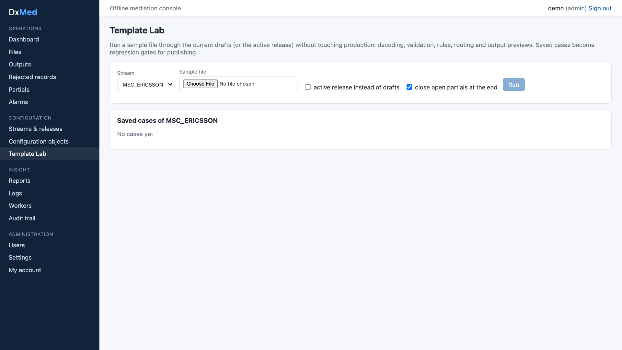
Template Lab
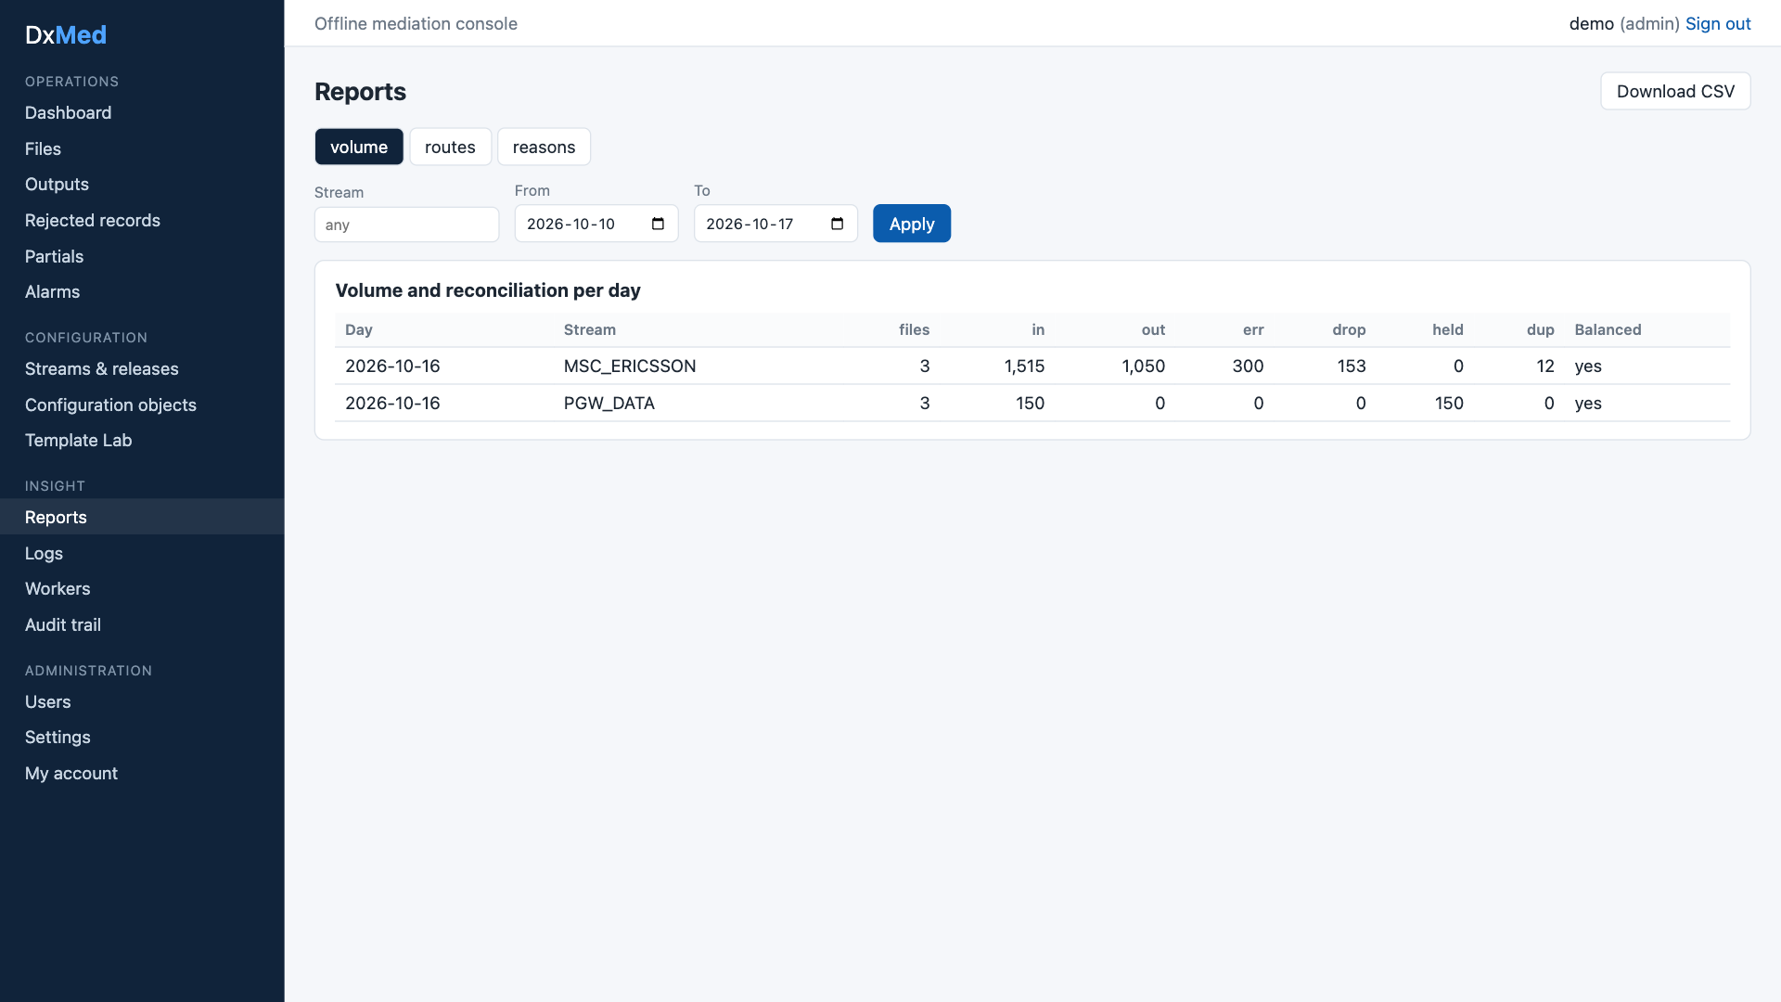
Reports: volume and reconciliation per day
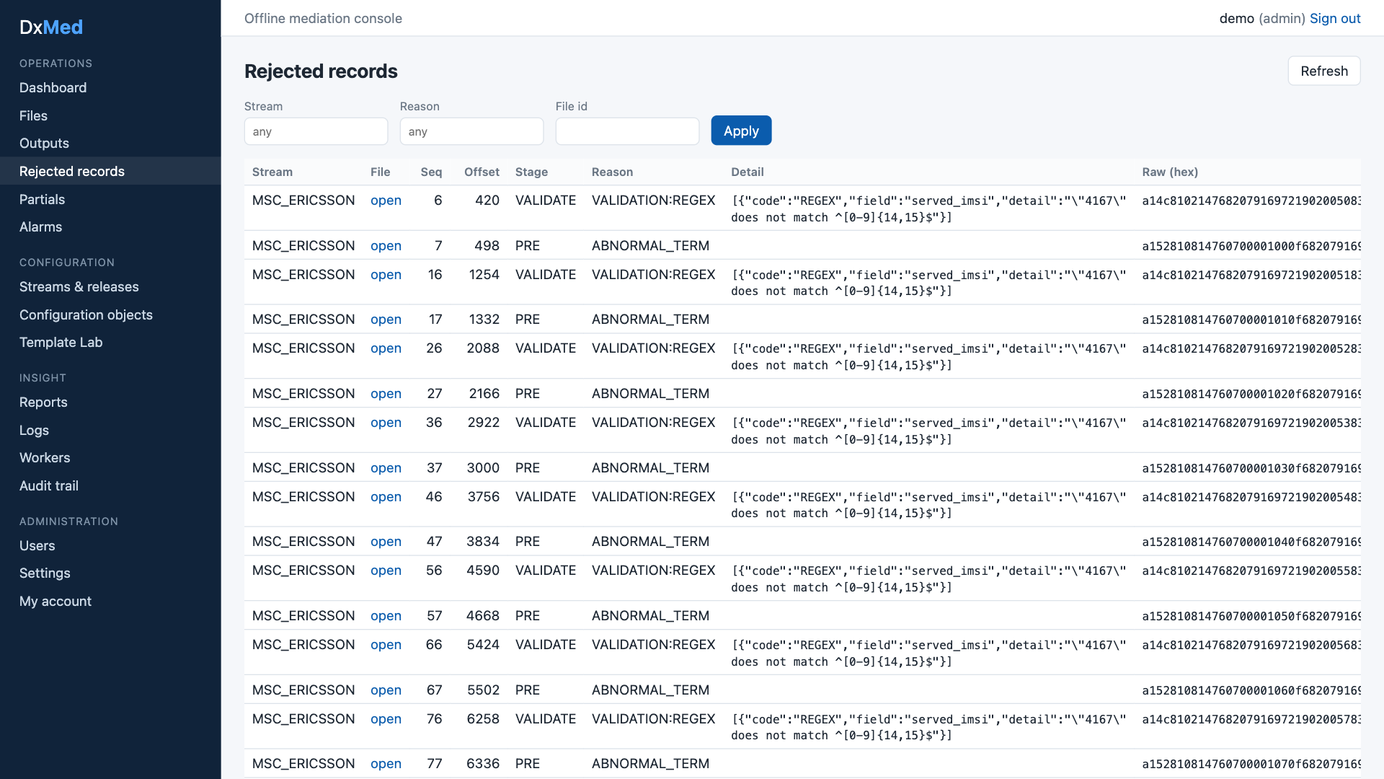
Rejected records with reason, detail and raw bytes
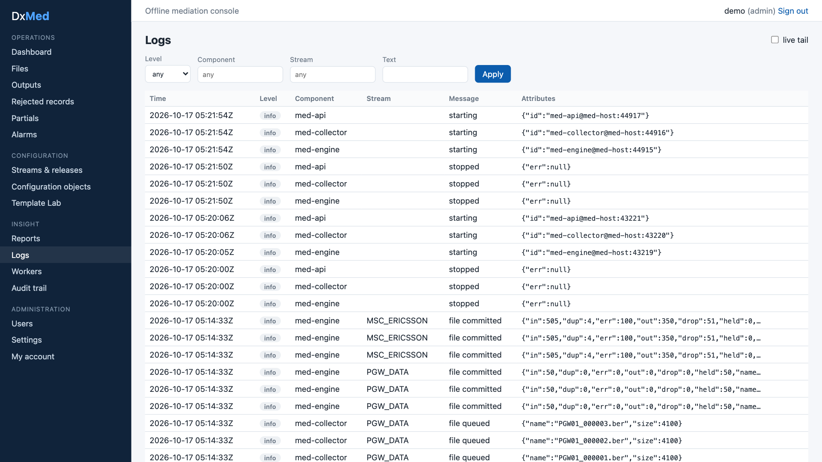
Logs
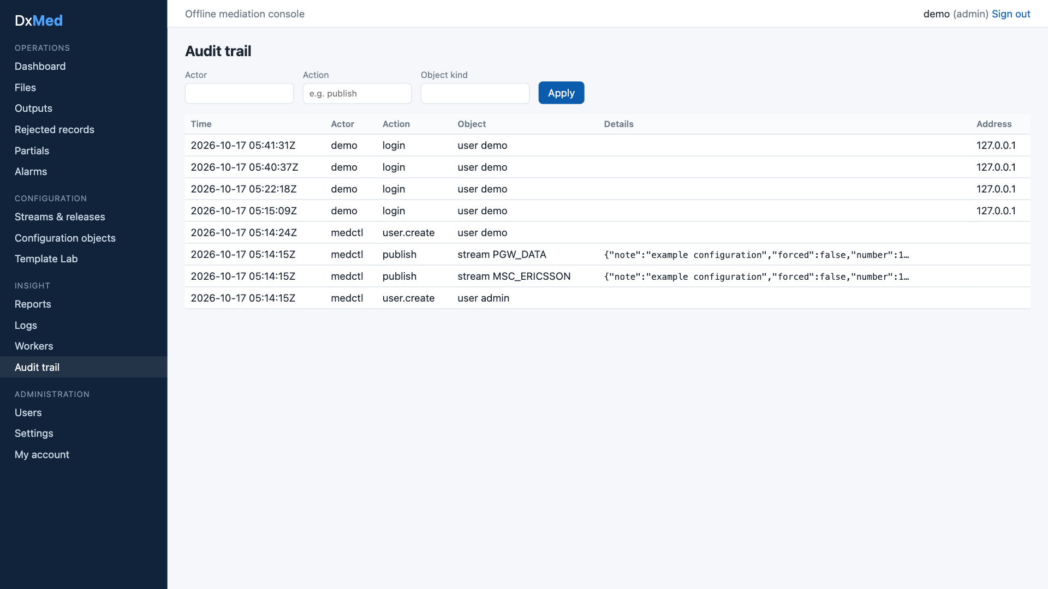
Audit trail
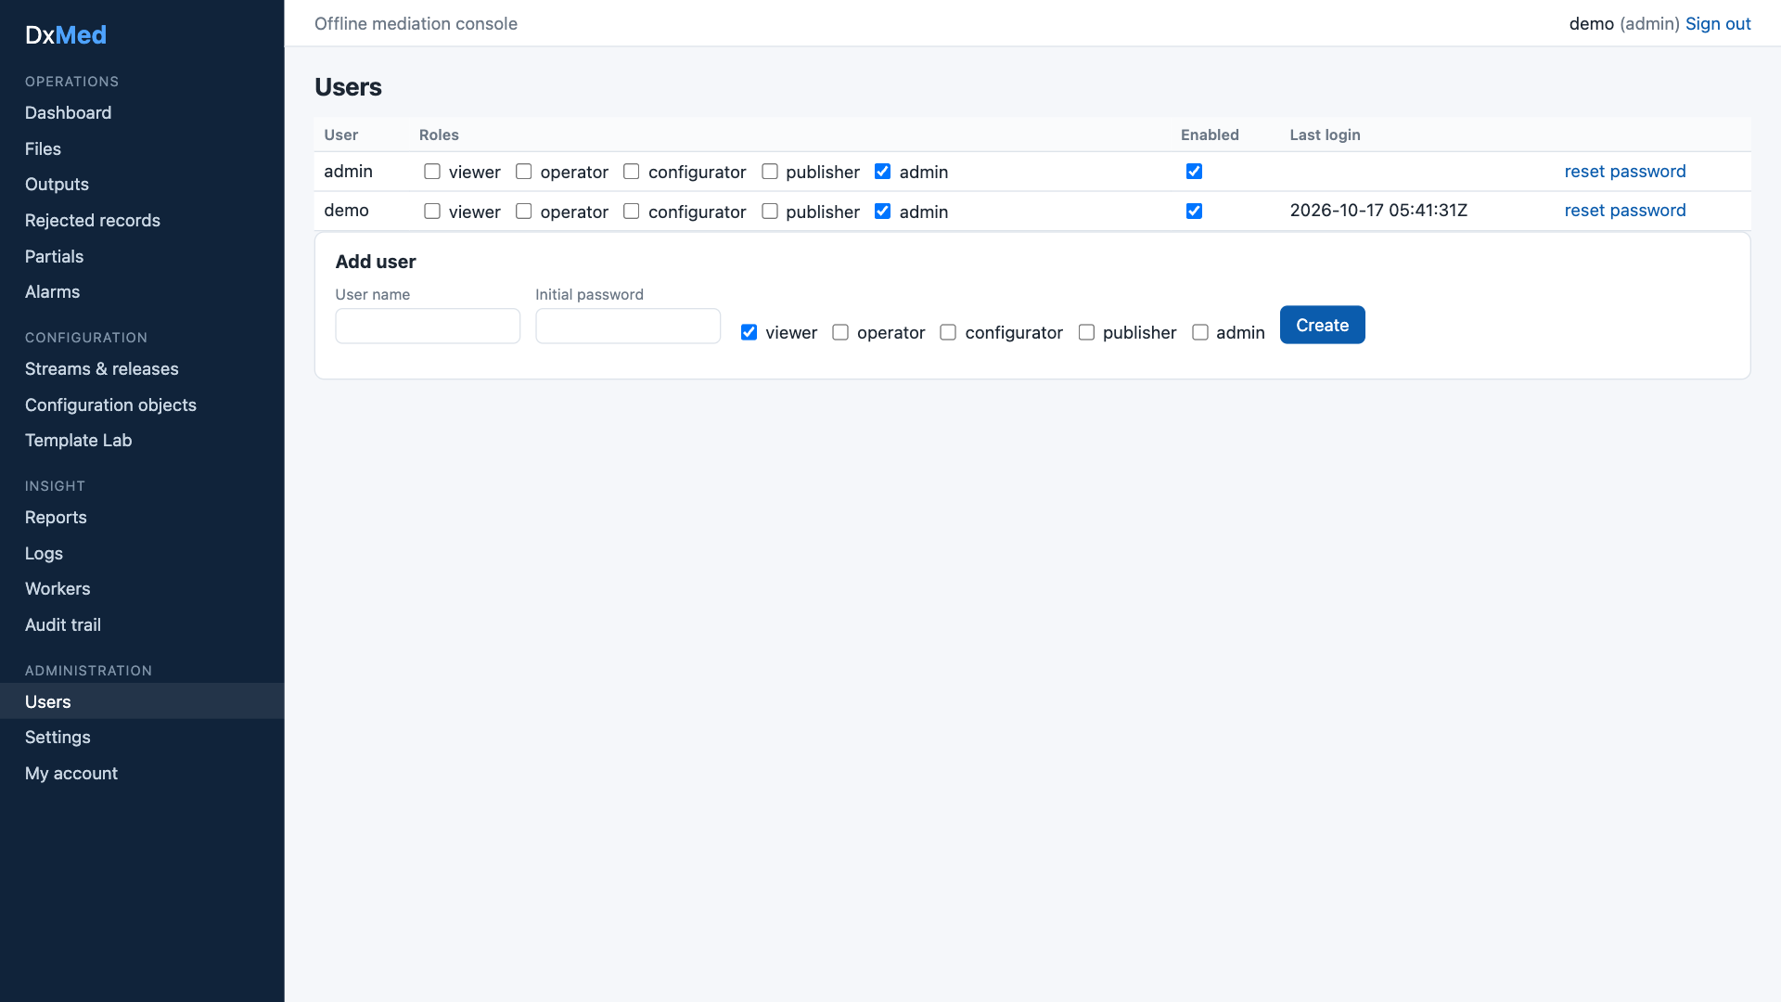
Users and roles

9. Observability, logging and reporting
- Logs: JSON (log/slog) to ~/med-runtime/logs/<component>.log and, from info level, to med.event_log for search and live tail in the UI. IMSI/MSISDN-like attributes are masked (416770******321) unless MED_LOG_NOMASK=1.
- Metrics: Prometheus text endpoint per component: engine 127.0.0.1:9301, collector 127.0.0.1:9302 (files, records by disposition, outputs, queue depth, pending partials, file duration, alarms, post-action failures; collector files and scan errors).
- Statistics: per file × stage × call type × action × reason × stream with count, duration and volume.
- Reconciliation: per file and per day (in = out + err + drop + held + dup).
- Audit: every configuration change, publish, activation, file action, user change and login, with actor, IP and before/after.
- Workers: each component heart-beats into med.worker (host, pid, version).

10. Reliability and recovery
Concern | Design
Double processing | Files are leased with FOR UPDATE SKIP LOCKED and a lease expiry, renewed by heartbeat; the commit checks the lease owner, so a worker that lost its lease cannot commit
Partial outputs | .part files + atomic rename after commit; recovery finishes interrupted renames and removes orphans
Merge state | med.partial_record is updated in the same transaction as the file commit; merge streams are serialised by an advisory lock
Poison files | Retry with back-off, then DEAD; reprocess or re-drive from the UI
Changed input | The engine re-checks SHA-256 before processing
Config errors | Publish requires validation and passing Template Lab cases (admins may force)
Edited migrations | Migrations are checksummed; a changed, already-applied migration stops start-up with a clear error
Leader tasks | Scheduler leadership is a lease row with expiry; another engine takes over automatically

11. Security
- TLS (minimum 1.2) for UI and API; PostgreSQL over TLS with full verification; loopback binding by default.
- Local users with Argon2id password hashes; login limiter (5 failures per 5 minutes per IP and user); sessions stored only as token hashes, 8-hour lifetime; password change ends other sessions.
- UI session in an HttpOnly, Secure, SameSite=Strict cookie; mutations require an anti-CSRF header; Content-Security-Policy and other security headers on UI and API.
- RBAC per API route: viewer < operator < configurator < publisher < admin.
- Optimistic locking (ETag / If-Match) on configuration objects; request body limit 16 MiB; strict JSON decoding; CSV exports guarded against formula injection.
- No shell execution: Readg’s EXEC post-action is not carried over.
- Secrets in ~/med-runtime/secrets.env (mode 600), never logged, never returned by the API.
- scripts/sec-scan.sh: govulncheck, go vet, npm audit, secret patterns in tracked files.

12. Testing strategy and measured coverage
Layer | Tooling | Gate | Measured (release 1.0)
Engine packages: model, datatype, ber, decode, encode, transform, filter, lookup, validate, dedupe, merge, route, config, pipeline, lab, sample, obs | go test -race, table tests, golden files, Go fuzzing (ber, decode, datatype) | 100% | 100% each
Service packages: store, engine, api, app, ctl, ops, auth, collector, postaction | Unit tests with temp dirs and injected clocks; integration tests against a throw-away database dxmed_test on the same cluster | — | store 91.9%, engine 83.1%, api 98.0%, app 98.6%, ctl 96.2%, ops 96.4%, auth 96.5%, collector 98.8%, postaction 97.9%
Whole Go module | tools/covergate (merged profiles) | ≥ 95% | 97.3%
UI | Vitest + Testing Library (all pages, BFF proxy, library) | ≥ 90% | 99.85% statements, 98.4% branches
scripts/test-all.sh runs everything and fails below a gate. End-to-end behaviour was verified on the live stack with the sample data set (6 files, 1,665 records, all reconciled).

13. Deployment and operations
Runtime directory ~/med-runtime (binaries, logs, pid files, spool directories, PKI, secrets). Shared PostgreSQL cluster of DxPS.
Listener | Address
UI (HTTPS) | https://localhost:8090
API (HTTPS) | https://localhost:8543
Metrics | 127.0.0.1:9301 (engine), 127.0.0.1:9302 (collector)
These do not clash with DxPS. Scripts: infra-setup.sh, run-all.sh, status.sh, stop.sh, test-all.sh, sec-scan.sh, reset-db.sh (development only). See the Operations Guide.

14. Roadmap after 1.0
Item | Notes
Benchmarks (NFR-01) | Per-stage go test -bench and a 10M-record load test
SFTP pull and push | Collector source type sftp; post-action sftp_push
Bundle import, release diff | Offline transfer between environments
Lookup CSV import, XLSX/PDF reports | UI and API
More alarm rules | Disk space, no file received in N minutes, error ratio
Structured editors | Tree editor for templates, rule grid, hex viewer (today: JSON editor + Lab)
Optional | TAP3/RAP output, Kafka exporter, OIDC login, Readg configuration importer

15. Decisions (resolved)
# | Topic | Decision
D1 | Meaning of “offline” | Batch/file mediation plus offline configuration (drafts, Template Lab, releases, no internet needed)
D2 | Shared database | Same DxPS cluster and database dxps, schema med, roles med_owner, med_app, med_ops, med_reader
D3 | Reading DxPS data | No direct read; DxMed keeps its own lookup tables
D4 | UI technology | Next.js (TypeScript, React); plain CSS components, no external UI kit
D5 | Coverage gate | 100% engine packages, ≥ 95% Go overall, ≥ 90% UI
D6 | First CDR formats | Generic 3GPP-style samples: MSC voice (BER) and PGW data with partials (BER)
D7 | Readg configuration import | Not in release 1.0
D8 | Product name | DxMed

