DxMed — CDR Mediation Platform
  - Low-Level Design (LLD) — version 1.0
17 October 2026
Table of Contents

Item | Value
Document | DxMed LLD, version 1.0 (as built)
Date | 17 October 2026
Status | Approved (16 October 2026); updated to the implemented release 1.0
Read with | DxMed_HLD.md (requirement ids FR-xx / NFR-xx), DxMed_Operations_Guide.md
Change history
Version | Date | Change
0.9 | 16 Oct 2026 | Design for approval
1.0 | 17 Oct 2026 | Rewritten to match the code: package layout, configuration schemas, operators and functions, commit transaction, scheduler, schema, API routes and roles, UI/BFF, test results

1. Repository layout
Mediation/
go.mod module dxmed (Go 1.26): pgx/v5, shopspring/decimal, zeebo/xxh3, x/crypto
cmd/
med-engine/ med-collector/ med-api/ medctl/ thin mains (signal handling, app.Run / ctl.Main)
internal/
model/ Value, Record, FieldError engine, 100%
datatype/ 28 data type codecs (§4.3) engine, 100%
ber/ streaming BER/TLV reader and writer engine, 100%
decode/ format drivers: ber, binblock, csv, fwv, tagged, json, xml engine, 100%
validate/ field dictionary checks engine, 100%
transform/ 40 field functions (§5) engine, 100%
lookup/ set / map / prefix tables engine, 100%
filter/ rule compiler + evaluator, 37 operators, trace (§6) engine, 100%
dedupe/ file-level and record-level duplicate logic (§7) engine, 100%
merge/ sort & merge, merge functions, partial encoding (§8) engine, 100%
route/ routing, naming patterns, rotation (§9) engine, 100%
encode/ writers csv, fwv, lines, jsonl, xml, ber; header/trailer engine, 100%
config/ object schemas, validation, release bundle, compile to Plan engine, 100%
pipeline/ per-file orchestration of the stages above engine, 100%
lab/ Template Lab runner and saved-case gate engine, 100%
sample/ example configuration + MSC/PGW sample file generators engine, 100%
obs/ slog JSON logger with masking and DB sink, Prometheus registry engine, 100%
auth/ roles, Argon2id hashing, session tokens
collector/ directory scanning and completion detection
postaction/ checksum, gzip, copy, move, delete runner
store/ PostgreSQL access, embedded migrations, leasing, commit, queries
engine/ worker loop, commit/rename, recovery, scheduler
ops/ publish, validate, activate, file actions (shared by API and medctl)
api/ REST + SSE handlers, auth, RBAC, audit
app/ process wiring for med-engine, med-collector, med-api
ctl/ medctl commands
dbtest/ test database helper (not shipped)
tools/covergate/ coverage gate (strict package list + overall minimum)
ui/ Next.js application (§15)
scripts/ env.sh, infra-setup.sh, run-all.sh, status.sh, stop.sh, test-all.sh, gotest.sh,
sec-scan.sh, reset-db.sh, build-docs.sh
docs/ HLD, LLD, Operations Guide (Markdown sources, Word and PDF), img/
Engine packages are pure Go: no database, network or clock access. This is why they reach 100% coverage and run unchanged in Template Lab. All I/O sits in the service packages.

2. Core data model
type Kind uint8 // KNull, KString, KInt, KUint, KDecimal, KBytes, KTime, KDuration, KBool, KIP, KList
type Value struct {
Kind Kind
S string // KString, KIP (canonical text)
I int64 // KInt, KBool (0/1)
U uint64 // KUint
D decimal.Decimal // fixed point: no float rounding in charging fields
B []byte
T time.Time
Dur time.Duration
List []Value
}
type Record struct {
Stream, FileID string
Seq, Offset int64 // position in the input file (1-based) and byte offset
Length int
RecordType string // e.g. moCallRecord, from the template
CallType string // selects the rule block (Readg CallType)
Fields map[string]Value
Raw []byte // original bytes (kept for rejected records)
Action, Reason string // set by the filter
Errs []FieldError // {Field, Code, Detail}
}
Field names are flat (served_imsi) or dotted for constructed elements (location.lac). The pipeline adds file.name and file.exchange_id to every record. Output fields can also read rec.seq, rec.record_type, rec.call_type, rec.action, rec.reason and constants (const:x).

3. Configuration objects and releases
Nine kinds are stored as JSON documents in med.config_object (kind, name, version, doc, updated_by, updated_at). Every save inserts a new version; a NULL document marks a deletion; the view med.config_current returns the latest version of each object. The API uses the version as ETag, and PUT/DELETE require If-Match, so two people cannot overwrite each other’s edits.
Kind | Key fields
stream | name, enabled, source{type:"dir", path, pattern, stable_for, done_suffix}, decoding_template, dictionary, rule_set, merge_profile, routes[], lookups[], dedupe{record_key[], retention, file{name, checksum, seq_range, time_range, gap}, on_range_dup}, error_route, dup_route, duration_field, volume_field, seq_field, time_field
decoding_template | format, file{header, trailer, block, exchange_id{regex}, sequence{regex}}, records[]{tag, record_type, call_type, fields[]}, unknown_tag
field_dictionary | fields[]{name, kind (string, number, time, ip, bool), mandatory, min, max, regex, max_future, max_age}
rule_set | default{action, reason}, stages{PRE, COL, UNCOL}[]{call_type, conditions[], default}
transform_group | calls[]{fn, args[]}
lookup_table | kind (set, map, prefix), rows{key: value}
merge_profile | sort[], relate[], end_condition[], rules[], close_times[], ttl, max_partials, on_expiry
route | code, name, output_template, dir, naming, rotation{mode}, post_actions[]
output_template | format, header_line, header, trailer, sep, root (xml), fields[]{name, source, format, default, mandatory, len, align, pad, tag, type}
Publish (ops.Publish, used by API and medctl publish):
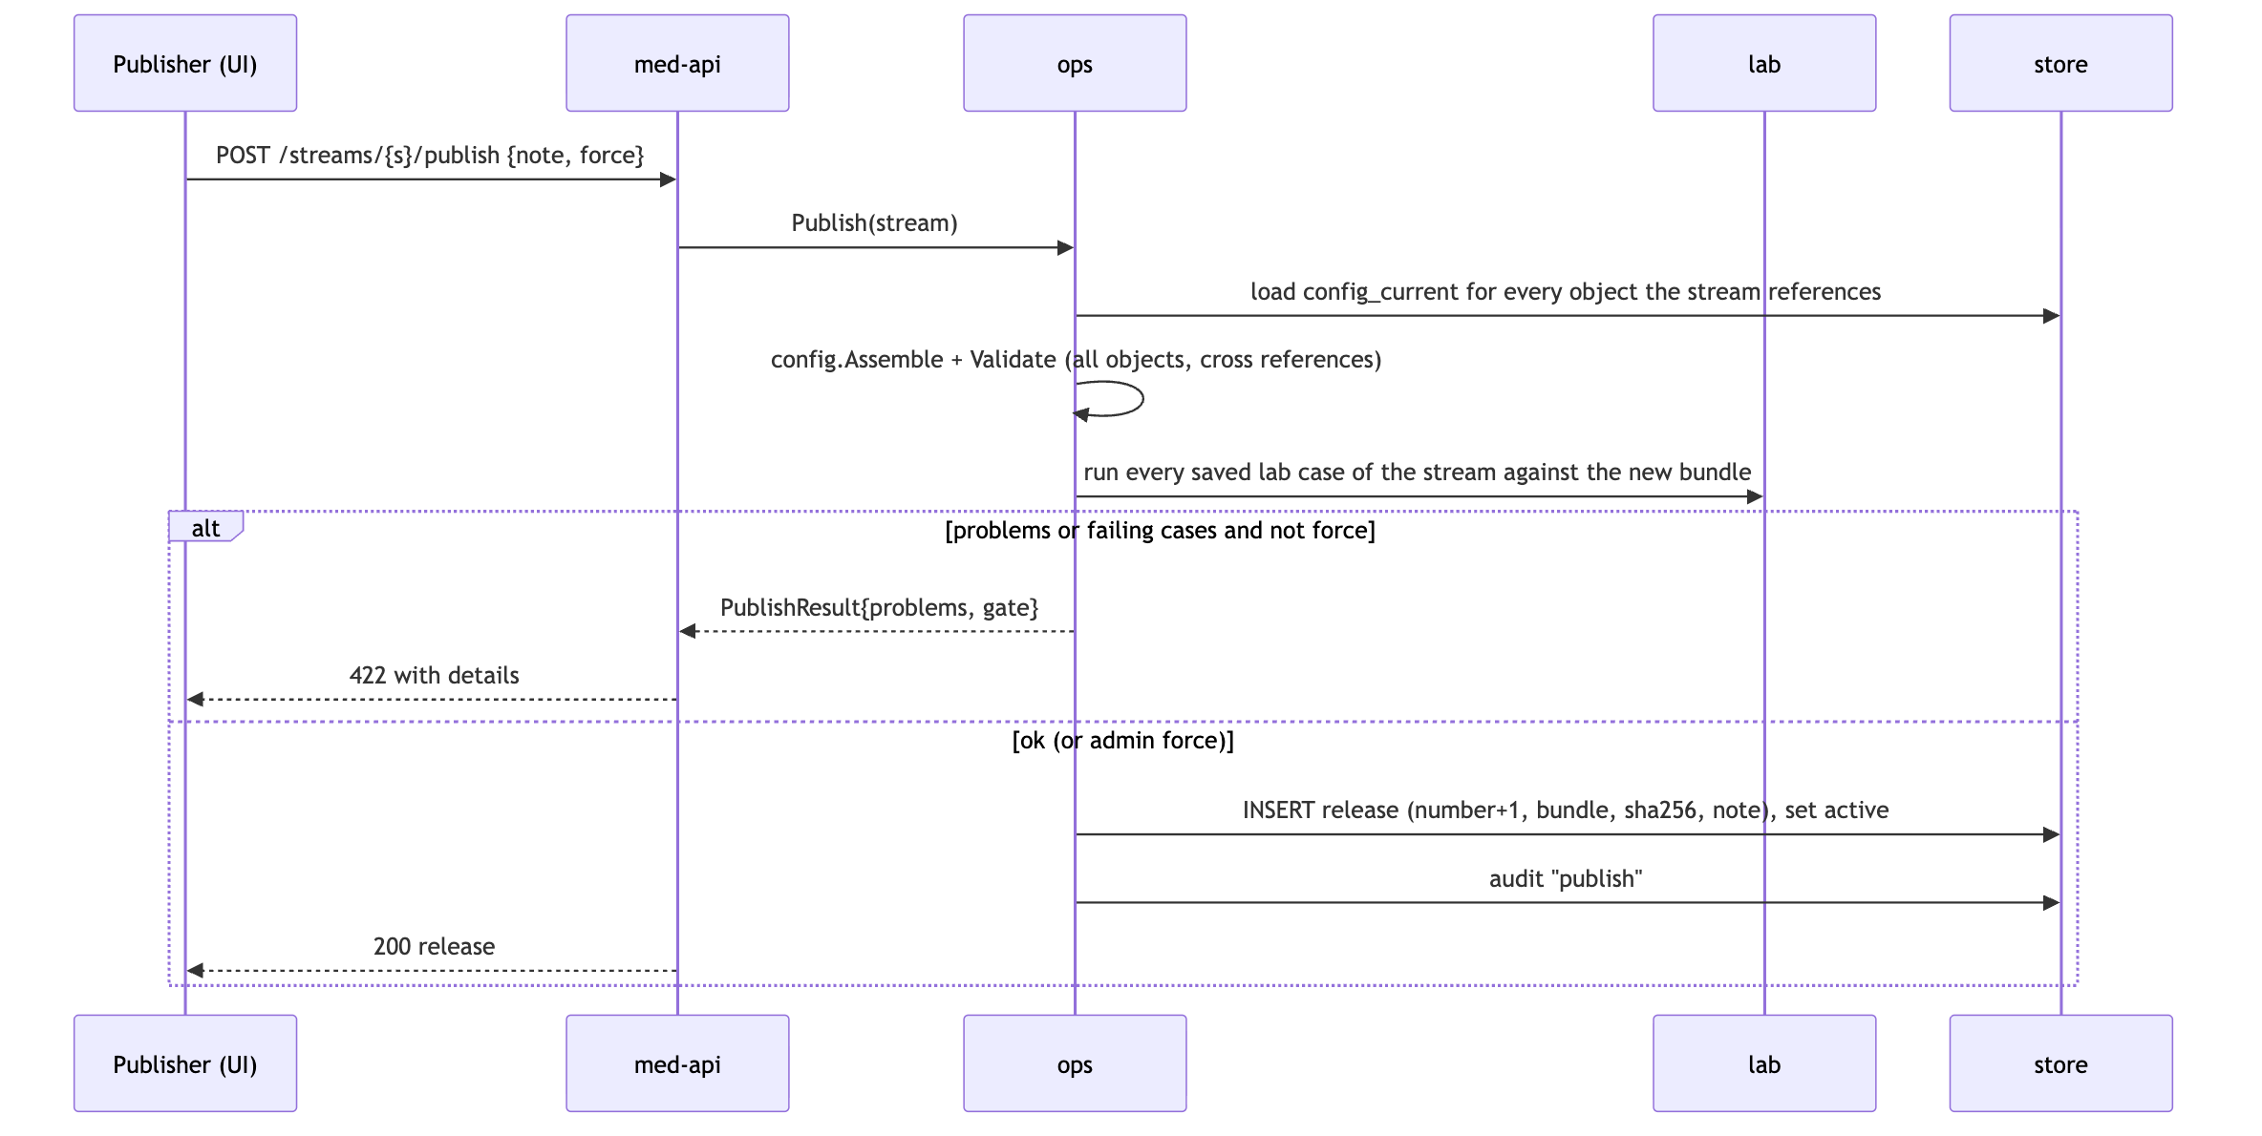
Hot reload (NFR-05). Before each lease the engine reads the active releases (ActiveReleases). Compiled plans (config.Compile) are cached by release id, so a new release is compiled once and used from the next file on. Activating an older release (rollback) works the same way.

4. Decoding

4.1 Decoding template
{
"name": "ERICSSON_MSC",
"format": "ber",
"file": {"exchange_id": {"regex": "^(MSC[0-9]+)_"}},
"unknown_tag": "ignore",
"records": [
{"tag": "[1] C", "record_type": "moCallRecord", "call_type": "1", "fields": [
{"tag": "[1]", "name": "served_imsi", "type": "TBCD", "mandatory": true},
{"tag": "[2]", "name": "served_msisdn", "type": "TBCD", "opts": {"skip_ton_npi": true}},
{"tag": "[5] C", "name": "location", "type": "STRUCT", "fields": [
{"tag": "[0]", "name": "lac", "type": "HEX"},
{"tag": "[1]", "name": "ci", "type": "HEX"}]},
{"tag": "[6]", "name": "start_time", "type": "TIME_BCD"},
{"tag": "[8]", "name": "duration_s", "type": "NUM"},
{"tag": "[*]", "name": "", "type": "IGNORE"}
]}
]
}
Format | Field addressing
ber | tag: [n] context, APP n, UNI n, PRIV n; suffix C = constructed; [*] = any other tag
binblock | pos, len within fixed-size records; file header/trailer and block size/filler
fwv | pos, len characters per line
csv | idx (column) or header (column name); separator and quoting options
tagged | prefix (Readg tag-line mode)
json, xml | path (dotted path / element path)

4.2 BER reader (ber)
encoding/asn1 only supports DER, so DxMed has its own reader:
- Identifier: class, constructed bit, tag number (0x1F → base-128 multi-byte tag).
- Length: short form, long form (up to 4 bytes) or indefinite (0x80, constructed only) terminated by end-of-contents 00 00.
- Tag lookup per template level (map tag → field); unknown tags follow unknown_tag (ignore or error).
- Constructed STRUCT → recurse; repeated elements → list.
- Primitive → data type codec (§4.3).
- Top-level record tags start a new record; 0x00/0xFF filler between records is skipped.
- Limits: depth 32, element length ≤ remaining bytes. A violation rejects the record with DECODE:<code> and decoding resumes at the next top-level element when possible.
The reader and the decoders are fuzzed (go test -fuzz) for panics and unbounded allocation.

4.3 Data types (datatype)
Type | Kind | Decoding
TBCD | String | Telephony BCD, low nibble first, F filler ends; option skip_ton_npi
TBCDR | String | Telephony BCD, high nibble first
BCD | String | Packed BCD, high nibble first
BCDS | Int | Signed packed BCD, last nibble C/F = +, D = −
ABCD | String | BCD with F fillers anywhere (skipped)
HEX | String | Bytes as upper-case hex
NUM / NUMR | Uint | Unsigned big-endian / little-endian integer
INT | Int | Two’s complement big-endian (ASN.1 INTEGER)
BITS | Uint | Bit field with mask/shift, or flag names
ASCII / ASCIIS / ASCIIP | String | Text as is / trimmed / printable only
EBCDIC | String | EBCDIC CP037 text
IPADD | IP | IPv4 (4 bytes) or IPv6 (16 bytes); text form accepted
TIME_BCD | Time | BCD YYMMDDhhmmss with optional sign and hhmm offset (3GPP TS 32.298)
TIME_ASC | Time | ASCII time with layout
TIMEUNX / TIMEUNXDEC | Time | Unix seconds, binary / decimal text
DURATION / DURATIONDEC | Duration | Binary / decimal duration with unit (s, ds, cs, ms)
DECIMAL | Decimal | Decimal text, optional implied scale
BOOL | Bool | 0x00 = false, anything else true
SET | String | Constant value when the tag is present
LOOK / LOOKS | String | Numeric / text code translated through a lookup table
SEP | List | Separator-delimited sub-fields
RAW | Bytes | Raw bytes
STRUCT, IGNORE | — | Container with children / skip (template keywords)
Every codec has Decode and Encode; tests check Decode(Encode(v)) == v. The ber output writer uses Encode to re-encode records.

4.4 Validation (validate)
With a field dictionary, each record is checked for mandatory, kind, min/max and regex. A failure adds FieldError{field, code, detail} and the record goes to the error route with reason VALIDATION:<code> (for example VALIDATION:REGEX).

5. Transform library (transform)
A transform group is an ordered list of {fn, args}; arguments are field names, constants ('text') or lookup table names. Groups are compiled once per release.
Group | Functions
Assign / move | SET, COPY, MOVE, SWAP, RESET, REMOVE, CONCAT
Text | SUBSTR, TRIM, LTRIM, RTRIM, TRIMNUM, STRIP, CASE, PAD, REGEX_REPLACE
Arithmetic (decimal) | ADD, SUB, MULT, DIV, ROUND, ROUNDBY
Time | INCTS, DECTS, DIFFTIME, UTC, TOZONE, TIME2NUM, NUM2TIME, DATE2TEXT, TEXT2DATE, SEC2HMS, DURATION
Conversion | HEX2NUM, NUM2HEX, FLIP
Network | TRIMIP, IP2HEX, E164
Enrichment | LOOKSET dst table key

6. Filter engine (filter)

6.1 Rule model
{
"name": "MSC_RULES",
"default": {"action": "L", "reason": "LOCAL"},
"stages": {
"PRE": [
{"call_type": "*any", "conditions": [
{"no": 1, "items": [{"field": "duration_s", "op": "=", "value": "0"}], "action": "DROP", "reason": "ZERO_DUR"},
{"no": 2, "items": [{"field": "cause_for_term", "op": "*in", "values": ["98", "99"]}],
"action": "ERROR", "reason": "ABNORMAL_TERM"},
{"no": 3, "items": [{"field": "*any"}], "action": "L", "reason": "LOCAL",
"transform": "TG_NORMALISE", "flow": "continue"}]},
{"call_type": "1", "conditions": [
{"no": 1, "items": [{"field": "served_imsi", "op": "*notprefix", "lookup": "home_plmn"}],
"action": "R", "reason": "ROAM_OUT"},
{"no": 3, "items": [{"field": "served_msisdn", "op": "*prefix", "lookup": "mvno_ranges"}],
"action": "MVNO", "reason": "MVNO", "transform": "TG_MVNO"}],
"default": {"action": "L", "reason": "LOCAL_MO"}}
]
}
}
- Items in a condition are ANDed; conditions are tried in no order (OR); the first full match fires.
- Flow (Readg CDR_RET): stop (default) ends evaluation; continue applies action and transform and keeps evaluating (last action wins); error rejects the whole file (status DEAD, reason recorded).
- Two passes: the *any block runs first; unless it stopped, the block of the record’s call type runs; if nothing matched, that block’s default, else the rule set default; else reason NO_RULE (error route).
- Actions: a route code (R, L, MVNO…), MULTI:R,L (copy to several routes), DROP, ERROR, HOLD (to sort & merge), DUP.
- Operands: value (constant), value_field (another field), values (list), lookup (table), len: true (compare the field length), from/length (substring, 0-based).

6.2 Operators
Operators | Meaning
= <> < > <= >=, *eq *gt *gte *lt *lte | Numeric when both sides are numbers, time-aware for times, otherwise text
*string *notstring | Exact text
*prefix *notprefix *suffix *notsuffix | Prefix / suffix; with a prefix lookup the longest match is used
INSTR, *contains *notcontains | Substring
ISDGT *digits, ISCHR *letters | All digits / all letters
*in *notin | Value list or lookup membership
*empty *notempty *exists *notexists | Presence
*regex *notregex | RE2, compiled once
*ipnet *notipnet | CIDR membership
*between | Inclusive range
*timewin | Time-of-day / weekday window
*any | Always true (catch-all item)

6.3 Evaluation and statistics
Each item is compiled into a closure with its operand already parsed (numbers, sets, regexes). Per record:
for block in [stage["*any"], stage[rec.CallType]]:
for cond in block.conditions: # ordered by no
if all(item(rec) for item in cond.items):
apply(cond.transform); rec.Action, rec.Reason = cond.action, cond.reason
trace(cond) # Template Lab only
if cond.flow == stop: return
if cond.flow == error: reject file; return
if rec.Action == "": apply block default, then rule-set default, else NO_RULE
Statistics are counted per (stage, call_type, action, reason) with count, total duration (duration_field) and total volume (volume_field) and stored in med.file_stat at commit.

7. Duplicate detection (dedupe)
File level (stream dedupe.file):
Check | When | Against
name | before decoding | committed files of the stream with the same name
checksum | before decoding | committed files with the same SHA-256
seq_range | after decoding | overlap of [seq_from, seq_to] per exchange in med.file_seq_range
time_range | after decoding | overlap of [time_from, time_to] per exchange
gap | after decoding | missing sequence numbers → alarm seq_gap (file still processed)
A duplicate file gets status DUPLICATE with dup_of set to the earlier file. With on_range_dup: "records" an overlapping range falls back to record-level dedupe instead of rejecting.
Record level: key = the stream’s record_key fields, hashed with 128-bit xxh3. Within a file an in-memory set is used; across files med.record_key (partitioned by day) is checked in batches and new keys are inserted in the commit transaction. Duplicates go to dup_route with action DUP. Retention follows dedupe.retention (scheduler retention for the table defaults to 35 days).

8. Sort & merge (merge)

8.1 Merge profile
{
"name": "GPRS_PARTIALS",
"sort": [{"field": "record_seq"}],
"relate": ["charging_id", "pgw_address"],
"end_condition": [{"field": "cause_for_close", "op": "=", "value": "0"}],
"rules": [
{"field": "*record", "fn": "FIRST", "content": "BASE"},
{"field": "duration_s", "fn": "SUM"},
{"field": "volume_up", "fn": "SUM"},
{"field": "end_time", "fn": "LAST"},
{"field": "record_seq", "fn": "COUNT", "target": "partials"},
{"field": "rat_type", "fn": "DIFCNT", "target": "rat_changes"}
],
"close_times": ["00:00"],
"ttl": "6h",
"max_partials": 100,
"on_expiry": "uncol"
}
Merge functions: FIRST, LAST (with content: BASE the first/last partial is the base record), SUM, MIN, MAX, AVG, COUNT, DIFCNT (distinct values), HAVE (any partial has a value), EQU (all equal, else merge error), USE (value from the partial that matches).

8.2 Algorithm
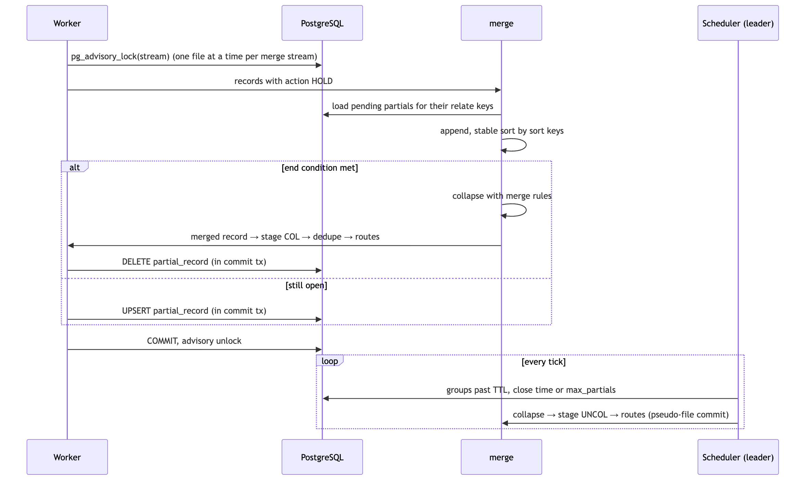
Pending partials are stored as a gob encoding of the partial records in med.partial_record.payload, with the release id, first/last seen and count. Operators can close groups from the Partials page (POST /partials/close), which runs the same flush.

9. Routing, outputs and the commit protocol

9.1 Routes and naming
{"code": "R", "name": "Outbound roaming (visited networks)", "output_template": "CDR_CSV",
"dir": "/Users/me/med-runtime/out/roaming",
"naming": "ROAM_{stream}_{yyyy}{MM}{dd}{HH}{mm}{ss}_{seq:6}.csv",
"rotation": {"mode": "per_input"},
"post_actions": [{"op": "checksum"}]}
Naming tokens: {stream}, {source}, {exchange_id}, {input_name}, {input_base}, {route}, {release}, {file_id}, {seq:N} (gap-free per stream and route, allocated in the commit transaction from med.route_seq), and date tokens {yyyy}{MM}{dd}{HH}{mm}{ss}. Rotation: per_input (one output per input file and route) or rolling.

9.2 Writers (encode)
Format | Notes
csv | Separator, quoting, optional header line
fwv | Fixed width: len, align, pad per field
lines | One field per line (Readg LIN)
jsonl | One JSON object per record
xml | One element per record
ber | Re-encode through the data type codecs (definite lengths); fields carry tag and type
Header and trailer lines are templates with the tokens {stream}, {route}, {input_name}, {created}, {file_seq}, {count}, {sum:f}, {min:f}, {max:f}.

9.3 Commit protocol (exactly once per input file)
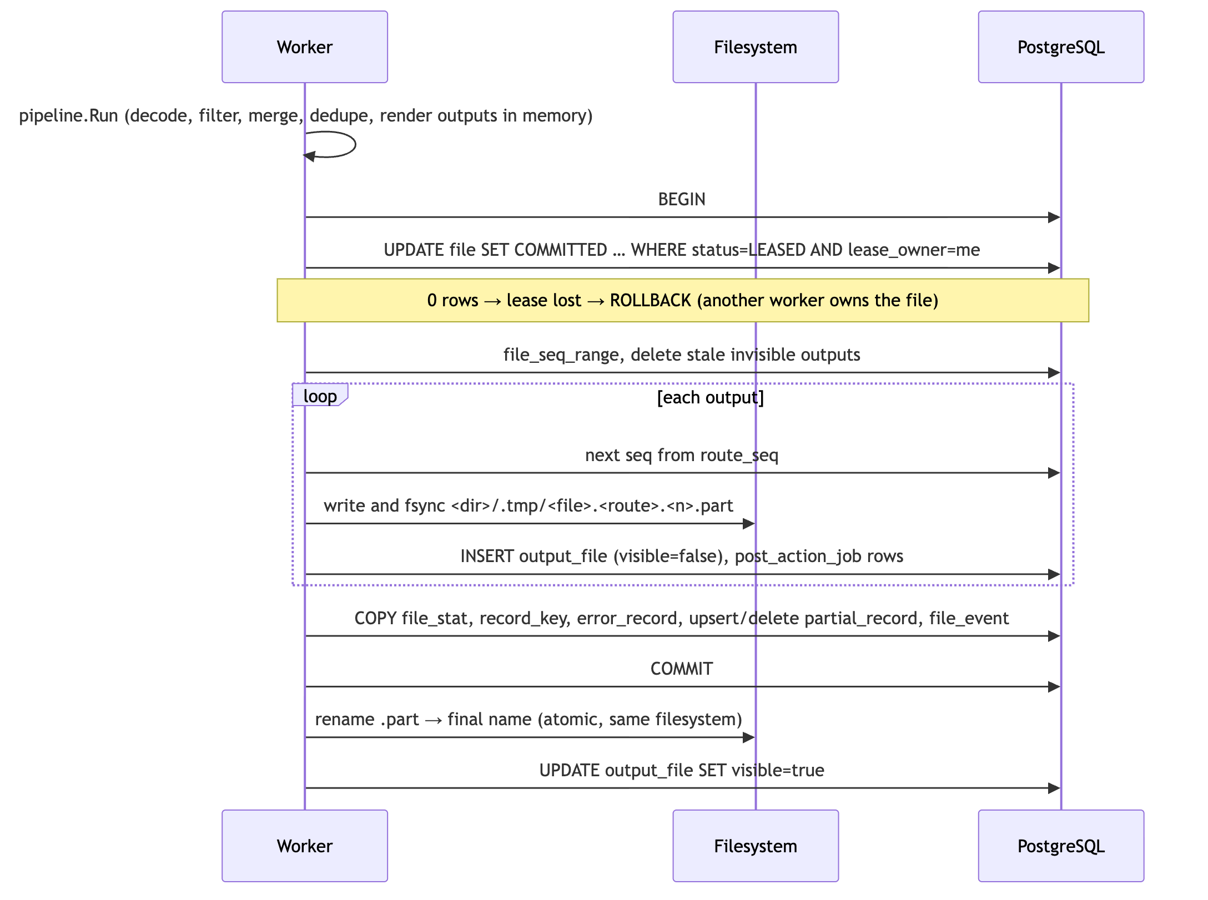
Recovery (at start and every minute): committed outputs still invisible are renamed (or marked visible if already renamed); .part files of rolled-back attempts older than two lease periods are removed. The scheduler moves a file to POSTED (with a history event) once all its outputs are visible and all post-action jobs are DONE.

9.4 Post-actions (postaction)
Jobs in med.post_action_job run in step order per output file, leased with expiry and retried: checksum (writes <file>.sha256), gzip, copy {dir}, move {dir}, delete. Target directories must be absolute; there is no shell execution.

10. File states, leasing and scheduler

10.1 Leasing
UPDATE med.file f SET status = 'LEASED', lease_owner = $1, lease_until = $2,
attempts = attempts + 1, started_at = $3
WHERE f.id = (SELECT id FROM med.file
WHERE status = 'NEW' AND stream_id = ANY($4) AND not_before <= $3
ORDER BY priority, received_at
FOR UPDATE SKIP LOCKED LIMIT 1)
RETURNING …;
Parameter | Default | Variable
Workers per engine | 4 | MED_WORKERS
Lease TTL (heartbeat every TTL/3) | 5 min | MED_LEASE_TTL
Attempts before DEAD | 5 | —
Back-off | 30 s × attempt, max 15 min | —
Idle poll | 1 s | MED_POLL
Scheduler tick | 10 s | MED_TICK_EVERY
Collector scan | 2 s | MED_SCAN_EVERY

10.2 Operator actions
Action | Allowed from | Result
reprocess | COMMITTED, POSTED, DEAD, FAILED, DUPLICATE, CANCELLED | NEW, attempts reset
hold | NEW, FAILED | HELD
release | HELD | NEW
cancel | NEW, HELD, FAILED, DEAD | CANCELLED
re-drive | DEAD files of one stream or all (_all) | NEW
Every transition writes a med.file_event row (shown as the file history in the UI).

10.3 Scheduler tick (leader only)
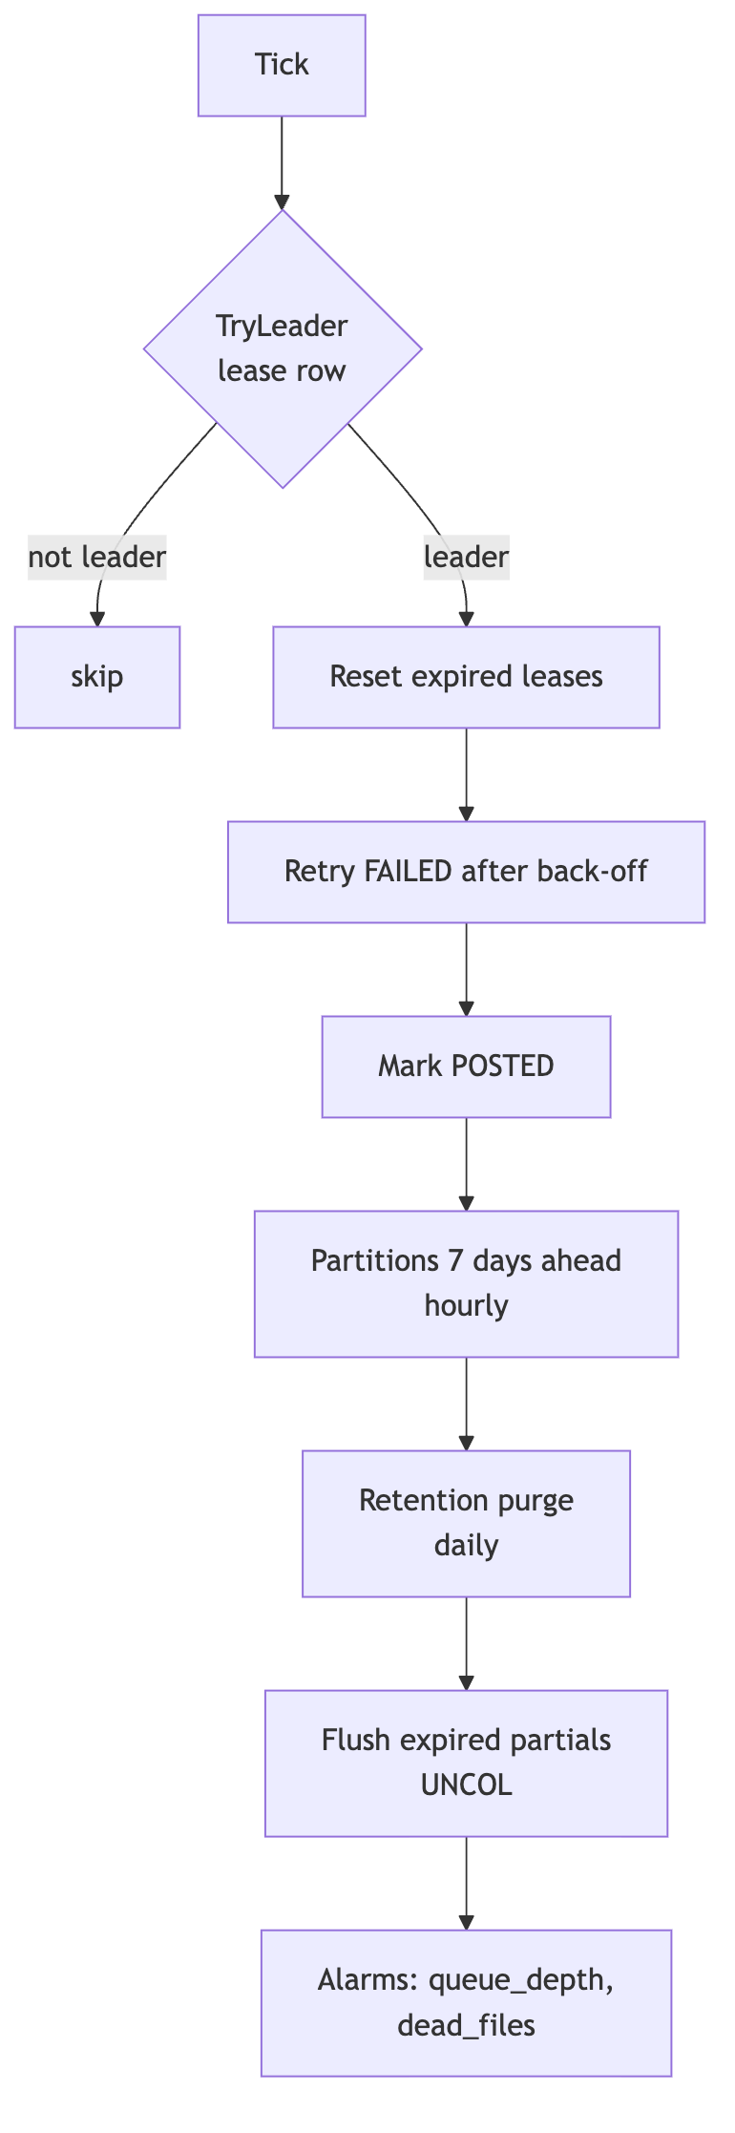
Retention defaults: file_stat 400 days, record_key 35 days, error_record 30 days, event_log 30 days, expired sessions after 1 day.

11. Database schema (schema med)
Created by the embedded migration internal/store/migrations/001_schema.sql (run by medctl migrate as med_owner). Applied migrations are recorded with a SHA-256 in med.schema_migration; a changed migration file stops start-up (“add a new migration instead”).
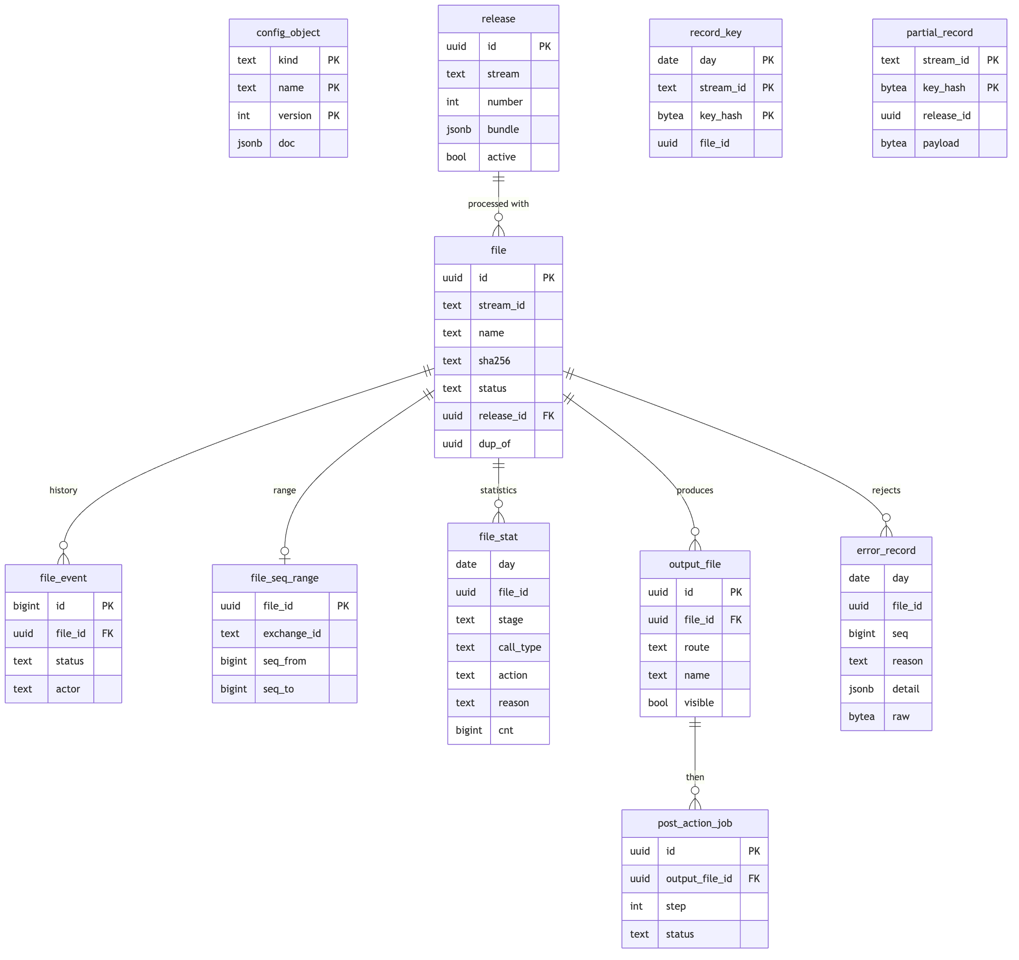
Table | Purpose | Partitioned
config_object, view config_current | All versions of configuration objects
release | Immutable bundles; one active per stream
lab_case | Saved Template Lab cases (sample + expected counts and routes)
file, file_event | Queue, lifecycle, counters, history
file_seq_range | Sequence and time ranges for file dedupe
file_stat | Statistics per stage × call type × action × reason | by day
output_file, route_seq | Outputs and gap-free sequences
post_action_job | Durable post-action queue
record_key | Record dedupe keys | by day
partial_record | Pending merge state
error_record | Rejected records with detail and raw bytes | by day
event_log | Structured logs for the UI | by day
audit_log | Audit trail with before/after
alarm | Open/acknowledged/cleared alarms (one open per rule and stream)
app_user, session | Users, roles, session token hashes
worker, leader | Heartbeats; scheduler leadership
setting | Key/value settings edited by admins
Partition functions med.ensure_partitions and med.drop_partitions run with the owner’s rights and are callable by med_app.

12. REST API (https://localhost:8543/api/v1)
Authentication: POST /auth/login returns a token; every other call sends Authorization: Bearer <token>. Errors are JSON {error, details} with status 400, 401, 403, 404, 409 (conflict), 412 (ETag mismatch), 413, 422 (validation or publish gate), 428 (If-Match required), 429 (login limiter), 503.
Method and path | Role
GET /healthz, GET /readyz (no prefix, no auth) | —
POST /auth/login | —
POST /auth/logout, GET /auth/me, POST /auth/password | viewer
GET /dashboard, /files, /files/{id}, /outputs, /errors, /partials, /workers, /alarms | viewer
GET /reports/{volume\|routes\|reasons} (format=csv for CSV) | viewer
GET /logs, GET /logs/stream (Server-Sent Events) | viewer
POST /files/{id}/actions, POST /streams/{stream}/redrive, POST /partials/close, POST /alarms/{id}/ack | operator
GET /config, /config/{kind}, /config/{kind}/{name} (ETag), /versions, /versions/{version} | viewer
PUT /config/{kind}/{name} (If-Match; absent = create), DELETE … (If-Match), POST …/clone | configurator
GET /streams, /streams/{stream}/releases, /streams/{stream}/bundle, /releases/{id} | viewer
POST /streams/{stream}/validate, POST /lab/run, PUT /lab/cases, DELETE /lab/cases/{stream}/{name}; GET /lab/cases (viewer) | configurator
POST /streams/{stream}/publish (force needs admin), POST /releases/{id}/activate, GET /audit | publisher
GET /settings (viewer), PUT /settings/{key}, GET/POST /users, PUT /users/{name} | admin
Lists use cursor paging (before + limit). Every mutating call writes med.audit_log. Request bodies are limited to 16 MiB and decoded strictly (unknown fields rejected).
Template Lab run — request {stream, file_name, data (base64), release (optional), flush, samples}; response {counts, balanced, decode, routes, stats, samples (with rule trace), outputs (previews), rejects, pending_partials, problems, file_error, millis}. With flush, open partials are closed at the end so a single sample file shows the merged result.

13. Security design
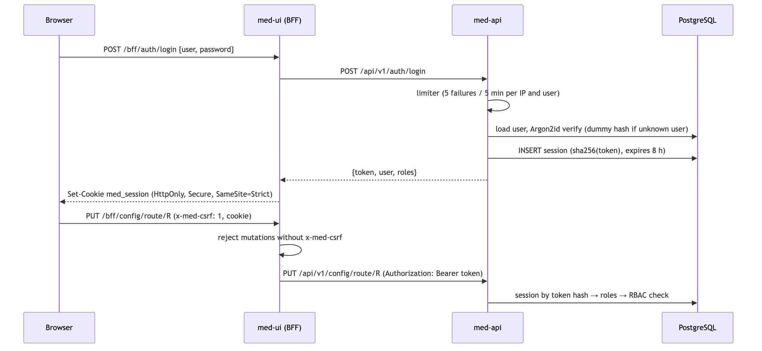
- The token never reaches browser JavaScript; the UI server is the only API client.
- A password change or disabling a user deletes all of that user’s sessions.
- An admin cannot disable or demote their own account.
- CSV exports prefix text cells starting with =, +, -, @, tab or CR with ' to block formula injection (numbers are left as they are).
- Headers: CSP, X-Content-Type-Options, X-Frame-Options: DENY, Referrer-Policy, HSTS on HTTPS.

14. Logging and metrics
Log record: time, level, msg, component plus context (stream, file_id, name, counts, err). Identities in attributes such as IMSI/MSISDN are masked (first 6 and last 3 characters kept) unless MED_LOG_NOMASK=1. Level via MED_LOG_LEVEL (default info); info and above also go to med.event_log.
Metric | Labels | Component
med_files_total | stream, outcome | engine
med_records_total | stream, disposition (out, err, drop, held, dup) | engine
med_output_files_total | stream, route | engine
med_file_duration_seconds (histogram) | stream | engine
med_queue_depth, med_partials_pending | stream | engine
med_alarms_active | — | engine
med_post_action_failures_total | op | engine
med_collected_files_total, med_scan_errors_total | stream | collector

15. UI (ui/, Next.js 16, React 19, TypeScript)
ui/
server.mjs HTTPS server (MED_UI_CERT / MED_UI_KEY / MED_UI_PORT)
next.config.ts CSP and security headers
app/
login/page.tsx
bff/[...path]/route.ts proxy to med-api: cookie → Bearer, CSRF check, SSE pass-through
(main)/layout.tsx session provider + shell (navigation by role)
(main)/page.tsx dashboard
(main)/files, files/[id], outputs, errors, partials, alarms
(main)/streams, config, config/[kind], config/[kind]/[name], lab
(main)/reports, logs, workers, audit, users, settings, account
components/ui.tsx Badge, Card, Table, Field, Stat, Json, Notice, ErrorBox, Page
components/Shell.tsx SessionProvider, useSession, Can (role gate), navigation
lib/ api client, hooks (useApi, useAction), proxy, upstream (TLS to API), format, types
test/ Vitest + Testing Library suites
- Client components fetch through /bff/*; a 401 sends the user to the login page.
- The configuration editor shows the JSON document with version history; saving sends If-Match, so a concurrent change is refused (412) and shown as an error instead of being overwritten.
- Release publishing shows validation problems and failing Lab cases returned in the 422 details.
- All assets are bundled locally (NFR-09).

16. Test design
Package group | What is tested
datatype, ber, decode | Every type and edge case (odd nibbles, fillers, time offsets), round trips, all length forms, multi-byte tags, indefinite lengths, truncation, unknown tags, every format driver; fuzz targets
transform, filter, lookup, validate | Every function and operator, argument errors, two-pass evaluation, flows, defaults, trace, compile errors
dedupe, merge | All file checks and verdicts; every merge function, end conditions, TTL/close time/max partials, encoding round trip
route, encode | Naming tokens, rotation, every writer byte-exact, header/trailer aggregates, BER re-encode
config, pipeline, lab | Validation messages, assemble/compile, full sample runs with reconciliation, Lab gate
store | Real database: migrations and drift detection, leasing under concurrency, commit/lease-lost, partitions, retention, queries
engine | End-to-end on the database with sample files: routing counts, duplicates, merge across files, retries, recovery, scheduler
api | Every route: RBAC, ETag/If-Match, validation, publish gate, Lab, CSV, SSE, limiter, closed-store errors
app, ctl, ops | Process wiring with TLS, every CLI command, publish/activate/actions
UI | Every page, role gating, BFF proxy (cookie, CSRF, SSE), API client, formatting
scripts/test-all.sh: go vet, go test -race with cross-package coverage, tools/covergate (strict list at 100%, overall ≥ 95%), HTML report, then tsc and vitest --coverage (≥ 90%).

17. Traceability
Requirement | Section
FR-01 | HLD §4.1, Operations Guide (collector)
FR-02, FR-03 | §4
FR-04 | §4.4
FR-05, FR-06 | §6
FR-07 | §5
FR-08 | §7
FR-09 | §8
FR-10 | §3 (lookup_table), §6.1 operands
FR-11, FR-12 | §9
FR-13 | §6.3, §11 file_stat
FR-14 | §3
FR-15 | §12 Template Lab
FR-16 | §10.2, §8.2
FR-17 | §12 reports
FR-18 | §14, §12 logs/audit
FR-19 | §10.3 alarms
FR-20 | §12 roles, §13
NFR-03, NFR-04 | §9.3, §10
NFR-05 | §3 hot reload
NFR-06 | §13
NFR-07 | §16, HLD §12

