DxPS
Real-time Provisioning System
Components and Data Guide
PostgreSQL structure and examples - Kafka topics and messages - services
18 | 41 | 36 | 303 ms
PostgreSQL tables | Kafka topics | consumer groups | example order

Item | Value
Document | DXPS-COMPONENTS-GUIDE
Version | 1.0
Date | 07 October 2026
Applies to | dxps source of the same date; PostgreSQL 18, Apache Kafka 4.3.1, Go 1.26.6
Examples | Real records read with dxpsctl trace from the local run of 06 October 2026

Table of Contents
1. Purpose and component map 3
2. One order through every component 4
3. PostgreSQL 18 - system of record 5
3.1 What PostgreSQL is used for 5
3.2 Database, schema and roles 5
3.3 The tenant model 5
3.4 Table catalogue 6
3.5 Partitioning 7
3.6 Real rows 7
3.7 A real rollback (saga compensation) 8
3.8 Concurrency patterns 8
3.9 Useful queries 9
4. Apache Kafka 4 - asynchronous transport 10
4.1 What Kafka is used for 10
4.2 Topic catalogue 10
4.3 Keys and headers 11
4.4 Messages (real) 11
4.5 Producers 12
4.6 Consumers 12
4.7 Outbox relay: database and Kafka in step 12
4.8 Volumes after the 2,000-order load run 12
5. The other components 13
5.1 Gateway (northbound API) 13
5.2 Orchestrator 13
5.3 Catalog 13
5.4 Adapter and network elements 13
5.5 Network simulators 14
5.6 Event hub 14
5.7 Mosaic dashboard 14
5.8 PKI, secrets and dxpsctl 14
6. What happens when something fails 15

1. Purpose and component map
This guide explains what each DxPS component is responsible for, how it is used and what data it holds. It covers PostgreSQL (tables, keys, tenancy, partitions), Apache Kafka (topics, keys, headers, messages, consumer groups) and the DxPS services around them. Every example row and message is real: it was read from the running system with dxpsctl trace: order 1f2cd4a6-6333-5fbc-8fe1-0979d5966478 (tenant host-mno, a subscriber plus VoNR, submitted from the Mosaic load generator through the live services), plus an order that was rolled back in the end-to-end tests.
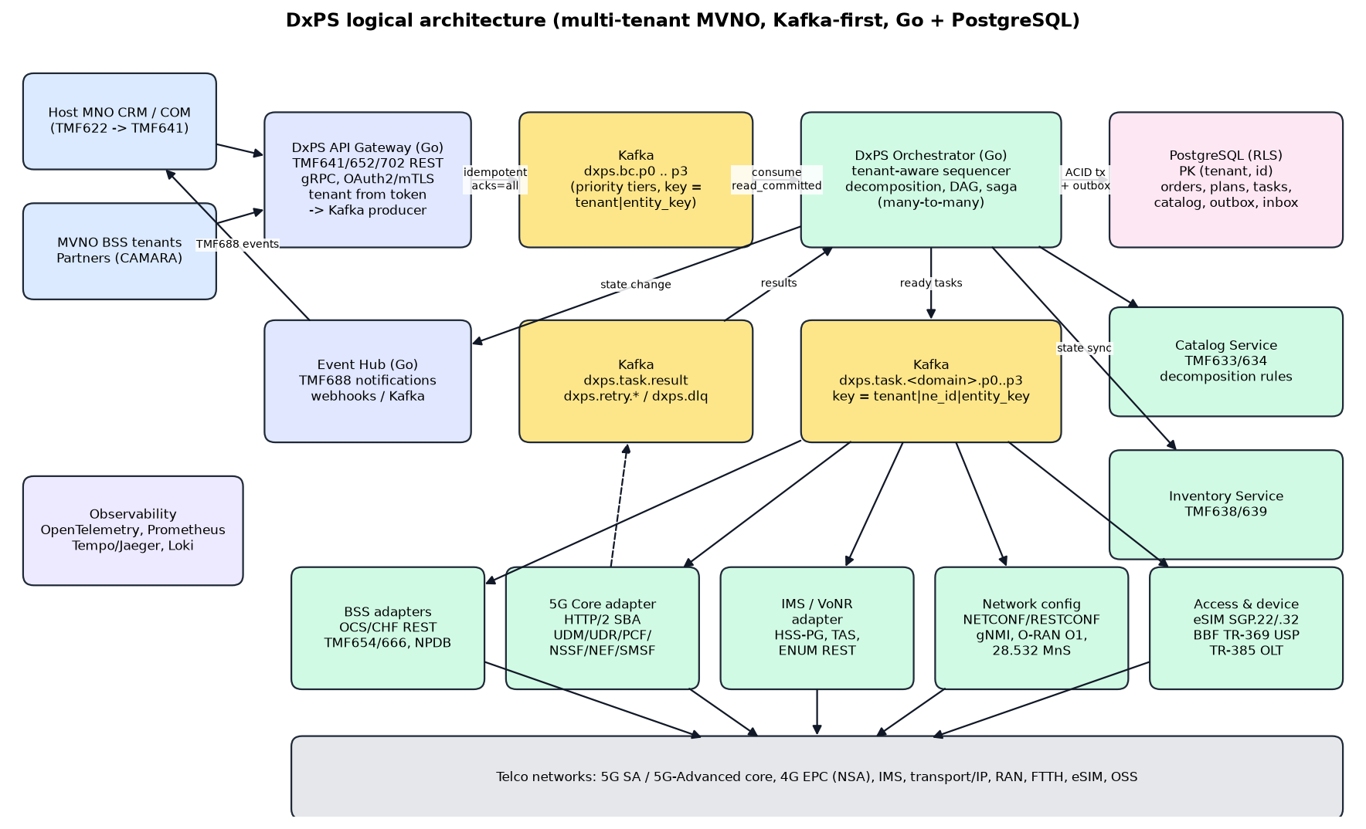
Figure: DxPS logical architecture
Component | Technology | Responsibility | Code
Gateway | Go, HTTP/2, TLS 1.3 | TMF641 order API and TMF688 hub; authenticates the tenant; stores the order and its business commands in one transaction | internal/gateway
Orchestrator | Go | Plans each business command into a DAG of NE tasks; runs the DAG; retries; saga compensation; order state | internal/orchestrator, planner, saga, scheduler, keylane
Adapter | Go, HTTP/2 mTLS | Renders NE payloads and calls the network elements for 7 domains; NE budgets and circuit breakers | internal/adapter, registry, breaker
Event hub | Go | Delivers TMF688 state-change events to tenant webhooks, HMAC-signed | internal/eventhub, secretbox
PostgreSQL 18 | pgx v5 | System of record: tenants, NE inventory, catalog, orders, plans, tasks, attempts, audit, outbox | internal/store, migrations/001_schema.sql
Apache Kafka 4 (KRaft) | franz-go | Asynchronous transport between services, priority lanes, retry ladder, events, dead letters | internal/bus, internal/contract
Catalog | YAML + CEL | Service recipes: tasks, dependencies, conditions, compensations, payload templates; per-tenant overrides | internal/catalog/data
Network simulators | Go, HTTP/2 mTLS | Stand-ins for NRF, UDR, IMS, RESTCONF/USP, SM-DP+, OCS, NPDB, NEF; fault injection | internal/netsim
Mosaic dashboard | Go + HTML/JS | Live operations view and load generator | internal/dashboard
dxpsctl | Go CLI | Secrets, PKI, migrations, seed, topics, tokens, DLQ re-drive, API calls, trace, test report | cmd/dxpsctl

2. One order through every component
The timeline below is the real life of order 1f2cd4a6-6333-5fbc-8fe1-0979d5966478 (external id DEMO-HOST-MNO-8030236): CreateSubscriber5G plus AddVoNR, where the VoNR item dependsOn the subscriber item. The plan is LTE-20GB, so the catalog condition params.plan.startsWith('5G') removed the policy task and the planner created 4 tasks instead of 5. The order completed in 303 ms.
Time (20:44:..) | Component | What happened | Where it is recorded
10.346 | Gateway | Order accepted (HTTP 201). One transaction writes the service_order row and two outbox rows (one BusinessCommand per order item) | service_order, outbox
10.352 | Gateway -> Kafka | Both BusinessCommands published to dxps.bc.p1 (fast path, 6 ms after commit), key host-mno|supi:imsi-416771008030236 | outbox.published_at
10.353 | Orchestrator | Inbox dedupe; the entity sequencer admits item 'sub'; the planner creates 4 ne_task rows and their dependency edges; AddVoNR waits for 'sub'. The order moves to inProgress | orchestrator_inbox, business_command, entity_sequencer, ne_task, task_dependency, bc_task_link, service_order
10.385 | Orchestrator -> Kafka | First NeTask (udr.authSubscription.put) to dxps.task.sba.p1; TMF688 inProgress event to dxps.event.tmf688 and dxps.state.order | outbox
10.395 | Adapter -> udr01 | PUT authentication-subscription, HTTP 201 in 3.8 ms; the TaskResult and the consumed offset are committed in one Kafka transaction | task_attempt
10.442 - 10.463 | Orchestrator / Adapter | am-data and smf-selection run in parallel once auth succeeded | ne_task, task_attempt
10.499 | Adapter -> ocs01 | OCS account created after both am and smf (pivot task) | ne_task, task_attempt
10.507 - 10.649 | Orchestrator / Adapter | Item 'sub' completed, so AddVoNR starts on imspg01: IMPI -> IMPU -> MMTEL, strictly in order | business_command, ne_task, task_attempt
10.649 | Orchestrator | Both business commands completed: order completed; the subscriber's sequencer is released (next_seq 3) | service_order, entity_sequencer, outbox
10.673 | Orchestrator -> Kafka -> Event hub | completed event published; the event hub posts it, signed, to the host-mno webhook | dxps.event.tmf688, dxps.state.order

3. PostgreSQL 18 - system of record

3.1 What PostgreSQL is used for
- Everything that must survive a restart lives in PostgreSQL: tenants, NE inventory and entitlements, the catalog, orders, business commands, the task DAG, every NE attempt, audit and the outbox.
- Kafka is never the source of truth. If a Kafka message is lost or duplicated, the database state decides what happens (inbox dedupe, task attempt numbers, idempotency keys).
- Every state change and the messages it causes are committed in one transaction (transactional outbox). A crash can never leave a task marked dispatched without its Kafka message, or the other way round.

3.2 Database, schema and roles
One database dxps with one schema dxps, on localhost:5433. Connections require TLS 1.3 and SCRAM-SHA-256; pg_hba.conf contains only hostssl loopback entries. Three login roles separate duties:
Role | Used by | Rights | Row-level security
dxps_owner | dxpsctl migrate | Owns the schema; runs migrations | owner (not used at runtime)
dxps_app | Gateway, orchestrator, event hub, dxpsctl trace | SELECT/INSERT/UPDATE; no UPDATE on append-only tables; DELETE only on hub_subscription | Enforced: sees only the tenant of the current transaction
dxps_ops | Outbox relay, registry loader, seeding, dashboard statistics | Read all; write inventory/catalog; mark outbox rows published | BYPASSRLS (cross-tenant by design)

3.3 The tenant model
Every table starts with tenant (domain dxps_tenant = varchar(40) with a format check) and a UUIDv7 id; the primary key is always (tenant, id) and every foreign key includes the tenant, so a row can never point at another tenant's row.
CREATE DOMAIN dxps_tenant AS varchar(40) CHECK (VALUE ~ '^[A-Za-z0-9_.-]{1,40}$');
CREATE TABLE ne_task (
tenant dxps_tenant NOT NULL, id uuid NOT NULL DEFAULT uuidv7(),
order_id uuid NOT NULL, ne_tenant dxps_tenant NOT NULL, ne_id uuid NOT NULL,
...
PRIMARY KEY (tenant, id),
FOREIGN KEY (tenant, order_id) REFERENCES service_order (tenant, id),
FOREIGN KEY (ne_tenant, ne_id) REFERENCES network_element (tenant, id)
) PARTITION BY LIST (tenant);
-- applied to all 16 tenant tables
CREATE POLICY tenant_isolation ON ne_task
USING (tenant = current_tenant()) WITH CHECK (tenant = current_tenant());
The application never filters by tenant by hand. store.InTenant opens a transaction and sets the transaction-local setting app.tenant; current_tenant() reads it and the policy does the rest. If it is not set, current_tenant() is NULL and no rows are visible.
func (s *Store) InTenant(ctx context.Context, tenantID string, fn func(pgx.Tx) error) error {
return pgx.BeginTxFunc(ctx, s.App, pgx.TxOptions{IsoLevel: pgx.ReadCommitted}, func(tx pgx.Tx) error {
if _, err := tx.Exec(ctx, "SELECT set_config('app.tenant', $1, true)", tenantID); err != nil {
return err
}
return fn(tx)
})
}
Note: Real effect: in a trace of an mvno-beta order (d9e8f3cb-2cf1-5f23-8429-8781c9eeb0d1) the NE code column is empty. The NE udr01 belongs to host-mno, so mvno-beta's transaction cannot read the network_element row, even though its own tasks reference it through (ne_tenant, ne_id). The catalog is the one deliberate exception: command_spec rows of tenant GLOBAL are readable by everybody.

3.4 Table catalogue
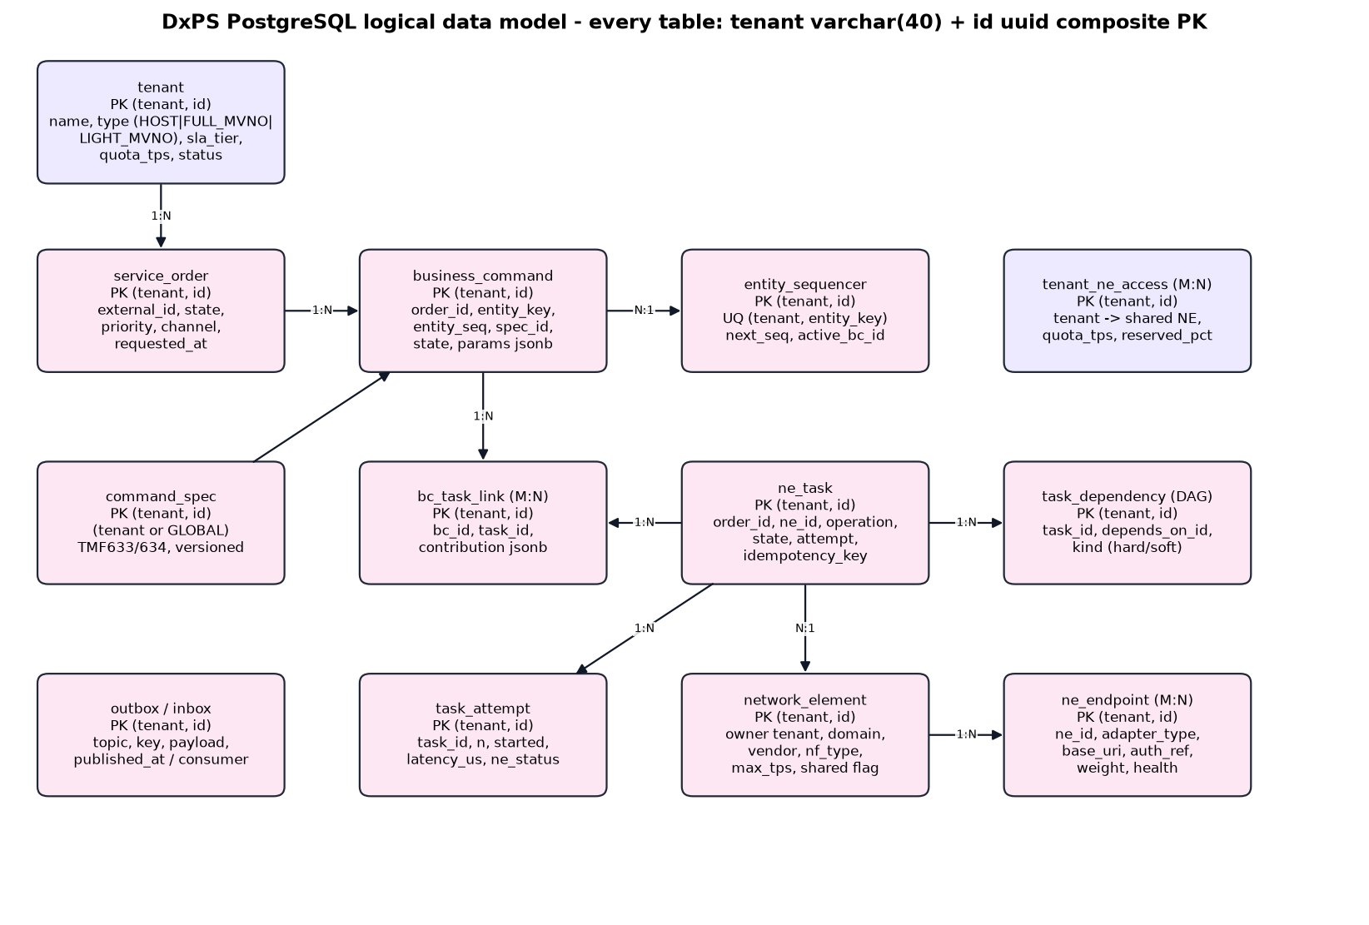
Figure: Entity relationships
Table | Purpose | Notable columns | Partitioning
tenant | Tenants: host MNO, MVNOs, enterprises | tenant_type, host_tenant, sla_weight, quota_tps, status | -
network_element | NE inventory, owned by a tenant | code, domain, nf_type, shared, max_tps, max_concurrency, reserved_pct | -
ne_endpoint | How to reach an NE (https only) | adapter_type, base_uri, auth_ref (vault reference, not a secret) | -
tenant_ne_access | Which tenant may use which NE, for which operations | quota_tps, allowed_ops[], subscriber_group | -
command_spec | Catalog recipes as loaded from YAML (GLOBAL or tenant override) | spec_code, version, status, body jsonb | -
service_order | TMF641 order | state, priority, tx_mode, idempotency_key, request_hash, items jsonb, version | LIST(tenant)
business_command | One per order item: what to do to which entity | entity_key, entity_seq, spec_code/version, params, depends_on_items | LIST(tenant)
bc_entity | Every entity key a command touches (supi, msisdn) | entity_key, bc_id | LIST(tenant)
entity_sequencer | Serialises commands per subscriber / resource | entity_key, next_seq, active_bc_id | LIST(tenant)
ne_task | One NE operation in the DAG | operation, state, attempt, in_degree, is_compensation, idempotency_key, coalesce_key, request, response | LIST(tenant)
task_dependency | DAG edges | task_id, depends_on_id, kind | LIST(tenant)
bc_task_link | Which command produced which task (tasks can be shared) | bc_id, task_id, contribution | LIST(tenant)
task_attempt | Append-only log of every NE call | n, started_at, latency_us, ne_status, ne_code, outcome | RANGE(id) daily
audit_event | Append-only audit trail | actor, acting_for_tenant, action, object | RANGE(id) daily
outbox | Kafka messages waiting to be published | shard, topic, key, payload, headers, published_at | -
orchestrator_inbox | Message ids already processed (dedupe) | id = Kafka message_id | RANGE(id) daily
hub_subscription | TMF688 webhook registrations | callback (https), query, secret_ref (encrypted) | -

3.5 Partitioning
- LIST by tenant for the busy order and orchestration tables. Large tenants get a dedicated partition (service_order_host_mno, service_order_mvno_alpha); everybody else shares a DEFAULT partition that is itself HASH-partitioned four ways (service_order_shared_00 .. _03). The traces show host-mno rows in service_order_host_mno and mvno-beta rows in service_order_shared_01.
- RANGE by id for the append-only tables. Ids are UUIDv7, so they sort by time; uuid_floor(ts) gives the lowest UUIDv7 of a timestamp and is used as the partition bound. One partition per day (task_attempt_20261006) plus a default safety net; old days can be detached and archived without touching live data.
- Fill factors are tuned per table: 70 for the hot entity_sequencer, 80 for ne_task, 90 for orders, 100 for insert-only links.

3.6 Real rows
service_order (trimmed; items holds the TMF641 order items as received):
{ "partition": "service_order_host_mno", "tenant": "host-mno",
"id": "1f2cd4a6-6333-5fbc-8fe1-0979d5966478", "external_id": "DEMO-HOST-MNO-8030236",
"channel": "DASHBOARD", "state": "completed", "priority": 1, "tx_mode": "ATOMIC", "version": 2,
"idempotency_key": "demo-01a11476-2868-7647-9fe0-2121b3bf35f9",
"requested_at": "2026-10-06T20:44:10.346741-07:00", "completed_at": "2026-10-06T20:44:10.649652-07:00",
"items": [ {"id": "sub", "service": {"serviceSpecification": {"id": "CreateSubscriber5G"}, ...}},
{"id": "volte", "service": {"serviceSpecification": {"id": "AddVoNR"}, ...},
"serviceOrderItemRelationship": [{"relationshipType": "dependsOn", "orderItem": {"itemId": "sub"}}]} ] }
business_command - one row per order item; the second one waits for the first:
order_item_id | spec (tenant / version) | entity_key | params | depends_on_items
sub | CreateSubscriber5G (GLOBAL / 3.2.0) | supi:imsi-416771008030236 | supi, msisdn 962718030236, plan LTE-20GB | -
volte | AddVoNR (GLOBAL / 1.1.0) | supi:imsi-416771008030236 | supi, msisdn | sub

ne_task - one row per NE operation. The request and response columns keep the exact payloads exchanged with the NE:
{ "partition": "ne_task_host_mno", "tenant": "host-mno", "id": "01a11476-287d-7ed4-89e1-aaa76229497b",
"ne_tenant": "host-mno", "ne_id": "01a113c4-d818-7b24-bb32-a35af5896bea", "ne_code": "udr01",
"domain": "sba", "operation": "udr.authSubscription.put",
"state": "SUCCEEDED", "attempt": 0, "in_degree": 0, "priority": 1, "is_compensation": false,
"idempotency_key": "host-mno:01a11476-287d-7ed4-89e1-aaa76229497b:0",
"request": { "supi": "imsi-416771008030236", "authenticationMethod": "5G_AKA", "algorithmId": "milenage",
"encPermanentKey": "hsm://host-mno/k/imsi-416771008030236",
"encOpcKey": "hsm://host-mno/opc/imsi-416771008030236",
"sequenceNumber": {"sqn": "000000000020", "sqnScheme": "NON_TIME_BASED"}, ... },
"ne_status": 201,
"created_at": "20:44:10.353", "dispatched_at": "20:44:10.353", "completed_at": "20:44:10.399" }
Note: Key material is never stored: the payload carries HSM references (hsm://tenant/k/...), not keys.
task_dependency (the DAG) and task_attempt (one row per NE call, partition task_attempt_20261006) for the same order:
Task | NE | Depends on | NE status / latency | Started
udr.authSubscription.put | udr01 | - | 201 / 3.8 ms | 10.395
udr.amData.put | udr01 | udr.authSubscription.put | 201 / 4.8 ms | 10.442
udr.smfSelection.put | udr01 | udr.authSubscription.put | 201 / 3.9 ms | 10.459
bss.account.create | ocs01 | udr.amData.put + udr.smfSelection.put | 201 / 7.7 ms | 10.499
ims.impi.put | imspg01 | (item 'sub' completed) | 200 / 5.5 ms | 10.552
ims.impu.put | imspg01 | ims.impi.put | 200 / 6.2 ms | 10.595
ims.mmtel.put | imspg01 | ims.impu.put | 200 / 6.2 ms | 10.643

entity_sequencer - the subscriber's lane. Both commands for imsi-416771008030236 ran through it in order; active_bc_id is empty again because nothing is running:
{ "partition": "entity_sequencer_host_mno", "tenant": "host-mno",
"entity_key": "supi:imsi-416771008030236", "next_seq": 3, "active_bc_id": null,
"updated_at": "2026-10-06T20:44:10.649652-07:00" }
outbox - the 13 Kafka records this order produced, in commit order. Each was published 6 - 35 ms after its transaction committed:
Topic | Key | schema_id | Count
dxps.bc.p1 | host-mno|supi:imsi-416771008030236 | dxps.v1.BusinessCommand | 2
dxps.task.sba.p1 | host-mno|<udr01 id>|supi:imsi-416771008030236 | dxps.v1.NeTask | 3
dxps.task.bss.p1 | host-mno|<ocs01 id>|supi:imsi-416771008030236 | dxps.v1.NeTask | 1
dxps.task.ims.p1 | host-mno|<imspg01 id>|supi:imsi-416771008030236 | dxps.v1.NeTask | 3
dxps.event.tmf688 | host-mno|1f2cd4a6-... | tmf688.ServiceOrderStateChangeEvent | 2 (inProgress, completed)
dxps.state.order | host-mno|1f2cd4a6-... | tmf688.ServiceOrderStateChangeEvent | 2

3.7 A real rollback (saga compensation)
Order 44a48169-3aae-50a2-9e8a-455f61bc205d (mvno-beta, CreateSubscriber5G, ATOMIC), from the end-to-end test TestCompensationE2E. The UDR rejected the AM data. The OCS step had not started, so it was skipped; the three steps that had succeeded were undone in reverse order, and the order failed with DXPS-3000. A dead-letter audit record was written to dxps.dlq.
Task | State | NE status / code | Done at
udr.authSubscription.put | COMPENSATED | 201 | 17.377
udr.amData.put | FAILED | 400 DXPS-3400:MANDATORY_IE_INCORRECT | 17.441
udr.smfSelection.put | COMPENSATED | 201 | 17.464
udr.policyData.put | COMPENSATED | 201 | 17.519
bss.account.create | SKIPPED | - | 17.441
udr.policyData.delete (compensation) | SUCCEEDED | 204 | 17.552
udr.smfSelection.delete (compensation) | SUCCEEDED | 204 | 17.575
udr.authSubscription.delete (compensation) | SUCCEEDED | 204 | 17.653

3.8 Concurrency patterns
- Optimistic versioning on service_order (version column) and row locks (SELECT ... FOR UPDATE) when the order state is derived.
- Outbox relay: SELECT ... ORDER BY shard, id LIMIT 500 FOR UPDATE SKIP LOCKED, so several relays never publish the same row.
- Partial indexes keep hot queries small: unpublished outbox rows (WHERE published_at IS NULL) and pending commands per entity (WHERE state = 'pending').
- Idempotency is enforced by unique keys: (tenant, idempotency_key) on orders and tasks, (tenant, id) on the inbox.
- Append-only tables (task_attempt, audit_event, orchestrator_inbox) have UPDATE revoked from dxps_app.

3.9 Useful queries
Run as dxps_ops for a cross-tenant view, or in a dxps_app transaction after SELECT set_config('app.tenant', 'host-mno', true). For one order, dxpsctl trace prints all of this as JSON without needing any password:
dxpsctl trace -tenant host-mno -order 1f2cd4a6-6333-5fbc-8fe1-0979d5966478
-- orders by tenant and state
SELECT tenant, state, count(*) FROM dxps.service_order GROUP BY 1, 2 ORDER BY 1, 2;
-- the task DAG of one order, in execution order
SELECT t.operation, t.state, t.attempt, t.is_compensation, t.ne_status, t.ne_code,
array_agg(p.operation) FILTER (WHERE p.id IS NOT NULL) AS depends_on
FROM dxps.ne_task t
LEFT JOIN dxps.task_dependency d ON d.tenant = t.tenant AND d.task_id = t.id
LEFT JOIN dxps.ne_task p ON p.tenant = d.tenant AND p.id = d.depends_on_id
WHERE t.tenant = 'host-mno' AND t.order_id = '1f2cd4a6-6333-5fbc-8fe1-0979d5966478'
GROUP BY t.id ORDER BY t.created_at, t.seq;
-- NE latency over the last 15 minutes (partition pruning through the UUIDv7 bound)
SELECT ne.code, count(*), percentile_cont(0.99) WITHIN GROUP (ORDER BY a.latency_us) AS p99_us
FROM dxps.task_attempt a
JOIN dxps.ne_task t ON t.tenant = a.tenant AND t.id = a.task_id
JOIN dxps.network_element ne ON ne.tenant = t.ne_tenant AND ne.id = t.ne_id
WHERE a.id >= dxps.uuid_floor(now() - interval '15 minutes') GROUP BY 1 ORDER BY 3 DESC;
-- outbox backlog (should be 0 within seconds)
SELECT count(*) FROM dxps.outbox WHERE published_at IS NULL;
-- orders that have not finished after 10 minutes
SELECT tenant, id, state, requested_at FROM dxps.service_order
WHERE state IN ('acknowledged', 'inProgress') AND requested_at < now() - interval '10 minutes';

4. Apache Kafka 4 - asynchronous transport

4.1 What Kafka is used for
- Decoupling: the gateway, orchestrator, adapters and event hub never call each other; they exchange messages.
- Priority lanes: every command and task topic exists once per priority (p0 emergency, p1 interactive, p2 standard, p3 bulk), so bulk work cannot delay interactive orders.
- Ordering where it matters: records are keyed by tenant and entity, so everything for one subscriber on one NE stays in one partition, in order.
- Delayed retries without sleeping consumers (retry ladder topics), dead letters, and compacted state topics for dashboards.
- Local setup: one KRaft broker (no ZooKeeper) on 127.0.0.1:9092, controller on 9093, auto topic creation disabled; dxpsctl topics creates the 41 topics.
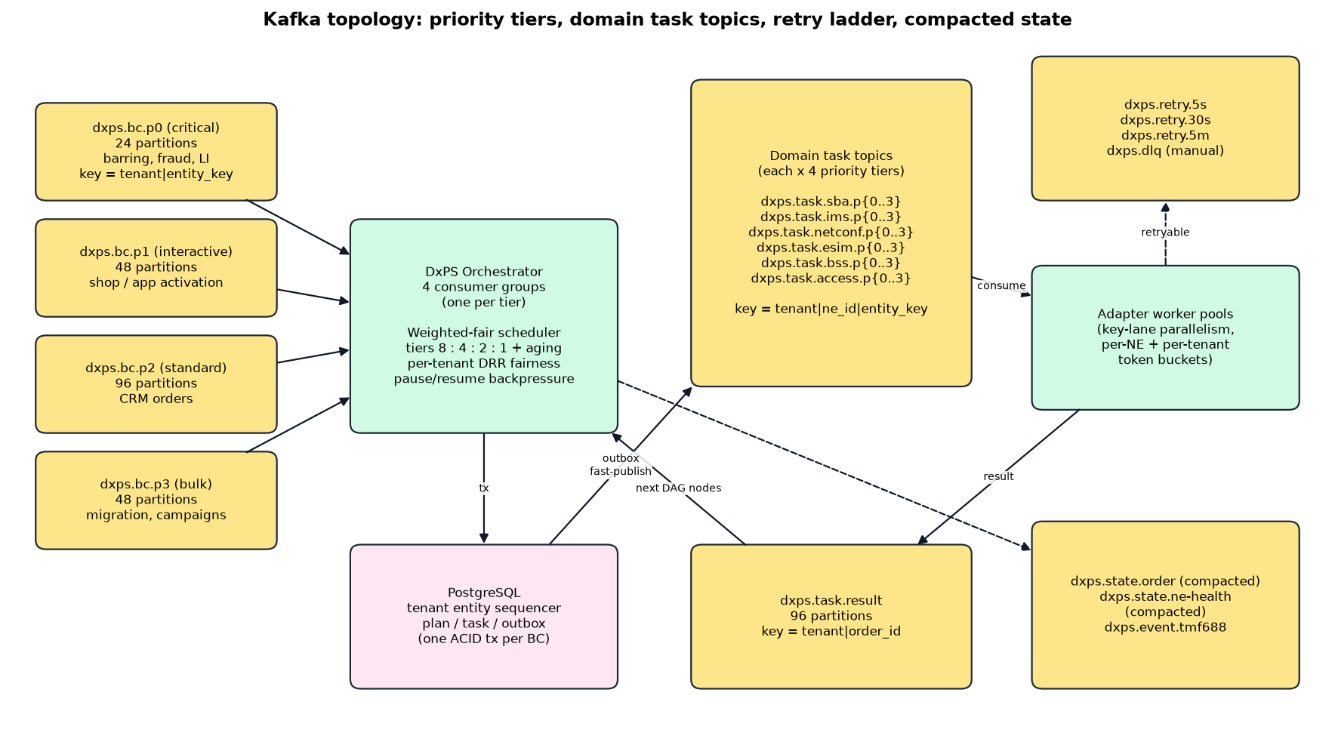
Figure: Kafka topology

4.2 Topic catalogue
Topics | Partitions | Retention / cleanup | Producer -> consumer group
dxps.bc.p0 .. p3 (4) | 6 | 7 days | Gateway (via outbox) -> dxps-orchestrator-bc.pN
dxps.task.<domain>.p0 .. p3 (7 domains x 4 = 28) | 3 | broker default | Orchestrator (via outbox) -> dxps-adapter-<domain>-pN
dxps.task.result | 6 | broker default | Adapters (transactional) -> dxps-orchestrator-result.pN
dxps.retry.5s / 30s / 5m | 3 | broker default | Orchestrator -> dxps-retry-forwarder (republishes when due)
dxps.dlq | 3 | 30 days | Any service -> dxpsctl redrive (dxps-dlq-redrive), operators
dxps.state.order | 6 | compacted | Orchestrator -> dashboards / downstream readers (latest state per order)
dxps.state.ne-health | 1 | compacted | Adapter -> dashboard
dxps.state.tenant | 1 | compacted | dxpsctl seed -> services (tenant snapshot)
dxps.event.tmf688 | 6 | broker default | Orchestrator (via outbox) -> dxps-eventhub.pN

All topics: min.insync.replicas=1 (single broker), unclean leader election off, CreateTime timestamps, producer-side compression. For a production cluster, use the same layout with replication factor 3 and min.insync.replicas=2.

4.3 Keys and headers
Topic family | Record key | Why
dxps.bc.* | tenant|entity_key (host-mno|supi:imsi-416771008030236) | All commands for one subscriber land in one partition, in order
dxps.task.* | tenant|ne_id|entity_key | Calls for one subscriber on one NE are serial; different NEs run in parallel
dxps.task.result, dxps.event.tmf688, dxps.state.order, dxps.dlq | tenant|order_id | Results and events of one order are processed in order

Header | Example | Meaning
tenant | host-mno | Must equal the key prefix and the payload tenant, otherwise the record is rejected (DXPS-1004)
message_id | ff905945-8113-5e8d-9180-7df27917d9f4 | Deterministic id; the orchestrator inbox drops duplicates
priority | p1 | Lane of the record
schema_id | dxps.v1.BusinessCommand | Message contract and version
not_before / target_topic | (retry topics) | When and where the retry forwarder republishes the record
traceparent | W3C trace context | End-to-end tracing

4.4 Messages (real)
BusinessCommand on dxps.bc.p1 (written by the gateway in the order transaction):
key: host-mno|supi:imsi-416771008030236
headers: tenant=host-mno priority=p1 schema_id=dxps.v1.BusinessCommand message_id=ff905945-8113-5e8d-9180-7df27917d9f4
{ "tenant": "host-mno", "message_id": "ff905945-8113-5e8d-9180-7df27917d9f4",
"order_id": "1f2cd4a6-6333-5fbc-8fe1-0979d5966478", "order_item_id": "sub",
"bc_id": "e602e652-1152-570a-87ac-533c5707d7b7",
"entity_key": "supi:imsi-416771008030236", "extra_entity_keys": ["msisdn:962718030236"], "entity_seq": 0,
"command_spec": "CreateSubscriber5G", "spec_version": "3.2.0", "action": "add",
"priority": 1, "tx_mode": "ATOMIC", "channel": "DASHBOARD",
"params": {"supi": "imsi-416771008030236", "msisdn": "962718030236", "plan": "LTE-20GB"} }
NeTask on dxps.task.sba.p1 (written by the orchestrator; the request is already rendered from the template):
key: host-mno|01a113c4-d818-7b24-bb32-a35af5896bea|supi:imsi-416771008030236
headers: tenant=host-mno priority=p1 schema_id=dxps.v1.NeTask message_id=...
{ "tenant": "host-mno", "task_id": "01a11476-287d-7ed4-89e1-aaa76229497b",
"order_id": "1f2cd4a6-6333-5fbc-8fe1-0979d5966478",
"ne_tenant": "host-mno", "ne_id": "01a113c4-d818-7b24-bb32-a35af5896bea", "ne_code": "udr01",
"domain": "sba", "operation": "udr.authSubscription.put", "entity_key": "supi:imsi-416771008030236",
"attempt": 0, "priority": 1, "compensation": false,
"idempotency_key": "host-mno:01a11476-287d-7ed4-89e1-aaa76229497b:0",
"request": { "supi": "imsi-416771008030236", "authenticationMethod": "5G_AKA", ... } }
TaskResult on dxps.task.result (adapter -> orchestrator; values of the same call):
key: host-mno|1f2cd4a6-6333-5fbc-8fe1-0979d5966478
{ "tenant": "host-mno", "task_id": "01a11476-287d-7ed4-89e1-aaa76229497b",
"order_id": "1f2cd4a6-6333-5fbc-8fe1-0979d5966478", "attempt": 0,
"outcome": "SUCCEEDED", "ne_status": 201, "latency_us": 3819, "response": { ... } }
outcome: SUCCEEDED | RETRYABLE (5xx, timeout: retry ladder) | FAILED (4xx: compensation)
TMF688 event on dxps.event.tmf688, then delivered by the event hub (real webhook call):
POST https://localhost:9109/hooks/host-mno (HTTP/2, 204 in 0.6 ms)
X-DxPS-Event-Id: 01a11476-2ce4-7d5f-bcdf-de0e52eeedbd
X-DxPS-Tenant: host-mno
X-DxPS-Signature: <HMAC-SHA256 of the body with the subscription secret>
{ "eventId": "01a11476-2ce4-7d5f-bcdf-de0e52eeedbd", "eventType": "ServiceOrderStateChangeEvent",
"eventTime": "2026-10-07T03:44:11.4928765Z",
"event": { "serviceOrder": { "id": "d635a915-6a95-5d96-b1a5-6e8418f4c286",
"externalId": "DEMO-HOST-MNO-8030241", "state": "completed",
"completionDate": "2026-10-07T03:44:11.4928765Z" } } }

4.5 Producers
Producer | Used for | Settings
fast | P0 / P1 records | acks=all, idempotent, lz4, no linger, 64 KB batches, 5 s delivery timeout, sticky key partitioner
bulk | P2 / P3 records | acks=all, idempotent, zstd, 10 ms linger, 1 MB batches, 120 s delivery timeout
transactional (adapter) | TaskResult + consumed offsets | transactional.id per domain, priority and instance; 30 s transaction timeout

4.6 Consumers
- Tiered consumer (orchestrator, event hub): one KIP-848 consumer group per priority tier (dxps-orchestrator-bc.p0 .. p3). Records go into the weighted-fair scheduler (P0 strict, P1:P2:P3 = 4:2:1, deficit round robin across tenants by SLA weight), then into the key-lane executor (same key serial, different keys parallel, up to 256). Only the highest contiguous completed offset per partition is committed, so a crash never skips a record.
- Exactly-once adapters: each adapter group (dxps-adapter-sba-p1, ...) consumes with read_committed, calls the NE, and produces the TaskResult and commits the consumed offset in one Kafka transaction.
- Retry ladder: a retryable failure goes to dxps.retry.5s, .30s or .5m with not_before and target_topic headers; dxps-retry-forwarder republishes it when due. After the maximum number of attempts the task fails with DXPS-4001.
- Dead letters: undecodable or tenant-mismatched records and failed tasks are written to dxps.dlq with an error header; dxpsctl redrive replays them to their source topic after a fix.
- Backpressure: the scheduler has a bounded capacity (4096); when full, polling stops instead of buffering without limit.

4.7 Outbox relay: database and Kafka in step
Services never produce to Kafka inside a database transaction. They insert outbox rows in the same transaction as the state change and, after commit, try an immediate publish (fast path). The relay in the orchestrator picks up anything older than 2 seconds that is still unpublished (crash, Kafka down) and publishes it with FOR UPDATE SKIP LOCKED. Delivery is therefore at-least-once; consumers make it effectively-once with the inbox, task attempt numbers and idempotency keys.

4.8 Volumes after the 2,000-order load run
Topic | Records | Topic | Records
dxps.task.result | 16,229 | dxps.task.bss.p1 | 1,417
dxps.state.ne-health | 7,612 | dxps.task.esim.p1 | 1,151
dxps.state.order | 7,155 | dxps.bc.p2 | 1,076
dxps.event.tmf688 | 7,155 | dxps.task.ims.p1 | 827
dxps.task.sba.p1 | 4,447 | dxps.dlq | 373
dxps.bc.p1 | 2,550 | dxps.retry.5s | 336

All 36 DxPS consumer groups were Stable with lag 0 after the run.

5. The other components

5.1 Gateway (northbound API)
Endpoint (base /tmf-api/serviceOrdering/v5) | Scope | Use
POST /serviceOrder | dxps:order:write | Create an order (Idempotency-Key header supported)
GET /serviceOrder?state=&limit=&offset= | dxps:order:read | List the tenant's orders
GET /serviceOrder/{id} | dxps:order:read | Order with item states and errors
POST /cancelServiceOrder | dxps:order:write | Cancel a running order
POST /hub, DELETE /hub/{id} | dxps:hub:write | Register / remove a TMF688 webhook

- OAuth2 bearer JWT (HS256 only; iss, aud, exp, nbf and tenant required). The tenant comes from the token, never from the body.
- Per-tenant rate limit from tenant.quota_tps; suspended tenants are refused.
- Duplicate submissions with the same Idempotency-Key return the original order; a different body with the same key is a conflict.

5.2 Orchestrator
- Planner: resolves the spec (tenant override first, then GLOBAL), validates parameters, evaluates CEL conditions (for example policy only when the plan starts with 5G), selects NEs the tenant owns or is entitled to, and coalesces tasks on the same resource.
- Entity sequencer: commands on the same subscriber run one at a time in arrival order; different subscribers run in parallel.
- Saga: ATOMIC rolls back completed steps in reverse order; PARTIAL_ALLOWED keeps what succeeded; BEST_EFFORT never rolls back. A pivot task (the OCS account) marks the point after which the command must go forward.
- Order state is derived from the business commands: acknowledged -> inProgress -> completed / failed / partial / cancelled / rejected.

5.3 Catalog
A spec is YAML. This is the real CreateSubscriber5G (GLOBAL 3.2.0), abbreviated:
spec: CreateSubscriber5G
version: 3.2.0
txMode: ATOMIC
priorityDefault: P1
params:
required: [supi, msisdn, plan]
properties:
supi: {type: string, pattern: "^imsi-[0-9]{15}$"}
entityKeys: ["'supi:' + params.supi", "'msisdn:' + params.msisdn"]
tasks:
- {id: auth, ne: {nfType: UDR}, op: udr.authSubscription.put, template: sba/auth-subscription.json.tmpl,
compensate: udr.authSubscription.delete}
- {id: am, dependsOn: [auth], op: udr.amData.put, coalesceKey: "'udr-am:' + params.supi", compensate: udr.amData.delete}
- {id: smf, dependsOn: [auth], op: udr.smfSelection.put, compensate: udr.smfSelection.delete}
- {id: policy, dependsOn: [auth], when: "params.plan.startsWith('5G')", op: udr.policyData.put}
- {id: ocs, dependsOn: [am, smf], ne: {nfType: OCS}, op: bss.account.create, pivot: true}
mvno-alpha overrides it (3.2.0-alpha.1) to use its own OCS and add a welcome bundle. Specs are loaded into command_spec at seed time; the version used is stored on every business command.

5.4 Adapter and network elements
NE | Owner | Domain / type | Simulator port | Entitled tenants (quota TPS)
nrf01 | host-mno | sba / NRF (OAuth2 tokens) | 9101 | shared
udr01 | host-mno | sba / UDR | 9102 | mvno-alpha (400), mvno-beta (150)
imspg01 | host-mno | ims / IMS provisioning gateway | 9103 | mvno-alpha (200), mvno-beta (100)
pe01 | host-mno | netconf / PE router (L3VPN) | 9104 | ent-acme (50)
olt01, usp01 | host-mno | access / OLT (TR-385), USP controller (TR-369) | 9104 | host only
smdp01 | host-mno | esim / SM-DP+ (ES2+) | 9105 | mvno-alpha (100), mvno-beta (50)
ocs01 | host-mno | bss / OCS (TMF666) | 9106 | mvno-beta (150)
ocs-alpha | mvno-alpha | bss / OCS of the full MVNO | 9106 | mvno-alpha only
npdb01 | host-mno | bss / number portability | 9107 | mvno-alpha (50), mvno-beta (50)
nef01 | host-mno | exposure / NEF (CAMARA QoD) | 9108 | mvno-alpha (100), ent-acme (50)

- Before every call the adapter takes a token from the NE budget (max_tps, max_concurrency, reserved share for the host) and the tenant quota; a circuit breaker per NE opens after consecutive failures.
- All NE calls use HTTP/2 over mutual TLS with the DxPS CA. mvno-beta has no entitlement on nef01, which is why its QoDSession orders fail with DXPS-1005 before any call is made.

5.5 Network simulators
netsim implements every southbound interface with payload validation and per-tenant state (a subscriber created by one tenant cannot be changed by another). The admin port 9199 sets latency and error rates. Test inputs trigger faults: a parameter ending in 997 gives a transient 503, 998 a permanent 4xx rejection, 999 an NE that is down; a USP device marked OFFLINE returns 7002; a QoD bandwidth above 10,000 returns 409.

5.6 Event hub
- Consumes dxps.event.tmf688 and posts each event to the tenant's registered callbacks.
- Callbacks must be https and allow-listed; redirects are not followed; delivery is retried with backoff.
- Each subscription has its own secret, stored encrypted (AES-256-GCM, bound to the tenant) and used for the X-DxPS-Signature HMAC.

5.7 Mosaic dashboard
Reads statistics from every service's loopback stats port, Kafka (topic end offsets, group lag) and PostgreSQL (as dxps_ops: orders by state, tasks by domain, NE latency percentiles, outbox backlog), and shows them as live tiles. It also contains a load generator and security probes.

5.8 PKI, secrets and dxpsctl
- dxpsctl secrets generates database passwords, the JWT key and the secret-box key into secrets.env (mode 0600) in the runtime directory.
- dxpsctl certs creates the development CA and ECDSA P-256 certificates for PostgreSQL, the gateway, the services and every simulator.
- dxpsctl migrate / seed / topics prepare PostgreSQL and Kafka; dxpsctl api and trace give read access without handling passwords.

6. What happens when something fails
Situation | What protects the order | Component
Client sends the same order twice | Idempotency-Key -> same order id (UUIDv5); unique (tenant, idempotency_key) | Gateway, PostgreSQL
Service crashes after commit, before publishing | Outbox row is still unpublished; the relay publishes it | PostgreSQL outbox, relay
Kafka unavailable | Orders are still accepted and stored; the outbox drains when Kafka is back | Outbox
Message delivered twice | Inbox (message_id), attempt numbers and NE idempotency keys make the repeat a no-op | Orchestrator, adapter
NE timeout or 5xx | Retry ladder 5 s / 30 s / 5 min, then DXPS-4001 and compensation | Orchestrator, retry forwarder
NE rejects the request (4xx) | ATOMIC: reverse-order compensation; order failed with the NE error | Saga
Adapter crashes mid-call | Offset was not committed (transaction aborted): the task is redelivered with the same idempotency key | Kafka EOS
Two orders change the same subscriber | Entity sequencer runs them one after the other | Orchestrator, PostgreSQL
A tenant floods the system | Gateway rate limit, tier weights, per-tenant DRR and NE quotas | Gateway, scheduler, registry
Forged tenant in a message | Header, key prefix and payload tenant must match; RLS blocks cross-tenant rows | All consumers, PostgreSQL

