**Overview**

This tutorial creates the following API:

| **API** | **Description** | **Request body** | **Response body** |
| --- | --- | --- | --- |
| GET /api/todoitems | Get all to-do items | None | Array of to-do items |
| GET /api/todoitem/{id} | Get an item by ID | None | To-do item |
| POST /api/todoitem | Add a new item | To-do item | To-do item |
| PUT /api/todoitem/{id} | Update an existing item | To-do item | None |
| DELETE /api/todoitem/{id} | Delete an item | None | None |

The following diagram shows the design of the app.

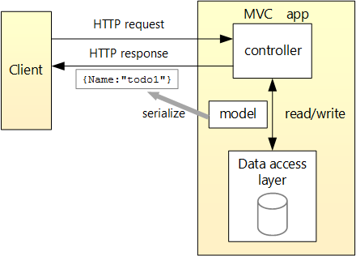

| **API** | **Description** | **Parameters** | **Response codes** |
| --- | --- | --- | --- |
| GET /api/todoitems | Get all to-do items | Url 🡪 QueryParam | 200, 400, 500 |
| GET /api/todoitems/{id} | Get an item by ID | Url 🡪 Routing + QueryParam | 200, 400, 404, 500 |
| POST /api/todoitems | Add a new item | Body 🡪 Json | 201, 400, 500 |
| PUT /api/todoitems/{id} | Update an existing item | Url 🡪 Routing +  Body 🡪 Json | 204. 400, 404, 500 |
| DELETE /api/todoitems/{id} | Delete an item | Url 🡪 Routing | 204, 404, 500 |