**Vishwa Adarsha College**

**Itahari-04, Sunsari**



**A Project Report**

**Of**

**Technology related content**

For the partial fulfillment of Bachelor’s Degree of Computer Applications

**SUBMITTED BY:**

Ankit Adhikari Apekshya Kc

BCA, Forth Semester BCA, Forth Semester

Symbol No: 46502117 SymbolNo:46502118

TU Registration No: 6-2-465-1-2022 TU RegistrationNo:6-2-465-2-2022

**SUBMITTED TO:**

Ghanashyam Adhikari, Niraj Poudel

Vishwa Adarsha College

Department of Bachelor in Computer Application

Affiliated to Tribhuvan University

2081

Table of Contents

Chapter 1 Introduction 6

1.1 Introduction of Proposed project 6

1.2 Problem Statement 6

1.3 Objectives 6

1.4 Scope and limitation 7

Chapter 2 Literature Review 8

Chapter 3 Methodology 9

3.1 Waterfall model 9

3.2 System Analysis 11

3.3 System Design 13

3.4 Gantt chart………………………………………………………………………………………………………….14

Chapter 4 Conclusion 14

4.1 Expected Outcome 14

References 15

Bibliography 15

**Chapter 1 Introduction**

**1.1 Introduction of the Proposed Project: Techfid**

Techfid is a platform for tech learners and professionals to share and discover tech-related content like articles, tutorials, videos, and projects. Covering topics from software development to artificial intelligence and cybersecurity, Techfid helps users stay updated on the latest tech trends. Techfid is more than just a site for sharing content; it's a community for those passionate about technology to grow their skills and stay ahead in the tech world.

**1.2 Problem Statement**

The tech community lacks a centralized, user-friendly platform for sharing and finding technology-related content. Tech enthusiasts and professionals face several challenges:

1. **Combines multiple content types:** Articles, tutorials, videos, projects within a single space, making it easier for users to discover diverse tech-related resources without jumping between platforms.
2. **Offers group collaboration features:** Platform where only tech related content can be post and users can create and join specialized groups, work on projects together, and discuss various tech topic something traditional platforms lack.

Community Building: Tech enthusiasts often seek meaningful interactions and connections with like-minded individuals, but current platforms do not facilitate the formation of focused communities around specific interests or projects.

These challenges highlight the need for Techfid, a dedicated platform that makes it easy to share, discover, and engage with tech content, building a vibrant tech community.

**1.3 Objectives**

The main objective of this project is to provide information about the technology and help to other to solve technological problems

1. Enable users to create groups for specific tech topics and discussions.
2. Users can join those groups and create post related to group

c. Provide a space for users to ask questions and get help with tech-related issues.

d. Facilitate sharing of the latest technology trends and insights.

**1.4 Scope and limitation**

**Scope**

a. Group creation for specific tech topics.

b. Sharing of tech articles, tutorials, and videos.

c. Platform for asking questions and solving tech issues.

e. User can search for the group or post they need

**Limitation**

a. Limited tags only available

b. Users may create irrelevant groups.

c. Notification feature is not available.

d. Group creator can’t delete the post done by the user.

e. After the post is made editing can’t be done.

**Chapter 2 Literature Review**

**Literature Review**

The rapid evolution of technology has created a pressing need for platforms that facilitate knowledge sharing, collaboration, and community engagement among tech enthusiasts. Existing platforms like GitHub and Stack Overflow have carved out niches, primarily focusing on code sharing and technical Q&A. However, they often lack the holistic integration of diverse content types and collaborative tools necessary for a comprehensive learning experience. Research by Mastan and Kumar (2018) emphasizes that while platforms like Medium allow for article sharing, they do not provide avenues for real-time discussions or project collaborations, which are critical for fostering deeper learning. Stack Overflow's model, while effective for problem-solving, can stifle broader discussions, as noted by Khansa, Ma, and Liginlal (2015). This limitation highlights the need for a dedicated space where users can not only share knowledge but also engage in meaningful interactions around shared interests.

Furthermore, personalization is essential for enhancing user engagement. Anderson (2013) identifies the importance of tailored content in improving user retention and satisfaction. Yet, many platforms fall short in delivering personalized learning paths, leaving users overwhelmed by generic recommendations. Techfid aims to leverage AI-driven algorithms to provide users with customized content suggestions based on their interests and activities, ensuring a more relevant and engaging experience.

**Existing Technology Platforms**

Several platforms currently serve technology enthusiasts and professionals, such as GitHub, Stack Overflow, Reddit, and LinkedIn. Each offers unique features: GitHub for code hosting and collaboration, Stack Overflow for Q&A, and LinkedIn for professional networking. However, these platforms do not offer a holistic approach that combines content sharing, problem-solving, and community interaction.

**Chapter 3 Methodology**

**3.1 Waterfall Process Model**

The Waterfall Model was the first Process Model to be introduced. It is also referred to as a linear-sequential life cycle model. It is very simple to understand and use. In a waterfall model, each phase must be completed before the next phase can begin and there is no overlapping in the phases.

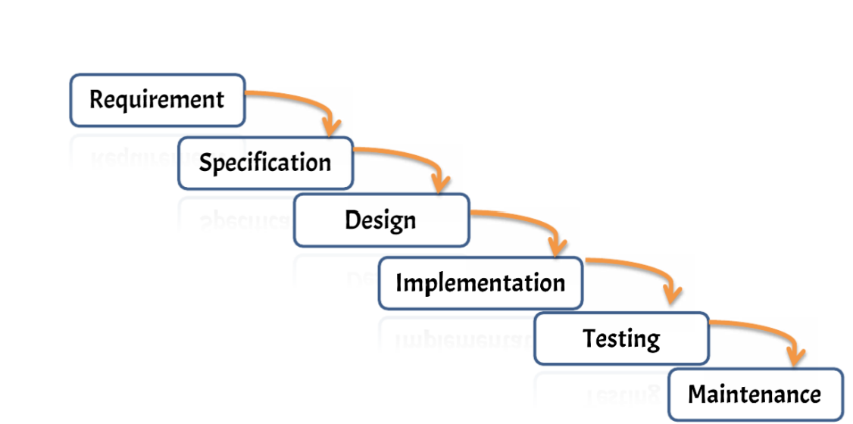

**Fig(a): Waterfall Model**

We are going to use the waterfall methodology while building the website. This project have specific documentation, ample time, fixed requirements, well-understood technology so in order to build this system, water fall methodology can be used.

## **3.2 System Analysis**

It is a process of collecting and interpreting facts, identifying the problems, and decomposition of a system into its components.

System analysis is conducted for the purpose of studying a system or its parts in order to identify its objectives. It is a problem solving technique that improves the system and ensures that all the components of the system work efficiently to accomplish their purpose.

**Requirements Identification:**

This system needs to fulfill following functional and non-functional requirements.

* **Functional Requirement**

1. Secure registration and login.
2. Create and submit technology-related posts (text, links, images).
3. Commenting and reply system.
4. Upvote/downvote system for posts.
5. User will be able to create and delete group
6. Browse by categories/tags and a search function.

.

* **Non-Functional Requirements**

1. Fast page loads and ability to handle high traffic.
2. HTTPS, secure password storage, and protection against web vulnerabilities.
3. Modular, well-documented code for easy updates.
4. Design to support multiple languages in the future.

**b. Feasibility study**:

A **feasibility study** is an evaluation and analysis of a project or system that somebody has proposed. Following feasibilities were studied before building the system to see if the system could be built with exact requirements in required time.

* **Technical Feasibility**: The project will be developed using HTML, CSS, and JavaScript for the frontend, ensuring a responsive and user-friendly interface. Node.js will handle the backend, providing scalability and the ability to manage multiple requests concurrently. Tags will be provided to filter out non-tech content for now and AI-driven and community-flagging feature will be provided in in future.
* **Economic Feasibility**: Estimating the budget for development, deployment, and maintenance, including costs for hosting, domain registration.
* **Operational Feasibility**: Operational challenges include ensuring that content remains tech-focused and monitoring the platform’s performance as user traffic grows other then that this project needs simple technology to design so it is user friendly.
* **Legal Feasibility**: Techfid will comply with data protection laws such as GDPR ensuring user privacy and data security. The platform will have clear Terms of Service and Content Ownership agreements, allowing users to retain control over their shared content.

**C Tools**

**Front end**

* Html
* CSS
* JavaScript

**Back end**

* Node JS

**Database**

* My sql

**3.3 System Design**

**Use case diagram**

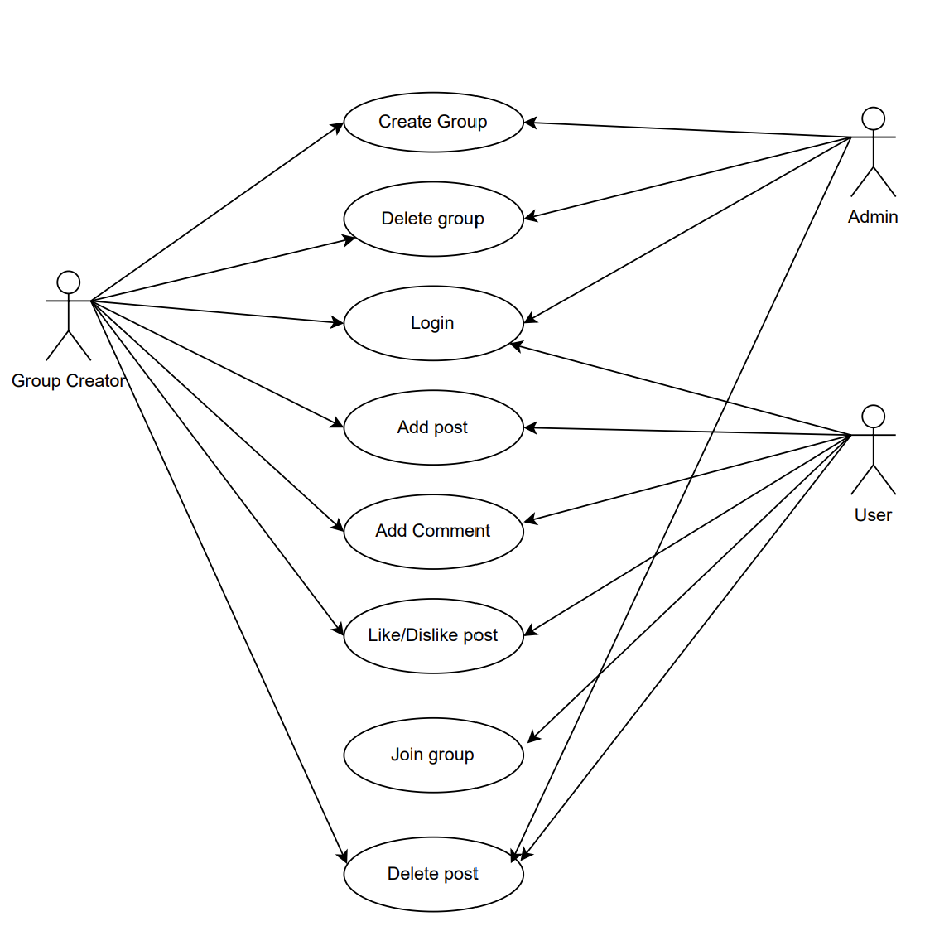

**3.4 Project Schedule**

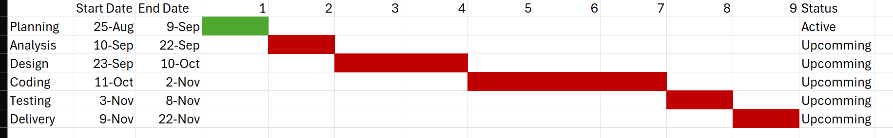

Fig: Gantt Chart

**Chapter 4 Conclusion**

Techfid is designed to create a collaborative space for tech enthusiasts, learners, and professionals. It addresses the need for a centralized platform where users can share, learn, and engage with tech-related content, from tutorials to project showcases. The platform's success depends on active user engagement and continuous improvements, fostering a community of innovation and growth.

**4.1 Expected Outcome**

1. **Central Hub for Tech Content:** A go-to platform for sharing and accessing tech articles, tutorials, and discussions.
2. **Active Community Engagement:** Users will interact, collaborate, and solve tech-related problems together.
3. **Enhanced Learning and Networking**: The platform will boost skill development and professional connections.

**References**

1. Royce, W. W. (1970). Managing the Development of Large Software Systems. *Proceedings of IEEE WESCON*, 1-9. Available at:

<https://www.cs.umd.edu/class/spring2003/cmsc838p/Process/waterfall.pdf>

1. Argote, L., & Ingram, P. (2000). Knowledge Transfer: A Basis for Competitive Advantage in Firms. *Organizational Behavior and Human Decision Processes*, 82(1), 150–169. Available at: <https://doi.org/10.1006/obhd.2000.2893>
2. Nonaka, I., & Takeuchi, H. (1995). *The Knowledge-Creating Company: How Japanese Companies Create the Dynamics of Innovation*. Oxford University Press.
3. European Commission. (2017). Guidelines on the feasibility study for building new systems. Available at: <https://ec.europa.eu/info/departments_en>
4. • Tech Feasibility Report. (2020). Analyzing Technical and Economic Feasibility in Software Development. Retrieved from: <https://www.techfeasibility.org>