In the name of GOD

Documentation of

**The Noting Project**

Created and Configured by:

**Atieh Mokhtari**

February 2025

Table of Contents

The Project Goal 3

User Registration & Authentication 3

Login & Session Management 3

Notes Management 3

Access Control & Security 3

Technologies Used 4

Database Schema & Relationships 4

Database Diagram 4

Project Development Steps 5

Setting Up Authentication 5

Creating the Note Model 5

Defining Routes 5

Implementing CRUD Operations 5

Building Views 6

Finalizing User Access Control 6

HOW DOES IT WORKS 6

User Registration: 6

User Login & Home Page: 7

Adding a New Note: 7

Viewing Notes: 8

Editing & Deleting Notes: 8

Database Management: 9

Final Words 10

# The Project Goal

The primary objective of this project is to develop a secure and user-friendly login system using Laravel. The system will allow users to register an account, log in, and manage their personal notes.

## User Registration & Authentication

* New users must be able to register with a valid email and password.
* The system will securely store user credentials and enforce authentication best practices.
* Laravel's built-in authentication system is utilized for user login and session management.

## Login & Session Management

* Registered users can log in using their credentials.
* Sessions will be managed to ensure security and user data protection.
* Unauthorized users cannot access protected pages.

## Notes Management

* Authenticated users can create, edit, and save personal notes.
* Each user's notes will be private and stored securely in the database.
* Users can view their saved notes only when logged in.

## Access Control & Security

* Users who are not logged in will not have access to any stored notes.
* Upon logging out, the session will be cleared, ensuring no unauthorized access to notes.

This project aims to provide a simple yet effective personal note-taking system with a focus on user authentication and data privacy.

# Technologies Used

* Laravel Version: 8.83
* PHP Version: 7.4
* Database: MySQL
* Database Management Tool: MySQL Workbench (for data visualization and management)
* Dependency Management: Composer
* Frontend Package Management: npm (installed via Composer)

# Database Schema & Relationships

The project utilizes a relational database structure with the following key relationships:

* Users Table: Stores user authentication details.
* Notes Table: Stores user-created notes.

The relationship between these tables follows a One-to-Many (1:N) structure:

* Each user can have multiple notes.
* Each note belongs to only one user.

This ensures that every note entry is linked to a specific user, maintaining data integrity and privacy.

MySQL is used as the primary database, ensuring efficient data storage and retrieval. Also MySQL Workbench is used to visualize and manage stored data.

## Database Diagram

Here is my database diagram created by workbench; it shows the relations between main tables:

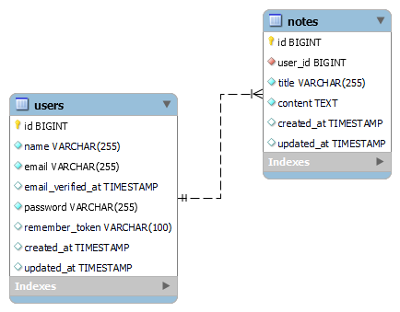

# Project Development Steps

## Setting Up Authentication

* Installed laravel/ui via Composer to enable authentication control.
* Configured Laravel authentication scaffolding to manage user login and registration.

## Creating the Note Model

* Added the Note model to represent user notes in the database.
* Defined the One-to-Many relationship between User and Note models.

## Defining Routes

* Created routes for handling note-related operations.
* Ensured that all routes for managing notes are accessible only to authenticated users.

## Implementing CRUD Operations

* Developed Create, Read, Update, and Delete (CRUD) functionalities for notes.
* Enforced authentication checks to restrict unauthorized access.

## Building Views

* Designed user-friendly views for:
* Creating a new note
* Displaying all notes (Index page)
* Editing & Updating an existing note
* Deleting a note

## Finalizing User Access Control

* Ensured that users can only manage their own notes.
* Restricted all note-related actions to logged-in users.

By following these steps, the system provides a seamless and secure note-taking experience, ensuring that only authenticated users can create, view, edit, and delete their personal notes.

# HOW DOES IT WORKS

The project now successfully implements a fully functional authentication and note management system. The key features include:

## User Registration:

A new user can register with a valid email and a password (minimum 8 characters).

User credentials are securely stored in the database.

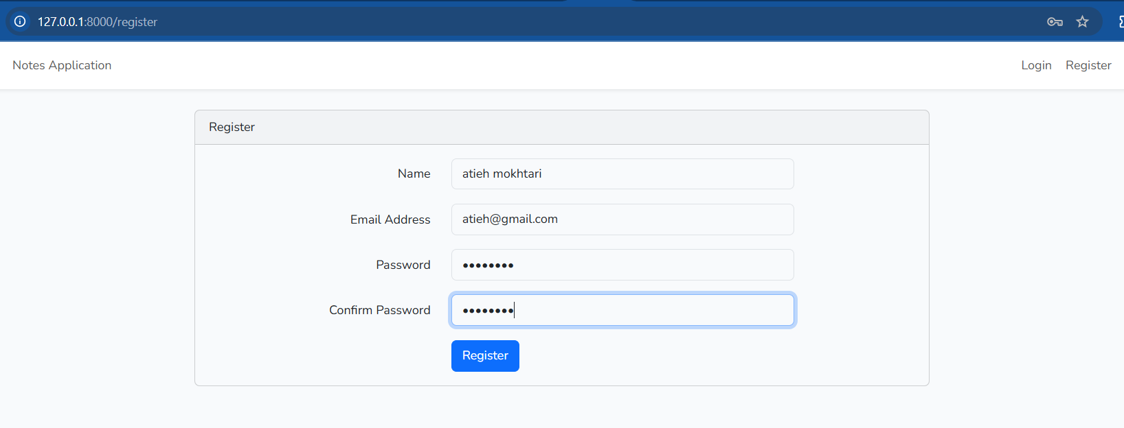

## User Login & Home Page:

A registered user can log in using their credentials. Upon successful login, the user is redirected to the homepage of the note-taking system.

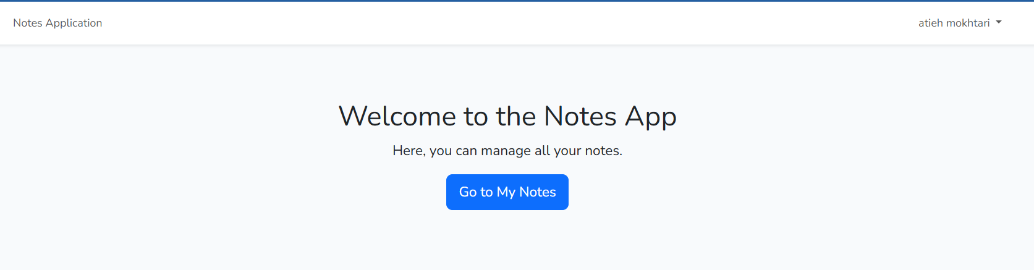

## Adding a New Note:

Users can create a new note by clicking the "Add New Note" button. A form is displayed where users enter the note details.Once submitted, the note is saved in the database.

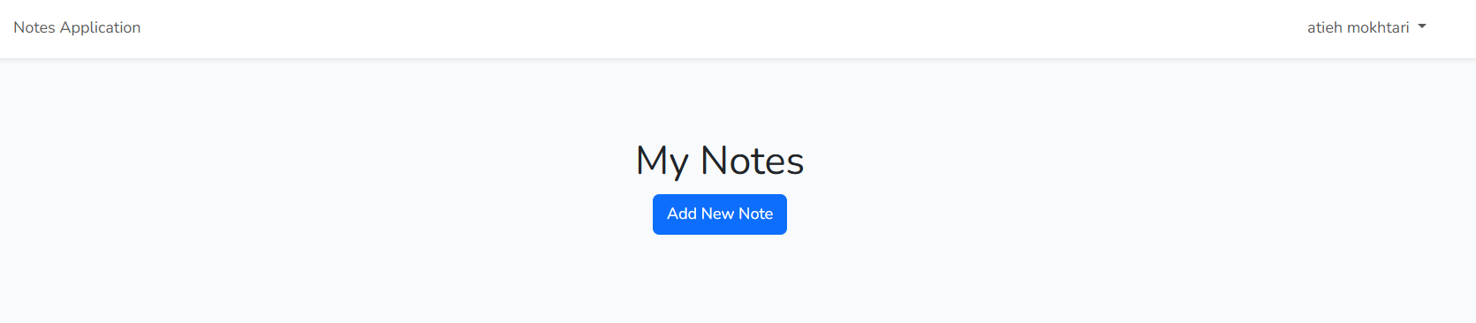

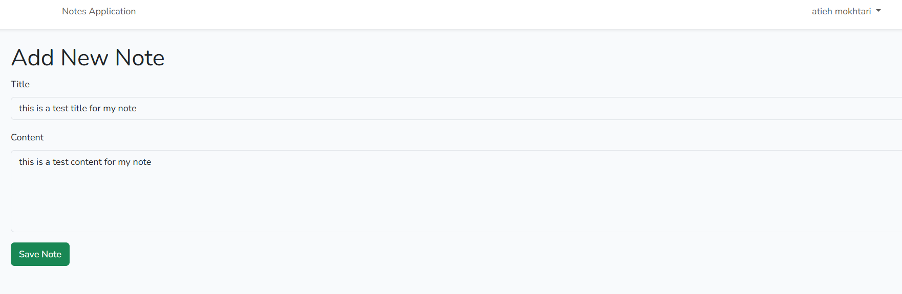

## Viewing Notes:

The created note appears on the Notes Page, displaying all saved notes. Users can click on any note to view its details.

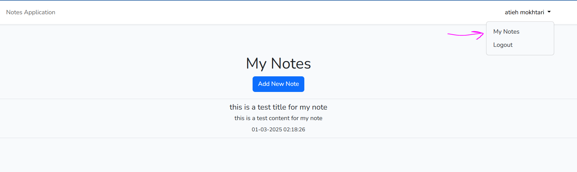

## Editing & Deleting Notes:

By selecting a specific note, users can access options to edit or delete it. Edits allow users to update the content, while deletion removes the note permanently from the database.

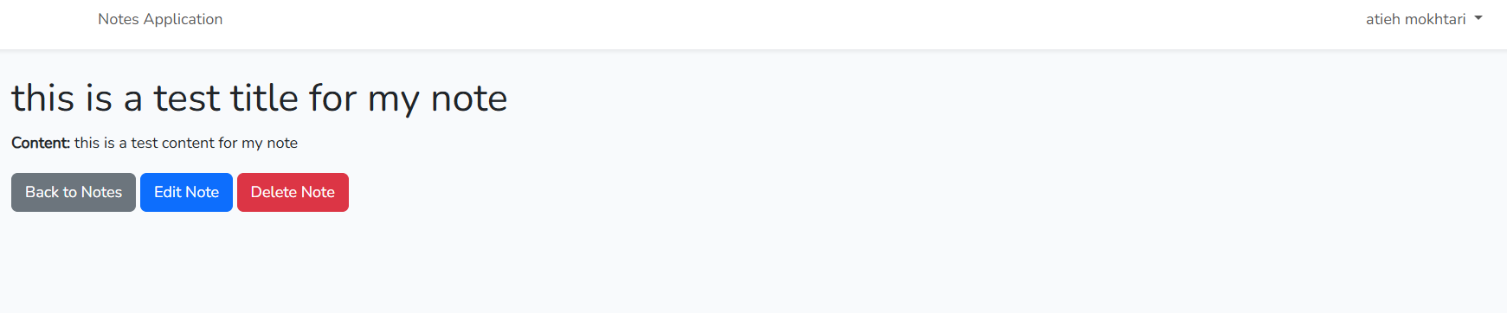

## Database Management:

User registration details are stored in the users table. All created notes are linked to the respective user and stored in the notes table. We can see also the details of registered user saving in the users table in our database and also the created note is saved in database:

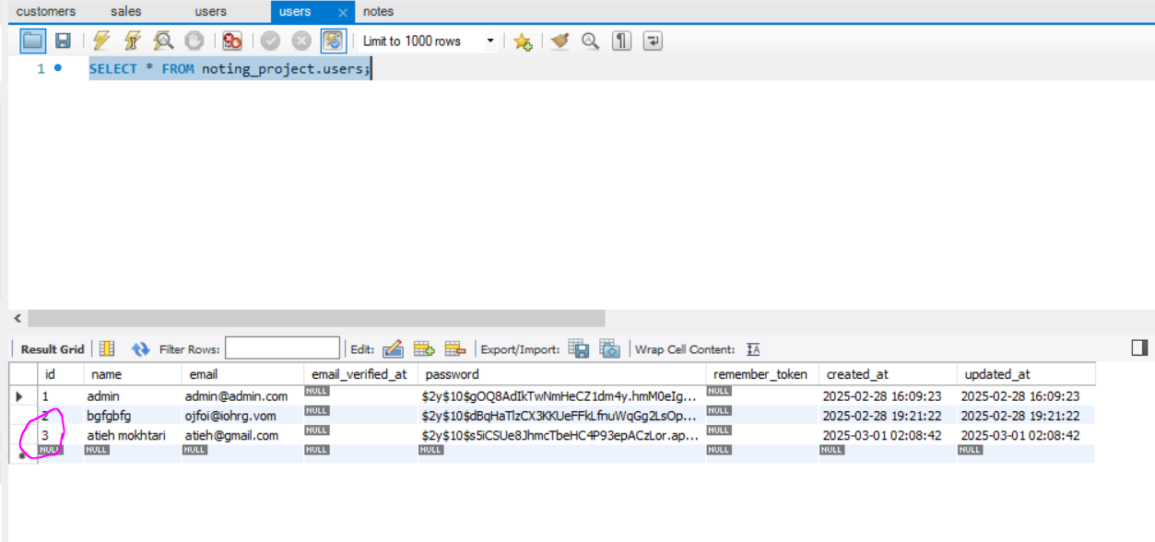

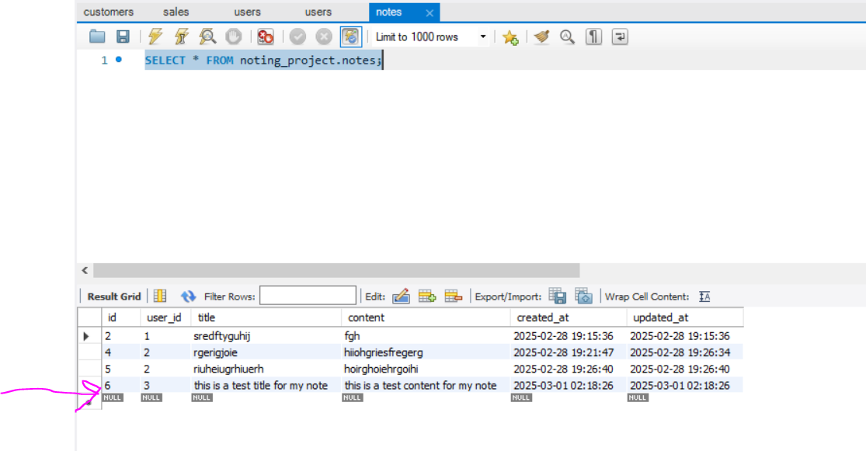

# Final Words

This project successfully implements a secure and efficient note management system using Laravel 8.83, ensuring proper authentication and data privacy. By following best practices in user authentication, database relationships, and access control, the system allows users to manage their notes with ease while keeping them private.

With a structured development approach (from setting up authentication to implementing CRUD operations and enforcing access control); the project provides a solid foundation for further enhancements. Future improvements could include adding search functionality, implementing note categorization, or integrating an API for mobile access.

This project not only strengthens Laravel development skills but also demonstrates practical experience in building secure web applications with authentication and database management.