Dear Sir/Madam,

Re: **APPLICATION FOR THE ROLE OF DEVELOPER**

I have hands-on experience working as a Freelance developer from 2016, working on several software projects for local businesses, as well as software assignments for International students, ranging from A.I. and Machine Learning, to things such as E-commerce platforms etc. I also got extra experience working as an I.T and Computer science lecturer at Datamine Technical Business Institute [www.datamineschool.ac.ug](http://www.datamineschool.ac.ug/). Am currently working as an ICT Manager for a government Nursing School, known as Masaka School of Comprehensive Nursing, Located at Masaka Regional Referral Hospital [www.mscn.ac.ug](https://www.mscn.ac.ug/). With over 8 years of experience.

I have worked on several projects developing, upgrading and maintaining web based projects and apps, all among others. Some of them include a Danish football academy-website below located in my hometown. (It is done in Wordpress - Elementor) <https://www.elcambioacademy.com/>. Here, I was inspired to learn template building from scratch, which i did in one one of my online job interviews. The wordpress template is in the next link.

<https://drive.google.com/file/d/1sJfL4w3YZLEqxZ0VjzcfZQJFrzMGKCmc/view?usp=sharing>

Next, I can do front-end development as one of my interview results do show below. I was required to get data of one patient from a Backend-API and replicate the design given to me.

This was their xd image-design.

<https://xd.adobe.com/view/121254c9-532f-4772-a1ba-dfe529a96b39-4741/>

This was my implementation

<https://sample1-site.tiiny.site/>

Also below are demo videos of my other work, among so many. I did them in PHP, JavaScript and bootstrap. They are not hosted but rather, they are used locally by their respective business owners. I made some demo videos. Just to mention but a few…., but I am worth much more

1.) Hospital Management System <https://youtu.be/IkFtKu_hFXE>

2.) Sales Management System <https://youtu.be/7KwvpwulAzg>

3.) School website <https://youtu.be/ysoeVA3CF2Q>

Yours, Jjinga Richard,

**CURRICULUM VITAE**

NAME : JJINGA RICHARD

NATIONALITY : UGANDAN

AGE : 39

SEX : MALE

TELEPHONE: +256763383379

PREFFERED MAIL :[richardjjinga@gmail.com](mailto:richardjjinga@gmail.com)

**EDUCATION BACKGROUND**

1992-1998. : Bishop Ddungu Primary School

1999-2002. : St. Henry’s College Kitovu ([www.sthenryskitovu.ac.ug](https://www.sthenryskitovu.ac.ug/))

2004-2004. : Masaka Secondary School, Masaka, Uganda

2005-2008 : Nkumba University (Bsc. B I T) ([www.nkumbauniversity.ac.ug](https://nkumbauniversity.ac.ug/))

2012-2012. : Multitech Business School (Cisco/CCNA) ([www.multitech.ac.ug](http://www.multitech.ac.ug/))

2023-2023. : Makerere University College of computing & Information Sciences,

(Cyber-Security three day training) ([www.mak.ac.ug](http://www.mak.ac.ug))

**EMPLOYMENT BACKGROUND**

* 2016-Now: A part-time Freelancer, working on software projects for local businesses as well as

International students’ assignments

* 2013-2018: Lecturer I.T / Computer science at DATAMINE TECHNICAL BUSINESS INSTITUTE

([www.datamineschool.ac.ug](http://www.datamineschool.ac.ug/))

* 2019-Now: ICT Manager at Masaka School of Comprehensive Nursing (Masaka Regional Referral Hospital)

([www.mscn.ac.ug](https://www.mscn.ac.ug/))

**MY SKILLS INCLUDE:**

* Advanced skills in (PHP, Python, JavaScript-Vanilla, ECMA Script, CSS, HTML, My SQL).
* AI & Machine learning (Mostly Data Analytics with Pyspark).
* Web Frameworks, Tools & Technologies (React, Django, Basic Laravel, Bootstrap, Ajax, Git, jquery).
* Database Design, Development and administration (Oracle, Mysql).
* Content Management Systems (Wordpress, Drupal, Joomla).
* Software Engineering and development (Visual Basic, C, C++).
* Basic Android app development.
* Graphics Design (Photoshop, In-design, Illustrator).
* General Systems administration (Including Web servers)
* Computer networking (CCNA , Voice)

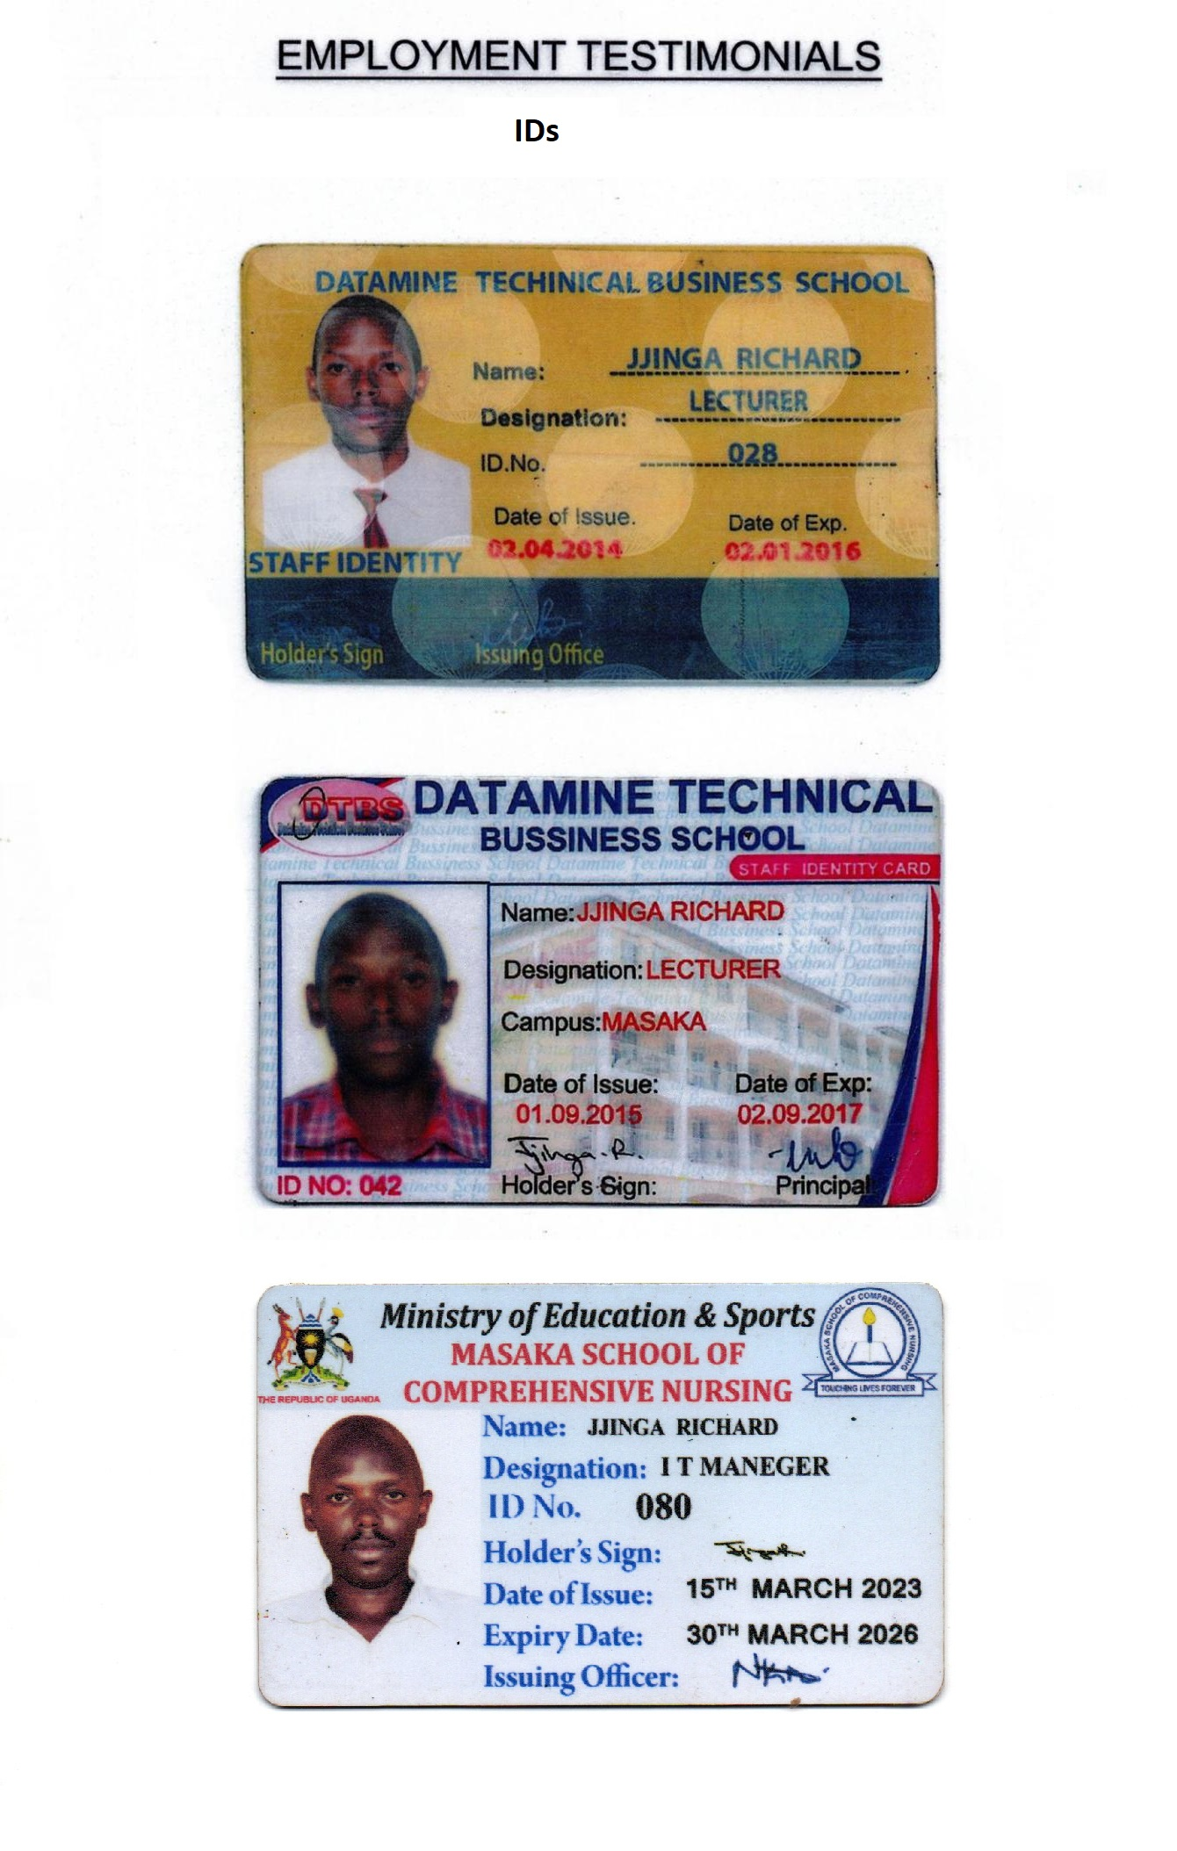

**University Certificate**

