Dear Sir/Madam,
Re: APPLICATION FOR THE ROLE OF DEVELOPER

I have hands-on experience working as a Freelance developer from 2016, working on several software projects for local businesses, as well as software assignments for International students, ranging from A.I. and Machine Learning, to things such as E-commerce platforms etc. I also got extra experience working as an I.T and Computer science lecturer at Datamine Technical Business Institute www.datamineschool.ac.ug. Am currently working as an ICT Manager for a government Nursing School, known as Masaka School of Comprehensive Nursing, Located at Masaka Regional Referral Hospital www.mscn.ac.ug. With over 8 years of experience.
I have worked on several projects developing, upgrading and maintaining web based projects and apps, all among others. Some of them include a Danish football academy-website below located in my hometown. (It is done in Wordpress - Elementor) https://www.elcambioacademy.com/. Here, I was inspired to learn template building from scratch, which i did in one one of my online job interviews. The wordpress template is in the next link.
https://drive.google.com/file/d/1sJfL4w3YZLEqxZ0VjzcfZQJFrzMGKCmc/view?usp=sharing
Next, I can do front-end development as one of my interview results do show below. I was required to get data of one patient from a Backend-API and replicate the design given to me.
This was their xd image-design.
https://xd.adobe.com/view/121254c9-532f-4772-a1ba-dfe529a96b39-4741/
This was my implementation
https://sample1-site.tiiny.site/
Also below are demo videos of my other work, among so many. I did them in PHP, JavaScript and bootstrap. They are not hosted but rather, they are used locally by their respective business owners. I made some demo videos. Just to mention but a few…., but I am worth much more
1.) Hospital Management System https://youtu.be/IkFtKu_hFXE
2.) Sales Management System https://youtu.be/7KwvpwulAzg
3.) School website https://youtu.be/ysoeVA3CF2Q

Yours, Jjinga Richard,

CURRICULUM VITAE
NAME : JJINGA RICHARD
NATIONALITY : UGANDAN
AGE : 39
SEX : MALE
TELEPHONE : +256763383379
PREFFERED MAIL : richardjjinga@gmail.com
EDUCATION BACKGROUND
1992-1998. : Bishop Ddungu Primary School
1999-2002. : St. Henry’s College Kitovu (www.sthenryskitovu.ac.ug)
2004-2004. : Masaka Secondary School, Masaka, Uganda
2005-2008 : Nkumba University (Bsc. B I T) (www.nkumbauniversity.ac.ug)
2012-2012. : Multitech Business School (Cisco/CCNA) (www.multitech.ac.ug)
2023-2023. : Makerere University College of computing & Information Sciences,
(Cyber-Security three day training) (www.mak.ac.ug)
EMPLOYMENT BACKGROUND

- 2016-Now: A part-time Freelancer, working on software projects for local businesses as well as
International students’ assignments
- 2013-2018: Lecturer I.T / Computer science at DATAMINE TECHNICAL BUSINESS INSTITUTE
(www.datamineschool.ac.ug)
- 2019-Now: ICT Manager at Masaka School of Comprehensive Nursing (Masaka Regional Referral Hospital)
(www.mscn.ac.ug)

MY SKILLS INCLUDE:
- Advanced skills in (PHP, Python, JavaScript-Vanilla, ECMA Script, CSS, HTML, My SQL).
- AI & Machine learning (Mostly Data Analytics with Pyspark).
- Web Frameworks, Tools & Technologies (React, Django, Basic Laravel, Bootstrap, Ajax, Git, jquery).
- Database Design, Development and administration (Oracle, Mysql).
- Content Management Systems (Wordpress, Drupal, Joomla).
- Software Engineering and development (Visual Basic, C, C++).
- Basic Android app development.
- Graphics Design (Photoshop, In-design, Illustrator).
- General Systems administration (Including Web servers)
- Computer networking (CCNA , Voice)
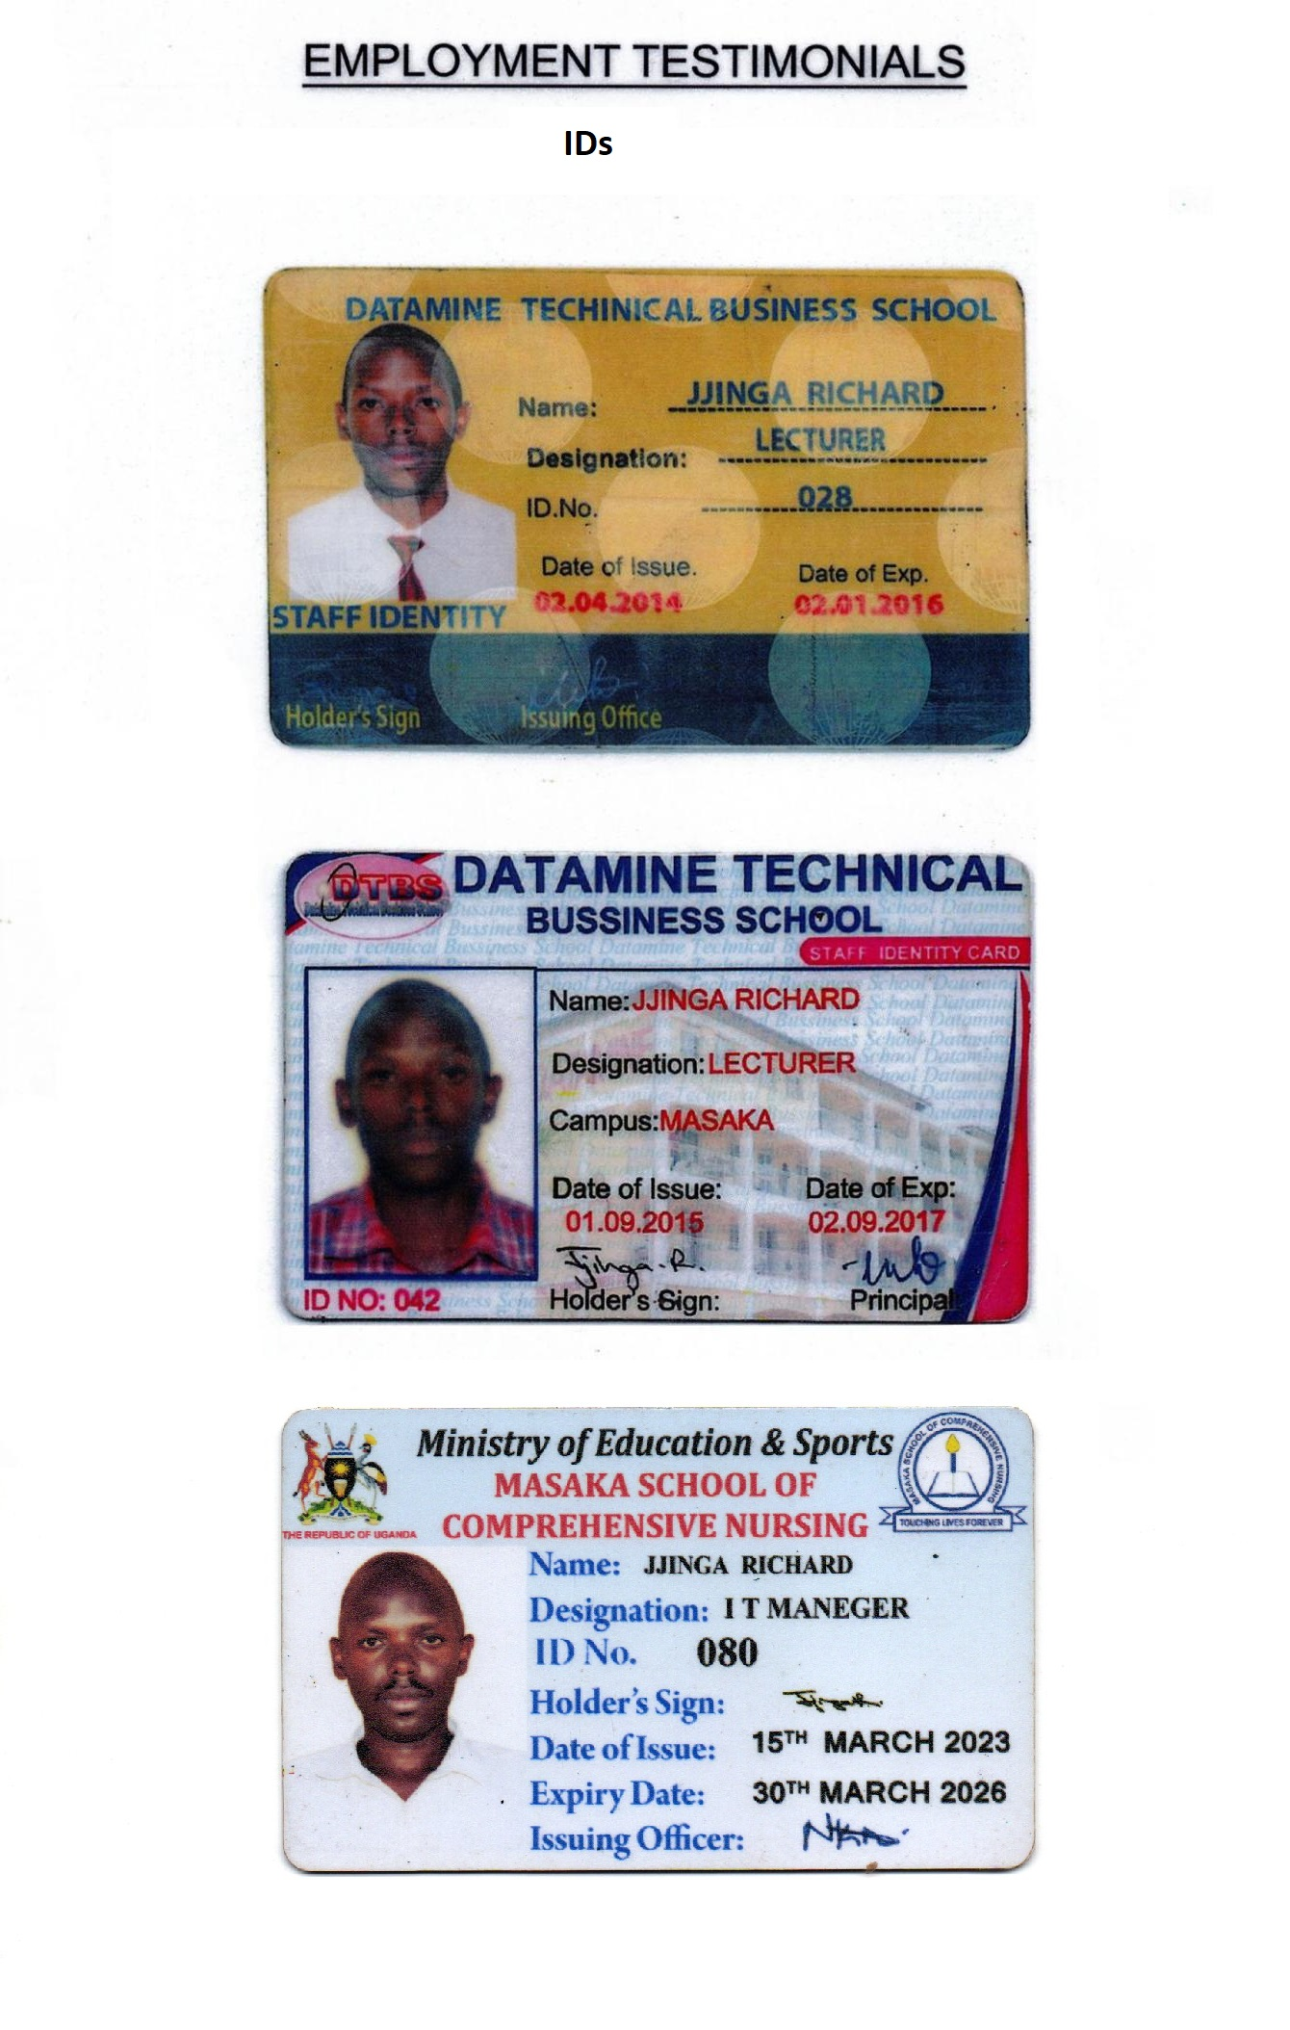
University Certificate

