CrowdGatherGo
Move more people, without moving more steel.
PROPOSAL · REVISED (v2)
Slot-Based Timetable Optimisation
Lifting trunk-corridor throughput toward ~500 train-slots/day on existing running lines — validated offline first
Prepared for
The Operations Leadership, South Central Railway
Office of the General Manager & Principal Chief Operations Manager
Rail Nilayam, Secunderabad
Prepared by
Atif Hussain — Founder, CrowdGatherGo
B.Tech (CSE), IIT Kanpur · MBA, IIM Bangalore
atif.hussain@gmail.com · +91 78381 73538 · crowdgathergo.com
9 June 2026 · Confidential

Executive Summary
The problem. South Central Railway's core trunk sections — notably Balharshah-Kazipet and Kazipet-Wadi on the Delhi-Chennai Grand Trunk route — run above 100% line-capacity. Saturation caps freight loading, erodes punctuality, and pushes the zone toward doubling and tripling works that cost years and ~Rs 20 crore per kilometre.
The proposition. Run every through-train on the main line at the section's uniform non-stop speed, evenly spaced on a 5-minute headway, and absorb all stopping at elongated station loops rather than on the running line. Because the main line then carries only full-speed, evenly-spaced trains, it behaves like a homogeneous freeway — lifting a saturated double-line corridor toward ~500-576 train-slots per day, without new running lines and without waiting for a Dedicated Freight Corridor.
Adopt it in steps. The work decomposes into four components. Two are useful on their own — a seconds-accurate kilometre-post timetable, and a live seconds-deviation readout that helps drivers self-correct — and together they build up to the slot-based throughput gain (component 3). A fourth, the optional WhatsComing locomotive-tracking app, lets trains pack tighter still, with improved safety.
Proof already in hand. This is not a concept sketch. A second-accurate, 5-minute-slot timetable has already been built for the New Delhi-Chennai (NDLS-MAS) route, mixing four train classes, alongside a stop-physics model that quantifies the time each halt costs. We seek to validate that model on SCR's own section data.
Zero-risk path in. We lead with an offline simulation that must first reproduce SCR's current Master Chart (the 24-hour time-distance train graph) from the live Working Time Table (WTT) to within minutes. No train is touched until the operating department is satisfied. Phases 0-1 are offered pro bono.
Credentials. The developer is an alumnus of IIT Kanpur (B.Tech, Computer Science) and IIM Bangalore (MBA), with analytical capacity-unlocking work across both rail and road.

1. The Capacity Challenge

1.1 Saturated trunk routes
After the 1 June 2026 reorganisation, South Central Railway comprises the Secunderabad, Hyderabad and Nanded divisions. SCR identifies the Gudur-Balharshah and Kazipet-Wadi (via Secunderabad) corridors as heavily saturated; the Mudkhed-Dhone corridor has been cited near 167% line-capacity. On Kazipet-Balharshah, coal accounts for roughly 40% of goods traffic — a slow, heavy stream sharing rails with 130 km/h services.

1.2 Why conventional answers are slow
Track doubling runs about Rs 20 crore per kilometre over years; Automatic Block Signalling adds roughly 15-20% capacity at ~Rs 2.5 crore per route-kilometre. Both are needed, but neither extracts the capacity already latent in how the timetable is built — which is the gap this proposal targets, faster and cheaper.

1.3 The national stakes
Rail moves freight with 75-90% less energy than road, yet rail's freight share has slipped to about 27% against the National Rail Plan target of 45% by 2030. India imports nearly 89% of its crude at a net oil bill near $100 billion a year, dominated by transport. Throughput on saturated corridors is therefore an energy-security and forex lever, not merely an operating metric.

2. The Approach: a Freeway for Trains

2.1 Four building blocks — the first two are deployable on their own
The approach is built from four components. The first two each deliver value independently and can be adopted on their own; together they build up to the throughput prize in component 3. Component 4 is an optional safety layer.
Component | What it is | Standalone value and role
1. Seconds-accurate km-post timetable [independent] | A timetable accurate to the second at every kilometre post, interpolated by physics-based spreadsheet formulae from non-stop trial runs. | On its own: a sharper Working Time Table and Master Chart, and a precise punctuality benchmark. Role: the measurement backbone every slot is built on.
2. Live seconds-deviation feedback [independent] | A live readout to each loco crew of how many seconds they are ahead of or behind their timetable, so they apply corrective measures. | On its own: punctuality gains on today's network, no slotting needed. Role: keeps trains glued to their slots so tight headways hold.
3. Slot-based 5-min-headway timetabling [the goal] | Uniform main-line speed; stops absorbed at elongated loops; each stop drops a slot. No Dedicated Freight Corridor. | The throughput prize that components 1 and 2 build up to.
4. WhatsComing loco tracking [optional] | Optional locomotive-tracking / driver gap-awareness app to pack trains more tightly with improved safety. | Lets headways tighten further, safely. RDSO-cleared before any reliance.

2.2 Pull stopping off the main line
The capacity of a double-line section is destroyed by two things: trains halting on the running line, and fast trains catching slow ones. We remove both from the main line. Every through-train holds the main line at the section's uniform non-stop speed, evenly spaced on a 5-minute headway. Any train that must stop peels onto an elongated station loop, halts there, and rejoins. The main line therefore only ever carries full-speed, equally-spaced trains — the condition under which ~500-576 slots per day becomes physically attainable.

2.3 How speed differences are absorbed — without a Freight Corridor
A stopping train brakes, takes the loop, dwells, and re-accelerates. Our stop-physics model puts the running-time penalty at roughly 80 seconds per stop (about 1.5 km to brake and 2.9 km to regain speed from ~90 km/h) plus its dwell. Having lost that time, the train simply surrenders its slot and takes a later one. The outcome is variable gaps under a uniform headway: trains differ in average door-to-door speed while every train on the main line runs at the same instantaneous speed. This needs neither a Dedicated Freight Corridor nor freight removed from the network — only a shared main-line running speed.

2.4 The honest precondition: freight homogenisation
For this to hold, every through-train must be able to make the section's non-stop speed while running. Under-powered freight is given added traction — long rakes can run on two contiguous slots with distributed power (engines roughly every 600 m) — or pathed in dedicated windows. The real residual limit is heavy-haul that is physically speed-restricted (loaded coal cannot reach trunk passenger speed regardless of power); the pilot's job is to quantify exactly how much traffic that affects and how to window it. We state this plainly rather than assume it away.

2.5 The enabling tools: slotting and WhatsComing
Train slotting. Survey each section's non-stop running time to the second and the kilometre-marker, build repeating 5-minute slots, and assign each train a slot it keeps while running and drops by one at every stop.
WhatsComing (optional locomotive tracking, low-cost). A RailTel-backed locomotive-tracking and gap-warning app over existing track-circuit and block logic. Once lane discipline keeps relative motion between consecutive trains low, gaps can be tightened safely. Any safety-bearing role would require independent RDSO assessment and operating-department clearance — presented for evaluation, not asserted as proven.

2.6 What we actually deliver
- A faithful section model built from SCR's Working Time Table (WTT), sectional running times (SRT), gradients, block sections and loop lengths.
- A reproduction proof — the model must reproduce SCR's current Master Chart (24-hour time-distance train graph) within minutes before proposing anything.
- A conflict-free path uplift — how many additional paths can be inserted into the Working Time Table under existing precedence and crossing rules, loop and maintenance-block constraints.
- A loop-and-overtake plan — where each train takes precedence or is crossed at a loop, drops its slot and rejoins, delivered as a revised Master Chart that self-stabilises against drift.

3. Evidence and Precedent

3.1 A working slot model already exists
A second-accurate 5-minute-slot timetable has been built for the NDLS-MAS Grand Trunk route, mixing four train classes on a double line:
Train class | Section run time | Daily slots
Non-stop / Goods (full speed) | 30 h 30 m | 72
Duronto / Rajdhani | 31 h 40 m | 72
Superfast / Express | 36 h 30 m | 48
Local / Passenger | 49 h 20 m | 96
Order-of-magnitude total | per direction | ~288 (x2 ≈ 576)

The slot arithmetic rests on a line-capacity model (on the order of 40 coaches per minute at 60 km/h on a double-line section, distance-based — analogous to classical traffic-stream formulae adapted to rail). The km-marker-level data is large and is intended to be delivered digitally via a companion mobile application.
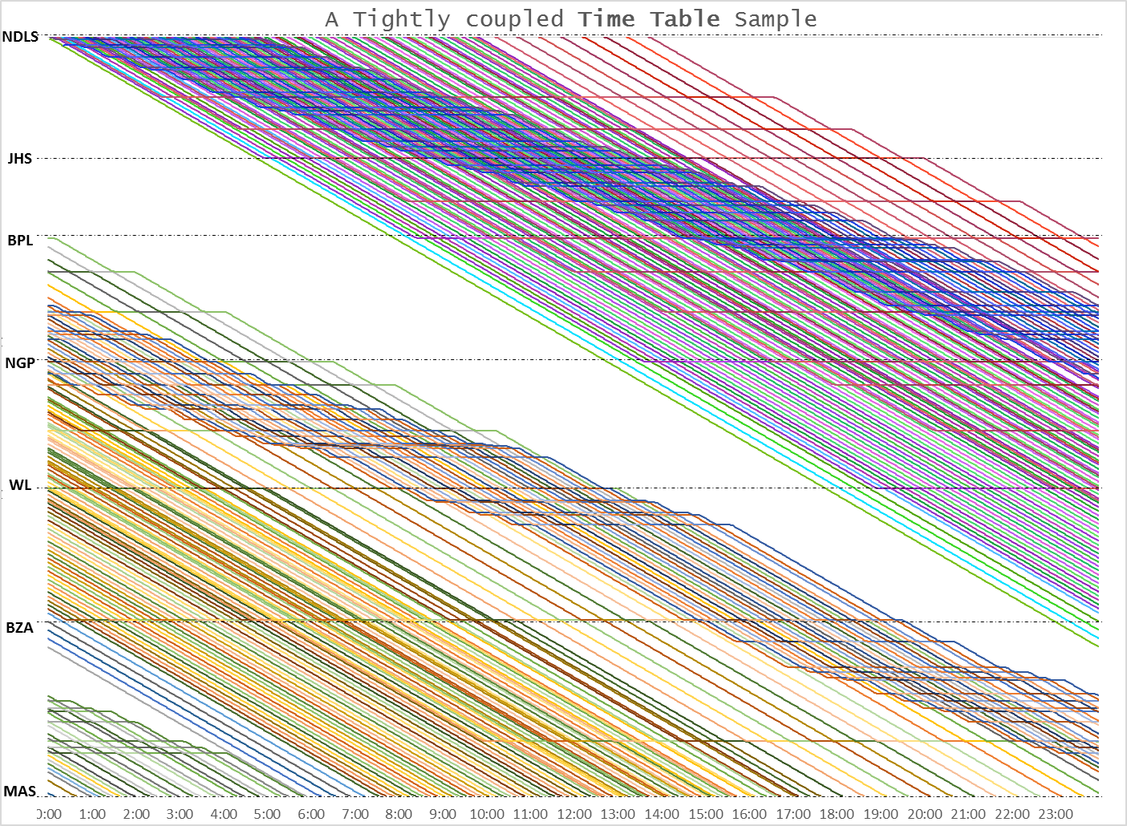
Figure 1 — A tightly-coupled 5-minute-slot timetable for the NDLS–MAS Grand Trunk route (New Delhi · Jhansi · Bhopal · Nagpur · Warangal · Vijayawada · Chennai), 24 hours horizontal. Steeper lines are full-speed through trains; the shallower bundles are stopping trains that step onto loops and pick later slots — the main line stays uniform.

3.2 Indian Railways has done this before
Western Railway's Surat-Vadodara programme is a close precedent: a 131 km high-density section, river-constrained against new lines, where all stations already had loops. WR upgraded freight speeds, moved to 4-aspect automatic signalling and computerised CTC, and extended loops into the block sections — cutting block lengths from 3-11 km toward under 6, then under 4 km. That is the same throughput-over-speed philosophy this proposal applies, already validated inside IR.

4. Preconditions and Honest Limits
This is presented with its costs visible, because a safety-first operating department will (rightly) look for them.
- Loop works. Stopping-station loops are elongated (~1.5 km) and turnout entry/exit speeds raised. This is targeted civil and signalling spend — far below doubling, but it is not nothing, and replaces any claim of zero infrastructure.
- Freight speed. Sub-speed freight must be re-powered or windowed; physically speed-limited heavy-haul is the binding residual and is quantified in the pilot.
- Signalling. Intermediate Block Sections and Automatic Block Signalling enable safe tailgating; WhatsComing (locomotive tracking) is a frugal complement, RDSO-cleared before any reliance.
- Robustness. At a 5-minute headway delays propagate quickly; the slot buffer and gap-warning must absorb perturbations — explicitly stress-tested in simulation, not assumed.
- Junctions and terminals. These still bound the corridor and are modelled, not wished away.

5. Scope of Work and Deliverables
Staged so the railway commits nothing irreversible until each prior stage proves itself. Phases advance only on the operating department's explicit sign-off. Every output is expressed in the operating department's own currency — a Working Time Table (WTT) and a Master Chart — so the timetable and control-office cells can scrutinise and adopt it directly.
Phase | Activity | Deliverable
Phase 0 | Data assembly & section model build (one pilot section) | Calibrated microsimulation that reproduces the section's current Master Chart from the live Working Time Table (WTT) within minutes
Phase 1 | Path-uplift + precedence/crossing (loop-overtake) analysis under existing safety rules | Draft revised Working Time Table & Master Chart with quantified extra paths; freight-windowing & precedence plan; report
Phase 2 | Tabletop review with control office & operating staff | Control-office-validated Master Chart & WTT scenario; agreed measures of success
Phase 3 | Supervised trial of a few off-peak slots | Before/after throughput & punctuality; scale-up recommendation

Pilot section. We recommend Balharshah-Kazipet — a segment of the already-modelled NDLS-MAS route, single-division and single-zone — as the primary candidate, with Kazipet-Wadi as the alternate. Because both carry heavy coal, the pilot will explicitly study how much freight needs re-powering or windowing.

6. Indicative Timeline
Offline phases carry no operational risk and run in parallel with normal working.
Milestone | Indicative duration | Dependency
Data assembly | 2-4 weeks | WTT, section data, control charts
Model build & reproduction proof | 3-5 weeks | Phase 0 data
Slot-uplift report | 2-3 weeks | Validated model
Tabletop review | 1 week | Operating-dept availability
Supervised off-peak trial | On SCR sign-off | CRS/RDSO clearance as applicable

7. Investment and Terms
CrowdGatherGo is a frugal, founder-led practice. We price for proof, not promises.
Engagement | Basis | Fee
Phase 0 - Section model & reproduction proof | Proof of value | Pro bono
Phase 1 - Slot-uplift analysis & report | Proof of value | Pro bono
Phase 2-3 - Tabletop & supervised trial support | Scoped on results | By agreement

What we ask in return. Access, under a data-sharing understanding, to the section Working Time Table (WTT), sectional running times, block-section and loop particulars, and the control office's Master Charts and control charts; and a little operating-team time for one tabletop review. No procurement, no capital outlay, no commitment beyond the next phase.

8. Expected Benefits
- Throughput. Toward ~500 train-slots/day on a saturated section, unlocked in weeks of analysis rather than years of construction.
- Faster freight. A disciplined main line moves freight at sustained speed between windows, improving wagon turnaround and loading.
- Service quality. Variable gaps under a uniform headway cut the cascading delays mixed-speed traffic causes today, and improve ticket availability through more paths.
- Profitability & deferred capex. Each extra path is revenue on existing assets, and latent capacity can defer doubling works at ~Rs 20 crore per kilometre.
- Oil-import & forex savings. Freight and passengers held on electrified rail rather than diesel road directly reduce imported-fuel demand and forex outflow.

9. Addressing the Operating Department's Concerns
- Isn't the throughput physically impossible because of mixed speeds? The mix is removed from the main line and absorbed at loops; the running-time cost of each stop is quantified in our stop-physics model, the full slot timetable already exists for NDLS-MAS, and the approach mirrors WR's Surat-Vadodara programme.
- Why trust an outside model? A working, second-accurate model already exists and will first be made to reproduce your current Master Chart. Only then do we propose changes — offline, and pro bono.
- Will this risk live operations? No. Phases 0-1 are entirely offline; nothing moves until you sign off on a validated scenario.
- Who carries the slow-train delay? It is explicit by design — variable gaps mean each stopping train openly takes a later slot, a deliberate operating choice, never a hidden cost.
- What about loops, freight power and maintenance? Loop elongation, freight re-powering/windowing, turnout speeds, traffic and power blocks and terminal limits are modelled as constraints, and stated as preconditions in Section 4.

10. Next Steps
- A 30-minute meeting with the operations team to fix the pilot section and the measures of success.
- A short data-sharing understanding for the pilot section.
- Commencement of Phase 0 - the offline section model - at no cost to SCR.

Acceptance
Agreed on behalf of the parties below:
For South Central Railway | For CrowdGatherGo
Name: ____________________________  Designation: ______________________  Signature & date: __________________ | Name: Atif Hussain  Designation: Founder, CrowdGatherGo  Signature & date: __________________

