ISHARA
Sign-to-Speech Communication
FINAL PROJECT REPORT
Course: CSE 2200 – Advanced Programming Laboratory
Department of Computer Science and Engineering
Khulna University of Engineering & Technology (KUET)
Submitted by: Md. Atif Absar
Platform: Android Studio • Java 17 • XML
Release: 6.1.0
Submission date: [INSERT DATE]
REPORT DRAFT — COMPLETE ALL HIGHLIGHTED EVIDENCE AND TEST RESULTS BEFORE SUBMISSION

Report completion note
This Word document is a structured report template based on the Ishara 6.1.0 source. Before submitting, insert actual screenshots from the final Android build, enter the GitHub repository URL, record the phone model and Android version, and replace every bracketed placeholder. Only mark a test as passed after running it on a real device or emulator.

1. Abstract
Ishara is a Java-centered Android communication support prototype. It focuses on two main workflows: camera-based gesture-to-message composition and live speech captions. Gesture Studio uses CameraX to capture frames and MediaPipe Gesture Recognizer to classify a limited set of general handshape categories. Java applies confidence and stability checks, maps recognized categories to illustrative Bangla phrases, builds editable sentences and uses Android TextToSpeech to speak a completed message. Live Captions uses Android SpeechRecognizer to convert speech into readable text that users can review, save locally and share.
Supporting modules include two-way conversation, a picture communication board, gesture learning, practice games, progress statistics, message history and Firebase room communication. The application also demonstrates Android Activities, XML layouts, ViewBinding, Intents, RecyclerView, Adapters, ViewHolders, a bound Service, BroadcastReceiver, ContentProvider access, permissions, HTTP/JSON, SQLite, WorkManager and Firebase Authentication, Realtime Database and Cloud Firestore.

2. Problem statement and objectives
Communication can become difficult when people use different communication methods. Ishara explores a low-cost mobile interface that supports gesture-assisted messages, speech captions and spoken replies.
- Build an accessible Android application primarily in Java.
- Implement a CameraX and MediaPipe gesture-recognition pipeline.
- Convert supported general handshapes into readable and editable demonstration messages.
- Provide Bangla text-to-speech and Bangla/English live captions where device services support them.
- Store local communication and learning data using SQLite.
- Demonstrate the Android programming concepts covered in CSE 2200 Lab Weeks 8–11.
- Integrate Firebase Authentication, Realtime Database and Cloud Firestore.

3. Main application features

3.1 Gesture-to-Text Studio
- CameraX live camera preview.
- MediaPipe Gesture Recognizer integration.
- Seven supported general handshape categories.
- Confidence display, stability checks and optional hand-landmark overlay.
- Context-specific illustrative phrase mapping.
- Sentence composition, add, undo, clear, save, share and speak.

3.2 Live Conversation Captions
- Bangla and English language selection, subject to device speech-service support.
- Partial and finalized recognition text.
- Session transcript, sentence count, save, copy and share.
- Runtime microphone permission and lifecycle-safe stop behaviour.

3.3 Supporting modules
- Two-way conversation with speech recognition and spoken replies.
- Picture Board with ready-made communication tiles and local image preview.
- Gesture Dictionary, camera practice and calibration.
- Ishara Quest and practice progress.
- Sentence Builder, Quick Phrases and Message History.
- Firebase Connect rooms for live messages between devices.

4. User interface evidence
The home screen prioritizes Gesture Studio and Live Captions. Play, Learn and Connect are grouped as supporting paths, while secondary communication, learning and project tools remain available below.
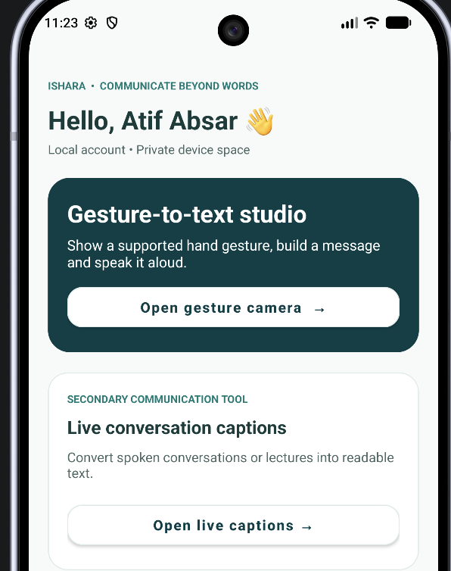
Figure 1. Home screen reference supplied for the Ishara project. Replace with a screenshot captured from the final 6.1.0 build if the interface changes.
[INSERT ACTUAL DEVICE SCREENSHOT: Gesture Studio showing camera preview, model readiness and detected gesture]
[INSERT ACTUAL DEVICE SCREENSHOT: Live Captions showing a real Bangla or English transcript]
[INSERT ACTUAL DEVICE SCREENSHOT: Picture Board showing a photo selected through Android Photo Picker]

5. System architecture

5.1 Gesture processing path
CameraX → ImageAnalysis executor → MediaPipe Gesture Recognizer → Java confidence and stability logic → GestureDictionary → SentenceComposer → TextToSpeech / SQLite / Share Intent.

5.2 Live caption path
Microphone permission → Android SpeechRecognizer → CaptionController callbacks → Java transcript state → SQLite / Copy / Share.

5.3 Cloud and media paths
Firebase Authentication → Realtime Database room messages. Cloud Firestore stores the user profile and user-triggered aggregate practice progress. WorkManager performs the progress upload in the background when a network connection is available.
Android Photo Picker → content URI → ContentResolver / ContentProvider → ImageView preview. Selected pictures are not copied to app storage or uploaded.

6. Lab 8–11 coverage
Week | Topic | Ishara implementation
8 | Android Studio architecture, Gradle, Manifest | Native Java project, Gradle configuration and AndroidManifest.
8 | Activity lifecycle | Activity callbacks and lifecycle logging in Lab Showcase.
8 | XML, ViewBinding, event handling | XML screen layouts, generated Activity bindings and Java click listeners.
8 | Explicit and implicit Intents | Activity navigation, share chooser and app settings navigation.
9 | Layouts and reusable UI | LinearLayout, ScrollView, Material Components and custom Views.
9 | RecyclerView, Adapters, ViewHolders | Chat, History, Dictionary, Lesson and Phrase adapters.
10 | Services | Bound SpeechService for TextToSpeech.
10 | BroadcastReceiver | BatteryReceiver for battery and airplane-mode system events.
10 | ContentProvider | Internal MessageProvider and Android media URI access through ContentResolver.
10 | Permissions | Runtime camera/microphone permissions and scoped Photo Picker access.
11 | HTTP and JSON | HTTPS GET and JSONObject parsing in a background executor.
11 | SQLite | MessageDbHelper, IsharaDataStore, QuestDb and LabDemoDb.
11 | Background task | WorkManager progress-sync worker.
11 | Firebase Authentication | Email/password account and anonymous guest identity.
11 | Firebase Realtime Database | Room-based live message exchange.
11 | Cloud Firestore | User profile and aggregate practice progress documents.

7. Firebase implementation
Firebase Authentication supports email/password registration and login. Anonymous authentication is used for guest access to live rooms. Realtime Database stores room messages under rooms/{roomCode}/messages. Cloud Firestore stores account profiles under users/{uid} and optional aggregate practice progress under users/{uid}/progress/summary.
The user must configure the Firebase project and publish the security rules described in docs/FIREBASE_SETUP.md. The application uses client configuration values only; no Admin SDK key is embedded in the app.
[INSERT ACTUAL DEVICE SCREENSHOT: Firebase Authentication user list after creating an account]
[INSERT ACTUAL DEVICE SCREENSHOT: Cloud Firestore users collection and profile document]
[INSERT ACTUAL DEVICE SCREENSHOT: Realtime Database room message records]
[INSERT ACTUAL DEVICE SCREENSHOT: Cloud Firestore progress summary after WorkManager sync]

8. API, database and Android components

8.1 HTTP and JSON
JsonDemoClient performs an HTTPS GET request to a public test endpoint and parses the JSON response with JSONObject on a background executor. Insert a screenshot of the actual response below.
[INSERT ACTUAL DEVICE SCREENSHOT: Actual HTTP GET response and parsed JSON fields]

8.2 SQLite
SQLiteOpenHelper-based classes store message history, captions, gesture trials, phrase usage, Quest scores and isolated Lab demonstration rows. The Lab Showcase provides a sample CREATE, READ, UPDATE and DELETE demonstration.

8.3 Android system components
SpeechService is a bound Service used for TextToSpeech. BatteryReceiver handles battery changed/low/okay and airplane-mode broadcasts while the system tools screen is visible. Picture Board uses Android Photo Picker and ContentResolver to read a selected content URI. MessageProvider exposes the app’s own local message table through a content URI.
[INSERT ACTUAL DEVICE SCREENSHOT: BatteryReceiver or airplane-mode event displayed in the app]
[INSERT ACTUAL DEVICE SCREENSHOT: Lab Showcase showing bound SpeechService or SQLite CRUD]

9. Data handling and privacy
- Camera frames and hand landmarks remain on the device and are not uploaded.
- Conversation history, captions and practice records remain in local SQLite by default.
- Live room messages are sent only when the user presses Send.
- Aggregate learning progress is uploaded only after the user presses the sync button.
- The WorkManager upload contains counts and average confidence only, not transcripts or images.
- Selected pictures are previewed from a content URI and are not permanently stored or uploaded. Firebase Storage is not used.
- Firebase access depends on published security rules. No Firebase Admin credentials are embedded in the Android app.

10. Limitations
The stock MediaPipe model recognizes seven general handshape classes. The phrase mapping is illustrative and is not a complete or validated Bangla Sign Language translation system. Model confidence is not the same as measured recognition accuracy. Actual performance must be tested on a physical phone under different lighting and hand positions. Live caption language availability and quality depend on the Android speech-recognition service installed on the device. The Firebase demonstration is an academic prototype and is not end-to-end encrypted.

11. Testing and results
Complete the acceptance checklist in docs/61_V6_1_0_TEST_AND_ACCEPTANCE.md. Record only outcomes observed on the target device. Do not mark a test PASS until it has been run.
Test area | Device / environment | Actual result | Evidence
Android Gradle build | [Phone / emulator / build environment] | [PENDING: record result] | [Screenshot / CI link]
Gesture Studio | [Phone model and Android version] | [PENDING: record result] | [Screenshot / video]
Live Captions | [Phone model and speech service] | [PENDING: record result] | [Screenshot / video]
Firebase Auth / RTDB / Firestore | [Firebase project and two clients] | [PENDING: record result] | [Console screenshots]
System broadcasts / media provider | [Phone model and Android version] | [PENDING: record result] | [Screenshot / video]

12. Conclusion
Ishara demonstrates how Java-based Android development can combine camera processing, speech recognition, accessible UI, local databases, Android system components, background work and Firebase services in one focused communication application. Its main value is the integration of gesture-assisted message composition and live captions, supported by learning and connection tools.

13. Submission details
Item | Value
Project title | ISHARA – Sign-to-Speech Communication
GitHub repository | [INSERT PUBLIC GITHUB URL]
Video demonstration | [INSERT PUBLIC VIDEO URL]
Firebase project | [INSERT PROJECT ID, DO NOT INSERT PRIVATE CREDENTIALS]
Final showcase date | [INSERT DATE]

