We strictly use this flow which you have provided us

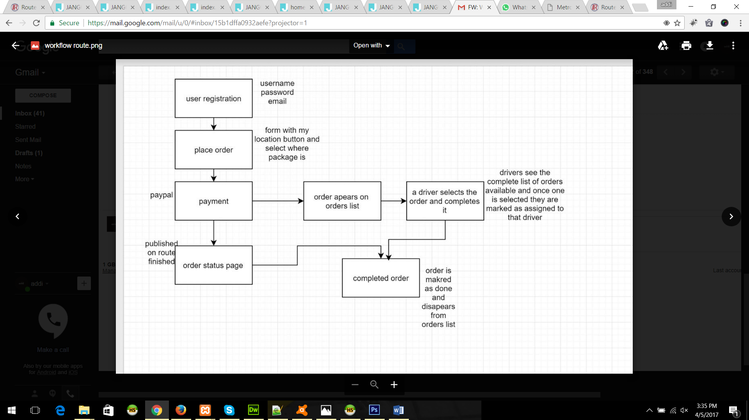

We need some information regarding Route Application.

**GENERAL REQUIREMENTS**

1. Please send us the detail of how to calculate an order amount.
2. Where and who can add products/items.

**BECOME A ROUTER**

First of all when a router will register him/herself with route, after registration who will approve the router and how a router can register him/herself. Because at the time of registration there is no option for declaring a password.

***“Please give us flow to become a router”*** and requirements of router like his vehicle number etc. and who is going to assign him rest information either himself router or only admin can edit a router’s information.

**What we did:**

When a router register him/herself, the information is sent to the admin on admin dashboard there is a tab named Drivers where all routers is showing.

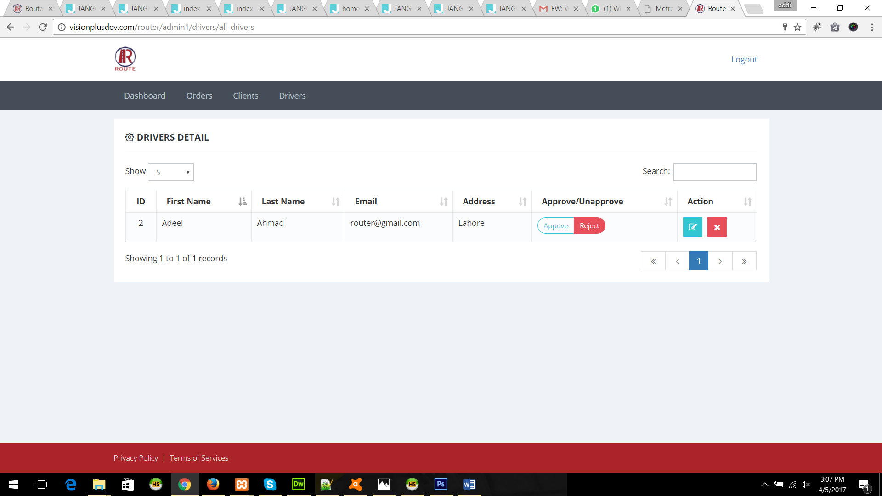

Admin has to assign him password and approve him as driver/router. After approving as a driver/router. Router can access his account.

**ROUTER**

**Router Dashboard**

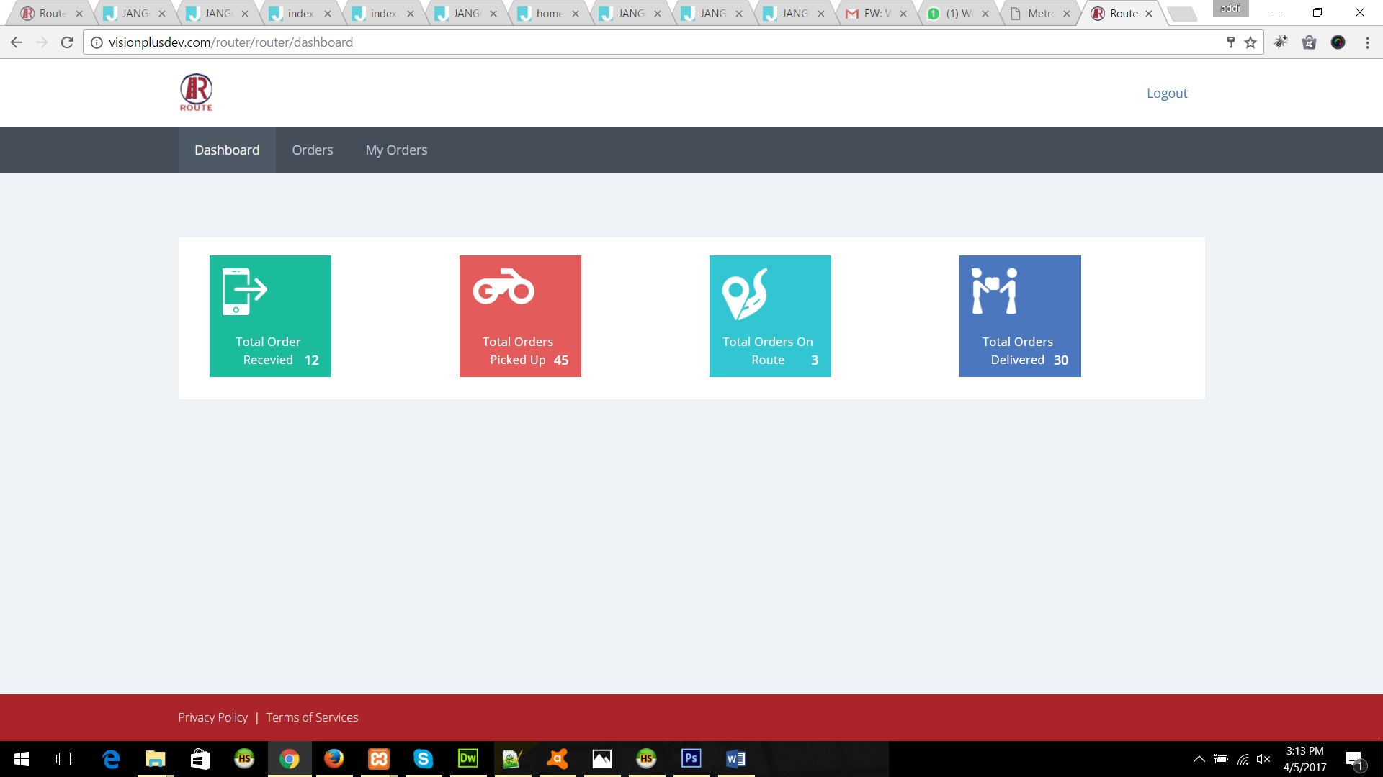

**Current Unassigned Orders**

In this page all unassigned orders will show, these orders will appear here when it clears the payments. A router can take this order after clicking the button ***“Take this Order”*** once an order assigned to the router that order will disappear from here. And it’ll show to the routers ***“My Orders->Current Orders”*** page.

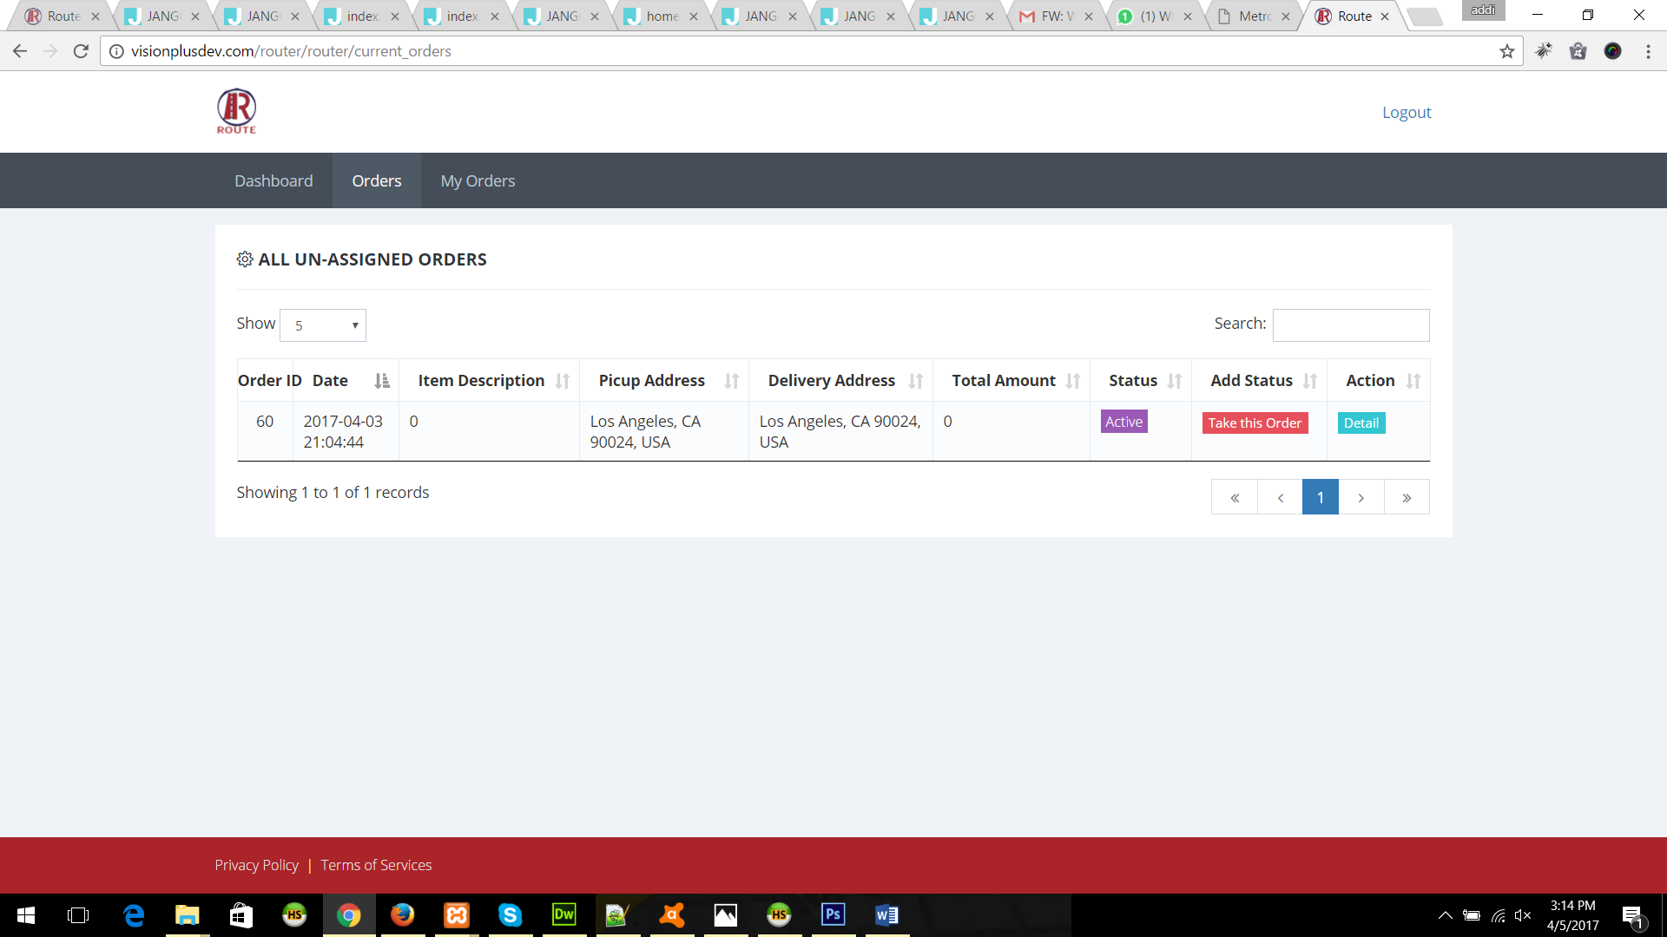

**Router Current Running Orders**

A router can see his current running orders in this page. He/she can change the status of an order by clicking the button ***“Add Order Status”.***

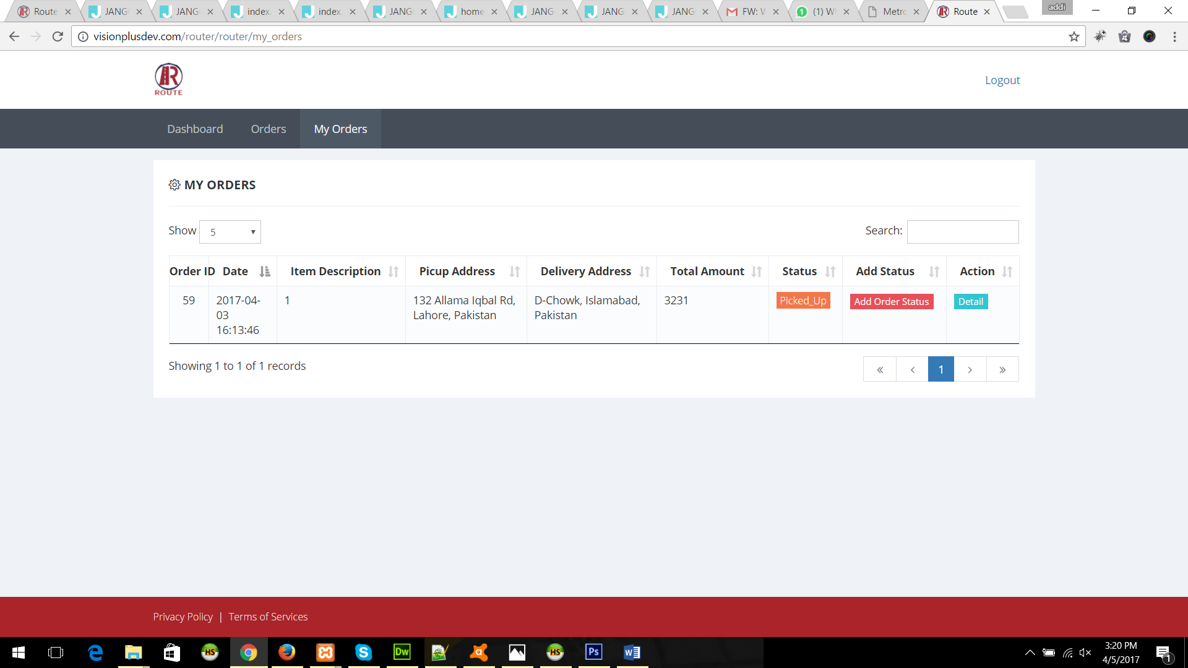

**Order Status**

After clicking the button ***“Add Order Status”.*** This page will appear where a router can change the status of an order.

**Note** *“This is the main and only page where status of an order can be change. And it will show on whole application order status”*

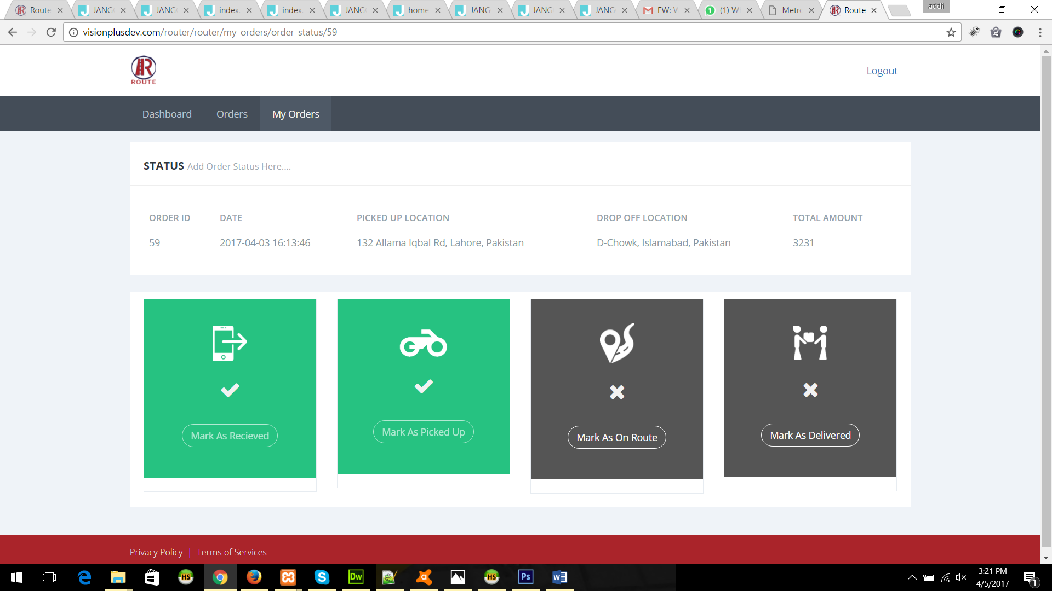

**CLIENT DASHBOARD**

1. Please send us the requirements for Saved Addresses Page of the client.