|  |
| --- |
| University at Buffalo |
| Fast Virtual Stenting |
| High Performance Computing Final Project |
|  |
| **Nikhil Paliwal** |
| **12/17/2013** |

|  |
| --- |
|  |

Contents

Introduction 3

Why simulate the FD deployment in patient specific aneurysm? 4

Background 4

Fast Virtual Stenting[3] 4

Simplex mesh 5

Parent vessel 5

Method 5

Algorithm 6

MATLAB Sequential 6

MATLAB Parallel 7

FORTRAN with OPEN MP 7

Results 8

Parallel Speedup 9

Parallel Efficiency 11

Discussion 12

Future Directions 12

References 12

Appendix 13

Appendix 1 13

Main.m 13

pointTriangeDistance.m 14

Findneighbor.m 19

Com_flength_fangle_ling.m 21

Appendix 2 25

Main.m for parallel MATLAB 25

Appendix 3 27

Slurm file for CCR: 28

Appendix 4 29

# Introduction

Aneurysm is a brain disorder in which the blood vessel in the brain remodels themselves due to the flow modifications and result in bulging of the blood vessels. It is considered as one of the main reasons for stroke. Research has shown that flow of blood (hemodynamics) and the biological response of the cells (endothelial cells) plays an important role in formation of aneurysm. Studies have shown that aneurysms are usually developed at regions where the flow becomes abnormal, especially at bifurcations of the blood vessels.

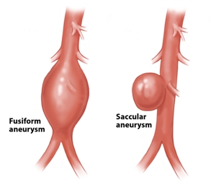There are mainly two kind of aneurysm found in the blood vessels, namely fusiform and saccular. These are shown in the figure. The flow of blood through this aneurysm might cause the blood vessel to rupture and cause stroke.

The flow of blood and remodeling of the vessel are related to each other. The blood flow is modified, resulting in the different response of the cells and remodeling of the vessel, which further changes the hemodynamics, and this trend continues until the aneurysm actually ruptures.

There have been various treatment methods introduced to treat aneurysm. Initially surgical clipping was performed which is done by opening the skull and removing the aneurysm from the flow loop by clipping it. This method is not the most efficient as the skull has to be opened and the brain exposed during the procedure.

Next was the introduction of metallic coils to fill the aneurysm sac with. The coils were mainly made of platinum, and their purpose was to block the blood flow in aneurysm and as a result, the aneurysm would thrombose and clot eventually. There were complications due to this method as well. Coils might get out of the aneurysm and get into the parent vessel, which can cause complications.

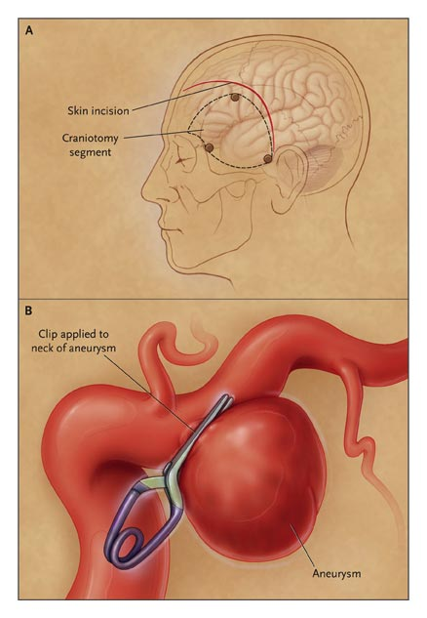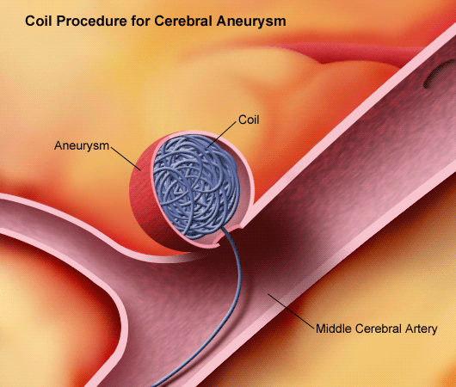

Surgical Clipping

Coiling

Surgical Clipping

After these two methods, stents were introduced to treat aneurysm. Stents are cylindrical porous metallic/alloys wireframe which can be deployed in the main vessel to make sure that flow is going through the parent vessel (parent vessel is the one on which the aneurysm has grown). Different kinds of stents were introduced and the currently surgeons use Flow Diverter (FD). It is made up of platinum and Ni-Co-Cr alloy. 48 wires are braided together in a cylindrical mesh shape. The deployment of these FD makes sure that the flow does not go into the aneurysm and normal hemodynamics is maintained in the blood vessel. This project deals with the virtual deployment of the FD in a blood vessel.

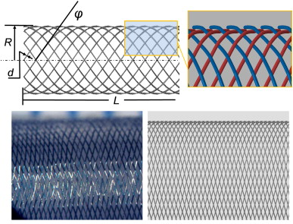

Flow Diverter

# Why simulate the FD deployment in patient specific aneurysm?

An important question to consider is why we need to simulate this deployment of FD in a patient on a computer. There are two aspects associated with the proper deployment of a FD. Firstly, surgeons need to make sure that FD is placed correctly inside the blood vessel, and secondly and more importantly, what will be the change in hemodynamics due to placement of FD. There have been cases where FD placement has lead to rupture. There are various theories that try to explain this, but it is necessary to study the hemodynamics after the placement of FD inside the blood vessel. This is where the simulations can help. FD can be deployed virtually in the blood vessel and then CFD can help tell the flow of blood inside the blood vessel, and surgeons can decide whether placement of FD is favorable or not. An alternative method can be making use of some coils as well. This method is called stent-assisted coiling. Hence the simulations can help answer a lot of questions before actually treating the patient.

# Background

There have been methods developed that deploy FD in blood vessel and CFD is performed. One of them is the HiFiVS method[2] which takes use of Finite Element based method and run on the software ABAQUS. It is a very accurate method but one major disadvantage is the time taken for each simulation. It takes around 120 hours for each simulation to run and hence cannot be used in a large number of clinical cases. In order to counter this problem a new method is developed called the Fast Virtual Stenting (FVS) method. This method is relatively quick but is not as accurate as the HiFiVS method.

# Fast Virtual Stenting[3]

This method simplifies the stent structure into a simplex mesh. A simplex mesh can be considered as a background mesh that is used for the main simulation, and then FD is mapped onto the simplex mesh structure.

## Simplex mesh

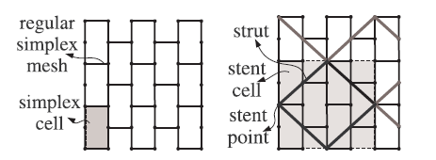 A simplex mesh for FD can be considered as a 64 concentric circles, with 48 points on each circle connected alternately as shown in the figure on the right. Once cell consists of 4 simplex points, and the connectivity between these points decide the mapping of FD on the simplex mesh. In total a simplex mesh has 64X48 points. This simplex mesh is initially placed in the vessel along the centerline of the vessel.

## untitled3.jpgParent vessel

Parent vessel is input in the form of triangle mesh, with an average vessel consisting of anywhere between 4000 to 15000 triangles. The spatial coordinates of each point in these triangles is known and stored in a stereolithography file (.stl). This information can be imported by writing a simple code. The figure shows a part of the vessel and the simplex mesh in red and green color. The same stl file can be used to get the centerline of the blood vessel using the open source software virtual modeling tool kit (vmtk). This centerline is used to align the simplex mesh along the vessel centerline.

## Method

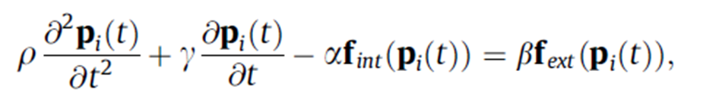 The simplex mesh is placed inside the blood vessel as shown in the above figure and then expanded using a mathematical force model based on the equation given below:

This is the dynamic equation for the position *pi* of the simplex mesh point within the blood vessel. The first term is the acceleration term and second term in the equation is the damping term. These define the motion of the point. The fint anf fext terms are the forces among the simplex mesh points and between simplex mesh and blood vessel respectively. Internal forces are calculated based on 2 parameters: F-angle, F-length. F-length is the forces that arise from the relative positioning of the simplex mesh points. Similarly F-angle changes due to the change in the angle between the simplex points. External forces come from the distance of the mesh from the vessel.

The above equation is discretized and the position of each stent point is calculated with respect to the previous position. Once the mesh starts expanding, it has to stop before it touches the wall. This tolerance to touch the wall is very small and is usually around 0.03 mm, equal to the radius of the actual FD wires. This way once the simulation is completed, the wires can be extruded to the given radius and the final FD will touch the vessel wall.

To make sure the mesh does not go outside the vessel wall, a **collision detection** algorithm is also implemented. This makes sure that the stent at no time goes out of the vessel. For this the distance of each simplex point to the triangles in the vessel wall is calculated. **This is the most time consuming part of the method, and takes more than 90% of the actual computational time. This project aims at looking at the collision detection part of the code and testing the efficiency of the collision detection of the code in FORTRAN using Open-MP and in MATLAB parallel.**

# Algorithm

The algorithm can be best explained by the use of this flow chart. This will help understand the main code. As explained previously, collision detection step is the most time consuming part of this algorithm.

Algorithm for collision detection takes each of the 64X48 stent points and calculated the distance of each point with every triangle in the vessel, and gives the distance from the nearest triangle. This part of the code can be parallelized which would increase the efficiency of the whole code tremendously. For this specific project, this part will be coded in FORTRAN and compared with MATLAB sequential as well as MATLAB parallel code.

# MATLAB Sequential

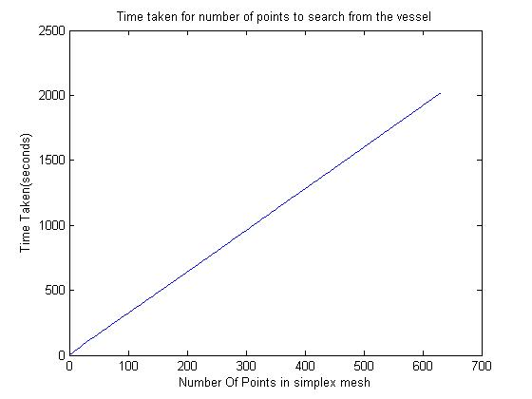 The code is attached in the appendix 1. The profiling time of this code is shown in the following figure. As expected, the time taken by the code increases with increasing the number of triangles in the search. This is due to the sequential task of considering one triangle at a time and then moving on. The number of triangles in the particular vessel of consideration in this case is 8037.

This result gives enough evidence to apply knowledge of parallel computing to this particular code. For this project only the collision detection part of the code is parallelized since the remaining part takes less than a second to execute, and there is no point in parallelizing that part of the code. Parallelizing the entire code might also reduce the efficiency, since it might take time in communication which will slow down the code.

# MATLAB Parallel

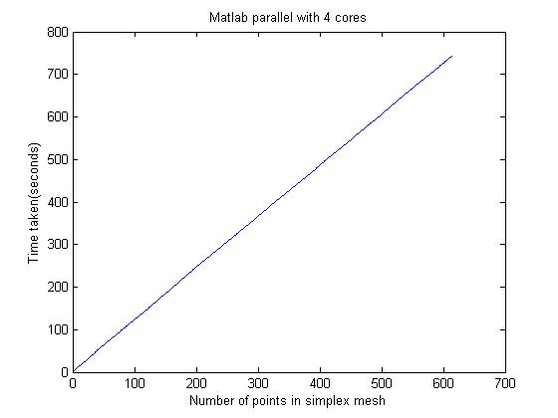 Parallel MATLAB code is attached in appendix 2. The changes from the MATLAB sequential is the use of 12-core for the calculation of the collision detection. Only one for loop is modified to parfor (parallel for loop) for parallel computing. The code was run on a quad-core local computer in the Toshiba Stroke and Vascular Research Center (TSVRC) in downtown campus. The functions like sqrt in MATLAB can automatically run on parallel processors in MATLAB so there is no need to modify that part of the code in MATLAB. MATLAB parallel works more like Open-MP for now, hence it can run on a 12-core processor and the processes are shared within the cores of a single node on CCR. Matlabpool requests the number of cores user want to use in their code.

It is quite clear with the above figure that even with 4 cores in MATLAB, the efficiency of the code goes up a lot. It has gone for roughly 390 seconds for 600 points as compared to 2000 seconds for the same number of points.

For further computation, UB CCR server was used for both MATLAB and FORTRAN.

# FORTRAN with OPEN MP

For this project purpose, FORTRAN code is developed and tested for the collision detection part only. The point triangle distance algorithm is taken from the source [1]. There is a single code in appendix 3 for FORTRAN with OPENMP where sequential code can be obtained from setting Nthreads equal to 1. Data from stl file is imported from MATLAB, and saved in file ‘data.dat’ and simplex mesh points are saved in ‘simplex.dat’. Node k08n18s01 received OPENMP parallel job.

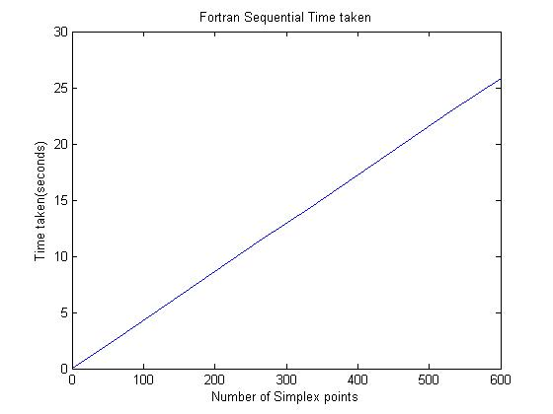

# Results

Most important thing was to make sure that the final deployment of the stent makes sense or not. Result obtained is shown in appendix 4 and is consistent across codes.

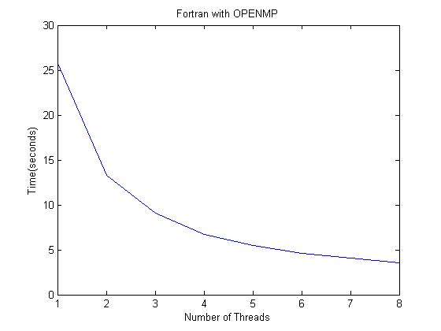

Clearly FORTRAN is quicker than the MATLAB code, for the same number of simplex points (600 points used to search in 8037 triangles). It is also interesting to note that MATLAB code converges at 10 cores and does not improve performance on further increasing the number of cores.

## Parallel Speedup

In order to calculate parallel speedup, the time taken for 1 thread was used as the sequential time taken and put in the following equation to get the speedup:



The results for parallel speedup are as follows:

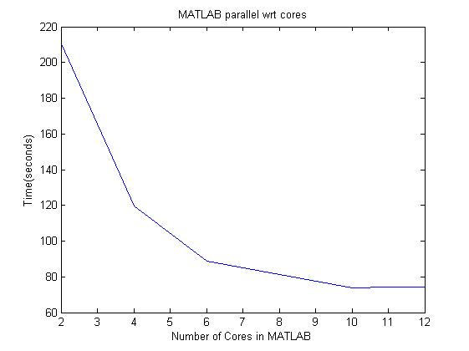 MATLAB parallel gives a speedup of around 5.25 and then its speedup does not go up, where as in OPENMP, speedup is more than 7 and it will increase if we increase the number of threads used in calculation. This also gives us a very good indication that parallelizing the code in FORTRAN will surely speedup the code performance wise.

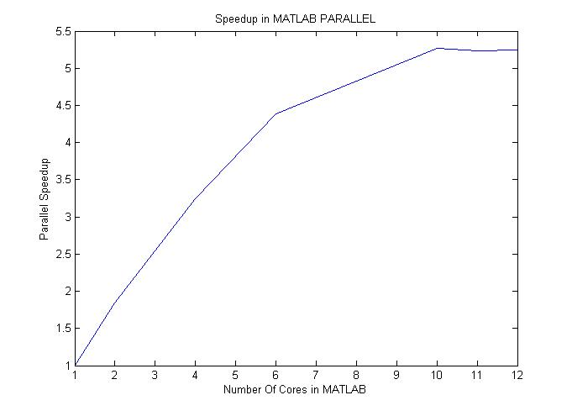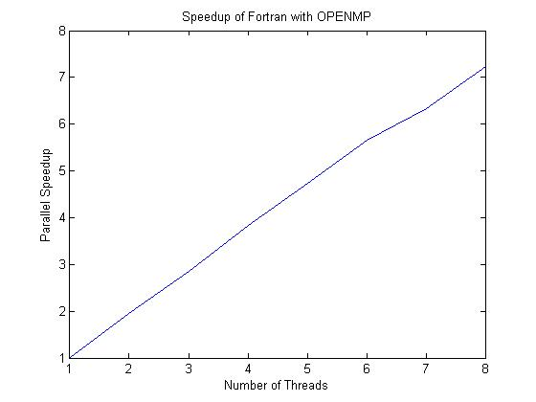

## Parallel Efficiency

 Efficiency is defined as the speedup per thread, so the equation for parallel efficiency becomes:

Where P is the number of threads/cores

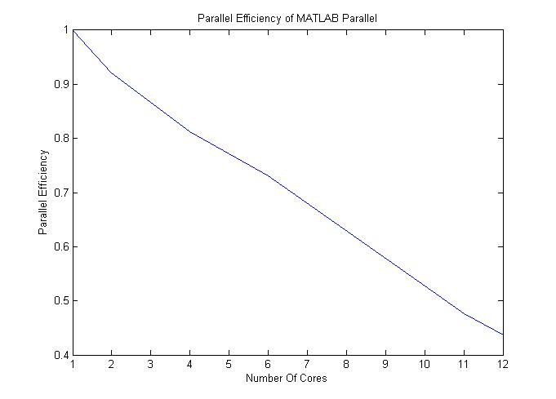

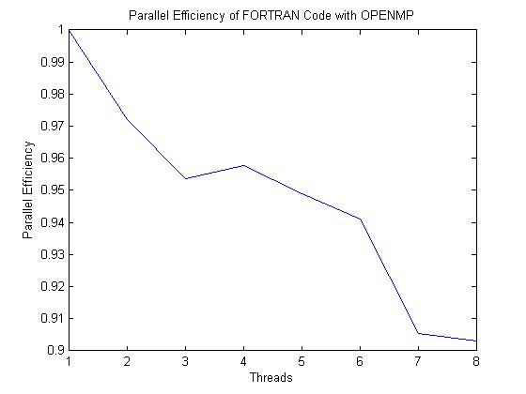

# Discussion

This project provided some very important insight on the importance of high performance computing in the particular field of bioengineering. It is also quite clear that FORTRAN is way superior language than MATLAB when it comes to larger calculations and better parallel speedups can be achieved by parallelizing the code with OPENMP. Having said that, the algorithms for calculating the point triangle distance used in both the codes are different and they might also play a crucial role in eventually efficiency of each codes. A final result is shown in the table below:

|  |  |
| --- | --- |
| Code | Time Taken(seconds) |
| MATLAB Sequnetial | 388.65 |
| MATLAB Parallel with 4 cores | 119.65 |
| FORTRAN Sequential | 25.86 |
| FORTRAN with OPENMP 4 Threads | 6.75 |

These times are all based on running on UB’s CCR server.

Hence this project gives a clear idea that the code needs to be converted into FORTRAN and parallelized with OPENMP for high performance.

# Future Directions

This project has been very instrumental in increasing the parallel speedup of the engineering tool used for virtual deployment of the stent inside the aneurysm. The project sets upa stone for future directions in the project. First thing, the whole code should be written in FORTRAN and parallelized with OPENMP. Comparing OPENMP with MPI might also be useful for efficiency of the code. Once this is done, this code will provide a very important tool for clinicians to use and apply in their surgical decision-making on treating patients with aneurysm.

# References

1. [*http://orion.math.iastate.edu/burkardt/papers/fortran_arrays.html#Dynamic_Array_Allocation*](http://orion.math.iastate.edu/burkardt/papers/fortran_arrays.html#Dynamic_Array_Allocation), December 10, 2013
2. *High Fidelity Virtual Stenting (HiFiVS) for Intracranial Aneurysm Flow Diversion: In Vitro and In Silico* [Ding Ma](http://link.springer.com/search?facet-author=%22Ding+Ma%22), et. al. , [Annals of Biomedical Engineering](http://link.springer.com/journal/10439), October 2013, Volume 41, [Issue 10](http://link.springer.com/journal/10439/41/10/page/1), pp 2143-2156

# *Fast virtual deployment of self-expandable stents: method and in vitro evaluation for intracranial aneurysmal stenting*.[Larrabide I](http://www.ncbi.nlm.nih.gov/pubmed?term=Larrabide%20I%5BAuthor%5D&cauthor=true&cauthor_uid=20627664), et.al, [Med Image Anal.](http://www.ncbi.nlm.nih.gov/pubmed/20627664) 2012 Apr;16(3):721-30

1. HPC Lecture Slides

# Appendix

## Appendix 1

### Main.m

clc;

clear;

load lijianyicutl1

load stent_03

elapsed_time=[];

number_of_points=[];

raw=48;

slice=length(meshpoint1(:,1,:));

length_c=0.37*2;

arfa=0.1;

beta=0.1;

ax=0.4;

epsl=0.6;

scale=0.5;

meshpoint=meshpoint1;

tic

for n=1:1

n

% Find the 3 neighboring nodes (Ñ°ÕÒ3ÁÚµã)

[point1,point2,point3]=findneighbor(slice,raw,meshpoint);

% Calculate angle force and strut length force (¼ÆËã½Ç¶ÈºÍ³¤¶ÈÔ¼ÊøÁ¦)

[flength,fangle]=com_flength_fangle_ling(meshpoint,length_c,raw,slice);

for i=1:slice

for j=1:raw

stentpoint(1:3)=meshpoint(i,j,1:3);

distance=zeros(face_num,1);

for k=1:face_num

tri=[node_xyz(:,(k-1)*3+1)';node_xyz(:,(k-1)*3+2)';node_xyz(:,(k-1)*3+3)'];

distance(k)=pointTriangleDistance(tri,stentpoint);

end

% end

d=min(distance);

elapsed_time(end+1)=toc

number_of_points(end+1)=(i-1)*48 + j;

sign=1;

stent_center_distance=sqrt((meshpoint(i,j,1)-center(i,1))...

*(meshpoint(i,j,1)-center(i,1))+(meshpoint(i,j,2)-...

center(i,2))*(meshpoint(i,j,2)-center(i,2))+...

(meshpoint(i,j,3)-center(i,3))*(meshpoint(i,j,3)...

-center(i,3)));

% Calculate the expansion coefficient

if stent_center_distance>0

dx=(meshpoint(i,j,1)-center(i,1))/stent_center_distance;

dy=(meshpoint(i,j,2)-center(i,2))/stent_center_distance;

dz=(meshpoint(i,j,3)-center(i,3))/stent_center_distance;

else

dx=0;

dy=0;

dz=0;

end

% Update the position of stent point

newmeshpoint(i,j,1)=meshpoint(i,j,1)+arfa*(point1(i,j,1)/3+...

point2(i,j,1)/3+point3(i,j,1)/3-meshpoint(i,j,1)+...

ax*flength(i,j,1)+epsl*fangle(i,j,1))+beta*scale*...

meshpoint(i,j,1)*sign*dx;

newmeshpoint(i,j,2)=meshpoint(i,j,2)+arfa*(point1(i,j,2)/3+...

point2(i,j,2)/3+point3(i,j,2)/3-meshpoint(i,j,2)+...

ax*flength(i,j,2)+epsl*fangle(i,j,2))+beta*scale*...

meshpoint(i,j,2)*sign*dy;

newmeshpoint(i,j,3)=meshpoint(i,j,3)+arfa*(point1(i,j,3)/3+...

point2(i,j,3)/3+point3(i,j,3)/3-meshpoint(i,j,3)+...

ax*flength(i,j,3)+epsl*fangle(i,j,3))+beta*scale*...

meshpoint(i,j,3)*sign*dz;

end

end

meshpoint=newmeshpoint;

end

### pointTriangeDistance.m

function [dist,PP0] = pointTriangleDistance(TRI,P)

% calculate distance between a point and a triangle in 3D

% SYNTAX

% dist = pointTriangleDistance(TRI,P)

% [dist,PP0] = pointTriangleDistance(TRI,P)

%

% DESCRIPTION

% Calculate the distance of a given point P from a triangle TRI.

% Point P is a row vector of the form 1x3. The triangle is a matrix

% formed by three rows of points TRI = [P1;P2;P3] each of size 1x3.

% dist = pointTriangleDistance(TRI,P) returns the distance of the point P

% to the triangle TRI.

% [dist,PP0] = pointTriangleDistance(TRI,P) additionally returns the

% closest point PP0 to P on the triangle TRI.

%

% Author: Gwendolyn Fischer

% Release: 1.0

% Release date: 09/02/02

% Release: 1.1 Fixed Bug because of normalization

% Release: 1.2 Fixed Bug because of typo in region 5 20101013

% Release: 1.3 Fixed Bug because of typo in region 2 20101014

% Possible extention could be a version tailored not to return the distance

% and additionally the closest point, but instead return only the closest

% point. Could lead to a small speed gain.

% Example:

% %% The Problem

% P0 = [0.5 -0.3 0.5];

%

% P1 = [0 -1 0];

% P2 = [1 0 0];

% P3 = [0 0 0];

%

% vertices = [P1; P2; P3];

% faces = [1 2 3];

%

% %% The Engine

% [dist,PP0] = pointTriangleDistance([P1;P2;P3],P0);

%

% %% Visualization

% [x,y,z] = sphere(20);

% x = dist*x+P0(1);

% y = dist*y+P0(2);

% z = dist*z+P0(3);

%

% figure

% hold all

% patch('Vertices',vertices,'Faces',faces,'FaceColor','r','FaceAlpha',0.8);

% plot3(P0(1),P0(2),P0(3),'b*');

% plot3(PP0(1),PP0(2),PP0(3),'*g')

% surf(x,y,z,'FaceColor','b','FaceAlpha',0.3)

% view(3)

% The algorithm is based on

% "David Eberly, 'Distance Between Point and Triangle in 3D',

% Geometric Tools, LLC, (1999)"

% http:\\www.geometrictools.com/Documentation/DistancePoint3Triangle3.pdf

%

% ^t

% \ |

% \reg2|

% \ |

% \ |

% \ |

% \|

% *P2

% |\

% | \

% reg3 | \ reg1

% | \

% |reg0\

% | \

% | \ P1

% -------*-------*------->s

% |P0 \

% reg4 | reg5 \ reg6

%% Do some error checking

% if nargin<2

% error('pointTriangleDistance: too few arguments see help.');

% end

% P = P(:)';

% if size(P,2)~=3

% error('pointTriangleDistance: P needs to be of length 3.');

% end

%

% if size(TRI)~=[3 3]

% error('pointTriangleDistance: TRI needs to be of size 3x3.');

% end

% ToDo: check for colinearity and/or too small triangles.

% rewrite triangle in normal form

B = TRI(1,:);

E0 = TRI(2,:)-B;

%E0 = E0/sqrt(sum(E0.^2)); %normalize vector

E1 = TRI(3,:)-B;

%E1 = E1/sqrt(sum(E1.^2)); %normalize vector

D = B - P;

a = dot(E0,E0);

b = dot(E0,E1);

c = dot(E1,E1);

d = dot(E0,D);

e = dot(E1,D);

f = dot(D,D);

det = a*c - b*b; % do we have to use abs here?

s = b*e - c*d;

t = b*d - a*e;

% Terible tree of conditionals to determine in which region of the diagram

% shown above the projection of the point into the triangle-plane lies.

if (s+t) <= det

if s < 0

if t < 0

%region4

if (d < 0)

t = 0;

if (-d >= a)

s = 1;

sqrDistance = a + 2*d + f;

else

s = -d/a;

sqrDistance = d*s + f;

end

else

s = 0;

if (e >= 0)

t = 0;

sqrDistance = f;

else

if (-e >= c)

t = 1;

sqrDistance = c + 2*e + f;

else

t = -e/c;

sqrDistance = e*t + f;

end

end

end %of region 4

else

% region 3

s = 0;

if e >= 0

t = 0;

sqrDistance = f;

else

if -e >= c

t = 1;

sqrDistance = c + 2*e +f;

else

t = -e/c;

sqrDistance = e*t + f;

end

end

end %of region 3

else

if t < 0

% region 5

t = 0;

if d >= 0

s = 0;

sqrDistance = f;

else

if -d >= a

s = 1;

sqrDistance = a + 2*d + f;% GF 20101013 fixed typo d*s ->2*d

else

s = -d/a;

sqrDistance = d*s + f;

end

end

else

% region 0

invDet = 1/det;

s = s*invDet;

t = t*invDet;

sqrDistance = s*(a*s + b*t + 2*d) ...

+ t*(b*s + c*t + 2*e) + f;

end

end

else

if s < 0

% region 2

tmp0 = b + d;

tmp1 = c + e;

if tmp1 > tmp0 % minimum on edge s+t=1

numer = tmp1 - tmp0;

denom = a - 2*b + c;

if numer >= denom

s = 1;

t = 0;

sqrDistance = a + 2*d + f; % GF 20101014 fixed typo 2*b -> 2*d

else

s = numer/denom;

t = 1-s;

sqrDistance = s*(a*s + b*t + 2*d) ...

+ t*(b*s + c*t + 2*e) + f;

end

else % minimum on edge s=0

s = 0;

if tmp1 <= 0

t = 1;

sqrDistance = c + 2*e + f;

else

if e >= 0

t = 0;

sqrDistance = f;

else

t = -e/c;

sqrDistance = e*t + f;

end

end

end %of region 2

else

if t < 0

%region6

tmp0 = b + e;

tmp1 = a + d;

if (tmp1 > tmp0)

numer = tmp1 - tmp0;

denom = a-2*b+c;

if (numer >= denom)

t = 1;

s = 0;

sqrDistance = c + 2*e + f;

else

t = numer/denom;

s = 1 - t;

sqrDistance = s*(a*s + b*t + 2*d) ...

+ t*(b*s + c*t + 2*e) + f;

end

else

t = 0;

if (tmp1 <= 0)

s = 1;

sqrDistance = a + 2*d + f;

else

if (d >= 0)

s = 0;

sqrDistance = f;

else

s = -d/a;

sqrDistance = d*s + f;

end

end

end

%end region 6

else

% region 1

numer = c + e - b - d;

if numer <= 0

s = 0;

t = 1;

sqrDistance = c + 2*e + f;

else

denom = a - 2*b + c;

if numer >= denom

s = 1;

t = 0;

sqrDistance = a + 2*d + f;

else

s = numer/denom;

t = 1-s;

sqrDistance = s*(a*s + b*t + 2*d) ...

+ t*(b*s + c*t + 2*e) + f;

end

end %of region 1

end

end

end

% account for numerical round-off error

if (sqrDistance < 0)

sqrDistance = 0;

end

dist = sqrt(sqrDistance);

% if nargout>1

% PP0 = B + s*E0 + t*E1;

% end

### Findneighbor.m

function [point1,point2,point3]=findneighbor(slice,raw,meshpoint)

% Search 3 neighboring points of the stent point (Ñ°ÕÒÖ§¼ÜµãµÄ3ÁÚµã)

for i=1:slice

for j=1:raw

if i==1 % the 1st row (µÚ1ÐÐ)

if j==1

point1(i,j,1:3)=meshpoint(i,raw,:);

else

point1(i,j,1:3)=meshpoint(i,j-1,:);

end

if j==raw

point2(i,j,1:3)=meshpoint(i,1,:);

else

point2(i,j,1:3)=meshpoint(i,j+1,:);

end

point3(i,j,1:3)=meshpoint(i+1,j,:);

end

if i==slice % the last row (µÚÄ©ÐÐ)

if j==1

point1(i,j,1:3)=meshpoint(i,raw,:);

else

point1(i,j,1:3)=meshpoint(i,j-1,:);

end

if j==raw

point2(i,j,1:3)=meshpoint(i,1,:);

else

point2(i,j,1:3)=meshpoint(i,j+1,:);

end

point3(i,j,1:3)=meshpoint(i-1,j,:);

end

% the rest rows (from 2 to the last 2nd row) (ÆäÓà2-µ¹ÊýµÚ¶þÐÐ)

if i>=2 && i<=slice-1

if mod(i,2)==0

if mod(j,2)==0 % even rows and even columns (Ë«ÊýÐÐ Ë«ÊýÁÐ)

if j==raw

point3(i,j,1:3)=meshpoint(i,1,:);

else

point3(i,j,1:3)=meshpoint(i,j+1,:);

end

point1(i,j,1:3)=meshpoint(i-1,j,:);

point2(i,j,1:3)=meshpoint(i+1,j,:);

else % even rows and odd columns (Ë«ÊýÐÐ µ¥ÊýÁÐ)

if j==1

point3(i,j,1:3)=meshpoint(i,raw,:);

else

point3(i,j,1:3)=meshpoint(i,j-1,:);

end

point1(i,j,1:3)=meshpoint(i-1,j,:);

point2(i,j,1:3)=meshpoint(i+1,j,:);

end

else % odd rows (µ¥ÊýÐÐ)

if mod(j,2)==0 % odd rows and even columns (µ¥ÊýÐÐ Ë«ÊýÁÐ)

if j==1

point3(i,j,1:3)=meshpoint(i,raw,:);

else

point3(i,j,1:3)=meshpoint(i,j-1,:);

end

point1(i,j,1:3)=meshpoint(i-1,j,:);

point2(i,j,1:3)=meshpoint(i+1,j,:);

else % odd rows and odd columns (µ¥ÊýÐÐ µ¥ÊýÁÐ)

if j==raw

point3(i,j,1:3)=meshpoint(i,1,:);

else

point3(i,j,1:3)=meshpoint(i,j+1,:);

end

point1(i,j,1:3)=meshpoint(i-1,j,:);

point2(i,j,1:3)=meshpoint(i+1,j,:);

end

end

end

end

end

% Finish searching 3 neighboring points (Ñ°ÕÒ3ÁÚµã½áÊø)

### Com_flength_fangle_ling.m

function [flength,fangle]= com_flength_fangle_ling(meshpoint,length_c,raw,slice)

%Initialization

flength(1:slice,1:raw,1:3)=0;

fangle(1:slice,1:raw,1:3)=0;

%%%%%%%%%%%%%%%%%%%%%%%%%%%%%%%%%%%%%%%%%%%%%%%

%%%%%%%%%%%%%%%%%%%%%%%%%%%%%%%%%%%%%%%%%%%%%%%

% Search neighboring points on the 1st row and calculate f

i=1;

n=2; %number of neighboring points

for j=1:4:raw-3

neighbor2=meshpoint(i+2,j+2,:);

if j==1

neighbor1=meshpoint(i+2,raw-1,:);

else

neighbor1=meshpoint(i+2,j-2,:);

end

% Distance between the point and neighboring point 1

dneighbor1=sqrt((meshpoint(i,j,1)-neighbor1(1))* (meshpoint(i,j,1)-...

neighbor1(1))+(meshpoint(i,j,2)-neighbor1(2))*...

(meshpoint(i,j,2)-neighbor1(2))+(meshpoint(i,j,3)-...

neighbor1(3))*(meshpoint(i,j,3)-neighbor1(3)));

% Distance between the point and neighboring point 2

dneighbor2=sqrt((meshpoint(i,j,1)-neighbor2(1))* (meshpoint(i,j,1)-...

neighbor2(1))+(meshpoint(i,j,2)-neighbor2(2))*...

(meshpoint(i,j,2)-neighbor2(2))+(meshpoint(i,j,3)-...

neighbor2(3))*(meshpoint(i,j,3)-neighbor2(3)));

% Calculate flength

flength(i,j,:)=((length_c-dneighbor1)*(meshpoint(i,j,:)-neighbor1)/dneighbor1+...

(length_c-dneighbor2)*(meshpoint(i,j,:)-neighbor2)/dneighbor2)/n;

pangle12=(neighbor1+neighbor2)/2;

dpangle12=sqrt((meshpoint(i,j,1)-pangle12(1))* (meshpoint(i,j,1)-...

pangle12(1))+(meshpoint(i,j,2)-pangle12(2))*...

(meshpoint(i,j,2)-pangle12(2))+(meshpoint(i,j,3)-...

pangle12(3))*(meshpoint(i,j,3)-pangle12(3)));

angle12=2*acos(dpangle12/dneighbor1);

% Calculate fangle

fangle(i,j,:)=-abs(dneighbor1*cos(angle12))*(meshpoint(i,j,:)-pangle12)/dpangle12;

end

%%%%%%%%%%%%%%%%%%%%%%%%%%%%%%%%%%%%%%%%%%%%%%%

%%%%%%%%%%%%%%%%%%%%%%%%%%%%%%%%%%%%%%%%%%%%%%%

% Search neighboring points on the last row and calculate f

i=slice;

n=2; % Number of neighboring points

for j=1:4:raw-3

neighbor2=meshpoint(i-2,j+2,:);

if j==1

neighbor1=meshpoint(i-2,raw-1,:);

else

neighbor1=meshpoint(i-2,j-2,:);

end

% Distance between the point and neighboring point 1

dneighbor1=sqrt((meshpoint(i,j,1)-neighbor1(1))* (meshpoint(i,j,1)-...

neighbor1(1))+(meshpoint(i,j,2)-neighbor1(2))*...

(meshpoint(i,j,2)-neighbor1(2))+(meshpoint(i,j,3)-...

neighbor1(3))*(meshpoint(i,j,3)-neighbor1(3)));

% Distance between the point and neighboring point 2

dneighbor2=sqrt((meshpoint(i,j,1)-neighbor2(1))* (meshpoint(i,j,1)-...

neighbor2(1))+(meshpoint(i,j,2)-neighbor2(2))*...

(meshpoint(i,j,2)-neighbor2(2))+(meshpoint(i,j,3)-...

neighbor2(3))*(meshpoint(i,j,3)-neighbor2(3)));

% Calculate fangle

flength(i,j,:)=((length_c-dneighbor1)*(meshpoint(i,j,:)-neighbor1)/dneighbor1+...

(length_c-dneighbor2)*(meshpoint(i,j,:)-neighbor2)/dneighbor2)/n;

pangle12=(neighbor1+neighbor2)/2;

dpangle12=sqrt((meshpoint(i,j,1)-pangle12(1))* (meshpoint(i,j,1)-...

pangle12(1))+(meshpoint(i,j,2)-pangle12(2))*...

(meshpoint(i,j,2)-pangle12(2))+(meshpoint(i,j,3)-...

pangle12(3))*(meshpoint(i,j,3)-pangle12(3)));

angle12=2*acos(dpangle12/dneighbor1);

% Calculate fangle (¼ÆËãfangle)

fangle(i,j,:)=-abs(dneighbor1*cos(angle12))*(meshpoint(i,j,:)-pangle12)/dpangle12;

end

%%%%%%%%%%%%%%%%%%%%%%%%%%%%%%%%%%%%%%%%%%%%%%%

%%%%%%%%%%%%%%%%%%%%%%%%%%%%%%%%%%%%%%%%%%%%%%%

% Search neighboring points on the 3rd, 7th, 11th, ..., (slice-2)th row and calculate f

%

n=4;

for i=3:4:slice-2

for j=3:4:raw-1

if j==raw-1

neighbor2=meshpoint(i-2,1,:);

neighbor4=meshpoint(i+2,1,:);

else

neighbor2=meshpoint(i-2,j+2,:);

neighbor4=meshpoint(i+2,j+2,:);

end

neighbor1=meshpoint(i-2,j-2,:);

neighbor3=meshpoint(i+2,j-2,:);

% Distance between the point and neighboring point 1

dneighbor1=sqrt((meshpoint(i,j,1)-neighbor1(1))* (meshpoint(i,j,1)-...

neighbor1(1))+(meshpoint(i,j,2)-neighbor1(2))*...

(meshpoint(i,j,2)-neighbor1(2))+(meshpoint(i,j,3)-...

neighbor1(3))*(meshpoint(i,j,3)-neighbor1(3)));

% Distance between the point and neighboring point 2

dneighbor2=sqrt((meshpoint(i,j,1)-neighbor2(1))* (meshpoint(i,j,1)-...

neighbor2(1))+(meshpoint(i,j,2)-neighbor2(2))*...

(meshpoint(i,j,2)-neighbor2(2))+(meshpoint(i,j,3)-...

neighbor2(3))*(meshpoint(i,j,3)-neighbor2(3)));

% Distance between the point and neighboring point 3

dneighbor3=sqrt((meshpoint(i,j,1)-neighbor3(1))* (meshpoint(i,j,1)-...

neighbor3(1))+(meshpoint(i,j,2)-neighbor3(2))*...

(meshpoint(i,j,2)-neighbor3(2))+(meshpoint(i,j,3)-...

neighbor3(3))*(meshpoint(i,j,3)-neighbor3(3)));

% Distance between the point and neighboring point 4

dneighbor4=sqrt((meshpoint(i,j,1)-neighbor4(1))* (meshpoint(i,j,1)-...

neighbor4(1))+(meshpoint(i,j,2)-neighbor4(2))*...

(meshpoint(i,j,2)-neighbor4(2))+(meshpoint(i,j,3)-...

neighbor4(3))*(meshpoint(i,j,3)-neighbor4(3)));

% Calculate flength

flength(i,j,:)=((length_c-dneighbor1)*(meshpoint(i,j,:)-neighbor1)/dneighbor1+...

(length_c-dneighbor2)*(meshpoint(i,j,:)-neighbor2)/dneighbor2+...

(length_c-dneighbor3)*(meshpoint(i,j,:)-neighbor3)/dneighbor3+...

(length_c-dneighbor4)*(meshpoint(i,j,:)-neighbor4)/dneighbor4)/n;

pangle12=(neighbor1+neighbor2)/2;

pangle13=(neighbor1+neighbor3)/2;

pangle24=(neighbor2+neighbor4)/2;

pangle34=(neighbor3+neighbor4)/2;

dpangle12=sqrt((meshpoint(i,j,1)-pangle12(1))* (meshpoint(i,j,1)-...

pangle12(1))+(meshpoint(i,j,2)-pangle12(2))*...

(meshpoint(i,j,2)-pangle12(2))+(meshpoint(i,j,3)-...

pangle12(3))*(meshpoint(i,j,3)-pangle12(3)));

dpangle13=sqrt((meshpoint(i,j,1)-pangle13(1))* (meshpoint(i,j,1)-...

pangle13(1))+(meshpoint(i,j,2)-pangle13(2))*...

(meshpoint(i,j,2)-pangle13(2))+(meshpoint(i,j,3)-...

pangle13(3))*(meshpoint(i,j,3)-pangle13(3)));

dpangle24=sqrt((meshpoint(i,j,1)-pangle24(1))* (meshpoint(i,j,1)-...

pangle24(1))+(meshpoint(i,j,2)-pangle24(2))*...

(meshpoint(i,j,2)-pangle24(2))+(meshpoint(i,j,3)-...

pangle24(3))*(meshpoint(i,j,3)-pangle24(3)));

dpangle34=sqrt((meshpoint(i,j,1)-pangle34(1))* (meshpoint(i,j,1)-...

pangle34(1))+(meshpoint(i,j,2)-pangle34(2))*...

(meshpoint(i,j,2)-pangle34(2))+(meshpoint(i,j,3)-...

pangle34(3))*(meshpoint(i,j,3)-pangle34(3)));

angle12=2*acos(dpangle12/dneighbor1);

angle13=2*acos(dpangle12/dneighbor1);

angle24=2*acos(dpangle12/dneighbor2);

angle34=2*acos(dpangle12/dneighbor3);

% Calculate fangle

fangle(i,j,:)=-(abs(dneighbor1*cos(angle12))*(meshpoint(i,j,:)-pangle12)/...

dpangle12+abs(dneighbor1*cos(angle13))*(meshpoint(i,j,:)-pangle13)/...

dpangle13+abs(dneighbor2*cos(angle24))*(meshpoint(i,j,:)-pangle24)/...

dpangle24-abs(dneighbor3*cos(angle34))*(meshpoint(i,j,:)-pangle34)/...

dpangle34)/n;

end

end

%%%%%%%%%%%%%%%%%%%%%%%%%%%%%%%%%%%%%%%%%%%%%%%

%%%%%%%%%%%%%%%%%%%%%%%%%%%%%%%%%%%%%%%%%%%%%%%

% Search neighboring points on the 5th, 9th, 13th, ..., (slice-4)th row and calculate f

%

n=4;

for i=5:4:slice-4

for j=1:4:raw-3

if j==1

neighbor1=meshpoint(i-2,raw-1,:);

neighbor3=meshpoint(i+2,raw-1,:);

else

neighbor1=meshpoint(i-2,j-2,:);

neighbor3=meshpoint(i+2,j-2,:);

end

neighbor2=meshpoint(i-2,j+2,:);

neighbor4=meshpoint(i+2,j+2,:);

% Distance between the point and neighboring point 1

dneighbor1=sqrt((meshpoint(i,j,1)-neighbor1(1))* (meshpoint(i,j,1)-...

neighbor1(1))+(meshpoint(i,j,2)-neighbor1(2))*...

(meshpoint(i,j,2)-neighbor1(2))+(meshpoint(i,j,3)-...

neighbor1(3))*(meshpoint(i,j,3)-neighbor1(3)));

% Distance between the point and neighboring point 2

dneighbor2=sqrt((meshpoint(i,j,1)-neighbor2(1))* (meshpoint(i,j,1)-...

neighbor2(1))+(meshpoint(i,j,2)-neighbor2(2))*...

(meshpoint(i,j,2)-neighbor2(2))+(meshpoint(i,j,3)-...

neighbor2(3))*(meshpoint(i,j,3)-neighbor2(3)));

% Distance between the point and neighboring point 3

dneighbor3=sqrt((meshpoint(i,j,1)-neighbor3(1))* (meshpoint(i,j,1)-...

neighbor3(1))+(meshpoint(i,j,2)-neighbor3(2))*...

(meshpoint(i,j,2)-neighbor3(2))+(meshpoint(i,j,3)-...

neighbor3(3))*(meshpoint(i,j,3)-neighbor3(3)));

% Distance between the point and neighboring point 4

dneighbor4=sqrt((meshpoint(i,j,1)-neighbor4(1))* (meshpoint(i,j,1)-...

neighbor4(1))+(meshpoint(i,j,2)-neighbor4(2))*...

(meshpoint(i,j,2)-neighbor4(2))+(meshpoint(i,j,3)-...

neighbor4(3))*(meshpoint(i,j,3)-neighbor4(3)));

% Calculate flength

flength(i,j,:)=((length_c-dneighbor1)*(meshpoint(i,j,:)-neighbor1)/dneighbor1+...

(length_c-dneighbor2)*(meshpoint(i,j,:)-neighbor2)/dneighbor2+...

(length_c-dneighbor3)*(meshpoint(i,j,:)-neighbor3)/dneighbor3+...

(length_c-dneighbor4)*(meshpoint(i,j,:)-neighbor4)/dneighbor4)/n;

pangle12=(neighbor1+neighbor2)/2;

pangle13=(neighbor1+neighbor3)/2;

pangle24=(neighbor2+neighbor4)/2;

pangle34=(neighbor3+neighbor4)/2;

dpangle12=sqrt((meshpoint(i,j,1)-pangle12(1))* (meshpoint(i,j,1)-...

pangle12(1))+(meshpoint(i,j,2)-pangle12(2))*...

(meshpoint(i,j,2)-pangle12(2))+(meshpoint(i,j,3)-...

pangle12(3))*(meshpoint(i,j,3)-pangle12(3)));

dpangle13=sqrt((meshpoint(i,j,1)-pangle13(1))* (meshpoint(i,j,1)-...

pangle13(1))+(meshpoint(i,j,2)-pangle13(2))*...

(meshpoint(i,j,2)-pangle13(2))+(meshpoint(i,j,3)-...

pangle13(3))*(meshpoint(i,j,3)-pangle13(3)));

dpangle24=sqrt((meshpoint(i,j,1)-pangle24(1))* (meshpoint(i,j,1)-...

pangle24(1))+(meshpoint(i,j,2)-pangle24(2))*...

(meshpoint(i,j,2)-pangle24(2))+(meshpoint(i,j,3)-...

pangle24(3))*(meshpoint(i,j,3)-pangle24(3)));

dpangle34=sqrt((meshpoint(i,j,1)-pangle34(1))* (meshpoint(i,j,1)-...

pangle34(1))+(meshpoint(i,j,2)-pangle34(2))*...

(meshpoint(i,j,2)-pangle34(2))+(meshpoint(i,j,3)-...

pangle34(3))*(meshpoint(i,j,3)-pangle34(3)));

angle12=2*acos(dpangle12/dneighbor1);

angle13=2*acos(dpangle12/dneighbor1);

angle24=2*acos(dpangle12/dneighbor2);

angle34=2*acos(dpangle12/dneighbor3);

% Calculate fangle

fangle(i,j,:)=-(abs(dneighbor1*cos(angle12))*(meshpoint(i,j,:)-pangle12)/...

dpangle12+abs(dneighbor1*cos(angle13))*(meshpoint(i,j,:)-pangle13)/...

dpangle13+abs(dneighbor2*cos(angle24))*(meshpoint(i,j,:)-pangle24)/...

dpangle24-abs(dneighbor3*cos(angle34))*(meshpoint(i,j,:)-pangle34)/...

dpangle34)/n;

end

end

## Appendix 2

### Main.m for parallel MATLAB

clc;

clear;

matlabpool 4

load lijianyicutl1

load stent_03

elapsed_time=[];

number_of_points=[];

raw=48;

slice=length(meshpoint1(:,1,:));

length_c=0.37*2;

arfa=0.1;

beta=0.1;

ax=0.4;

epsl=0.6;

scale=0.5;

meshpoint=meshpoint1;

tic

for n=1:1

n

% Find the 3 neighboring nodes (Ñ°ÕÒ3ÁÚµã)

[point1,point2,point3]=findneighbor(slice,raw,meshpoint);

% Calculate angle force and strut length force (¼ÆËã½Ç¶ÈºÍ³¤¶ÈÔ¼ÊøÁ¦)

[flength,fangle]=com_flength_fangle_ling(meshpoint,length_c,raw,slice);

for i=1:slice

for j=1:raw

stentpoint(1:3)=meshpoint(i,j,1:3);

distance=zeros(face_num,1);

parfor k=1:face_num

tri=[node_xyz(:,(k-1)*3+1)';node_xyz(:,(k-1)*3+2)';node_xyz(:,(k-1)*3+3)'];

distance(k)=pointTriangleDistance(tri,stentpoint);

end

% end

d=min(distance);

elapsed_time(end+1)=toc

number_of_points(end+1)=(i-1)*48 + j;

sign=1;

stent_center_distance=sqrt((meshpoint(i,j,1)-center(i,1))...

*(meshpoint(i,j,1)-center(i,1))+(meshpoint(i,j,2)-...

center(i,2))*(meshpoint(i,j,2)-center(i,2))+...

(meshpoint(i,j,3)-center(i,3))*(meshpoint(i,j,3)...

-center(i,3)));

% Calculate the expansion coefficient

if stent_center_distance>0

dx=(meshpoint(i,j,1)-center(i,1))/stent_center_distance;

dy=(meshpoint(i,j,2)-center(i,2))/stent_center_distance;

dz=(meshpoint(i,j,3)-center(i,3))/stent_center_distance;

else

dx=0;

dy=0;

dz=0;

end

% Update the position of stent point

newmeshpoint(i,j,1)=meshpoint(i,j,1)+arfa*(point1(i,j,1)/3+...

point2(i,j,1)/3+point3(i,j,1)/3-meshpoint(i,j,1)+...

ax*flength(i,j,1)+epsl*fangle(i,j,1))+beta*scale*...

meshpoint(i,j,1)*sign*dx;

newmeshpoint(i,j,2)=meshpoint(i,j,2)+arfa*(point1(i,j,2)/3+...

point2(i,j,2)/3+point3(i,j,2)/3-meshpoint(i,j,2)+...

ax*flength(i,j,2)+epsl*fangle(i,j,2))+beta*scale*...

meshpoint(i,j,2)*sign*dy;

newmeshpoint(i,j,3)=meshpoint(i,j,3)+arfa*(point1(i,j,3)/3+...

point2(i,j,3)/3+point3(i,j,3)/3-meshpoint(i,j,3)+...

ax*flength(i,j,3)+epsl*fangle(i,j,3))+beta*scale*...

meshpoint(i,j,3)*sign*dz;

end

end

meshpoint=newmeshpoint;

end

matlabpool close;

## Appendix 3

program PIomp

Use omp_lib

implicit none

real :: mysum,pi,x1,y1,z1,x2,y2,z2,x3,y3,z3,x,y,z,dist

real, dimension(3,24111) :: coordinates

real, dimension(3,600) :: simplex

real, dimension(24112/3) :: distance

real, dimension(600) :: D

double precision :: t_start, t_end, tot_time

integer :: Mflops, myid,Np,Nt, Nperprocess,triangle,a,stent,temp,iteration

integer ::i,j,k,N, ntr

integer, dimension(8) :: Nthreads

open(1, file='data.dat')

open(2, file='simplex.dat')

read(1,*)coordinates

read(2,*)simplex

Nthreads=(/ 1,2,3,4,5,6,7,8/)

do ntr=1,size(Nthreads)

Nt=Nthreads(ntr)

!print *, Nt

call OMP_SET_NUM_THREADS(Nt)

temp=0

myid = OMP_GET_THREAD_NUM()

Nt = omp_get_num_threads()

Np=omp_get_num_procs()

Nperprocess= N/Nt

t_start = OMP_GET_WTIME()

!$OMP PARALLEL DO

do iteration=1,100

do stent=1,600

do triangle=1,(24112/3)

a=(triangle-1)*3

x1=coordinates(1,a + 1)

y1=coordinates(2,a + 1)

z1=coordinates(3,a + 1)

x2=coordinates(1,a + 2)

y2=coordinates(2,a + 2)

z2=coordinates(3,a + 2)

x3=coordinates(1,a + 3)

y3=coordinates(2,a + 3)

z3=coordinates(3,a + 3)

x=simplex(1,stent)

y=simplex(2,stent)

z=simplex(3,stent)

call triangle_point_dist_3d(x1,y1,z1,x2,y2,z2,x3,y3,z3,x,y,z,dist)

temp=temp+1

distance(triangle)=dist

end do

D(stent)=minval(distance)

!print *,D(stent)

end do

end do

!$OMP END PARALLEL DO

!print *,temp

t_end = OMP_GET_WTIME()

tot_time = t_end - t_start

print *,tot_time, Nthreads(ntr)

Mflops = int(real((N*10)*1000)/(1000000*tot_time))

!print *, N, Nt, tot_time

!write(1,*)N, Nt, tot_time

end do

end program

triangle_point_dist_3d taken from reference 1.

### Slurm file for CCR:

#!/bin/sh

##SBATCH --partition=general-compute

#SBATCH --time=01:00:00

#SBATCH --nodes=1

#SBATCH --ntasks-per-node=8

##SBATCH --mem=24000

# Memory per node specification is in MB. It is optional.

# The default limit is 3GB per core.

#SBATCH --job-name="hpc_project"

#SBATCH --output=hpc_project.out

#SBATCH --mail-user=npaliwal@buffalo.edu

#SBATCH --mail-type=END

##SBATCH --requeue

#Specifies that the job will be requeued after a node failure.

#The default is that the job will not be requeued.

echo "SLURM_JOBID="$SLURM_JOBID

echo "SLURM_JOB_NODELIST"=$SLURM_JOB_NODELIST

echo "SLURM_NNODES"=$SLURM_NNODES

echo "SLURMTMPDIR="$SLURMTMPDIR

cd $SLURM_SUBMIT_DIR

echo "working directory = "$SLURM_SUBMIT_DIR

module load intel/13.0

module load intel-mpi/4.1.0

module list

ulimit -s unlimited

#

echo "Launch helloworld with srun"

srun ./main

echo "All Done!"

## Appendix 4