# Question 1

1. Code is attached in the appendix
2. The graph for number of iterations required wrt grid size is as follows

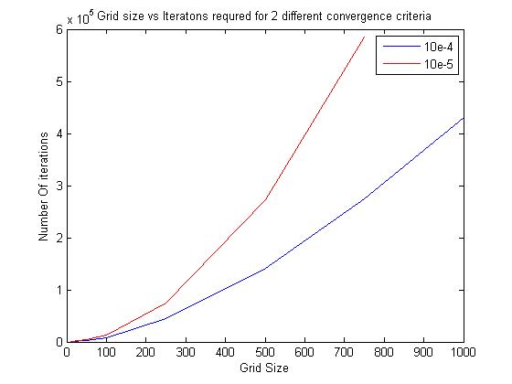

Clearly in the sequential code if the number of grid size is increased the nuber of iterations required for L2 norm condition for convergence increases. Two different convergence criteria were also tested: 10e-4 and 10e-5; which also gives sensible results that lower the convergence criteria, more iterations are required for the same grid size

These calculations were carried out on a general 8 core processor on CCR

1. The code is attached in the appendix

Note: the parallel code was submitted to CCR on node d09n09s02, with 8 threads with variation of number of threads 1,2,4 and 8 threads. Just one node was requested on CCR

1. The graphs after parallelizing the solver with openMP are given below and as expected gives a better parallel speedup and execution time as compared to just one thread, which is also the sequential code.

The grid size was 2000 for all these cases.

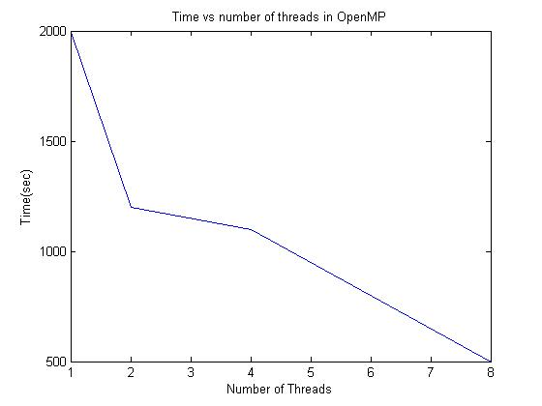

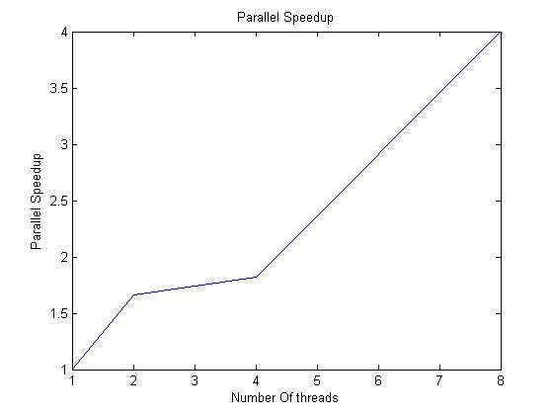

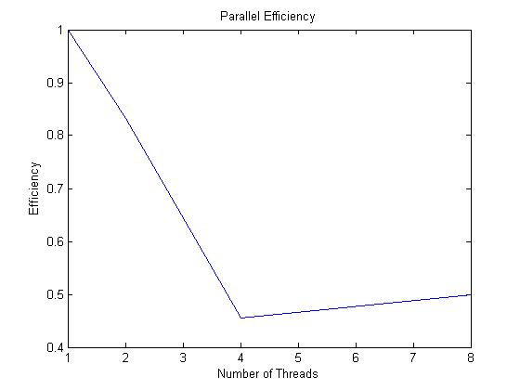

Parallel efficiency graph increases for 8 threads which is an indication that for the number of grid size used, it is best to use 4 threads to get the maximum efficiency.

# Appendix 1

program lap

implicit none

double precision :: dx,dy,dt, pi=3.14, norm

integer :: Nx,Ny,i,j,n,Nt,nitr

double precision, dimension(100) ::x,y

double precision, dimension(100,100) :: phi,phio

do i=1,100

do j=1,100

phio(i,j)=1.0

end do

end do

open(1,file='result.txt')

n=100

dt=0.01

Nt=int(n/dt)

dx=0.01

dy=0.01

Nx=100

Ny=100

do i=1,Nx

x(i)=i*dx

y(i)=i*dy

!print *,x(i)

end do

print *,x(100)

timeloop: do nitr=1,Nt

do i=1,100

phio(1,i)=sin(pi*x(i))

phio(Nx,i)=sin(pi*x(i))*exp(-pi)

phio(:,1)=0.0

phio(:,Ny)=0.0

end do

do i=2,Nx-1

do j=2,Ny-1

phi(i,j)=(phio(i+1,j)+phio(i,j+1)+phio(i-1,j)+phio(i,j-1))/4

!print *,norm

IF (abs(phio(i,j)-phi(i,j))<(10**-5)) exit timeloop

end do

end do

phio=phi

end do timeloop

do i=1,Nx

do j=1,Ny

!write(1,*) phi(i,j)

!print *,phi(i,j)

end do

!write(1,*)phi(i,:)

!write(1,*)''

end do

close(1)

!print *,nitr

end program

# Appendix 2

program lap

Use omp_lib

implicit none

double precision :: dx,dy,dt, pi=3.14, norm, t_start,t_end

integer :: Nx,Ny,i,j,n,Nt,nitr, Np, Nperprocess

double precision, dimension(2000) ::x,y

double precision, dimension(2000,2000) :: phi,phio

integer, dimension(8) :: Nthreads

Nthreads=(/ 1, 2, 3, 4, 5, 6, 7, 8/)

do i=1,100

do j=1,100

phio(i,j)=1.0

end do

end do

open(1,file='result.txt')

n=1000000

dt=0.01

Nt=int(n/dt)

dx=0.01

dy=0.01

Nx=2000

Ny=2000

do ntr=1,size(Nthreads)

call OMP_SET_NUM_THREADS(Nt)

!$OMP PARALLEL DO

myid = OMP_GET_THREAD_NUM()

Nt = omp_get_num_threads()

Np=omp_get_num_procs()

Nperprocess= N/Nt

t_start = OMP_GET_WTIME()

do i=1,Nx

x(i)=i*dx

y(i)=i*dy

!print *,x(i)

end do

timeloop: do nitr=1,Nt

do i=1,2000

phio(1,i)=sin(pi*x(i))

phio(Nx,i)=sin(pi*x(i))*exp(-pi)

phio(:,1)=0.0

phio(:,Ny)=0.0

end do

do i=2,Nx-1

do j=2,Ny-1

phi(i,j)=(phio(i+1,j)+phio(i,j+1)+phio(i-1,j)+phio(i,j-1))/4

!print *,norm

IF (abs(phio(i,j)-phi(i,j))<(10**-5)) exit timeloop

end do

end do

phio=phi

end do timeloop

do i=1,Nx

do j=1,Ny

!write(1,*) phi(i,j)

!print *,phi(i,j)

end do

!write(1,*)phi(i,:)

!write(1,*)''

end do

t_end = OMP_GET_WTIME()

tot_time = t_end - t_start

end do

close(1)

!print *,nitr

end program