Contents
1. Summary 2
2. Background 3
2.1. Comparison of quantum chemical methods 3
2.2. Big Data from Harvard Clean Energy Project 4
2.3. Gradient descent 4
3. Parallel implementation 5
3.1. Parallel gradient descent 5
3.2. Parallel data reading 6
3.3. Synergistic model: Simultaneous data reading and gradient descent 6
3.4. Parallel sorting of the data based on results from gradient descent 6
4. Results 6
5. Discussion 6
6. Impact of this project and future directions 6
7. 6

Accelerated data extraction and analysis through high performance computing

HPC course project by Mohammad Atif Faiz Afzal
Course instructor: Dr. Matthew Jones
12/17/2014

Summary
In our research group, one of the projects is to discover trends in data derived from different quantum chemical methods. The work focuses on the analysis and comparison of results of various molecular properties derived from different flavors of Density Functional Theory (DFT). These patterns in data have significant implications for the utility of the employed approximations and the design of new quantum chemical techniques. Different molecular properties of about 10 million molecular candidates has been evaluated in the Harvard Clean Energy Project (HCEP). Each of these molecular properties are determined using 9 different methods of DFT. Currently, linear regression models is being used to connect results from different methods. The code is currently written in python and the SciPy.stats library is being used for linear regression model. The model in the library only compare between two features at a time and is a serial code thus taking very long time (more than an hour) to get the fitting. As there are many flavors, large number of correlations are required and thus the overall time of computing is very high. I want to create a single linear regression model to fit all the features at once and simultaneously reduce the computation time. As part of the HPC project I would like to write the model in FORTRAN and then parallelize the code to decrease the computation time.
Second aspect of the project is to extract the data that do not fit in the close vicinity to the linear regression fit. This is currently done by calculating the distance of each data point from the linear fit and separating the data points that lie away from the linear fit. For a set of million data, the code takes about 2 days to run just for a pair of features. The CCR time constraint of 72 hours would limit the use of this code for more than two features. As part of the HPC project I would also like to write the code in FORTRAN and parallelize it so that I can reduce the computation time and thus can also use the code on more than two feature models.
Third aspect of the project is to study the data points that do not lie in the vicinity of the linear regression by using machine learning techniques. Clustering will be performed and then the data will be classified into special class of compounds and examine these special classes. As part of HPC project I would like to apply clustering algorithm such as K-means and use MapReduce to decrease the computation time.

Final Objectives
- Parallelize the code for linear regression model using OpenMP/MPI
- Write a parallel code to extract the data that does not fit regression model
- Apply machine learning technique to find different clusters of the extracted data and also implement data parallelization.

In this work, I propose to extend current state-of-the-art large scale screening, molecular library creation and data mining techniques. A hybrid framework consisting of these three elements will be developed. This framework would serve as a significantly more efficient way to rapidly discover organic materials which would outperform the conventional materials used in current optoelectronic applications.

Background

Comparison of quantum chemical methods
Computational techniques have been a tremendous help in discovering new compounds that can be particularly useful for chemical applications. For example, many new drugs that are used for medicinal purposes have sprouted from the use of computational techniques, like molecular simulations and modeling. Many scientists are using computer systems for data mining, to find in the massive amounts of data available, the main point that is relevant to one’s current efforts or to recover experiments done in the past. Computational techniques based on quantum chemistry, is extensively used in our graduate group to calculate certain properties of a compound. Quantum chemistry computations can be performed by various different flavors that are available.
Density functional theory (DFT) is a quantum chemical method that has found a huge resurgence in popularity over the past 20 years and is still the state-of-the-art in the quantum chemistry community. The low computational cost, combined with useful accuracy, has made DFT a customary technique in most branches of chemistry and physics. Electronic structure problems in a variety of fields are currently being tackled by DFT. However, DFT has many limitations in its present form: too many approximations (flavors), failures for strongly correlated systems, etc. This research involves finding correlations between computational inexpensive DFT flavors, with more expensive and accurate DFT flavors. Having these correlations published and accessible by the world can dramatically decrease the amount of time spent conducting future simulations and modelling of chemical compounds. This project is tremendously helpful in accordance to future work by Professor Hachmann’s Research group.
My PhD studies is currently related to using quantum chemical techniques to find the optical properties of different organic polymers for use in the optoelectronics field. These quantum chemical techniques use expensive DFT flavors that can take multiple days to run for a single organic polymer. Finding correlation between different DFT flavors could dramatically cut down the time required to run many of these calculations; by mapping expensive DFT flavor to a much cheaper flavor while maintaining comparatively accurate results. In the current project, these correlations are found out using supervised machine learning technique called gradient descent. The huge data for the finding these correlations is obtained from Harvard Clean Energy Project (CEP).

Big Data from Harvard Clean Energy Project

The Harvard Clean Energy Project (CEP) is an initiative which started out with the aim of discovering next generation of organic solar cell materials [1]. Carbon-based solar cells are being emerged as an interesting alternative to the conventional silicon-based solar devices. Organic photovoltaics range from crystalline small molecule approaches to amorphous polymers (plastics). These organic solar cell devices promise simple, low-cost, and high-volume production and have great potential in the prospect of merging the unique mechanical stability, flexibility and versatility of plastics with electronic features (see Figure 1). OPVs have attracting properties such as easy processability, are light-weight, and can essentially be molded into any desired shape. Further, they can also be made as transparent and/or colored for special applications such as solar windows. The resulting combination of availability and applicability make OPVs prime candidates to achieve the ubiquitous harvesting of solar energy, with building integrated and ultra-portable applications as foremost targets.
Figure 1: Examples of favorable organic photovoltaic (OPV) properties. Left: flexible OPV sheet. Center: transparent and colored OPV. Right: OPV production
The project, CEP, is a theory-driven search for the next generation OPV materials. In this project an automated framework was developed which studies the potential molecular motifs using first-principles quantum chemistry. Millions of molecular candidates were characterized using 9 different DFT flavors. Different Molecular properties such HUMO energy, LUMO energy, dipole moment etc., were determined using these different DFT flavors. The results were compiled in a reference database and are made available for public use. In the current project, the data from the CEP reference database will be used to find correlations between the different DFT flavors via supervised machine learning techniques such as gradient descent.

Gradient descent
Gradient descent method is an algorithm to determine local minimum of functions. In this algorithm, we start with an initial guess of the solution and determine the gradient of the function at this initial guess point. Then a step is taken in the negative direction of the gradient and the gradient is determined at the new guess solution. This process is iteratively repeated until the solution converges when gradient reaches a value of zero which is correspond to the local minimum. The gradient descent is a first-order algorithms because in this method we only take first derivative of the function.
When trying to fit a set of data to a function, an error function is considered. The error function,$J \left(θ\right)$, can be a squared error function as shown in the equation (1), where $h_{θ}\left(x^{\left(i\right)}\right)$ is the fitted equation value, $y^{\left(i\right)}$ is the actual data point and m is total number of data points. Gradient descent method can be used to minimize this error function. In each step of the gradient descent iteration a new solution is updated as shown in the equation where $θ^{n+1}$ is new solution, $θ^{n}$ is value from iteration n, () is the learning rate. This step is repeated until the convergence of the solution is obtained. For a linear fitting the equation (2) will be reduced to the equation (2).
 | $$J \left(θ\right)=\frac{1}{2m}\sum_{i=1}^{m}{{\left(h_{θ}\left(x^{\left(i\right)}\right)-y^{\left(i\right)}\right)}^{2}}$$ | (1)
 | $$θ^{n+1}:=θ^{n}-α\frac{∂}{∂θ}\left(J \left(θ\right)\right)$$ | (2)
 | $$θ^{n+1}:=θ^{n}-α\sum_{i=1}^{m}{\left(h_{θ}\left(x^{\left(i\right)}\right)-y^{\left(i\right)}\right).x^{\left(i\right)} }$$ | (2)
The steps taken while minimizing the error function can be seen qualitatively in the Figure 2. It can be seen that in each step the solution moves towards the local minima (red circle in the figure ()). The rate at which the solution moves towards the local minima is dependent on the value of α. α (>0) is generally kept a small number to make sure that the algorithm makes small steps to ensure the stability of the algorithm. Smaller the value of α, more stable the convergence and more likely to obtain the minima. When higher α is used, especially for a large data set, it is very probable that the solution might diverge.
Figure 2: Illustration of the gradient descent.

Parallel implementation

Parallel gradient descent
For a gradient descent with t iterations, the computation time can be represented as equation (), where m is number of samples, T1 is the computation time to process a single sample data point, and T2 is the computation time to update the parameters. Normally the number of data points is more than the number of parameters. For example, if there are 10 million data points, i.e. m=10 million, then computation time is very large. So if there are large number of data set, gradient descent becomes very expensive in terms of computation. One way to reduce to the cost of computation is to implement parallel computing in the gradient descent algorithm.
Parallel gradient descent can be obtained by diving the summation of the gradients as shown in the equation (2) into the number of available processors. The master processor will split the data into the available workers (processors) and send the corresponding data to each worker. The workers will then calculate the sum of the gradients and then send the sum value back to the master worker. The master worker will sum up the local gradients and update the weight for new solution and then the same process is repeated iteratively until the convergence is obtained. This can be represented in flow chart as shown in the Figure 3. The error in the gradient descent in each iteration can also be calculated parallel as shown in the Figure 4
Figure 3: Flow chart showing parallel implementation of gradient descent
Figure 4: Flow chart for parallel calculation of error

Parallel data reading
In the profiling of the code, it was observed that the amount of time take to read the data in a master processor and sending it to the workers is very expensive. Therefore, I thought of reading the data in parallel rather than reading the whole data from file by a single processor.
Data reading from a file is done using pointers. In the current project, the data is available in a .dat file with each row representing one molecular candidate and the columns giving the properties from different DFT flavors. Because there is data in a single row in the file, reading each line will take some computation time. If there are very large number of lines, the number of lines can be split into the number of processors. Then each worker depending on its worker number jumps the pointer directly to the corresponding data set and the reads only the assigned number of lines. By this way of parallel reading the computation time can be highly reduced.

Synergistic model: Simultaneous data reading and gradient descent
When parallelizing the gradient descent, the data is split and sent into individual workers. After the master workers sends the data to individual worker, the data other than its assigned data in the master worker is useless. Individual workers do calculations based on their individual assigned data. The only data that is communicated is the gradient sum and the updated solutions after each iteration. Exploiting this fact of the gradient descent, we can implement parallel data reading into individual worker. That is the master worker doesn’t need to read all the data from the file which would be very expensive. Instead, the individual workers would extract the data simultaneously from a single file stored in a folder and perform the required gradient descent calculations. This way, the time of reading in master worker and sending to the individual workers can be reduced. The flow chart for this synergistic model can be seen in the figure ().

Parallel sorting of the data based on results from gradient descent
Once the fitted curve is obtained, the next task is to determine the data points that lie in the close vicinity of the curve. For this we need to calculate the distance of each data point from the curve and then sort that data points based on this calculated distance. Sequential calculation of this task would be very expensive. However, this task can also be done in parallel. The master worker can send the final solution to the individual workers and then the individual workers would calculate the distance and send back the results to the master worker.

Results
Method used
All the codes in the project are written in python. The MPI package for python called MPI4Py is used in all my all my runs. All the computations were done CCR nodes and the jobs were submitted using SLURM. Two types of nodes that are available on CCR: 8 core node (CPU-L5520) and 12 core node (CPU-E5645) were used in my computations. The computation time in all the runs was determined using MPItime.
Parallel speedup is calculated by the formula
$$Parallel Speedup=\frac{Time for sequential running}{Time for running on N procs}$$
Parallel efficiency is calculated by dividing the parallel speedup with the no. of processors (P) used.
$$Parallel Efficiency=\frac{Time for sequential running}{Time for running on N Procs}. \frac{1}{P}$$
The learning rate of 0.01 is selected to make sure that the gradient descent is stable and there are no divergence issues encountered. To determine the number of iterations required, initial runs were done using sequential code to determine the dependence of error on the iteration number. Figure 5 shows the error variation with the iteration number when the learning rate is 0.01. It can be seen from the plot that the error becomes constant after about 400 iterations and thus, there is no improvement in the solution after 400 iterations. This means that the local minima is obtained in about 400 iterations. To make sure the convergence is obtained for all the other data sets, 1000 iterations would be a safe number to perform. Thus, a learning rate of 0.01 and the total number of iteration of 1000 were used in all of my calculations unless otherwise mentioned.
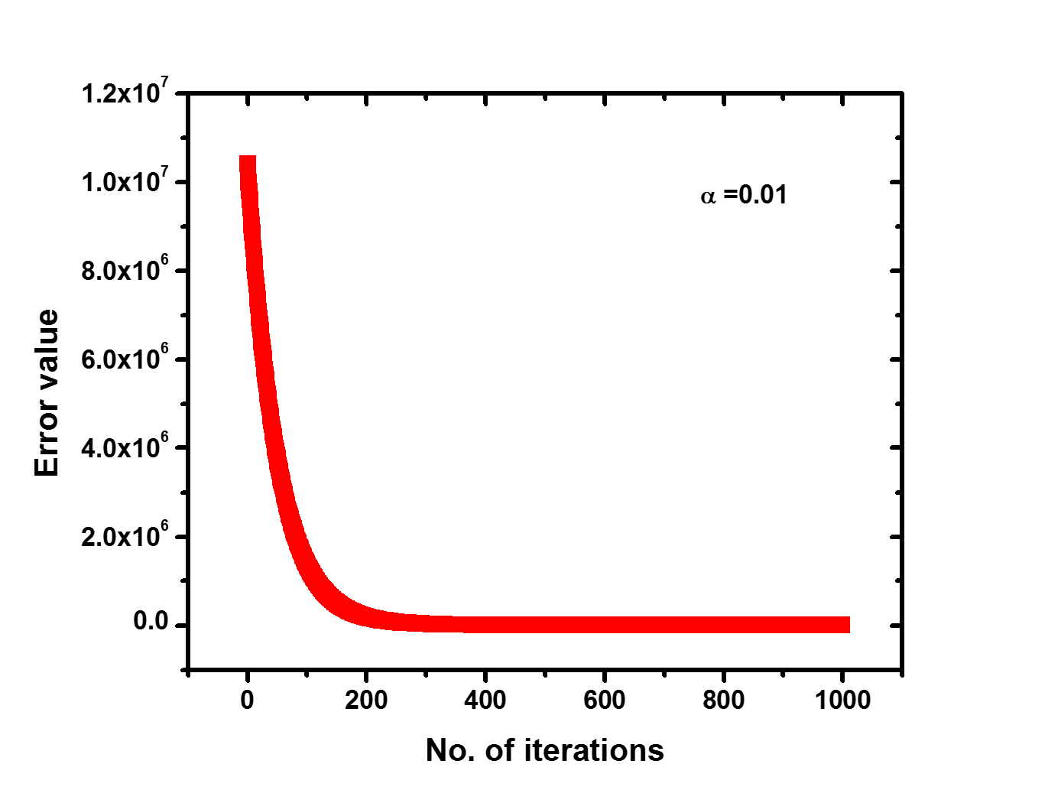
Figure 5: Error function variation with the number of iterations
Parallel Data Extraction
To check if we can read the data in parallel and reduce the computation time a code was written only to see the efficiency of data reading in parallel. The code is written in python and is attached in the appendix. The performance was determined using the L5520 nodes and shown in the Figure 6. It can be seen that the computation decreases with increasing number of processors. The speedup keeps on increasing however the efficiency keeps decreasing. In this case there is no communication between the processors, therefore there are no losses and that’s why we see continuous increase in the speedup.
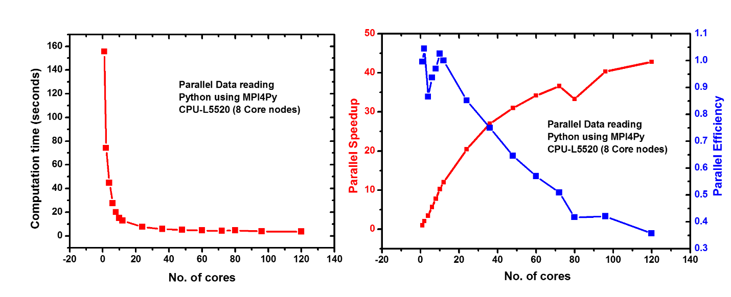
Figure 6: Parallel data reading using MPI4Py on L5520 nodes
Parallel gradient descent using the synergistic model
A parallel code implementing the parallel data reading and parallel gradient descent is written in python and the performance was measured with respect to the number of processors used. Figure 7 shows the performance of parallel gradient descent for 1000 iterations using 10 L5520 nodes (8 core nodes) making a total of 80 cores. It can be seen that the computation time decreases until 12 cores and then increases with the number of cores. The increase in the computation time after 12 cores is because the communication time dominates the processing time. This is probably because the code is written in python and this platform on CCR do not use the infiniband connection compared to the Fortran and C implementation on CCR. I think the Python platform uses the ethernet connection on CCR nodes. A maximum speedup of approximately 7 is observed when 12 cores are used whereas the efficiency keeps on decreasing. The efficiency decreases very rapidly when more than 12 cores are used and approaches zero when higher number of cores are used.
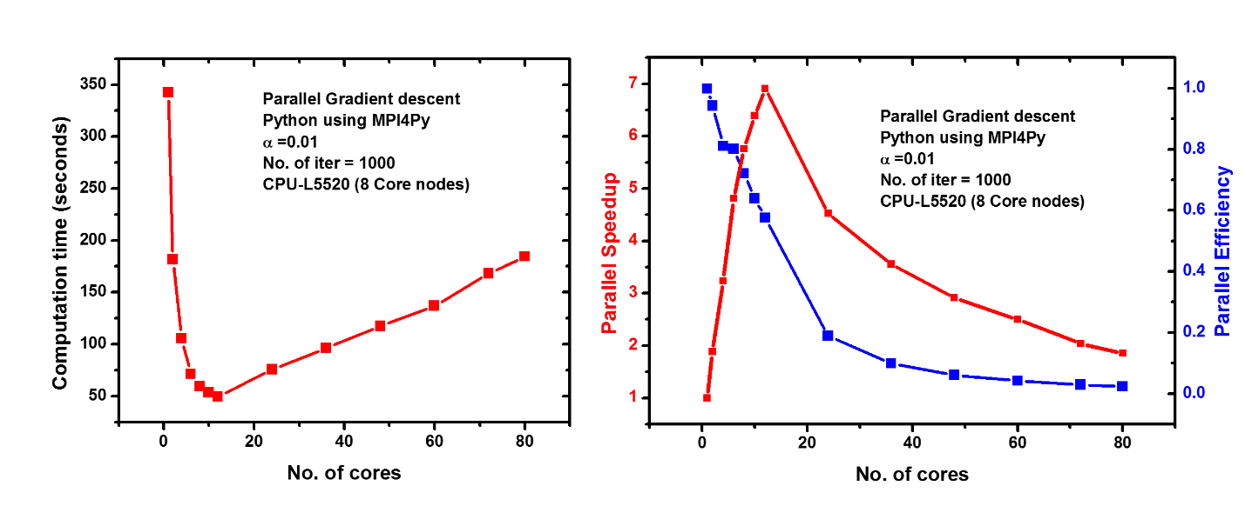
Figure 7: Parallel gradient descent (1000 iterations) performance using MPI4Py on L5520 nodes for a single correlation
To check the effect of the number of iteration on the speedup, the code was run for 500 iterations and the performance is shown in Figure 8. It can be observed that the speedup in this case increases up to approximately 8 and then decreases. This maximum speedup is observed when 12 cores are used. Thus, when higher number of iterations are required, it is probable that more speedup can be obtained when same number of cores are used.
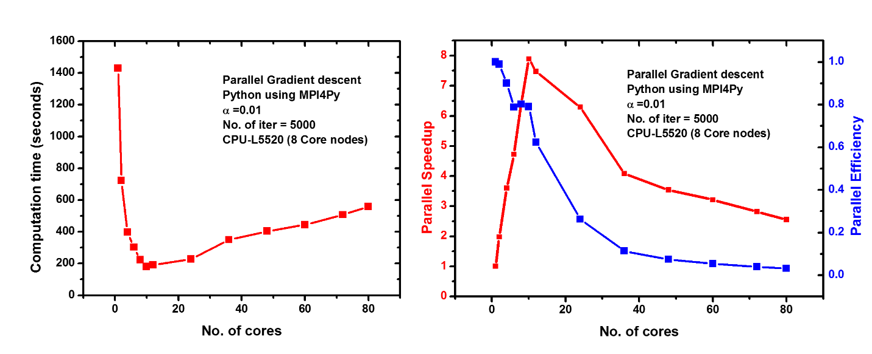
Figure 8: Parallel gradient descent (5000 iterations) performance using MPI4Py on L5520 nodes for a single correlation
It is very convenient when a single run can give correlations between different methods. So, a code which computes multiple correlations using gradient descent was written. The code is written in python and is attached in the appendix. This is the most generalized code and contains all the elements that are described in this project, therefore I have only attached this code in the appendix. To determine the parallel performance of this code the code was run multiple L5520 nodes and shown in Figure 9. It can be seen that computation time decreases up until 24 cores and then increases very slowly upon addition of more cores. This shows a better performance than when only one correlation was commutated. Thus, increasing the size of the problem leads to better performance in parallel gradient descent. The same can interpreted using the parallel speedup. The maximum speedup of approximately 12 was observed when 24 cores are used. Therefore, this code which computes 8 different correlations is a better way than computing individual correlations. In future when more methods are included, just by a single run different correlations can be obtained quickly.
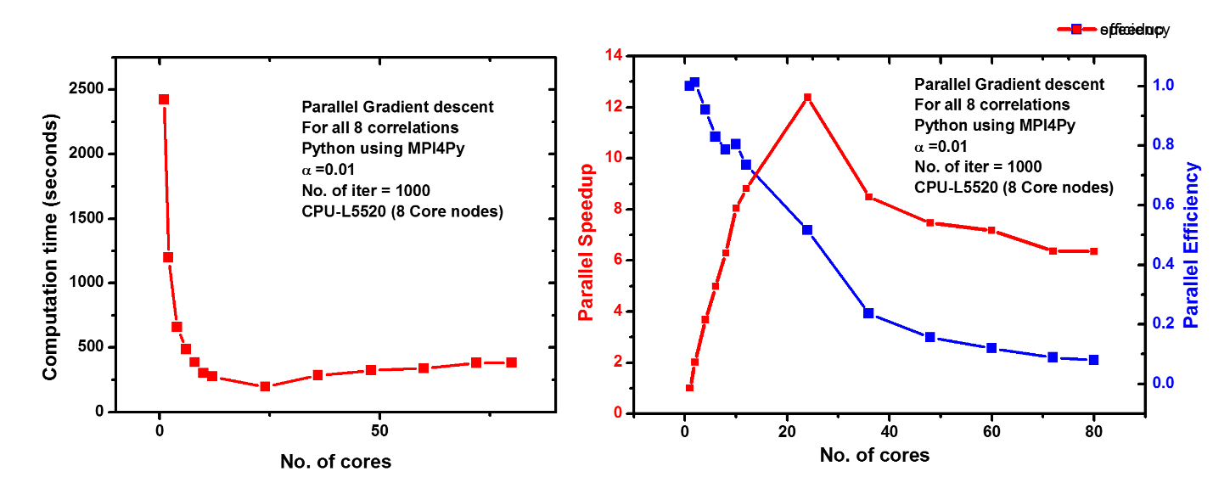
Figure 9: Parallel gradient descent (1000 iterations) performance using MPI4Py on L5520 nodes for a single correlation

Impact of this project and future directions
Using high performance computing, the computation time in finding correlations between millions of data can be dramatically decreased. This project shows that it is possible to perform accelerated data extraction and analysis. The parallel implementation demonstrated in this project will be an important tool in our research group, because most of the research in our group is based on Big Data.
Currently, I have only implemented gradient descent to find linear correlations between different methods. However, some correlations are not linear and need more advanced tools to find correlations between these methods. In future, one aspect of my graduate research is to develop tools to find more reliable non-linear correlations between the data generated using different quantum chemical methods. I believe that this project will be a vital tool throughout my research. This project has provided me with more insight into high performance computing tools in Python and made me appreciate the power of high performance computing.

1. Hachmann, J.; Olivares-Amaya, R.; Atahan-Evrenk, S.; Amador-Bedolla, C.; Sánchez-Carrera, R. S.; Gold-Parker, A.; Vogt, L.; Brockway, A. M.; Aspuru-Guzik, A. n., The Harvard Clean Energy Project: Large-Scale Computational Screening and Design of Organic Photovoltaics on the World Community Grid. The Journal of Physical Chemistry Letters 2011, 2 (17), 2241-2251.

