**Data Acquisition System For Home Automation**

**1. Abstract**

Internet of things is defined as interconnection of all the physical objects through the use of Internet connectivity and it is one of the most happening field in the current scenario of technology, collection of data from the sensors is one of the basic fundamental task of an iot system. In this project we discuss a devleopemnt of a system which is related to data acquisition in the scenario of home automation. System makes use of a few sensors to collect data and process the same through a controller (Raspberry Pi) and send the same to a sql server on cloud, so a application or other device can access it. Other available devices in the home automation network can make use of data to make decision which will help the device makers to develop the devices without the presence sensor unit layer.

**2. Block Diagram**

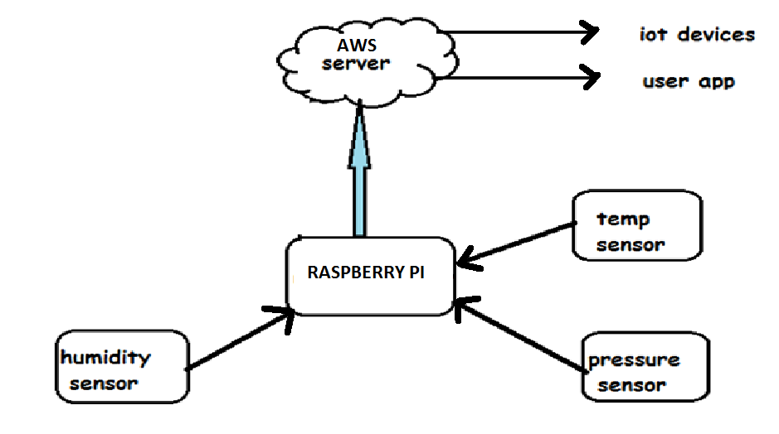

Device Side Algorithm:

CONNECT_TO_SERVER(AWS SERVER ADDRESS)

While(TRUE):

SENSOR_DATA=COLLECT DATA FROM SENSOR(TEMPRETURE,HUMIDITY,PRESSURE)

SQL_COMMAND_TO_INSERT_DATA(SENSOR_DATA)

WAIT_FOR_SECOND(5)

App Side Algorithm:

CONNECT_TO_SERVER(AWS SERVER ADDRESS)

While(True):

Data=SQL_COMMAND_TO_FETCH_DATA_FROM_TABLE()

DISPLAY_DATA_GUI(DATA)

WAIT_FOR_SECOND(5)

**3. Contribution**

* Proposed the concept of project.
* Requirement analysis and documentation.
* Setting up AWS MySQL database server and changing its permissions.
* Writing a python script to push collected sensors data to the remote database.
* Development of GUI Application on client side using python and kivy library.