AWS CLOUD SECURITY LABS
Lab 5
Build Your DB Server and Interact With Your DB Using an App
Amazon RDS (MySQL, Multi-AZ) · VPC Security Groups · DB Subnet Groups
Result: 20 / 20 — all four tasks 5/5
CYB 222 — Linux Systems Administration & Security
Cyber Security Analyst Diploma · Willis College

Objective
Provision an AWS-managed relational database (Amazon RDS for MySQL) with Multi-AZ high availability, restrict access so that only the web tier can reach it, and drive it from a live web application to confirm data persistence and cross-AZ replication.
By the end of the lab I could:
- Launch a Multi-AZ Amazon RDS DB instance.
- Configure the instance to accept connections only from the web server's security group.
- Connect a running web application to the database and perform live CRUD operations.

Architecture
Starting state — a single web server in a public subnet, with a NAT gateway, internet gateway, and empty private subnets across two Availability Zones.
End state — a two-tier, highly available design. The web server in AZ-B talks to an RDS master in AZ-A's private subnet, which synchronously replicates to an RDS standby in AZ-B's private subnet.
Component | Availability Zone | Subnet | CIDR
NAT Gateway | us-east-1a | Public subnet 1 | 10.0.0.0/24
Web Server | us-east-1b | Public subnet 2 | 10.0.2.0/24
RDS master | us-east-1a | Private subnet 1 | 10.0.1.0/24
RDS standby | us-east-1b | Private subnet 2 | 10.0.3.0/24

Task 1 — Create the DB Security Group
Created a security group to gate access to the database instance.
Setting | Value
Name | DB Security Group
Description | Permit access from Web Security Group
VPC | Lab VPC
Inbound rule | MySQL/Aurora — TCP 3306
Source | Web Security Group (sg-…)

Key concept — security-group chaining
The inbound source is another security group, not a CIDR block. Only instances that belong to the Web Security Group can reach port 3306, regardless of their IP address. This is the least-privilege, identity-based firewall pattern AWS recommends for tiered applications: there are no hardcoded IPs to maintain, and the rule keeps working as web instances are replaced or scaled.
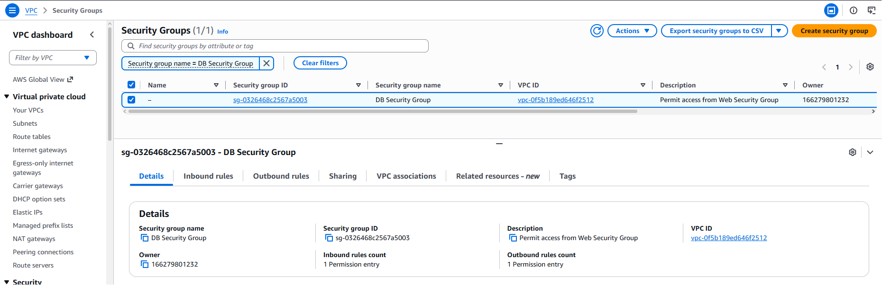
Figure 1 — DB Security Group created in the Lab VPC, inbound 3306 sourced from the Web Security Group.

Task 2 — Create the DB Subnet Group
A DB subnet group tells RDS which subnets it may deploy into. Multi-AZ requires subnets in at least two Availability Zones.
Setting | Value
Name | DB-Subnet-Group
Description | DB Subnet Group
VPC | Lab VPC
Availability Zones | us-east-1a, us-east-1b
Subnets | 10.0.1.0/24 (private), 10.0.3.0/24 (private)
Both selected subnets are private — the database never has a public-facing path. This satisfies the Multi-AZ two-AZ minimum while keeping the data tier fully isolated from the internet.
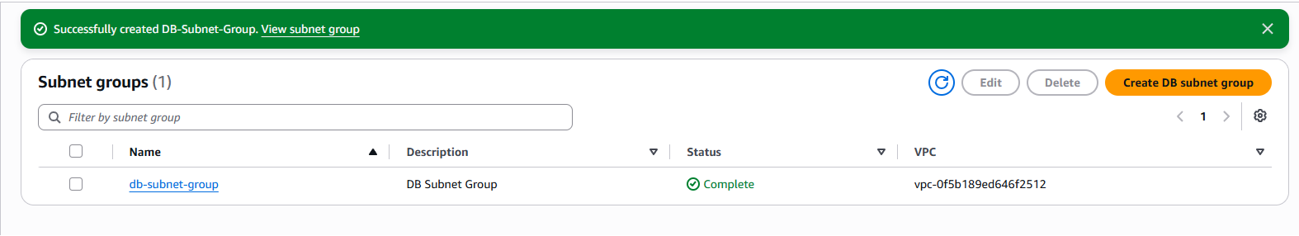
Figure 2 — DB subnet group created; Status: Complete.

Task 3 — Create the Amazon RDS DB Instance
Launched a Multi-AZ MySQL instance for the data tier.
Setting | Value
Engine | MySQL (Community)
Template | Dev/Test
Availability | Multi-AZ DB instance
DB instance identifier | lab-db
Master username | main
Instance class | Burstable — db.t3.micro
Storage | General Purpose SSD, 20 GB
VPC | Lab VPC
Security group | DB Security Group (default removed)
Enhanced monitoring | Disabled
Initial database name | lab
Automatic backups | Disabled (lab speed only)
Encryption | Disabled (lab speed only)
⚠ Gotcha Leaving Enhanced monitoring enabled triggers an iam:CreateRole authorization error in the restricted lab account. Disabling it avoids the failure.
After roughly 4 minutes the instance reached Available, deployed across two AZs. I copied the endpoint for the app-configuration step:
Endpoint:
lab-db.xxxx.us-east-1.rds.amazonaws.com : 3306

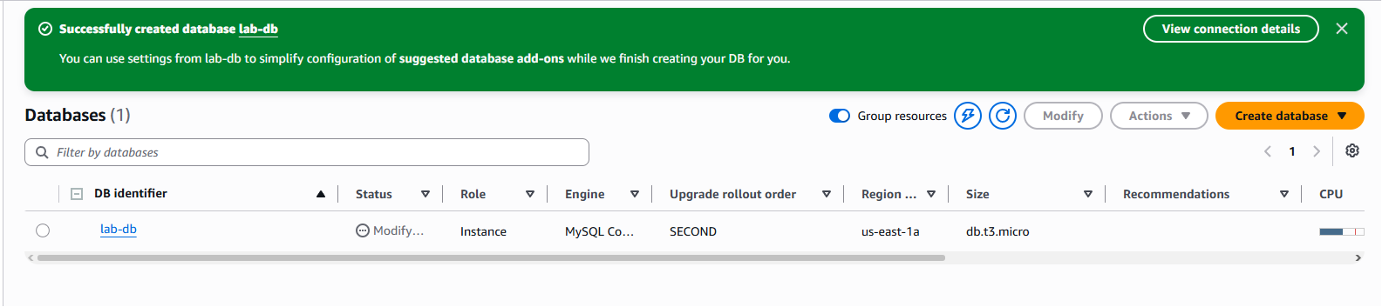
Figure 3 — lab-db created (MySQL Community, db.t3.micro, us-east-1a).
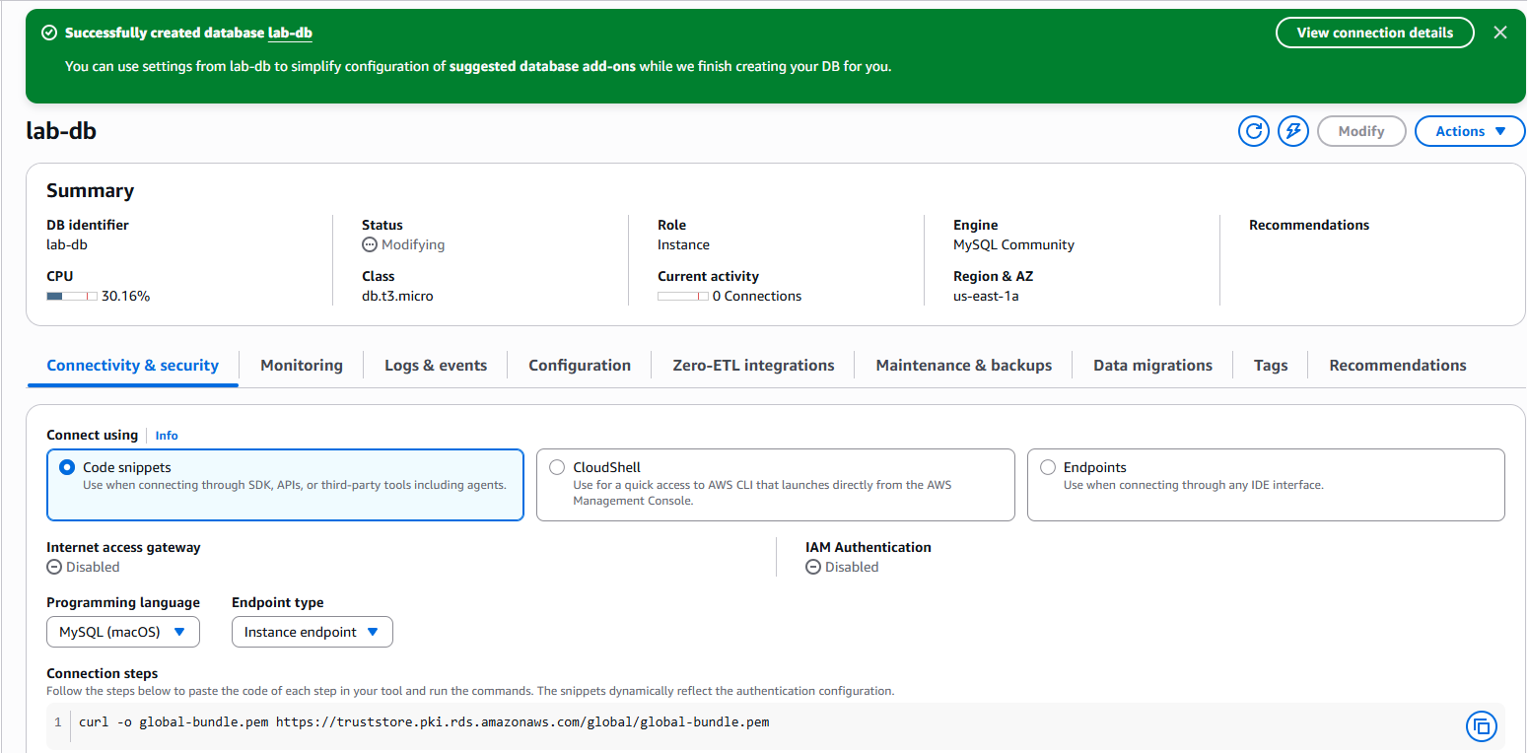
Figure 4 — lab-db Connectivity & security details.

Task 4 — Connect the App and Interact With the Database
Opened the web server by its public IP, went to the RDS tab, and pointed the app at the database:
Field | Value
Endpoint | lab-db.xxxx.us-east-1.rds.amazonaws.com
Database | lab
Username | main
Password | ••••••••
The app initialized the schema and rendered the Address Book. I added, edited, and removed contacts — each change persisted to the RDS master and replicated synchronously to the standby in AZ-B.
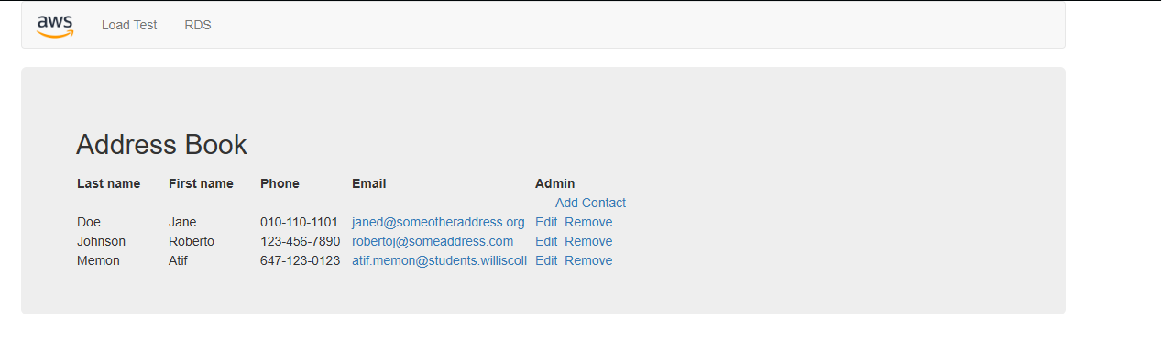
Figure 5 — Address Book web application running against the RDS database.

Result
Task | Description | Score
1 | Security Group created | 5/5
2 | DB subnet group | 5/5
3 | DB created | 5/5
4 | App connected to DB | 5/5
Total |  | 20/20

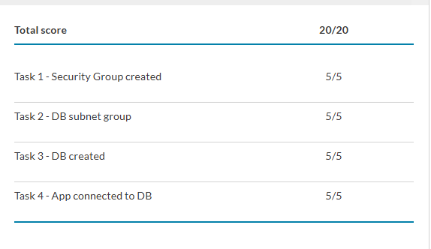
Figure 6 — Submission report: 20/20.

Key Takeaways
- Multi-AZ ≠ read replica. The standby is a synchronous copy for failover and durability — it is not readable and does not scale read traffic. A read replica (asynchronous, readable) is the tool for read scaling. This distinction is a common exam trap.
- Security-group chaining enforces least privilege at the network layer: the data tier trusts an identity (the Web SG), not an IP range, so the rule survives instance churn and auto-scaling.
- Private-subnet placement keeps the database with no public route — defense in depth beyond the security-group rule.
- Shared responsibility shift. With RDS, AWS owns OS patching, MySQL engine patching, and replication mechanics. I own the security-group rules, master credentials, encryption choice, and the schema. Contrast with the EC2 web server, where the guest OS is also my responsibility.
- Backups and encryption were disabled for lab speed only — both would be mandatory in any production deployment.
Part of the cloud-security-labs portfolio — hands-on AWS security labs completed during the Cyber Security Analyst Diploma at Willis College.

