AWS CLOUD SECURITY • LAB 1
Introduction to AWS IAM
Identity & Access Management | Users, Groups & Policies | Least Privilege

Course: CYB 222 — Linux Systems Administration & Security (AWS Cloud Module) Author: Atif Memon
Portfolio: github.com/atifkaloodi1/cloud-security-labs Profile: gravatar.com/atifmem
✔ LAB RESULT: 40 / 40 — full marks on all graded checks (group membership + permission tests for all three users).

Lab Overview & Objectives
AWS Academy — Introduction to AWS IAM • Duration ~40 min
AWS Identity and Access Management (IAM) is the service that controls who can do what in an AWS account. This lab explores pre-created IAM users, groups, and policies, then applies a real-world scenario: granting each user only the access their job requires by placing them in the right group — a hands-on lesson in least privilege.

Objectives
- Explore pre-created IAM users and groups.
- Inspect the IAM policies attached to each group (managed and inline).
- Add users to groups so they inherit the group's permissions.
- Locate and use the IAM sign-in URL.
- Test how policies control access to Amazon S3 and Amazon EC2.

Scenario & Architecture
Mapping users → groups → policies
Three users are each mapped to a group, and each group carries a policy that grants a specific level of access. Permissions flow from the policy, to the group, to the user — users themselves hold no direct permissions.
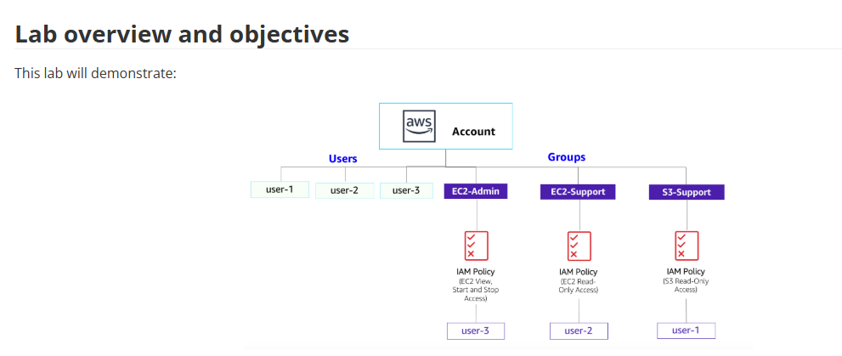
Figure 1 — IAM structure: three users, three groups, and the policy attached to each.

Business scenario
User | Group | Permissions
user-1 | S3-Support | Read-only access to Amazon S3
user-2 | EC2-Support | Read-only access to Amazon EC2
user-3 | EC2-Admin | View, Start, and Stop Amazon EC2 instances

Task 1 — Explore Users and Groups
Inspect the pre-created identities and their policies
1. Open the IAM console. Under Users, review user-1, user-2, user-3 — each has a console password but no permissions and no group membership yet.
2. Under User groups, inspect the three groups and their attached policies:
- EC2-Support — managed policy AmazonEC2ReadOnlyAccess (List/Describe on EC2, ELB, CloudWatch, Auto Scaling).
- S3-Support — managed policy AmazonS3ReadOnlyAccess (Get/List on S3).
- EC2-Admin — an inline policy granting Describe plus Start and Stop on EC2 instances.
NOTE
Every IAM policy statement has three key parts: Effect (Allow or Deny), Action (the API calls, e.g. cloudwatch:ListMetrics), and Resource (the scope, e.g. a specific bucket/instance or * for any). Managed policies are reusable and update everywhere at once; inline policies belong to a single user or group for one-off cases.
📷 OPTIONAL SCREENSHOT
IAM console showing the three users and the three groups with their attached policies.

Task 2 — Add Users to Groups
Grant access by group membership, not per-user
1. Add user-1 to S3-Support (User groups → S3-Support → Users → Add users).
2. Add user-2 to EC2-Support using the same steps.
3. Add user-3 to EC2-Admin.
4. Back on User groups, confirm each group shows 1 in the Users column.
SECURITY INSIGHT
Assigning permissions through groups rather than to individuals is the scalable, auditable way to do access control: change the policy once and every member inherits it, and onboarding a new hire is a single “add to group” action instead of hand-crafting permissions each time.
NOTE
“Not authorized” messages during this task are expected — the lab account itself has limited permissions and they don't affect completion.
📷 OPTIONAL SCREENSHOT
User groups list showing EC2-Admin, EC2-Support, and S3-Support each with 1 user.

Task 3 — Sign-In and Test Users
Prove that each policy grants exactly the intended access
1. From the IAM Dashboard, copy the Sign-in URL for IAM users (looks like https://<account-id>.signin.aws.amazon.com/console).
2. Open a private / incognito window and sign in as each user in turn to test permissions.

user-1 — S3-Support
Sign in (Lab-Password1). Can view S3 buckets and contents; opening EC2 → Instances returns You are not authorized to perform this operation.

user-2 — EC2-Support
Sign in (Lab-Password2). Can view the LabHost EC2 instance, but attempting Stop instance fails with a not-authorized error (read-only). S3 shows You don't have permissions to list buckets.

user-3 — EC2-Admin
Sign in (Lab-Password3). Selecting LabHost and choosing Stop instance succeeds — the instance enters the stopping state.
EXPECTED RESULT
The three tests together prove the policies work as designed: read-only groups can look but not touch, the admin group can act, and access to one service never leaks into another. Deny-by-omission is the default — a user gets nothing unless a policy explicitly grants it.
📷 OPTIONAL SCREENSHOT
user-2 receiving a not-authorized error when attempting to stop the instance (read-only).
📷 OPTIONAL SCREENSHOT
user-3 successfully stopping the LabHost instance (admin permissions).

Security Insights & Key Takeaways
Notes for the CYB 222 capstone article
- Least privilege in practice. Each user receives only the access their role needs — the foundational security principle, demonstrated end to end.
- Groups scale access control. Permissions attach to groups; users inherit them. One policy change propagates to every member.
- Managed vs inline policies. Managed policies are reusable and centrally updated; inline policies are bound to a single identity for one-off needs.
- Effect / Action / Resource. The anatomy of every policy statement — what's allowed or denied, which API calls, and over which resources.
- Deny by default. With no policy, a user can do nothing; access exists only where explicitly granted. Read-only vs admin is the difference between Describe and Start/Stop.
- Users, roles, and federation. IAM also supports roles (assumable identities) and federated sign-in — the basis for cross-account and enterprise SSO access without per-person users.

Lab Result
AWS Academy submission report
All graded checks passed with a perfect score — group membership for all three users plus each permission test.
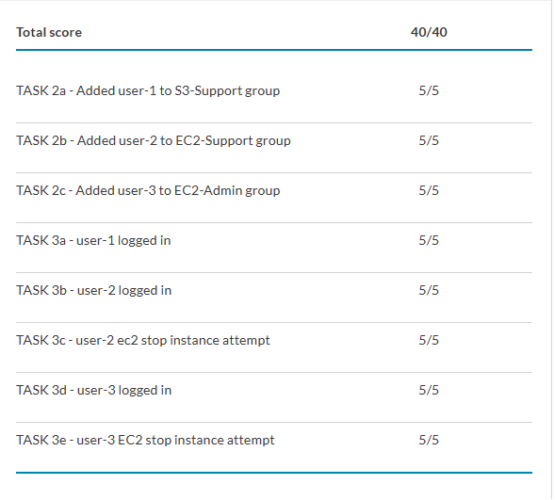
Submission report — Total score 40 / 40.
Atif Memon • cloud-security-labs • gravatar.com/atifmem

