AWS CLOUD SECURITY • LAB 6
Scale and Load Balance Your Architecture
Elastic Load Balancing | EC2 Auto Scaling | Launch Templates | CloudWatch Alarms

Course: CYB 222 – Linux Systems Administration & Security (AWS Cloud Module) Author: Atif Memon
Portfolio: github.com/atifkaloodi1/cloud-security-labs Profile: gravatar.com/atifmem
✔ LAB RESULT: 35 / 35 — full marks on all six tasks (AMI, Load Balancer, Launch Template, Auto Scaling Group, LB check, Auto Scaling check, Web Server 1 termination).

Lab Overview & Objectives
AWS Academy — Scale and Load Balance Your Architecture • Duration ~30 min
This lab uses Elastic Load Balancing (ELB) and EC2 Auto Scaling to make a single-server web application highly available and elastic. Traffic is spread across multiple EC2 instances in two Availability Zones, and capacity is added or removed automatically in response to CPU load measured by Amazon CloudWatch.

Objectives
- Create an Amazon Machine Image (AMI) from a running instance.
- Create an Application Load Balancer with a target group.
- Create a launch template and an Auto Scaling group.
- Automatically scale instances in and out based on demand.
- Create CloudWatch alarms and monitor infrastructure performance.
CAUTION
Never run 20 or more concurrent instances in this lab environment (any size). Doing so triggers immediate deactivation of the AWS account and deletion of all resources. The Auto Scaling group here is capped at a maximum of 6.

Architecture
From a single web server to an elastic, load-balanced fleet

Starting state
A single Web Server 1 lives in Public Subnet 2 (AZ-B). A Multi-AZ RDS database (primary + secondary) sits in the private subnets, with a NAT gateway in Public Subnet 1 providing outbound access. There is a single point of failure at the web tier.
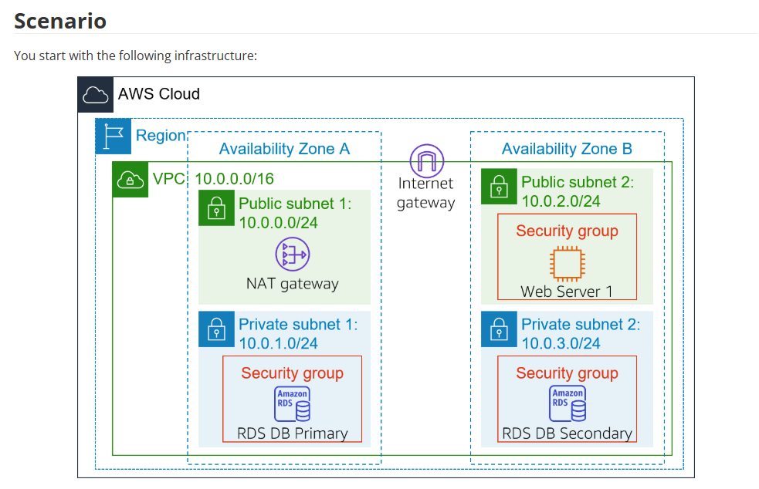
Figure 1 — Starting infrastructure: one web server, no load balancing.

Final state
An internet-facing Application Load Balancer spans both public subnets and distributes requests to an Auto Scaling group of web instances running across both AZs. The single point of failure is removed and the web tier now scales with demand.
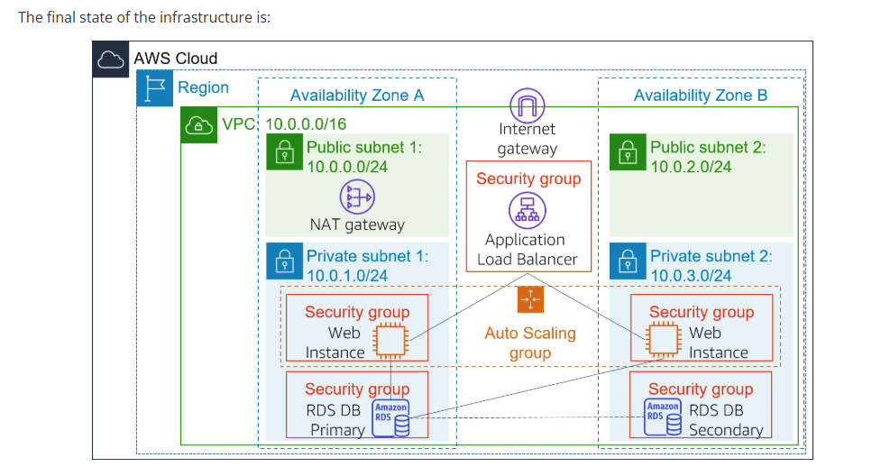
Figure 2 — Final infrastructure: ALB + Auto Scaling group across two AZs.
SECURITY INSIGHT
This is the reference pattern for web-tier high availability on AWS: an ALB in the public subnets fronting a private, auto-scaled compute fleet. The instances themselves are never exposed directly to the internet — only the load balancer's security group is — which shrinks the attack surface while keeping the tier resilient to instance or AZ failure.

Task 1 — Create an AMI for Auto Scaling
Capture the boot disk of Web Server 1 so identical instances can be launched
1. Open EC2 → Instances. Confirm Web Server 1 shows 2/2 checks passed.
2. Select Web Server 1, then Actions → Image and templates → Create image.
3. Set the values exactly (case-sensitive):
Create image
Image name: WebServerAMI
Image description: Lab AMI for Web Server
4. Choose Create image. A banner confirms the new AMI ID — this AMI is used by the launch template in Task 3.
NOTE
An AMI is a point-in-time snapshot of the root volume plus launch metadata. Because every scaled instance boots from the same image, the fleet is immutable and reproducible — no manual per-instance configuration drift.
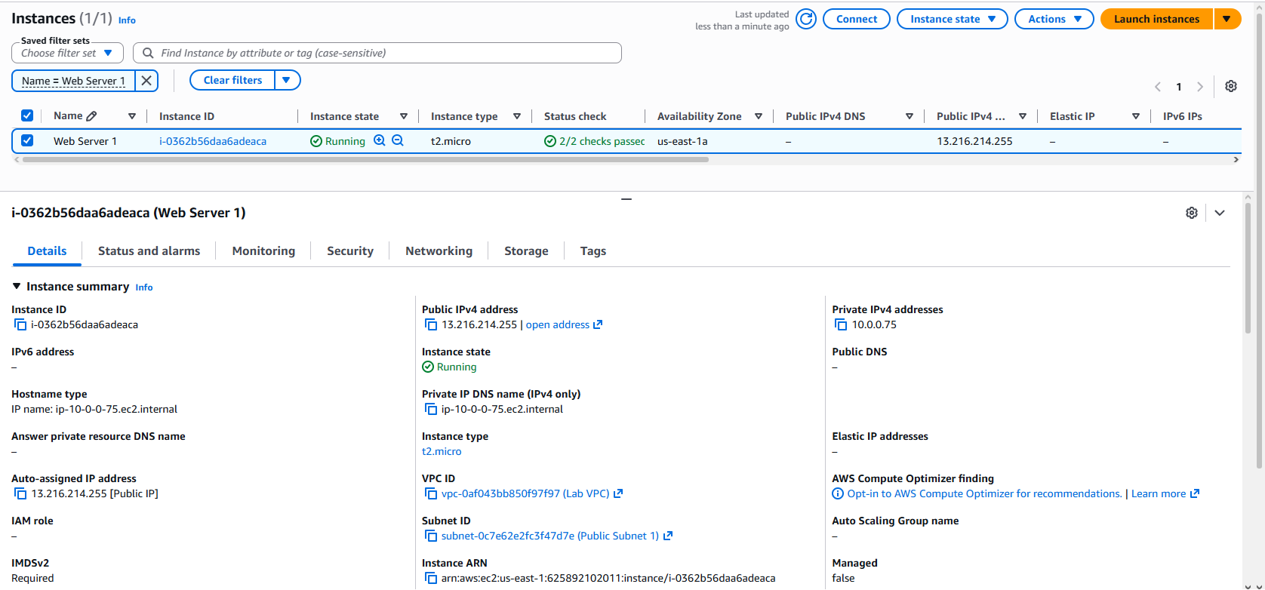
Web Server 1 running with 2/2 status checks passed — t2.micro in us-east-1a, in Lab VPC / Public Subnet 1.

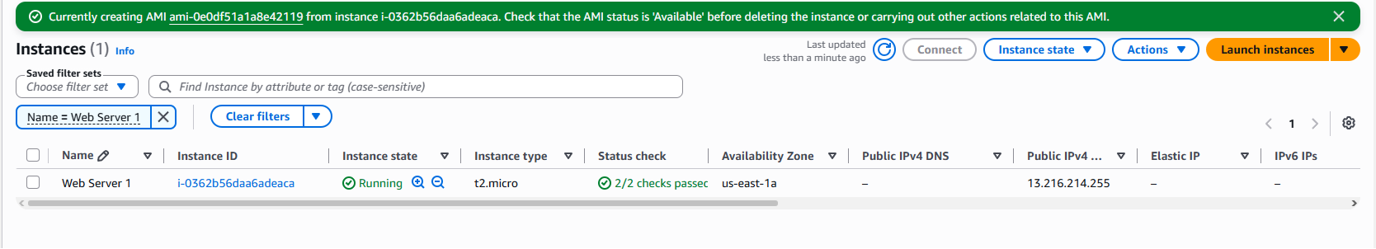
Confirmation banner: AMI ami-0e0df51a1a8e42119 (WebServerAMI) being created from instance i-0362b56daa6adeaca.

Task 2 — Create a Load Balancer
Target group + internet-facing Application Load Balancer

2a — Target group
1. EC2 → Target Groups → Create target group.
2. Target type Instances; name LabGroup; VPC Lab VPC.
3. Skip target registration (no instances yet) → Create target group.
NOTE
Target groups define where the ALB forwards traffic. An ALB operates at Layer 7 (the request level) and can route to different target groups based on the request URL — for example, sending /api or mobile traffic to a separate fleet.
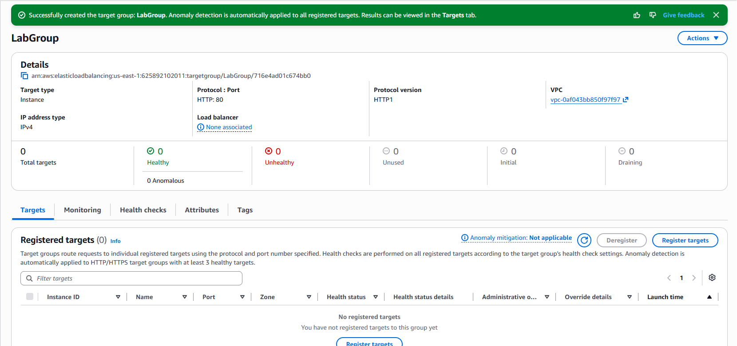
LabGroup target group created — target type Instance, HTTP:80, in Lab VPC, 0 registered targets (none yet), no load balancer associated.

2b — Application Load Balancer
1. EC2 → Load Balancers → Create load balancer → Application Load Balancer.
2. Name LabELB; scheme internet-facing.
3. Network mapping — VPC Lab VPC; map Public Subnet 1 (AZ-A) and Public Subnet 2 (AZ-B).
4. Security groups — select Web Security Group and remove the default group.
5. Listener HTTP:80 → default action forward to LabGroup.
6. Create load balancer. State will show provisioning — no need to wait.
SECURITY INSIGHT
Spanning two AZs is what buys the availability: if an entire Availability Zone degrades, the ALB keeps serving from the healthy zone. Only the ALB's security group faces the internet; the instances stay private.
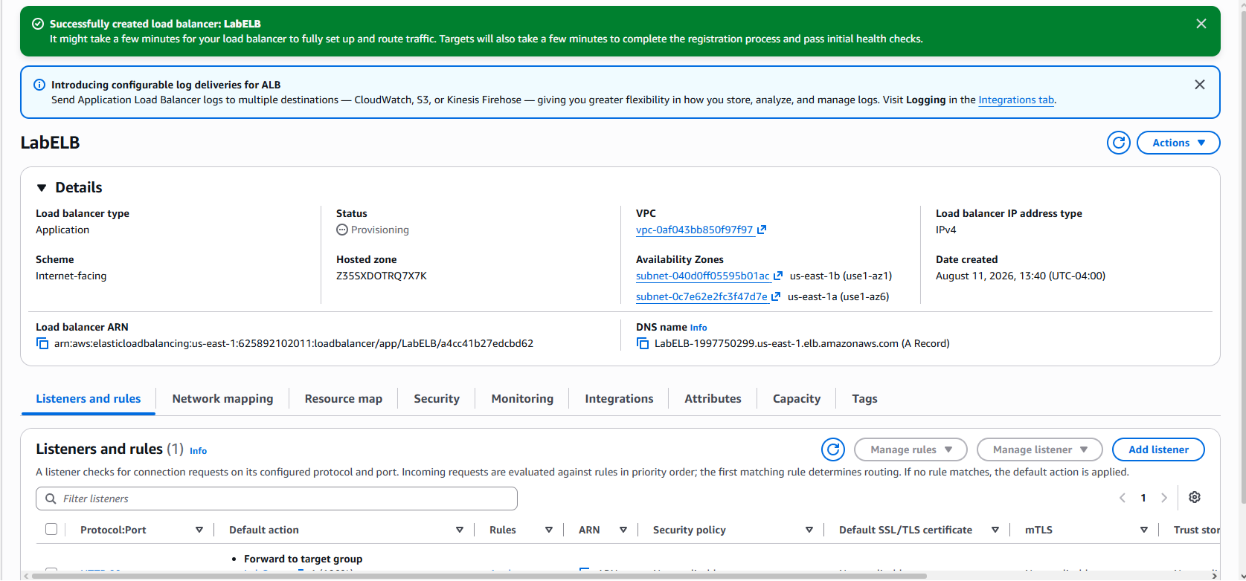
LabELB created — Application load balancer, scheme Internet-facing, spanning two AZs (us-east-1a / us-east-1b) in Lab VPC. DNS: LabELB-1997750299.us-east-1.elb.amazonaws.com.

Task 3 — Launch Template & Auto Scaling Group
The blueprint for scaled instances, plus the group that manages them

3a — Launch template
1. EC2 → Launch Templates → Create launch template.
2. Configure:
LabConfig — launch template
Launch template name: LabConfig
Auto Scaling guidance: Provide guidance... [enabled]
AMI (My AMIs): Web Server AMI (WebServerAMI)
Instance type: t2.micro
Key pair name: vockey
Security group: Web Security Group
Advanced > Detailed CloudWatch monitoring: Enable
3. Create launch template.
NOTE
Detailed CloudWatch monitoring reports metrics at 1-minute intervals instead of 5. Auto Scaling reacts faster to load changes as a result — important for a demo where scaling must happen within minutes.
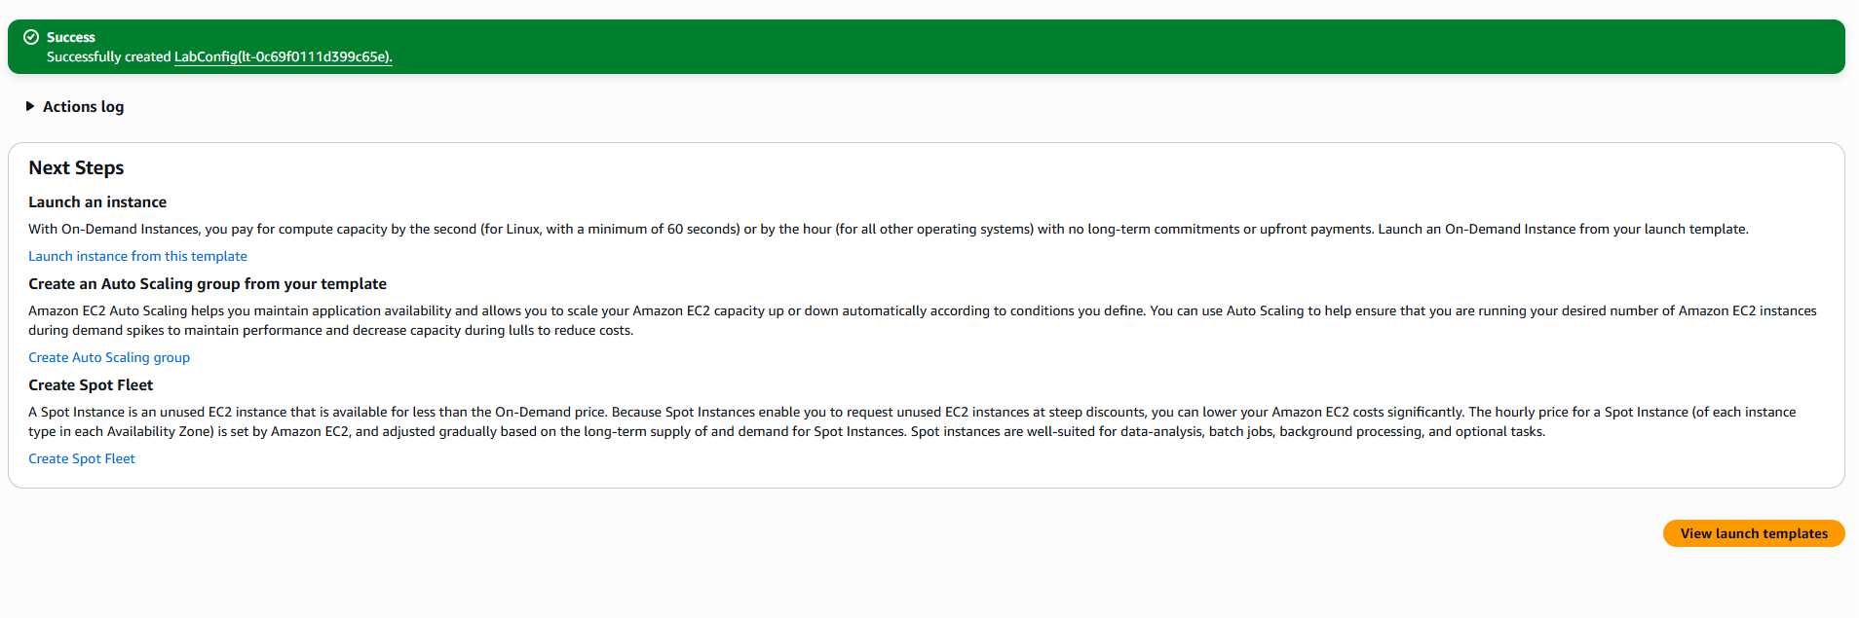
LabConfig launch template created (lt-0c69f0111d399c65e) — the blueprint the Auto Scaling group uses to launch identical instances.

3b — Auto Scaling group
1. From the launch template, Actions → Create Auto Scaling group.
2. Name Lab Auto Scaling Group; template LabConfig.
3. Network — VPC Lab VPC; subnets Private Subnet 1 and Private Subnet 2.
4. Attach to existing load balancer → target group LabGroup; enable group metrics collection in CloudWatch.
5. Group size and scaling policy:
Group size & LabScalingPolicy
Desired capacity: 2
Minimum capacity: 2
Maximum capacity: 6

Scaling policy: Target tracking
Policy name: LabScalingPolicy
Metric type: Average CPU Utilization
Target value: 60
6. Add tag Name = Lab Instance (propagates to launched instances) → review → Create Auto Scaling group.
SECURITY INSIGHT
Target tracking is a closed control loop: you declare the goal (keep average CPU near 60%) and Auto Scaling adds or removes instances to hold it there, within the 2–6 bound. You never write threshold math — CloudWatch creates the alarms for you. Instances launch into the private subnets, so the fleet scales without ever gaining a public IP.
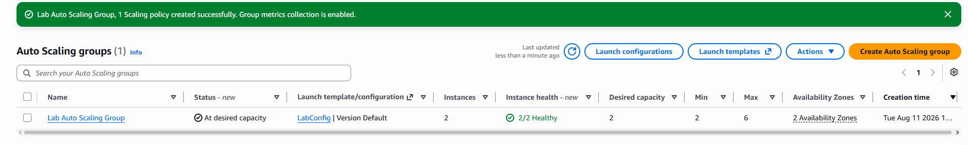
Lab Auto Scaling Group created — At desired capacity, using LabConfig, 2 instances 2/2 healthy across 2 AZs (desired 2 / min 2 / max 6), 1 scaling policy, group metrics enabled.

Task 4 — Verify Load Balancing
Confirm healthy targets and reach the app through the ALB
1. EC2 → Instances — two new Lab Instance instances should appear.
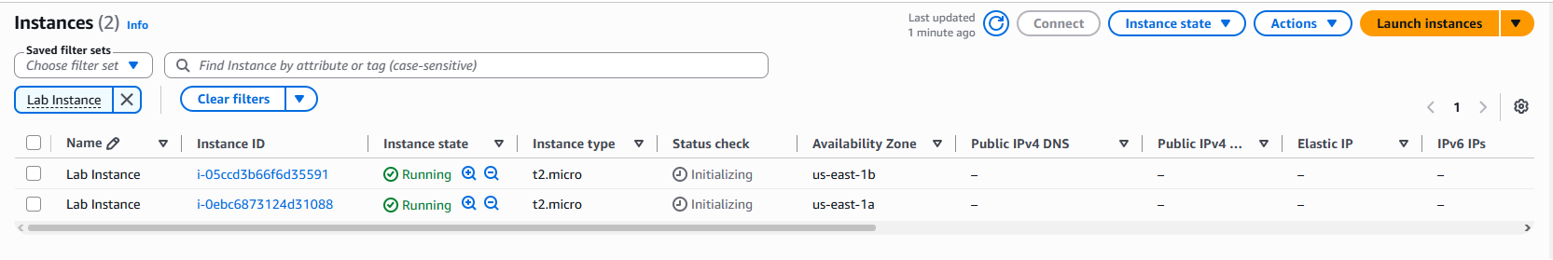
Two Lab Instance instances launched by Auto Scaling — one in us-east-1a and one in us-east-1b, both t2.micro (status checks still initializing).
2. EC2 → Target Groups → LabGroup → Targets tab. Wait until both show healthy.
3. Load Balancers → LabELB → copy the DNS name (omit “(A Record)”).
# ALB DNS name — paste into a new browser tab
LabELB-1997750299.us-east-1.elb.amazonaws.com
4. Open the DNS name in a browser — the application renders, proving the ALB forwarded the request to a backend instance and returned the response.
NOTE
“Healthy” means the instance passed the load balancer's health check, so the ALB is willing to route traffic to it. Unhealthy targets are automatically taken out of rotation — a failed instance simply stops receiving requests.
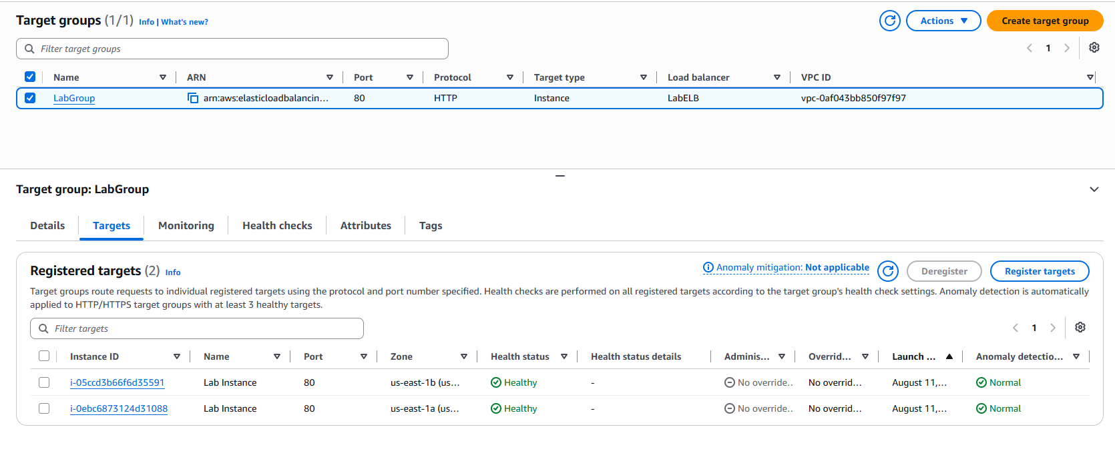
LabGroup Targets tab — both Lab Instances registered on HTTP:80 and showing Health status = Healthy (us-east-1a and us-east-1b), associated with LabELB.
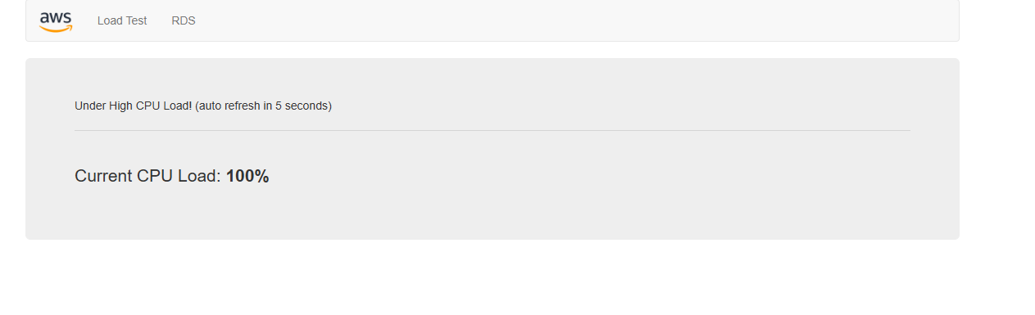
The web application served through the LabELB DNS name — the ALB received the request and returned a response from a backend instance. Shown here under the Load Test with Current CPU Load at 100%.

Task 5 — Test Auto Scaling
Drive CPU up and watch the fleet grow
1. CloudWatch → All alarms. Two alarms were auto-created by the ASG (an AlarmHigh and an AlarmLow).
2. Open the AlarmHigh alarm (state OK). It fires when average CPU exceeds the target for a sustained period.
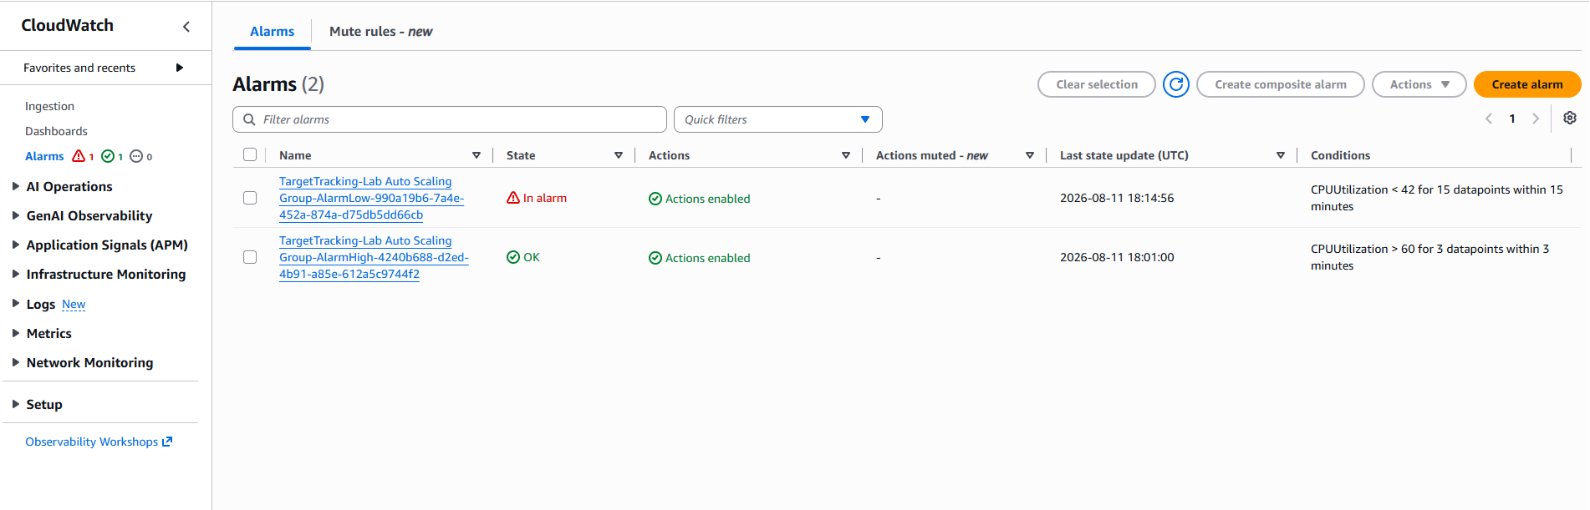
The two alarms auto-created by the ASG — AlarmHigh (CPUUtilization > 60 for 3 datapoints, currently OK) scales out; AlarmLow (currently In alarm) scales in. Together they hold average CPU near the target.
3. In the app browser tab, choose Load Test next to the AWS logo. The page auto-refreshes so every instance generates load.
4. Back in CloudWatch (refresh ~every 60s): within ~5 min AlarmLow → OK and AlarmHigh → In alarm once CPU holds above 60% for ~3 min.
5. EC2 → Instances — more than two Lab Instance instances are now running, launched in response to the alarm.
SECURITY INSIGHT
The optional tweak of lowering the target value to 50 in LabScalingPolicy makes the group more sensitive, so the scale-out event is easier to observe in the short lab window. In production you'd tune this against real traffic and cost targets rather than for speed of demonstration.
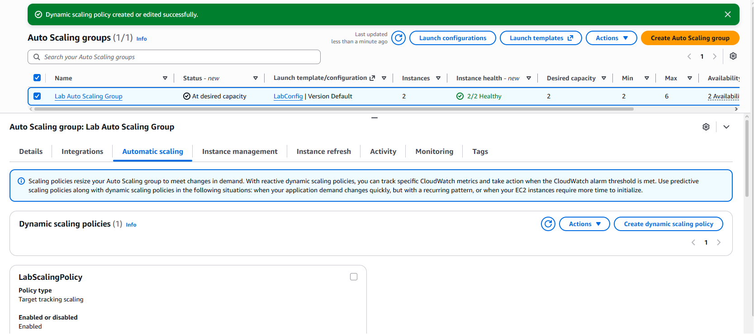
LabScalingPolicy (target tracking, Enabled) on the ASG's Automatic scaling tab — “Dynamic scaling policy created or edited successfully” after lowering the target value to make scale-out fire sooner.
NOTE
AlarmHigh entered the In alarm state once average CPU held above the target for three consecutive datapoints — the scale-out event below (a new Lab Instance initializing) is the direct result of that alarm firing and is captured in the following screenshot.
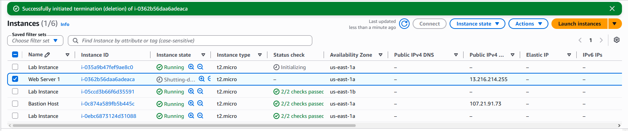
Scale-out fired — a new Lab Instance (i-035a9b47…) is Initializing, taking the fleet above the original two (6 instances total in the account). Auto Scaling launched it in response to AlarmHigh. (Web Server 1 is shutting down here as part of Task 6.)

Task 6 — Terminate Web Server 1
Retire the original single server
1. EC2 → Instances → select Web Server 1 only.
2. Instance state → Terminate instance → Terminate.
NOTE
Web Server 1 only existed to seed the AMI. Once the Auto Scaling group is serving traffic, the original instance is redundant — the fleet is now defined entirely by the launch template and scaling policy, not by any hand-built server.

“Successfully initiated termination of i-0362b56daa6adeaca” — Web Server 1 is Shutting-down. The fleet now runs entirely from the LabConfig launch template and LabScalingPolicy; the seed instance is no longer needed.

Configuration Reference
Exact, case-sensitive names used by the grading script
Resource | Type | Name / Value (exact)
AMI | Machine image | WebServerAMI
Target group | ELB target group | LabGroup
Load balancer | Application LB | LabELB
Launch template | Launch template | LabConfig
Instance type | EC2 size | t2.micro
Key pair | SSH key | vockey
Auto Scaling group | ASG | Lab Auto Scaling Group
Scaling policy | Target tracking | LabScalingPolicy
Target CPU | Metric target | 60% avg CPU
Capacity | min / desired / max | 2 / 2 / 6
Instance tag | Propagated tag | Name = Lab Instance

Security Insights & Key Takeaways
Notes for the CYB 222 capstone article
- High availability by design. An ALB across two AZs fronting an auto-scaled fleet removes the single point of failure at the web tier. Instance and AZ failures become non-events.
- Reduced attack surface. Scaled instances live in private subnets and never receive a public IP; only the load balancer's security group is internet-facing. Compute is isolated from direct inbound traffic.
- Immutable infrastructure. Every instance boots from the same AMI via the launch template — no configuration drift, no snowflake servers, and a clean rebuild path if an instance is compromised: terminate and let Auto Scaling replace it.
- Elasticity as a control. Target-tracking scaling is a closed feedback loop that also blunts certain load-based abuse: capacity absorbs spikes (up to the max), while the max cap prevents runaway cost from a flood.
- Health checks enforce integrity. Unhealthy targets are automatically removed from rotation, so a failing or degraded instance stops serving traffic without manual intervention.
- Observability built in. CloudWatch detailed monitoring + group metrics give per-minute visibility into the fleet — the same telemetry a SOC would use to spot anomalous CPU or scaling behaviour.

Lab Result
AWS Academy submission report
All six tasks were graded and passed with a perfect score.
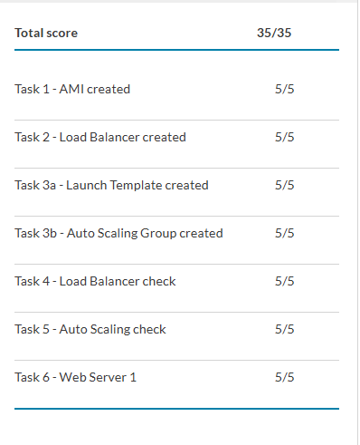
Submission report — Total score 35 / 35.
Atif Memon • cloud-security-labs • gravatar.com/atifmem

