AWS CLOUD SECURITY • LAB 3
Introduction to Amazon EC2
Launch · Monitor · Security Groups · Resize · Stop & Termination Protection

Course: CYB 222 — Linux Systems Administration & Security (AWS Cloud Module) Author: Atif Memon
Portfolio: github.com/atifkaloodi1/cloud-security-labs Profile: gravatar.com/atifmem
✔ LAB RESULT: 25 / 25 — full marks on all graded checks (instance, system log, security group, resize, stop protection).

Lab Overview & Objectives
AWS Academy — Introduction to Amazon EC2 • Duration ~35 min
Amazon EC2 provides resizable compute capacity in the cloud. This lab launches a web server from a bootstrap script, monitors it, opens it to HTTP traffic through a security group, resizes both the instance and its disk, explores service limits, and exercises the guardrails that prevent accidental stop and termination.

Objectives
- Launch a web server with termination protection enabled.
- Monitor the EC2 instance (status checks, CloudWatch, system log, screenshot).
- Modify the security group to allow HTTP (port 80) access.
- Resize the instance type and EBS volume, and enable stop protection.
- Explore EC2 service limits, then test stop protection and stop the instance.

Architecture
A single EC2 web server behind a security group
One EC2 instance runs in a public subnet of the Lab VPC, inside a security group that acts as its virtual firewall. A user-data bootstrap script turns it into a working web server on first boot.
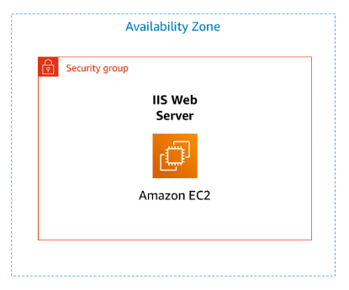
Figure 1 — EC2 web server inside a security group in one Availability Zone.
CORRECTION
The AWS diagram labels the server “IIS Web Server,” but that’s inaccurate for this build. IIS is Microsoft’s Windows web server; this instance runs Amazon Linux 2023 and the user-data script installs Apache (httpd). Knowing your actual stack matters — the running service is Apache, not IIS.

Task 1 — Launch Your EC2 Instance
With termination protection and a user-data bootstrap
1. EC2 (region us-east-1 / N. Virginia) → Launch instance.
2. Configure:
Launch configuration
Name: Web Server (creates tag Name = Web Server)
AMI: Amazon Linux 2023
Instance type: t2.micro (1 vCPU, 1 GiB)
Key pair: vockey
Network: Lab VPC / PublicSubnet1 (auto-assign public IP)
Security group: Web Server security group (remove the default inbound rule)
Storage: 8 GiB root (default)
Advanced: Termination protection = Enable
3. Paste the bootstrap script into User data:
User data — runs as root on first boot
#!/bin/bash
dnf install -y httpd
systemctl enable httpd
systemctl start httpd
echo '<html><h1>Hello From Your Web Server!</h1></html>' > /var/www/html/index.html
4. Launch, then wait for Running and 2/2 checks passed.
SECURITY INSIGHT
User data is instance bootstrapping: the script runs once, as root, on first boot — installing Apache, enabling it at startup, and publishing a page with no manual SSH. Termination protection is a safety control that blocks accidental deletion of the instance while enabled.
📷 SCREENSHOT
Web Server instance in the Running state with 2/2 status checks passed.

Task 2 — Monitor Your Instance
Status checks, CloudWatch, system log, screenshot
1. Status checks tab — confirm System reachability and Instance reachability both pass.
2. Monitoring tab — CloudWatch metrics (basic 5-minute monitoring is on by default; detailed 1-minute is optional).
3. Actions → Monitor and troubleshoot → Get system log — verify the httpd package installed from the user-data script.
4. Actions → Monitor and troubleshoot → Get instance screenshot — a console screenshot for troubleshooting when SSH/RDP is unavailable.
NOTE
The system log and instance screenshot are diagnosis tools for when an instance is unreachable before its SSH daemon starts — they give visibility into boot and kernel problems without needing to connect in.
📷 SCREENSHOT
System log output confirming the httpd package was installed via user data.
📷 SCREENSHOT
Instance screenshot from Get instance screenshot.

Task 3 — Security Group & Web Access
Open port 80 to reach the site
1. Copy the instance’s Public IPv4 address and open it in a browser — it fails to load.
2. Security Groups → Web Server security group → Inbound rules → Edit → Add rule:
Inbound rule
Type: HTTP
Port: 80
Source: Anywhere-IPv4 (0.0.0.0/0)
3. Save, refresh the browser — the page now shows Hello From Your Web Server!.
SECURITY INSIGHT
This is the security-group-as-firewall lesson in miniature: the web server was running the whole time, but unreachable because no inbound rule permitted port 80. Deny-by-default means nothing gets in until you explicitly allow it — the failed load, then the fix, makes the control visible.
📷 SCREENSHOT
Browser showing “Hello From Your Web Server!” after adding the HTTP inbound rule.

Task 4 — Resize the Instance & Volume
Scale compute and storage; enable stop protection
1. Stop the instance (required before resizing). No runtime charge while stopped; EBS storage still bills.
2. Actions → Instance settings → Change instance type: t2.micro → t2.small (2× the memory).
3. Actions → Instance settings → Change stop protection → Enable → Save.
4. Storage tab → select the volume → Actions → Modify volume: 8 GiB → 10 GiB, confirm.
5. Start the instance again — now t2.small with a 10 GiB root volume.
NOTE
On stop/start, an instance is usually migrated to a new host and gets a new public IPv4, but keeps its private IP and all EBS data. Elasticity works in both directions — you can size compute and storage up or down as the workload changes.
📷 SCREENSHOT
Instance details after resize — t2.small with a 10 GiB root volume.

Task 5 — Explore EC2 Limits
Service Quotas (not graded)
1. Service Quotas → AWS services → Amazon Elastic Compute Cloud (Amazon EC2).
2. Search running on-demand and observe the per-region limits on how many/which instance types can run.
NOTE
Default service quotas exist per region for images, instances, volumes, and snapshots. Launches that would exceed a running-instance limit are rejected — account owners can request increases. (This task carries no graded check.)

Task 6 — Test Stop Protection
The guardrail blocks the first stop
1. With stop protection enabled, choose Stop instance — it fails: The instance may not be stopped. Modify its 'disableApiStop' attribute and try again..
2. Actions → Instance settings → Change stop protection → uncheck Enable → Save.
3. Stop the instance again — it now succeeds.
SECURITY INSIGHT
Stop protection (and termination protection) are deliberate friction against destructive mistakes: the disableApiStop attribute forces an explicit, conscious step before a stop or delete can go through — a small control that prevents costly accidents.
GRADER TIMING
Some checks in this lab only credit ~5 minutes after the action is complete. Submitting too early can score a task 0/5 even when done correctly — wait a couple of minutes and re-submit. (This is exactly what caught Task 6 on the first attempt; it scored 5/5 on re-submission.)
📷 SCREENSHOT
Stop failing on the first attempt (stop protection), then succeeding after it’s disabled.

Security Insights & Key Takeaways
Notes for the CYB 222 capstone article
- Security groups are deny-by-default firewalls. The site was unreachable until an explicit HTTP:80 inbound rule was added — the clearest demo of allow-listing network access.
- User data automates secure bootstrapping. The instance configured itself on boot (install, enable, start, publish) with no interactive login — repeatable and hands-off.
- Guardrails prevent costly mistakes. Termination and stop protection add deliberate friction against accidental destruction of running resources.
- Know your actual stack. The diagram said IIS; the box ran Apache on Amazon Linux. Accurate mental models matter when you’re securing or troubleshooting a system.
- Elasticity, up and down. Instance type and EBS volume both resized on demand; stop/start rotates the public IP but preserves data and the private IP.
- Know the limits. Per-region service quotas cap running instances — relevant for both capacity planning and spotting abnormal (possibly malicious) resource growth.

Lab Result
AWS Academy submission report
All graded checks passed — instance creation, system log, security group, resize, and stop protection. (Task 5, Explore EC2 Limits, has no graded check.)
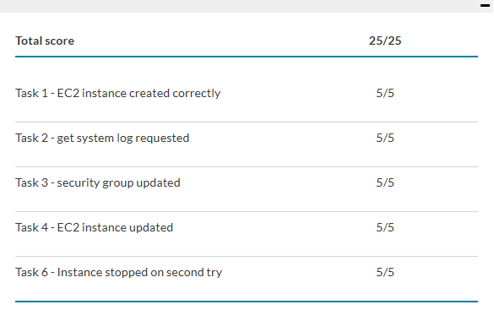
Submission report — Total score 25 / 25.
Atif Memon • cloud-security-labs • gravatar.com/atifmem

