In our meeting, we had discussed creating a menu that appears at the bottom of the mobile screen.

The same menu can appear for both Logged-In and Logged-Out state.

All icons when inactive will be light Gray color – When active, icons will be dark gray color. All images are being provided on Slack for both light gray color (inactive) and dark gray color (active) states

Additionally, when user is logged in, “Log In” icon will change to “Log Out” icon and icon heading will change from “Log In” to “Log Out”

This menu should ideally disappear when scrolling down and reappear when scrolling up (like LinkedIn)



**Home**

**My Account**

**Post Ad**

**Messages**

**Log In**

**My Account**

**Home**

**Ask/Discuss**

**Log In**

**Contacts**

**This is the menu for Networking module**



**Log Out**

**This is the menu for Classifieds module**



**Log Out**

This is the referenced LinkedIn menu



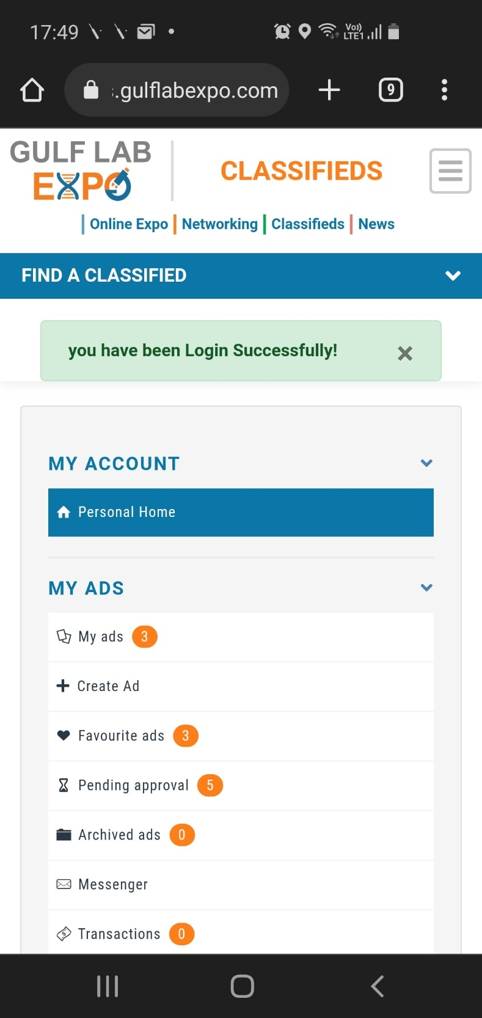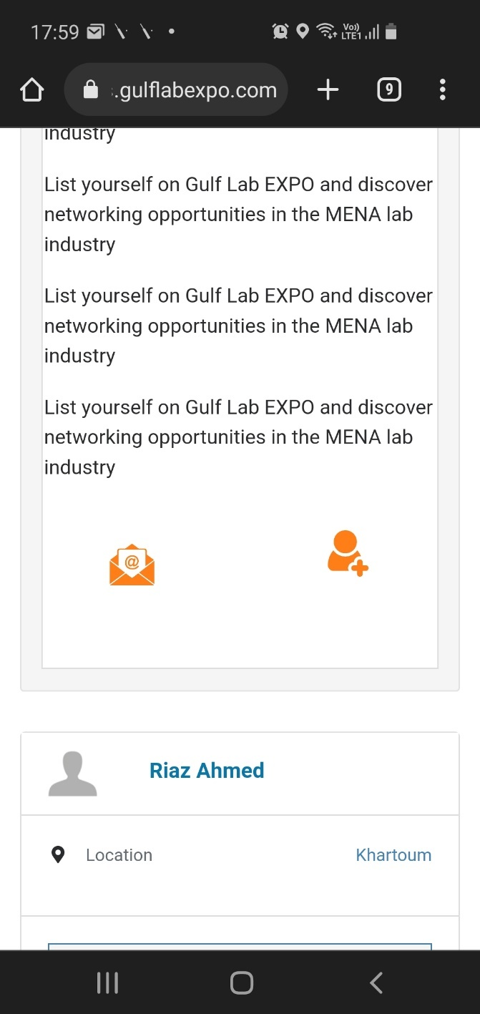

Please change message text to “You have Logged In successfully”

Please align these icon to same level  
**(Done)**

I used VPN and incognito mode. This page is appearing as home page. This is incorect. We had discussed this in a previous meeting as well.

