Atij Mahesh

905954423

CS 32 Homework 5

1a)

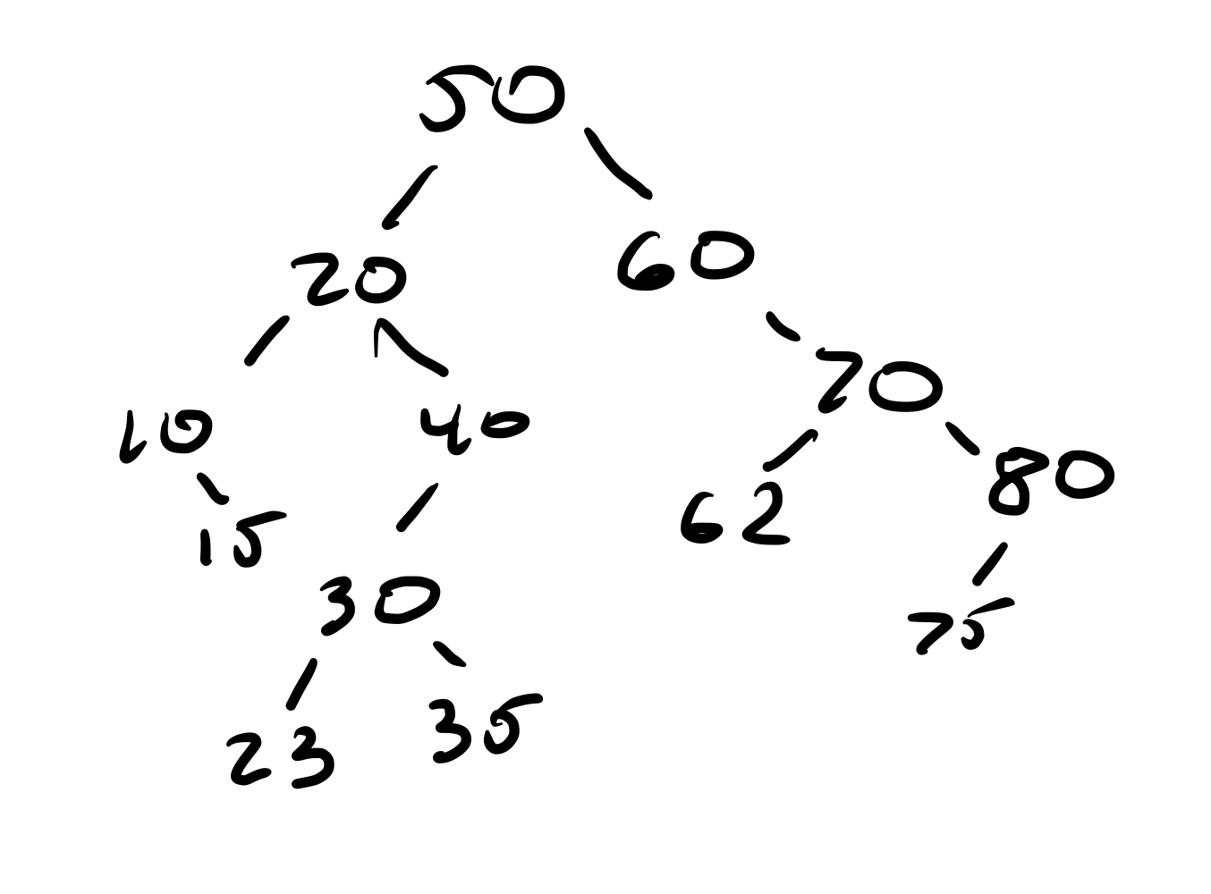

1b)

Inorder: 10, 15, 20, 23, 30, 35, 40, 50, 60, 62, 70, 75, 80

Preorder: 50, 20, 10, 15, 40, 30, 23, 35, 60, 70, 62, 80, 75

Postorder: 15, 10, 23, 35, 30, 40, 20, 62, 75, 80, 70, 60, 50

1c)

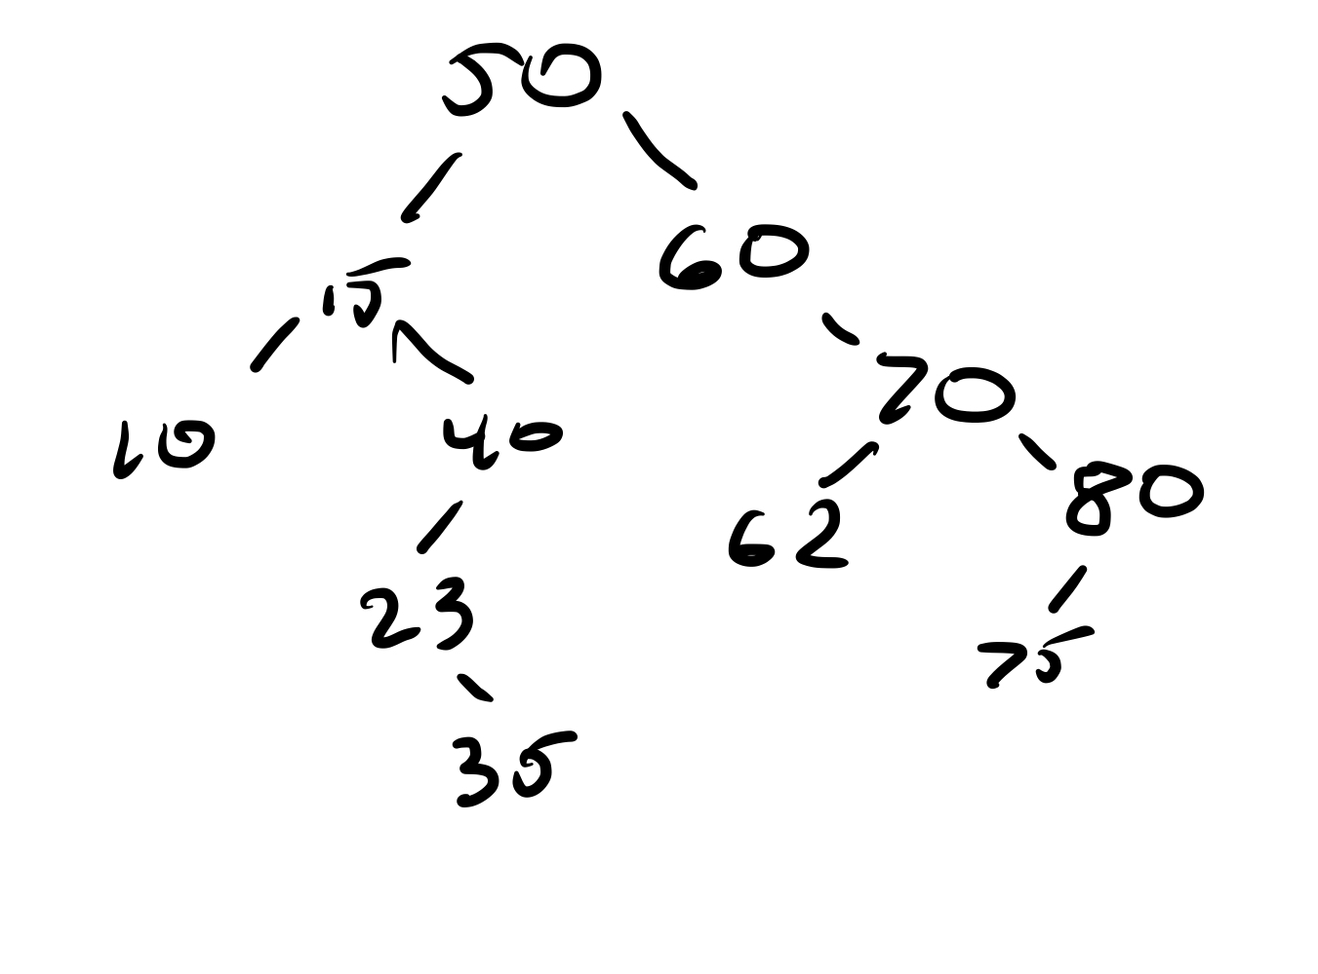

2a)

| struct Node {  Node* parent;  Node* left;  Node* right;  int data; } |
| --- |

2b)

| void function(Node insert, Node root) {  if the root is null   initialize the root as insert, and insert's left, right, and parent pointer as nullptr  set curr equal to root  if insert is less than the current node's data  if curr's left node isn’t nullptr  function(curr's left node pointer, curr)  else add insert to curr's left node and set insert's parent to curr and return  if insert is greater than the current node's data  if curr's right node isn’t nullptr  function(curr's right node pointer, curr)  else add insert to curr's right node and set insert's parent to curr and return  else   return } |
| --- |

3a)

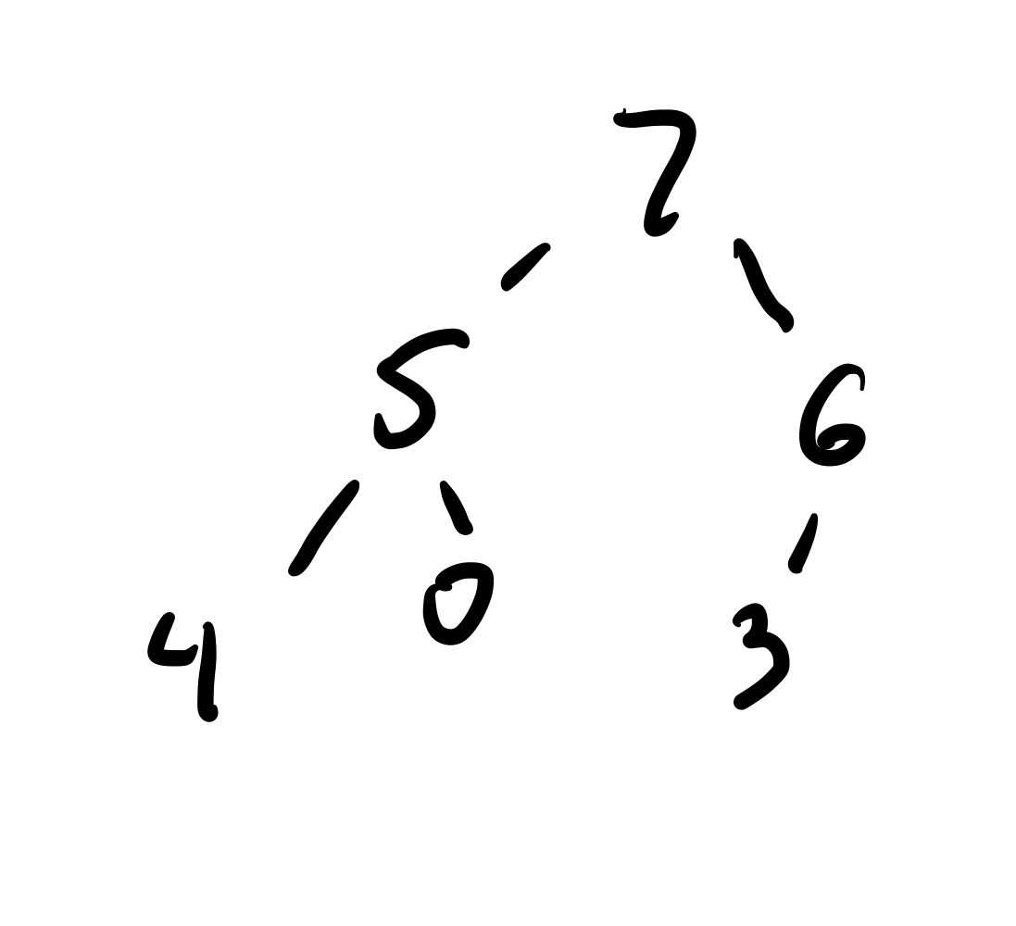

3b)

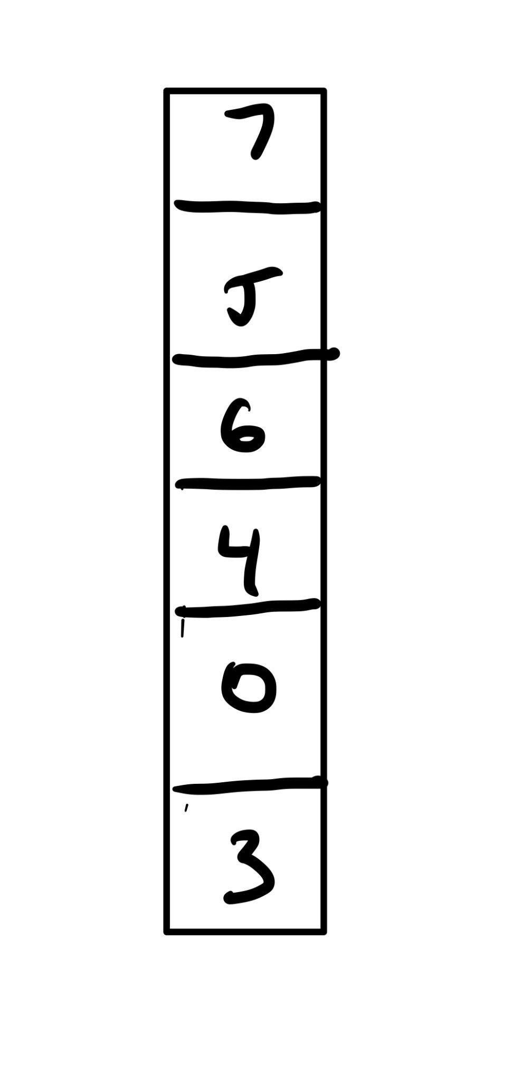

3c)

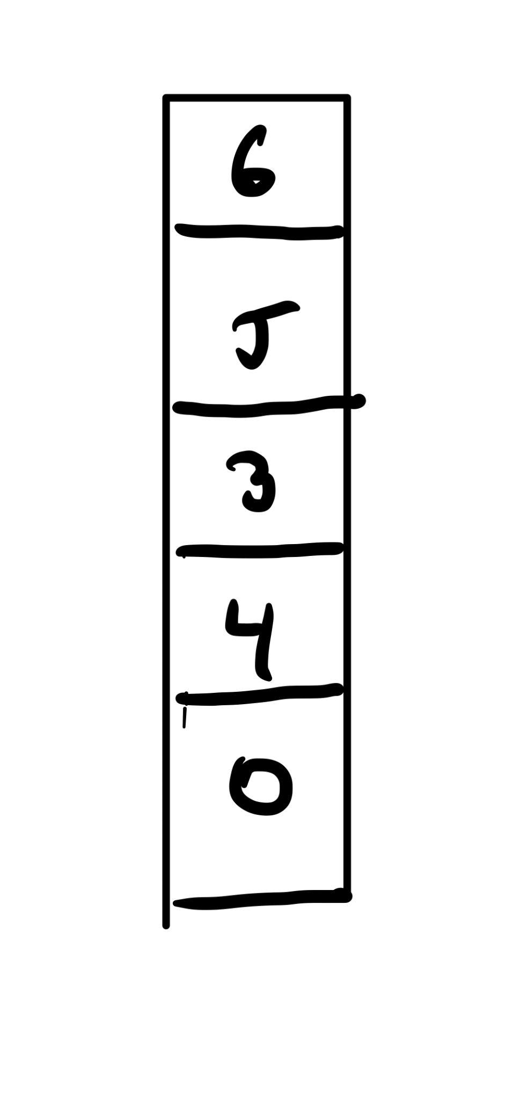

4a) O(C + S)

b) O(logC + S)

c) O(logC + logS)

d) O(logS)

e) O(1)

f) O(logC + S)

g) O(S(logS))

h) O(C(logS))