Register & Login Page

2/6/2021

1. Create login and register webpage

Backend

1. Install package.json to the project folder by using Terminal “npm init -y”
2. Install dependencies that are going to be use: (Forgot ejs)

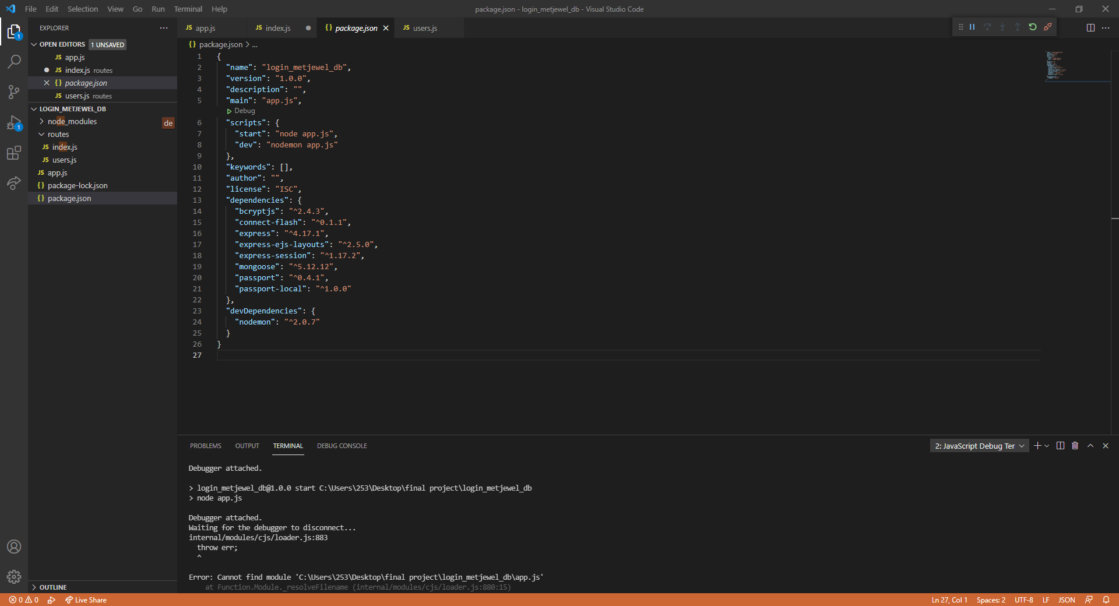

1. Install dev nodemon “npm dev nodemon”

