ASSIGNMENT 2

Nama : Atikah Khonsa Salsabila

NIM : 1313619002

Prodi : Ilmu Komputer 2019

1. File user.h line 28-39

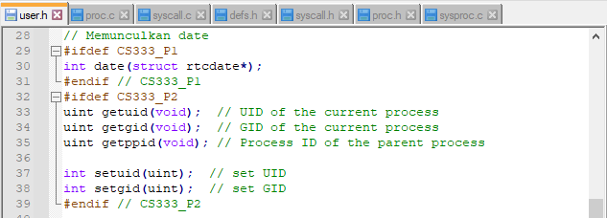

2. File ps.c line 1-56

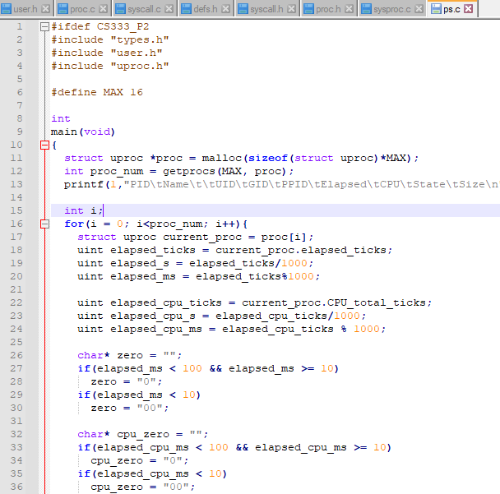

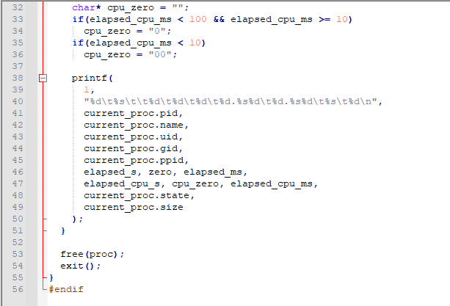

3. File proc.c line 9-11

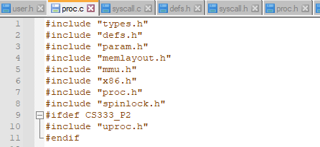

4. File syscall.c line 107



5. File syscall.c line 110 dan 112-119

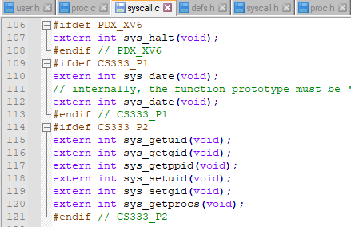

6. File syscall.c line 152-159

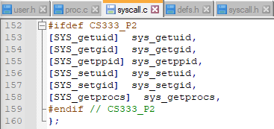

7. File syscall.c line 192-199

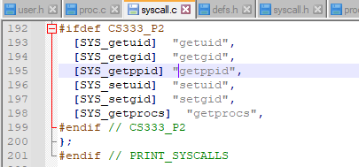

8. File defs.h line 1-3

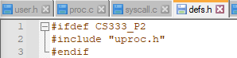

9. File defs.h line 130-132

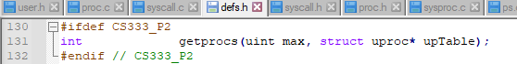

10. File syscall.h line 25-30

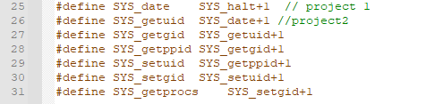

11. File proc.h line 54-59

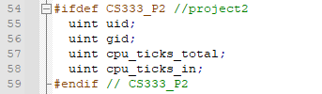

12. File sysproc.c line 115-170

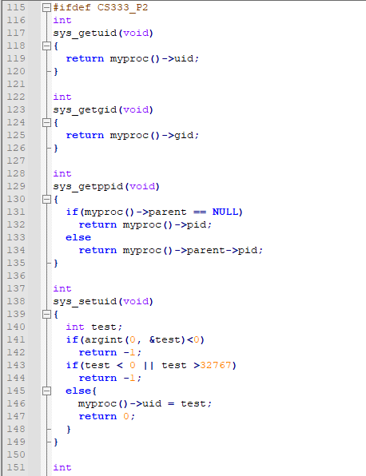

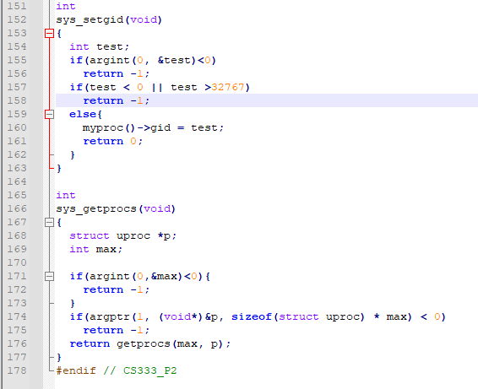

13. File time.c line 1-46

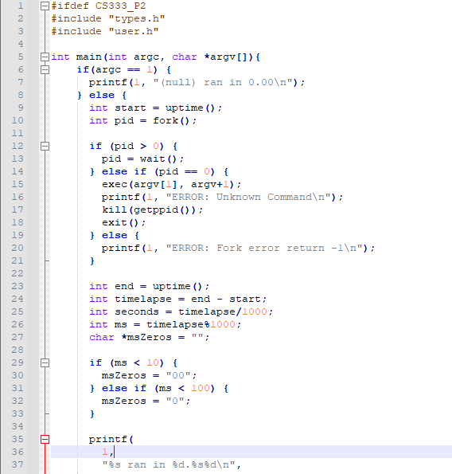

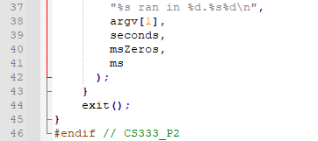

14. File usys.S line 34-39

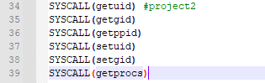

15. File testsetuid.c line 1-11

