Building/trade
You may trade any commodity at the 2:1 rate. | Highest Level


Building/trade
You may trade any commodity at the 2:1 rate. | Great Exchange  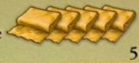


Building/trade
You may trade any commodity at the 2:1 rate. | Bank  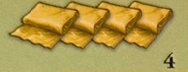


Building/trade
Merchant Guild
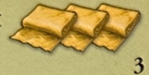


Building/trade
Trading House
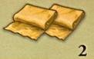


Building/trade
Bank
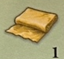

Building/Politics
You may promote strong knights to mighty knights! | Highest Level


Building/Politics
You may promote strong knights to mighty knights! | High Assembly  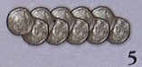

Building/Politics
You may promote strong knights to mighty knights! | Cathedral  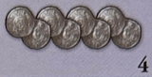

Building/Politics
Fortress
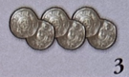

Building/Politics
Church
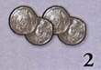

Building/Politics
Townhall
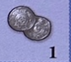

Building/Science
If not 7 and no production, you get a resource of your choice | Highest Level


Building/Science
If not 7 and no production, you get a resource of your choice | University  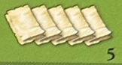

Building/Science
If not 7 and no production, you get a resource of your choice | Theater  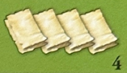

Building/Science
Aqueduct
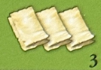

Building/Science
Library
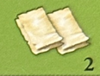

Building/Science
Abbey


You may trade any commodity at the 2:1 rate!
You may promote strong knights to mighty knights!
If you receive no production on a turn and the roll is not a 7 you may take 1 resource of your choice.
If not 7 and no production you get a resource of your choice
Market
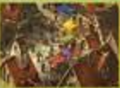
Trading house
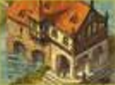
Merchant gald
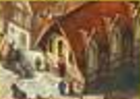
Town Hall
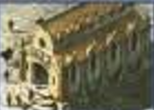
Church

Fortress:

Abbey
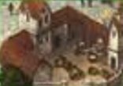
Library
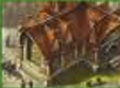
Apxxxx
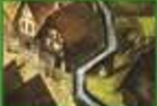

TownHall
Church
Fortress
Cathedral
High Assembly

Abbey
Library

Aqueduct
Theater
University

Market
Trading House

Merchant Guild
Bank
Great Exchange




